INTRODUCTION and why we are here

Dr E Vijayaragavn sir-

Me-A very good evening to everyone present here , our respected mentor Vijayaragav sir , Nilanjana ma'am , Shantunu sir and my fellow team leads .I am Pushpal Das, currently pursuing bachelor in technology in electronics and communication engineering third year from SRM Institute of science and technology.I have my interest in embedded system analysis, digital electronics, communication, integrated circuits, and information technology products.I am a believer in practical observations and working hand-on projects and research works. I lead a team of 9 members named RICKY KIDS, where we have a hub of projects and research works assigned by respected professors. I am currently working on four projects and five research work-publication, and competitions followed BY.

Abhishek Sarkar-

Ahel Das Chatterjee-

Suriya-

Our presentation

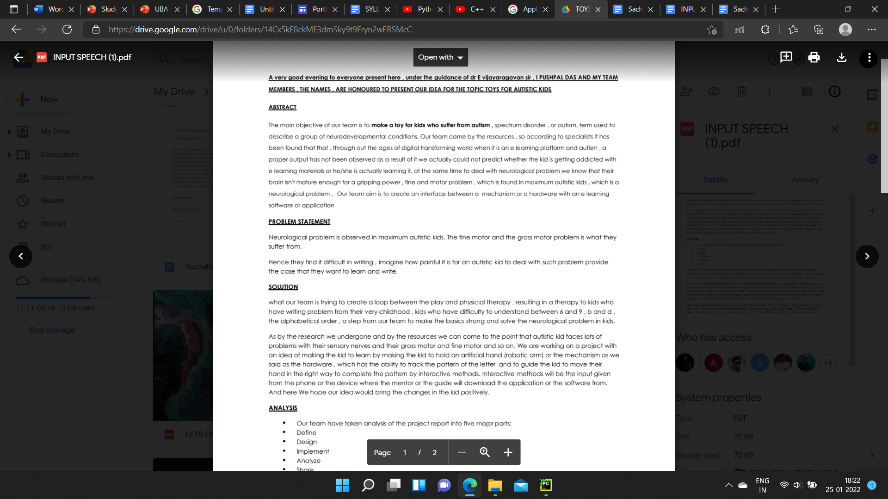

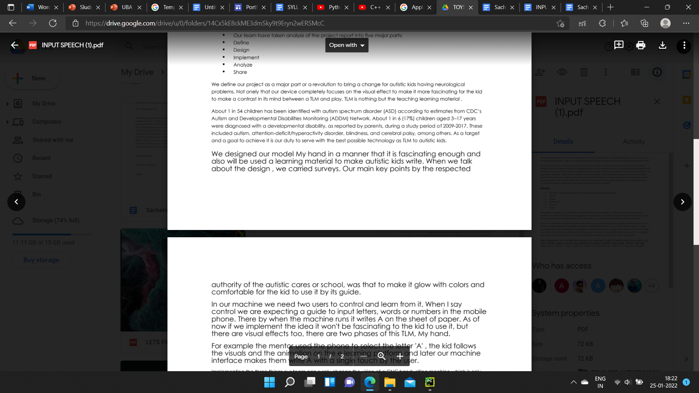

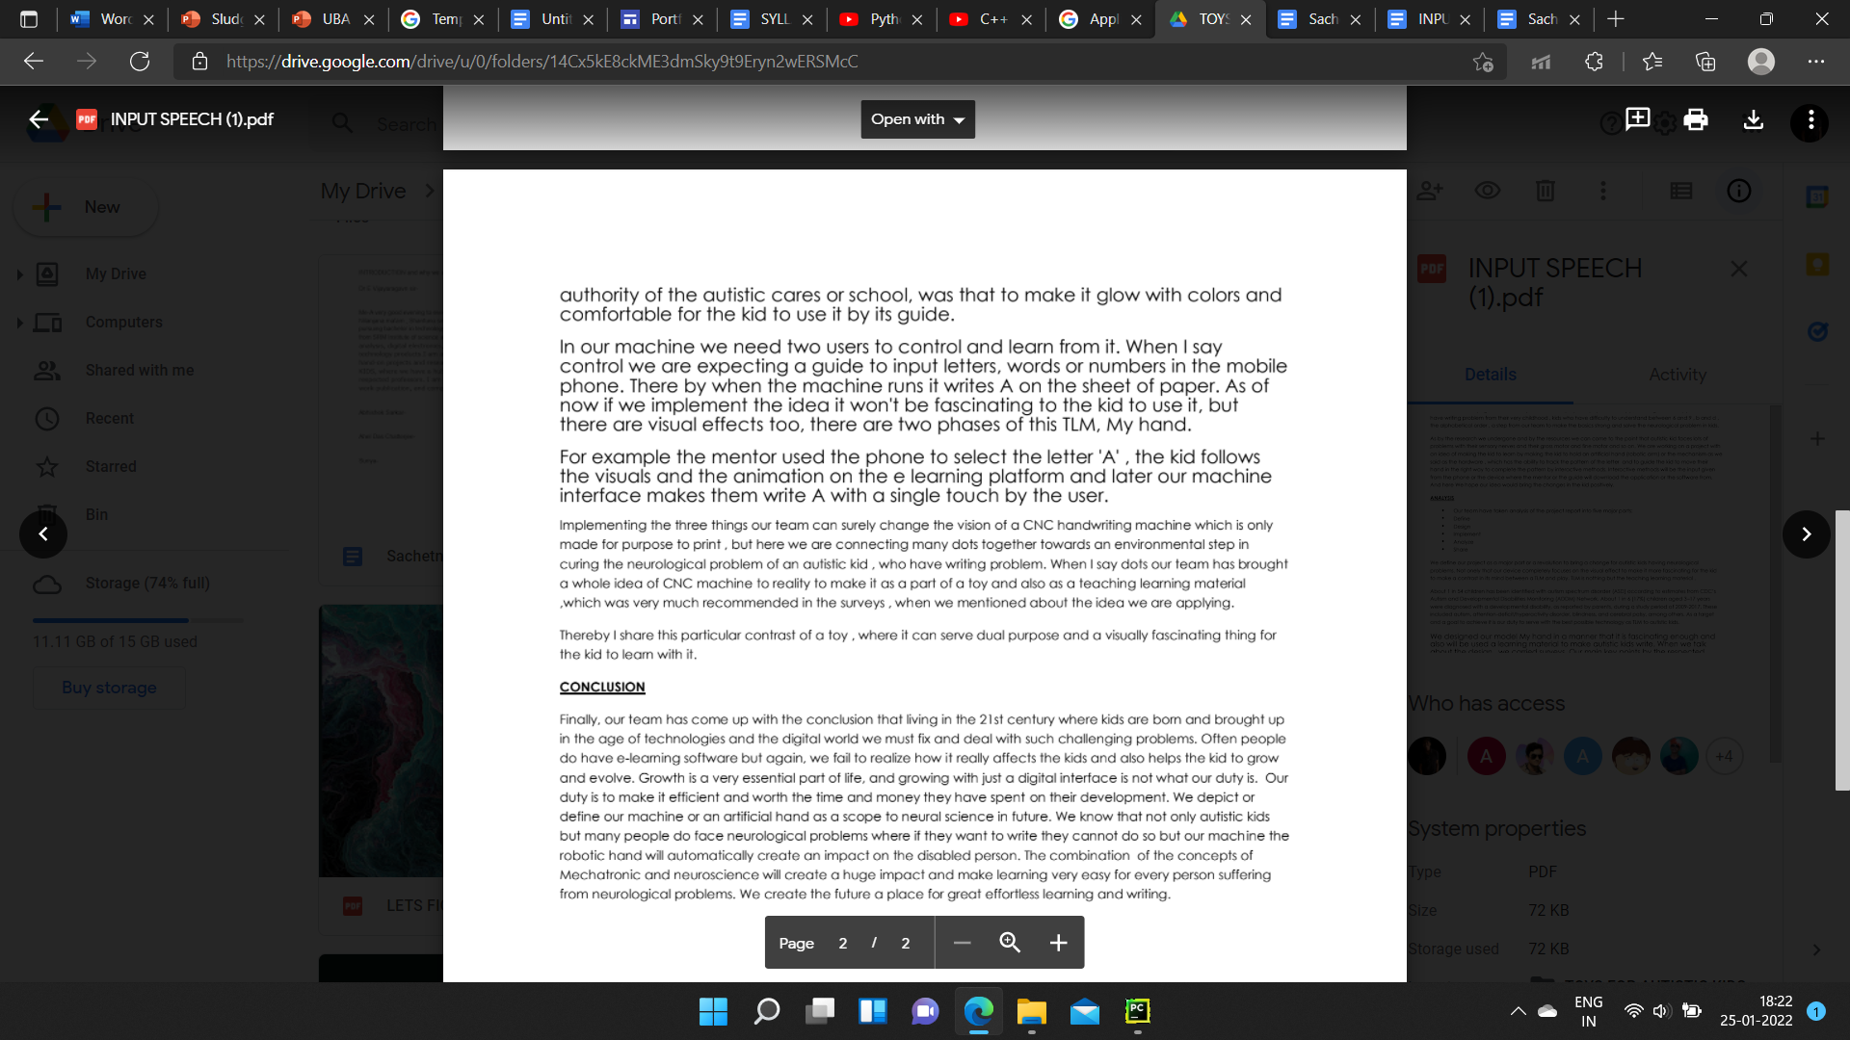

@me

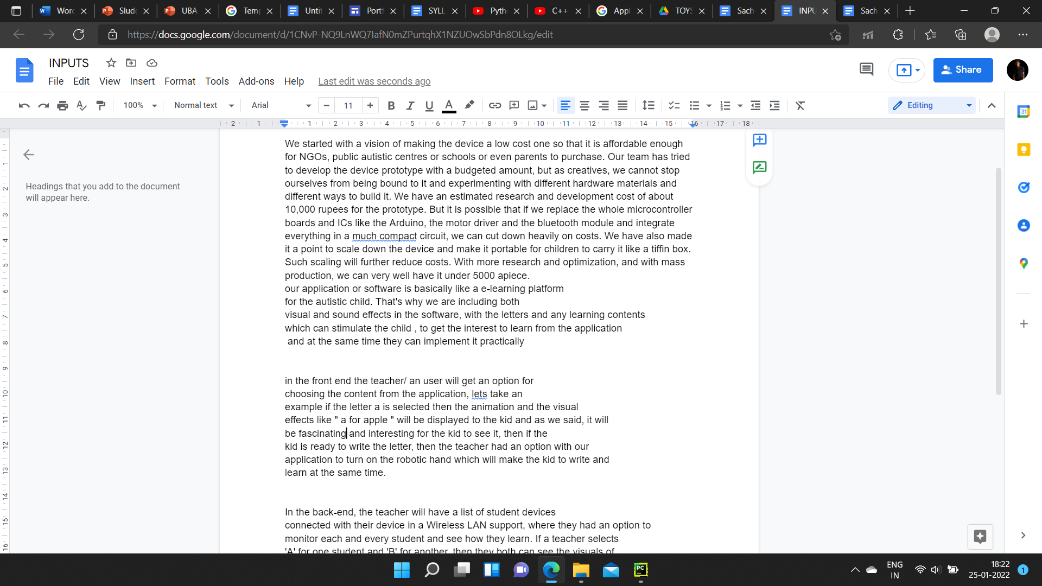

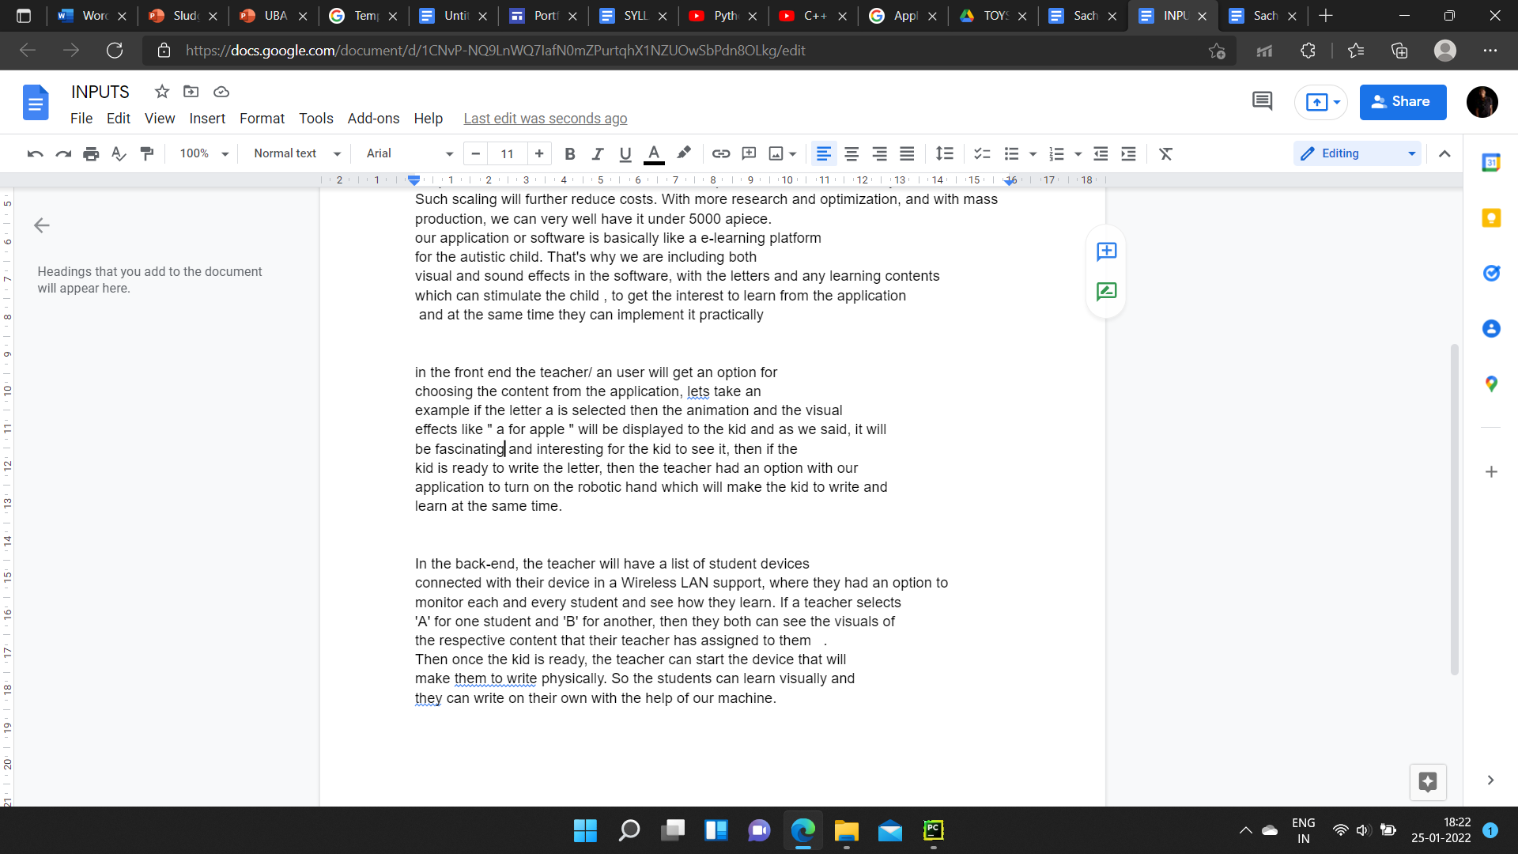

[aheldc@gmail.com](mailto:aheldc@gmail.com)AHEL

@me-**Starting , Abstract , problem statement , solution . Analysis.**

[as5539@srmist.edu.in](mailto:as5539@srmist.edu.in)**-HARDWARE PART!**

[aheldc@gmail.com](mailto:aheldc@gmail.com)**-SOFTWARE PART!**

[abhisrkr007@gmail.com](mailto:abhisrkr007@gmail.com)**-DESIGN CONSTRAINTS!**

**PRESENTATION-**[**https://drive.google.com/file/d/1DHgfut6E9dQgXVce7BeZ3q5r5HDMmfDi/view?usp=sharing**](https://drive.google.com/file/d/1DHgfut6E9dQgXVce7BeZ3q5r5HDMmfDi/view?usp=sharing)

What is the app all about? How cognitively can it helped ?

[aheldc@gmail.com](mailto:aheldc@gmail.com)AHEL

Why he is on board?What work made you over here?- Mr Shantanu Sinha

What is our marketing strategy?

[vijayare@srmist.edu.in](mailto:vijayare@srmist.edu.in)VIJAYARAGAVAN SIR

@me