**Non-contact based COVID-19 monitoring system**

P. Dasa, K. Kalimuthua, A. Sarkard, S.A.R. Devalanb, R. Paule, V.P. Dubeyc, N. Aryanc

a Department of Electronics & Communication Engineering, SRM Institute of Science and Technology, Kattankulathur, Tamil Nadu 603203, India.

b Department of Mechanical Engineering, SRM Institute of Science and Technology, Kattankulathur, Tamil Nadu 603203, India.

c Department of Computer Science and Engineering, SRM Institute of Science and Technology, Kattankulathur, Tamil Nadu 603203, India.

d Department of Electronics & Telecommunication Engineering, Jadavpur University, Kolkata, West Bengal 700032, India.

e Department of Electronics & Communication Engineering, VIT, Vellore Campus, Tiruvalam Rd, Katpadi, Vellore, Tamil Nadu 632014, India.

**Abstract**

Currently, the COVID-19 pandemic is one of the major global issues faced by health organisations. As of January 18, 2021, the total number of people worldwide confirmed to have been infected with SARS-COV-2 is more than 326.2 million, while the total number of fatalities from the coronavirus is more than 5.5 million, thereby proving that COVID-19 cases are surging worldwide very rapidly.​ COVID-19 patients have several symptoms, such as fever, shortness of breath, decrease in oxygen saturation level, dry cough, diarrhoea, vomiting, sore throat, headache, loss of taste and smell, body pain, and abnormal pulse rate.​ Among these symptoms, high fever, low oxygen saturation level, and abnormal pulse rate are considered serious. Low oxygen saturation level and shortness of breath cause hypoxemia and hypoxia, respectively. ​Sometimes, patients do not recognize hypoxemia and an increasing rate of pulse, and they subsequently die without receiving proper treatment. ​Therefore, it is important for COVID-19 patients to be regularly informed about their health conditions, especially body temperature, heart rate, and oxygen saturation (SpO2).​ In a setup of a large number of people it becomes very difficult to monitor. Moreover it may be time-consuming and difficult for most people to get regular health checkup appointments, so our IoT-based arrangements can be beneficial to individuals for routine health checkup.

**Introduction**

In the healthcare sector, there have been a high risk of disease transmission. Droplets, aerosols, infected surfaces and coming in direct contact with ill patients are some of the most common ways through which doctors, nurses, security​ guards, receptionists and other visitors are affected in this sector.

The aim of the present invention is to provide a monitoring targeted particularly for covid patients. Apart from covid patients it can also be installed in schools, colleges, and offices, thereby making it efficient to use in every sector where checking is a must. This technology will primarily focus on non-contact mode of awareness of the symptoms that any person affected with covid will be having. Such awareness can be notified by doctors, nurses or healthcare workers and even security personnel. Currently, other than the medical field, measuring body temperature is used to check whether a person is affected with COVID-19 or not solely on the measurement of their body temperature. And when it come to medical field, there are many tests done either by the doctor or the health care or nurse to check the symptoms of a person affected with COVID-19.​

The invention is an IoT-based device which will be able to monitor any covid patient or people without any event of contact happening between the observer or observatory and the person affected or being checked and this technology can be used in every possible field where the supervisors should be notified. This is an embedded device that will sense through sensors and send data over mobile phones connected through wifi or bluetooth, where the observer will be able to see the PsO2, body temperature and blood pressure through a cloud based application present in the phone. We aim to bring out a non-contact iot based covid monitoring device. ​

**Methodology/Implementation**

A Monitor was placed over a face of the stand connected to a rod for providing the support. It was movable along the z axis and this kind of arrangement is made to move the monitor as per the weight of display as well as to balance the centre of gravity along with better viewing angle in case of necessity. There was a firm rubber grip at the end of each leg which prevented unwanted movement along the remaining axes. A knob was placed between connecting rod and face of the stand to adjust the bush position at the T-junction to modify z axis. Sharp corners and edges were filleted to avoid physical harm during adjustments. Due to its lightweight property the stand could easily be swapped. Since the coronavirus has a characteristic to survive in glass, metal and plastic, the disinfectant should be sprayed over this stand.

The patient monitoring device collected all the patient body parameters using the suitable sensors and sends the data via Wi-Fi or Bluetooth to an IOT gateway. The IOT gateway is a physical platform which sends the sensor data from various IOT devices to the cloud service providers. Gateways serve as a wireless access portal to give IoT devices access to the Internet. In this device we have used MQTT communication protocol for data transfer from the IOT Gateway to the cloud.

MQTT is an OASIS standard messaging protocol for the Internet of Things (IoT). It is designed as an extremely lightweight publish/subscribe messaging transport that is ideal for connecting remote devices with a small code footprint and minimal network bandwidth. MQTT today is used in a wide variety of industries, such as automotive, manufacturing, telecommunications, oil and gas, etc.

The data sent to the cloud is processed and stored in a database. The cloud can also perform machine learning operations on these data which helps us to analyse and predict the possible outcomes in a more efficient way. This data in the database can also be accessed by web servers through the cloud services api and can be easily displayed in the dashboard on the doctors end. This helps the doctors to continuously monitor the patient from anywhere in the world and helps in non-contact based treatment.

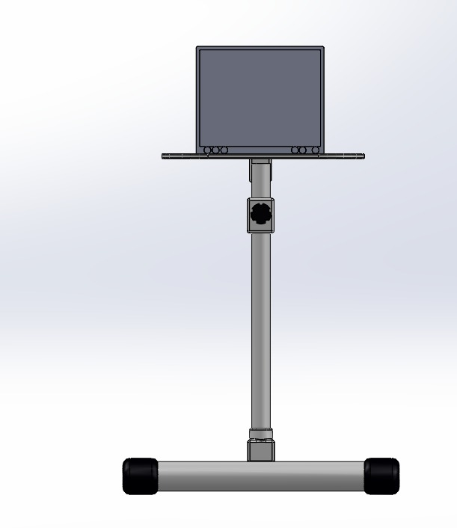 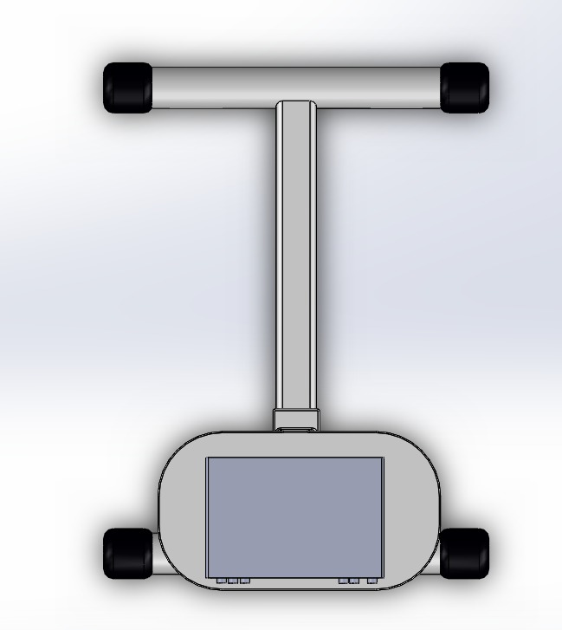

(a) (b)

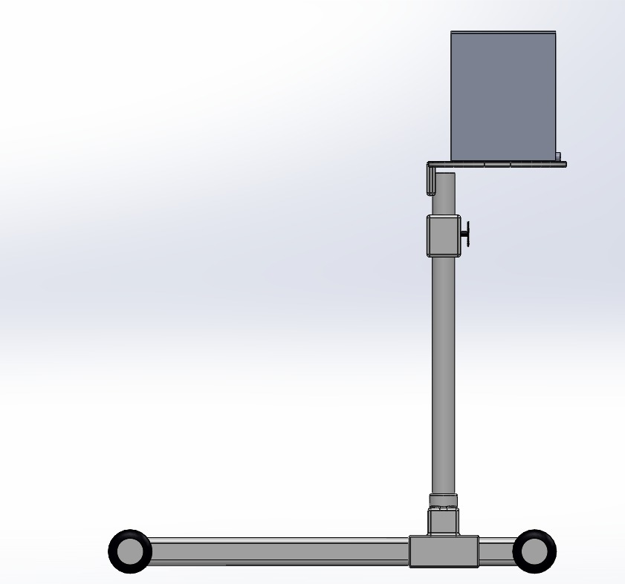

(c)

*Fig. 1:(a) Front-view, (b) Top-view, (c) Side-view of the monitor*

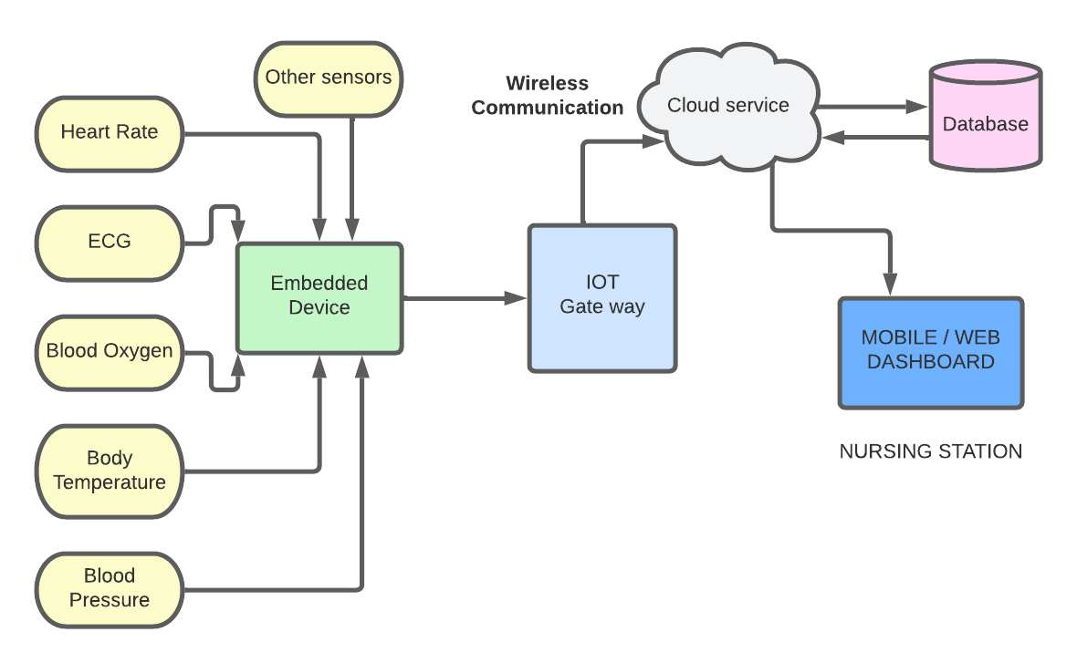

*Fig. 2: Connecting the monitor to cloud through IoT gateway*

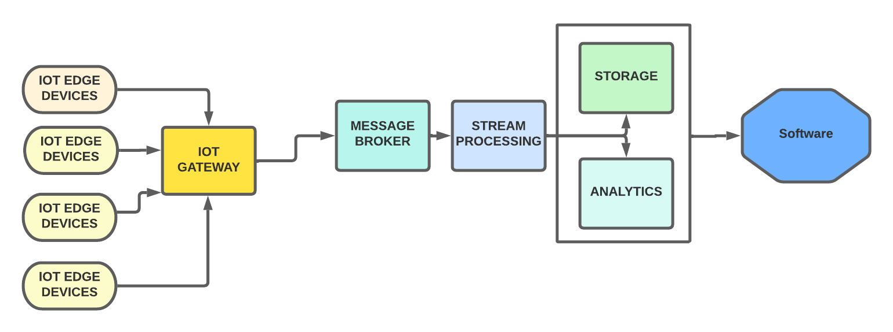

*Fig. 3: Device-software interfacing*

The approach for for planning and execution of signal handling frameworks on the SoC platform is focused on the utilisation of lightweight application programming connection points for applying standards of dataflow plan at various layers of abstraction. The improvement processes incorporated in our methodology are programming execution, equipment execution, equipment programming co-plan, and upgraded application planning. The proposed philosophy works with the advancement and incorporation of sign handling equipment and programming modules that include heterogeneous programming dialects and stages.

The coordinated programming arrangement should be approved to guarantee that it fulfils the predetermined exhibition estimations. The product setup might include at least two programming arrangement things that should be approved to work productively and really as a coordinated item. This includes designing an examination of the coordinated programming setup, considering the presentation of the predefined registering metrics and connection points to outer frameworks and applications. The incorporated programming setup approval should lay out projected functional execution estimations for information handling responsibilities that signify typical, extreme, and inordinate circumstances. This assurance should lay out the information handling responsibility that makes the product setup start to corrupt and become inert. This approval might have to use programming and testing records.

An embodiment of a medical device system as described here includes wireless devices that are configured to support a number of RF data communication protocols, techniques, and technologies that enable efficient routing of system data over wireless links. An embodiment of a medical device system may employ a wireless data communication signal having data fields transmitted over a wireless data communication channel between a first device in a medical device system and a second device in the medical device system. The display element is suitably configured to enable the monitor to display physiologic patient data, local device status information, clock information, alarms, alerts, and any information/data received or processed by the monitor. For example, a display element may be controlled to indicate an alert or alarm status when the monitor receives an incoming signal from the patient that conveys an alert signal or an alarm signal and promptly sends alert message wirelessly to the paired device as well as the cloud database. User interface features enable the user to control the operation of the monitor. In one example embodiment, user interface features enable the user to control the operation of one or more additional devices within the local infusion system, for example, an infusion pump.

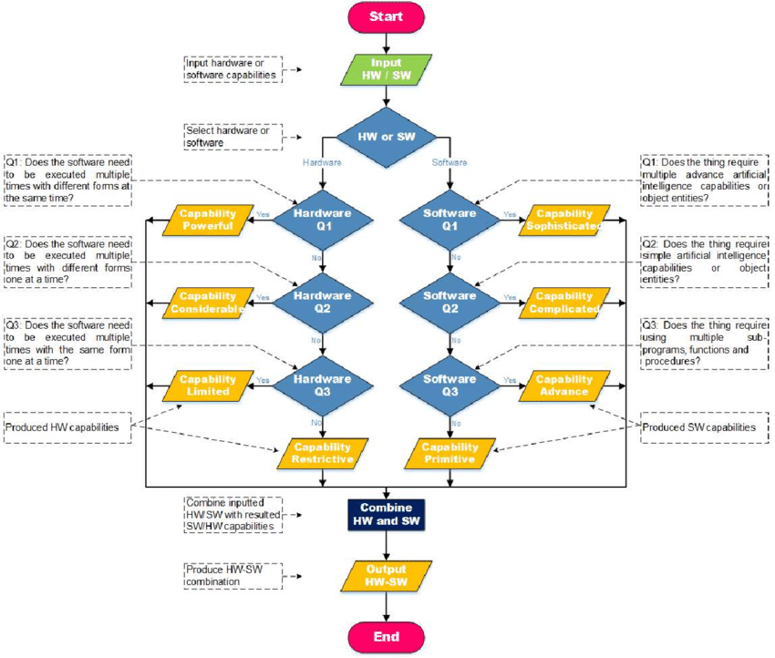

*Fig. 4: Interfacing algorithm for hardware and software*

The monitor may employ any number of local communication modules and any number of local device interfaces. Local communication module and local device interface are suitably configured to support local communications between monitor and devices directly connected to it like ventilators, anaesthesia gas machines, intravenous pumps and other physiological sensors. The local device interface may be configured to receive local communication from a transmitting device, and/or to transmit a local communication to a receiving device within the local monitoring system. Moreover, considering the particular implementation, the local communication module and local device interface should be configured to support both wireless data communication and wired/cabled data communication.

For wireless transmissions of network communications, network communication module and network interface, support one or more wireless data communication protocols that are also supported by the network device(s) communicating with the monitor. Any number of suitable wireless data communication protocols, techniques, or methodologies may be supported by monitors. In an embodiment, a wireless network interface may include or be realised as hardware, software, and/or firmware for a wireless local device interface.

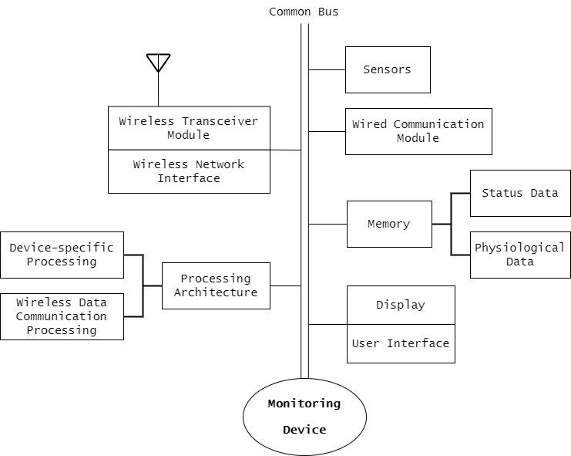

*Fig. 5: Device Architecture*

The processor may be implemented as a combination of computing devices, e.g., a combination of a digital signal processor and a microprocessor, a plurality of microprocessors, one or more microprocessors in conjunction with a digital signal processor core, or any other such configuration. In practice, the processing architecture may be suitably configured to interpret and process incoming information, data, and content that is conveyed in local communication received from a transmitting device and send the same through the wireless transceiver to the other devices.

Memory may be realised as RAM memory, flash memory, EPROM memory, EEPROM memory, registers, a hard disk, a removable disk, or any other form of storage medium known, and utilised to store device status data and/or physiologic data of the user, where such data is communicated to monitor via local communications, network communications, or directly.

**Conclusion**

Our team wants the healthcare field to be safe from covid 19 therefore we present our product where it monitors the health of the patient and reports it to the nurse remotely without any physical intervention and also to such sectors where checking is a necessary thing. ​Our product will help set up a virtual and physical barricade where nurses, guards will be able to monitor the patient or the person without any physical contact hence reducing the risk of infection.

**References**

1. <https://cloud.google.com/architecture/iot-overview>
2. <https://medium.com/google-cloud/build-a-weather-station-using-google-cloud-iot-core-and-mongooseos-7a78b69822c5>
3. <https://mqtt.org/>
4. <https://www.embitel.com/iot-insights/iot-cloud-architecture-insights-why-database-design-mat>
5. <https://grabcad.com/library/portable-laptop-stand-1>
6. [US20070254593A1 - Wireless data communication for a medical device network that supports a plurality of data communication modes - Google Patents](https://patents.google.com/patent/US20070254593A1/en)