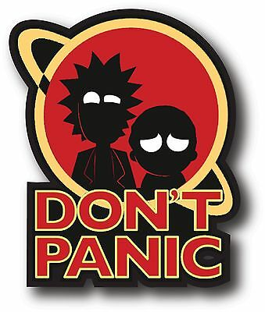

🔰

**PROFESSOR-IN-CHARGE**

**Dr. K.Kalimuthu-**[kalimutk@srmist.edu.in](mailto:kalimutk@srmist.edu.in)

**TEAMMATES**

Aryan**(FRONTEND, BACKEND)** -[panakalaryan@gmail.com](mailto:panakalaryan@gmail.com)-How data integration is done when its a cloud based live monitoring device!-**Research papers**

Abhishek -[abhisrkr007@gmail.com](mailto:abhisrkr007@gmail.com), @me - Depends on maam.

Ved**(FRONTEND, BACKEND)** -[dvedprakash2001@gmail.com](mailto:dvedprakash2001@gmail.com)-How data integration is done when its a cloud based live monitoring device!-**Research papers**

Suriya-[as5539@srmist.edu.in](mailto:as5539@srmist.edu.in)

Rohan**(BACKEND, HARDWARE-SOFTWARE BRIDGE)**-[rohanpaul060598@gmail.com](mailto:rohanpaul060598@gmail.com)-How Iot and cloud applications work?How monitoring takes place, as in the data?Go through research paper based on SMART WATCHES and their data transfer ….

**Date- 15th**

**ABSTRACT**

Non contact based COVID patient monitoring system.

**THINGS TO DO**

1. **Write the “PROBLEM STATEMENT”**

Event of contact for covid patients in the medical field and other sectors where monitoring is a necessary thing.

1. **What is the “Problem”?**

Currently, the COVID-19 pandemic is one of the major global issues faced by health organisations. As of January 18, 2021, the total number of people worldwide confirmed to have been infected with SARS-COV-2 is more than 326.2 million, while the total number of fatalities from the coronavirus is more than 5.5 million, thereby proving that COVID-19 cases are surging worldwide very rapidly.

COVID-19 patients have several symptoms, such as **fever, shortness of breath, decrease in oxygen saturation level, dry cough, diarrhoea, vomiting, sore throat, headache, loss of taste and smell, body pain, and abnormal pulse rate**.

Among these symptoms, **high fever, low oxygen saturation level, and abnormal pulse rate are considered serious**. Low oxygen saturation level and shortness of breath cause hypoxemia and hypoxia, respectively. Patients who suffer from hypoxemia and problems with pulse rate have a less chance of survival. Sometimes, patients do not recognize hypoxemia and an increasing rate of pulse, and they subsequently die without receiving proper treatment. Therefore, it is important for COVID-19 patients to be regularly informed about their health conditions, especially body temperature, heart rate, and oxygen saturation (SpO2).

**In a setup of a large number of people it becomes very difficult to monitor**. Moreover it may be time-consuming and difficult for most people to get regular health checkup appointments, so our IoT-based arrangements can be beneficial to individuals for routine health checkup.

To treat a COVID-19 patient, a doctor requires the patient’s oxygen saturation level and pulse rate. By using our proposed system, patients can inform doctors about their health conditions. This device can benefit COVID-19 patients as well as those suffering from other diseases, such as **chronic obstructive pulmonary disease (COPD) and asthma**.

1. **Causes of the problem.**

**Droplets or aerosols.** This is the most common transmission. When an infected person coughs, sneezes, or talks, droplets or tiny particles called aerosols carry the virus into the air from their nose or mouth. Anyone who is within 6 feet of that person can breathe it into their lungs.

**Surface transmission.** A less common method is when you touch surfaces that someone who has the virus has coughed or sneezed on. You may touch a countertop or doorknob that's contaminated and then touch your nose,mouth or eyes. The virus can live on surfaces like plastic and stainless steel for 2 to 3 days. To stop it, clean and disinfect all counters, knobs, and other surfaces you and your family touch several times a day.

**Airborne transmission.** Research shows that the virus can live in the air for up to 3 hours. It can get into your lungs if someone who has it breathes out and you breathe that air in. Experts are divided on how often the virus spreads through the airborne route and how much it contributes to the pandemic.

Doctors, Nurses, Security Guards, Receptionists and other visitors are mostly affected by these 3 common ways.

1. **Graphical analysis related to the problem statement.**

* **Importance of Home Quarantine and Household Isolation**
  1. **Effect in Chinese Provinces** 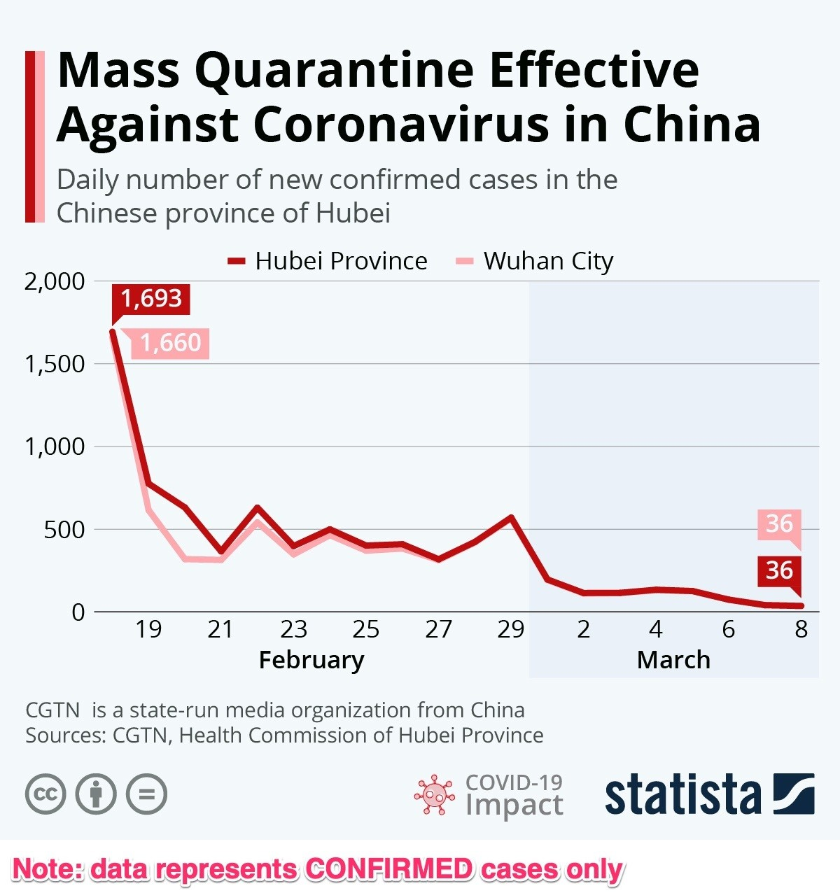
  2. **Overall case trends due to above mentioned isolation practises**

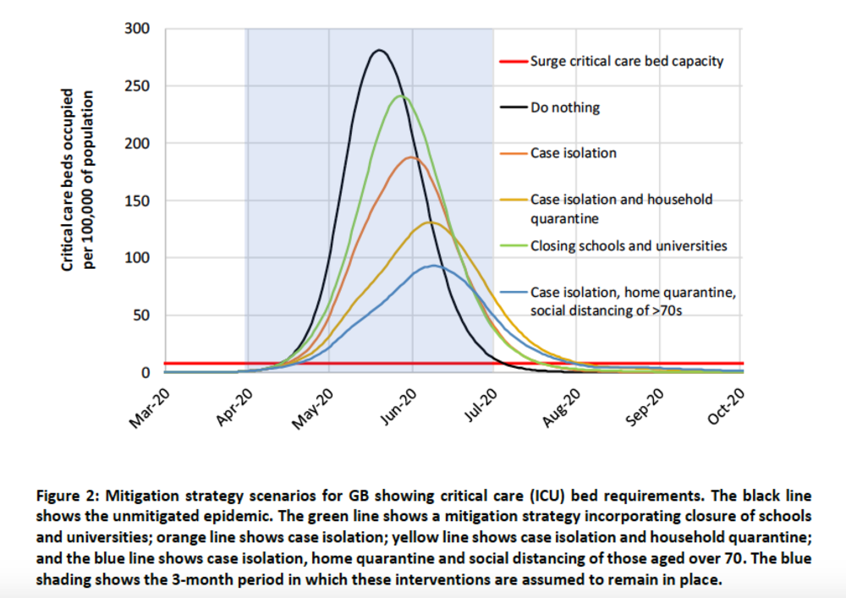

* **Importance of measuring and tracking symptoms throughout the treatment of the disease**

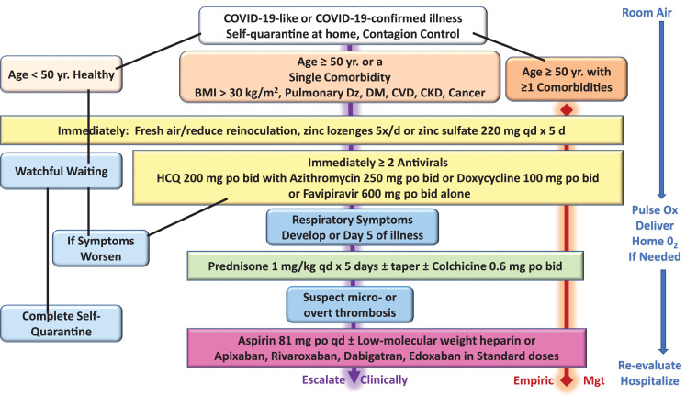

* **Sample metrics that could be useful to keep a track of**

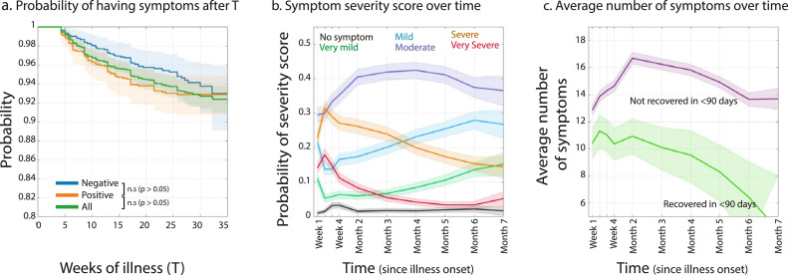

1. **Solution.**

Our team aims to provide a monitoring targeted particularly for covid patients. Apart from covid patients it can also be installed in schools , colleges and offices , thereby making it efficient to use in every sector . Our technology will solely focus on non contact mode of awareness of the symptoms that any person affected with covid will be having . Such awareness can be notified by doctors , nurses or healthcare workers and even security personnel. We know that currently apart from the medical field measuring body temperature is used to check whether a person is affected with covid or not. And when we come to medical field we know that there are many tests done either by the doctor or the health care or nurse to check the symptoms of a person affected with covid.​As a result of which our team solely focuses on bring out a technology which will be used in every possible field where the officials should be notified.Our team aims to bring out an IoT based device which will be able to monitor any covid patient or people without any event of contact happening between the observer or observatory and the person affected or being checked. We will be having an embedded device that will sense through sensors and send data over mobile phones connected through wifi or bluetooth , where the observer will be able to see the SpO2, body temperature and blood pressure through a cloud based application present in the phone. We aim to bring out a non-contact IoT based covid monitoring device. ​

1. **Conclusion.**

**Our team wants the healthcare field to be safe from covid 19 therefore we present our product where it monitors the health of the patient and reports it to the nurse remotely without any physical intervention and also to such sectors where checking is a necessary thing. Our product will help set up a virtual and physical barricade where nurses, guards will be able to monitor the patient or the person without any physical contact hence reducing the risk of infection.**

Aryan -[panakalaryan@gmail.com](mailto:panakalaryan@gmail.com)- **6**

Abhishek -[abhisrkr007@gmail.com](mailto:abhisrkr007@gmail.com)- **1**

Ved -[dvedprakash2001@gmail.com](mailto:dvedprakash2001@gmail.com)- **4**

Suriya-[as5539@srmist.edu.in](mailto:as5539@srmist.edu.in)- **3**

Rohan-[rohanpaul060598@gmail.com](mailto:rohanpaul060598@gmail.com)- **2**

@me- **5**

**ATTACH THE REFERENCES HERE!**

* [**https://www.hindawi.com/journals/cmmm/2021/8591036/**](https://www.hindawi.com/journals/cmmm/2021/8591036/)
* [**https://www.ncbi.nlm.nih.gov/pmc/articles/PMC749024**](https://www.ncbi.nlm.nih.gov/pmc/articles/PMC749024)
* [**How Coronavirus Is Transmitted: Here Are All the Ways It Can Spread (webmd.com)**](https://www.webmd.com/lung/coronavirus-transmission-overview#1)
* [**The Graph that Stopped the World — MATH VALUES**](https://www.mathvalues.org/masterblog/the-graph-that-stopped-the-world)
* [**How does quarantine prevent the spread of COVID-19? | World Economic Forum (weforum.org)**](https://www.weforum.org/agenda/2020/03/coronavirus-covid-19-quarantine-restrictions/)
* [**Pathophysiological Basis and Rationale for Early Outpatient Treatment of SARS-CoV-2 (COVID-19) Infection - The American Journal of Medicine (amjmed.com)**](https://www.amjmed.com/article/S0002-9343(20)30673-2/fulltext)
* [**Characterizing long COVID in an international cohort: 7 months of symptoms and their impact - EClinicalMedicine (thelancet.com)**](https://www.thelancet.com/journals/eclinm/article/PIIS2589-5370(21)00299-6/fulltext)

**250 words short abstract**

Problem statement-Event of contact for covid patients in the medical field and other sectors where monitoring is a necessary thing.

Our team aims to provide a monitoring targeted particularly for covid patients. Apart from covid patients it can also be installed in schools , colleges and offices , thereby making it efficient to use in every sector . Our technology will solely focus on the non contact mode of observing the symptoms that any person affected with covid will be having . Such awareness can be notified by doctors , nurses or healthcare workers and even security personnel. We know that currently apart from the medical field measuring body temperature is used to check whether a person is affected with covid or not. And when we come to medical field we know that there are many tests done either by the doctor or the health care or nurse to check the symptoms of a person affected with covid.​As a result of which our team solely focuses on bring out a technology which will be used in every possible field where the officials should be notified.Our team aims to bring out an IoT based device which will be able to monitor any covid patient or people without any event of contact happening between the observer or observatory and the person affected or being checked. We will be having an embedded device that will sense through sensors and send data over mobile phones connected through wifi or bluetooth , where the observer will be able to see the SpO2, body temperature and blood pressure through a cloud based application present in the phone. We aim to bring out a non-contact IoT based covid monitoring device. ​

**WORD COUNT - 283**