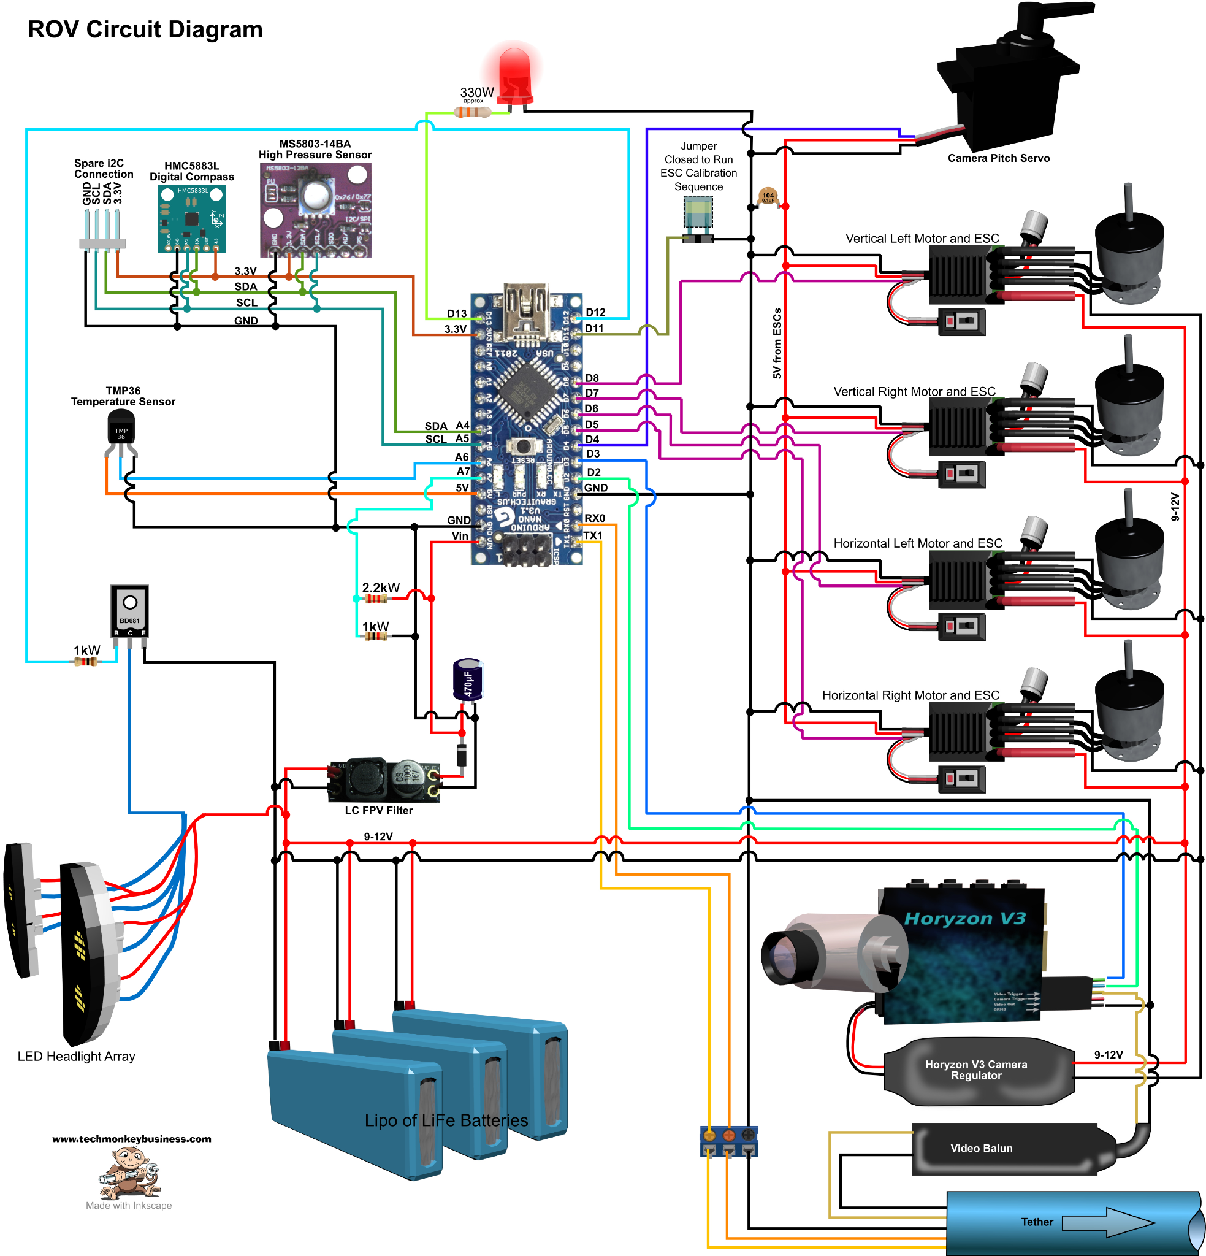

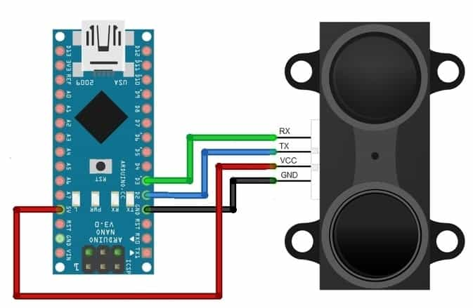

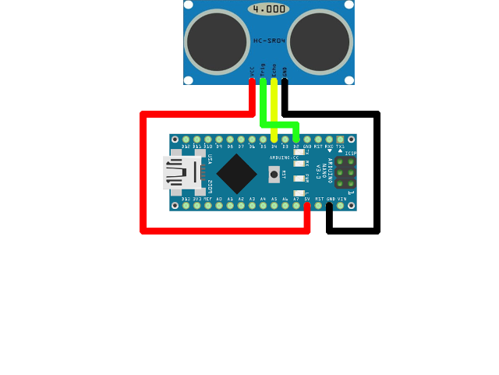

**COMPONENTS NEEDED**

**Video balun**

**A video balun is a wire connector device that allows UTP cable (such as CAT5) to transmit the video signal from CCTV cameras instead of using coaxial cable such as RG59.**

**LED headlights**

**LED stands for light emitting diode. LED lighting products produce light up to 90% more efficiently than incandescent light bulbs.LED headlights are light-emitting diode headlights. They use semiconductors to transmit energy-emitting photons that create light. These headlights can get hot, so some require additional fans or heat sinks to control the temperature.**

**LIPO Battery**

**The REVOLUTION ROV comes complete with two sets of lithium-ion batteries, each set lasts up to 6 hours.**

**Arduino Nano Sonar**

**Ultrasonic Sensor HC-SR04 is a sensor that can measure distance. It emits an ultrasound at 40 000 Hz (40kHz) which travels through the air and if there is an object or obstacle on its path It will bounce back to the module. Considering the travel time and the speed of the sound you can calculate the distance.**

**The configuration pin of HC-SR04 is VCC (1), TRIG (2), ECHO (3), and GND (4). The supply voltage of VCC is +5V and you can attach TRIG and ECHO pin to any Digital I/O in your Arduino Board.**

**I2C Module**

**Inter-Integrated Circuit – that's what I2C stands for. The I2C protocol is used to establish communication between two or more ICs (Integrated Circuits), hence why it's known as Inter-Integrated Circuit (I2C) communication.**

**HMC5883L**

**HMC5883L is a 3-axis digital compass used for two general purposes: to measure the magnetization of a magnetic material like a ferromagnet, or to measure the strength and, in some cases, the direction of the magnetic field at a point in space.**

MS5803-14BA

**transducer or instrument that converts an input mechanical pressure in gases or liquids into an electrical output signal.The MS5803-14BA is a new generation of high resolution pressure sensors with SPI and I2C bus interface. ... It provides a precise digital 24 Bit pressure and temperature value and different operation modes that allow the user to optimise for conversion speed and current consumption.**

**TMP36**

**The TMP36 is a low voltage, precision centigrade temperature sensor. It provides a voltage output that is linearly proportional to the Celsius temperature. It also doesn't require any external calibration to provide typical accuracies of ±1°C at +25°C and ±2°C over the −40°C to +125°C temperature range**

**BD681 transistor**

**In electronics, a multi-transistor configuration called the Darlington configuration (commonly called a Darlington pair) is a circuit consisting of two bipolar transistors with the emitter of one transistor connected to the base of the other, such that the current amplified by the first transistor is amplified further.**

**Transistor**

**Transistor, semiconductor device for amplifying, controlling, and generating electrical signals. Transistors are the active components of integrated circuits, or “microchips,” which often contain billions of these minuscule devices etched into their shiny surfaces.**

**ESC**

**Electronic stability control (ESC) helps prevent a vehicle from skidding – and the driver from losing control of his or her vehicle – when turning a corner, braking sharply or making a sudden manoeuvre. ESC technology automatically activates the brakes to help steer the vehicle in the right direction**

**Brushless motor**

**Need a brushless esc to work with a brushless motor but any esc can be connected to any receiver.A brushless motor is a direct current (DC) electric motor that operates without the mechanical brushes and commutator of a traditional brush motor. Brushless motors are used in various aspects of trenchless construction. A brushless motor may be referred to as a BLDC or BL motor.**

**LC and FVP filter**

**Motors and ESC’s can generate noise which can affect your FPV video quality.During flight, motor speed is constantly changing in order to stay airborne. The change of motor speed means change of current drawn by the motors, and voltage ripples (fluctuations in voltage level), which is basically noise.The most common signs of noise are disturbing lines appearing across the screen when we are flying.An LC filter can suppress the noise in the power getting to your FPV setup (e.g. your VTX and FPV camera). You might or might not need an LC filter. Some voltage regulators have some degree of power filtering ability, but an LC filter can enhance filtering.**

**Capacitors used**

**Capacitor, device for storing electrical energy, consisting of two conductors in close proximity and insulated from each other. A simple example of such a storage device is the parallel-plate capacitor.The 470uF means that it has 470millionths of a Farad of capacity. A Farad is a very large unit, it's equal to a capacitor the can supply 1 amp for 1 second and only lose 1 volt DC. The common units are microfarads, nanofarads, and picofarads.**

**0.1uF - (104) Ceramic Capacitor Use this capacitor for power decoupling, having a smooth power in your circuit, timing circuits etc. It is always a good idea to put one of these next to the power pins of a microcontroller.**

**Servo gimbal for camera**

**The gimbal uses the IMU to detect any sudden jolts or movements of the person holding the camera. These motions are cancelled out on the gimbal by powering the three brushless motors to keep the gimbal stabilised within milliseconds of unwanted motion.**

**Horyzon V3**

**HoryzonHD is a revolutionary Full HD 1080P camcorder and FPV camera.It has a separated cam module connecting the mainboard module by 20cm cam wire.It creates a lot of possibility and saves a lot of weight for HD FPV and other applications.**

**The Arduino Nano is a small, complete, and breadboard-friendly board based on the ATmega328P released in 2008. It offers the same connectivity and specs of the Arduino Uno board in a smaller form factor.The Arduino Nano is equipped with 30 male I/O headers, in a DIP30-like configuration, which can be programmed using the Arduino Software integrated development environment (IDE), which is common to all Arduino boards and running both online and offline. The board can be powered through a type-B mini-USB cable or from a 9 V battery.**

**CPS**

**An Arduino Nano V3 controls the ROV circuit, which is connected to the topside master via the tether using RS232 serial communication. On board the ROV, the Arduino sends commands to the thrusters and the camera pitch servo.An Arduino Nano V3 controls the ROV circuit, which is connected to the topside master via the tether using RS232 serial communication. On board the ROV, the Arduino sends commands to the thrusters and the camera pitch servo.**

**There are total 16 electronics components use from sensors to brushless dc motor, to work with a brushless motor but any esc can be connected to any receiver.ECS is nothing but Electronic stability control (ESC) helps prevent a vehicle from skidding – and the driver from losing control of his or her vehicle – when turning a corner, braking sharply or making a sudden manoeuvre.**

**Strating from different sorts of transistors, capacitors and resistor a circuit has been successfully drawn out of it. There are total of 4 sensors used as the digital compass , pressure sensor, sonar sensor and temperature sensor. Arduino nano is the the microcontroller which is complete, breadboard-friendly board based on the ATmega328P released in 2008. It offers the same connectivity and specs of the Arduino Uno board in a smaller form factor. Along with it for the live footage of the video input Horyzon V3 along with its regulator and balun connected to the gimbal servo to control to its axis.**