

🔰

**PROFESSOR-IN-CHARGE**

**Dr. E. Vijayaragavan-** [vijayare@srmist.edu.in](mailto:vijayare@srmist.edu.in)

**TEAMMATES**

Aryan-[panakalaryan@gmail.com](mailto:panakalaryan@gmail.com) - **CONNECTION WITH THE ROV, SOFTWARE AND UNDERWATER CONNECTION.**

Abhishek-[abhisrkr007@gmail.com](mailto:abhisrkr007@gmail.com) & @ME - **SENSORS, DSP, ROV Research paper**

Ved-[dvedprakash2001@gmail.com](mailto:dvedprakash2001@gmail.com) - **Tech for streaming footage integrated in a software, DIP.**

Sudeshna di-[sdindia246@gmail.com](mailto:sdindia246@gmail.com) - **European tech research, RESEARCH PAPER ON LIVE STREAMING FROM A SOFT.**

Suriya-[as5539@srmist.edu.in](mailto:as5539@srmist.edu.in) - **WATERPROOF MATERIAL, ROV FRAMEWORK.**

**15th is the date.**

**ABSTRACT**

**THINGS TO DO**

1. **Write the “PROBLEM STATEMENT”**
   1. To navigate sewers in order to find structural faults/cracks and also to lay pipes for cleaning
2. **What is the “Problem”?**

Underground pipe systems are a key to any modern 21st century settlement. They can vary from **gas pipes to water supply** and it is key to ensure that the pipes are maintained to be kept in good condition which can otherwise lead to **explosions in case of gas systems and loss of water or water supply poisoning** in case of water systems. These pipeline networks can be extensive and difficult to survey for ordinary human and human tools especially in third world or developing countries where funds and resources for such an endeavour is scarce.Human effort is not the solution to 100% to a country like India where faults and error rate is quite high and on the other hand we have only human labour to rely on.

1. **Causes of the problem:**
   1. Sonar/LiDAR fitted drones to navigate sewers in order to find structural faults/cracks and also to lay pipes for cleaning

-While toilets are a necessary part of the solution, an arguably bigger yet often overlooked issue is how to contain and treat India’s sewage.

-Untreated sewage is the leading polluter of water sources in India, causing host of diseases. In some places, the cleaners are generally very poor men who dive into the toxic sludge to clean it. In others, manholes are lifted and pumps are used to clean the sewers. A total of 631 people have died in the country while cleaning sewers and septic tanks in the last 10 years, [the National Commission for Safai Karamcharis](https://timesofindia.indiatimes.com/topic/the-National-Commission-for-Safai-Karamcharis) (NCSK) said in a response to an RTI query in 2020.

-Sewers in Indian cities are not well-developed. There are no pathways in the sewage system along which people can traverse. While India’s largest cities have centralized sewage systems with underground pipes, pumping stations, and treatment plants, these systems are expensive to build and to operate, requiring uninterrupted power, skilled operators, and extensive maintenance which are not organised well in the country.

-Such sewer lines prevent engineers from examining them and the entire architecture from within.

1. **Graphical analysis**

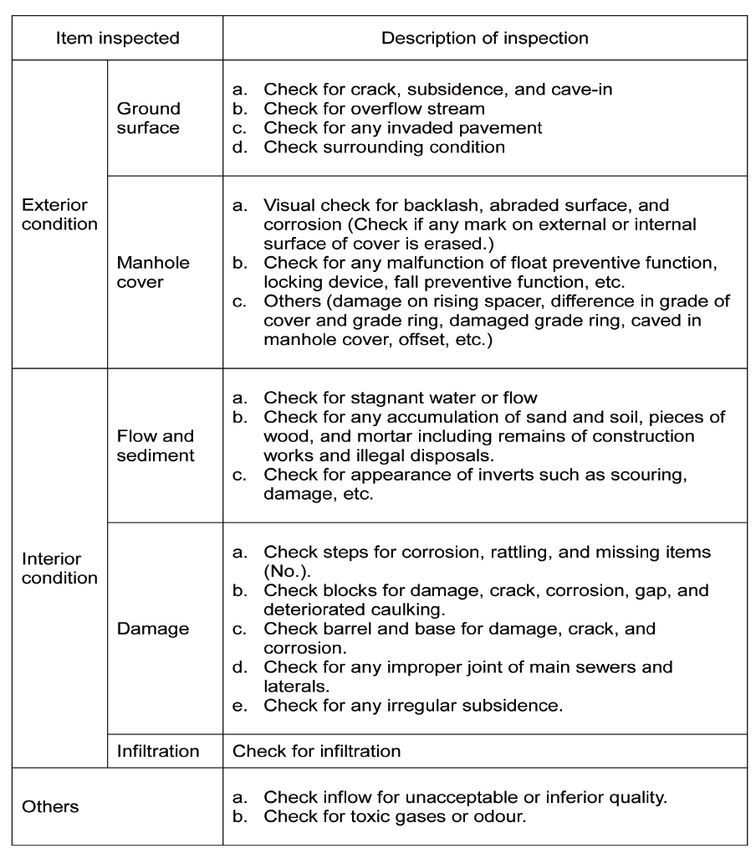

Inspection and Examination items for Manhole. Source:JASCOMA, 2007([**https://cpheeo.gov.in/upload/uploadfiles/files/operation_chapter2.pdf**](https://cpheeo.gov.in/upload/uploadfiles/files/operation_chapter2.pdf))

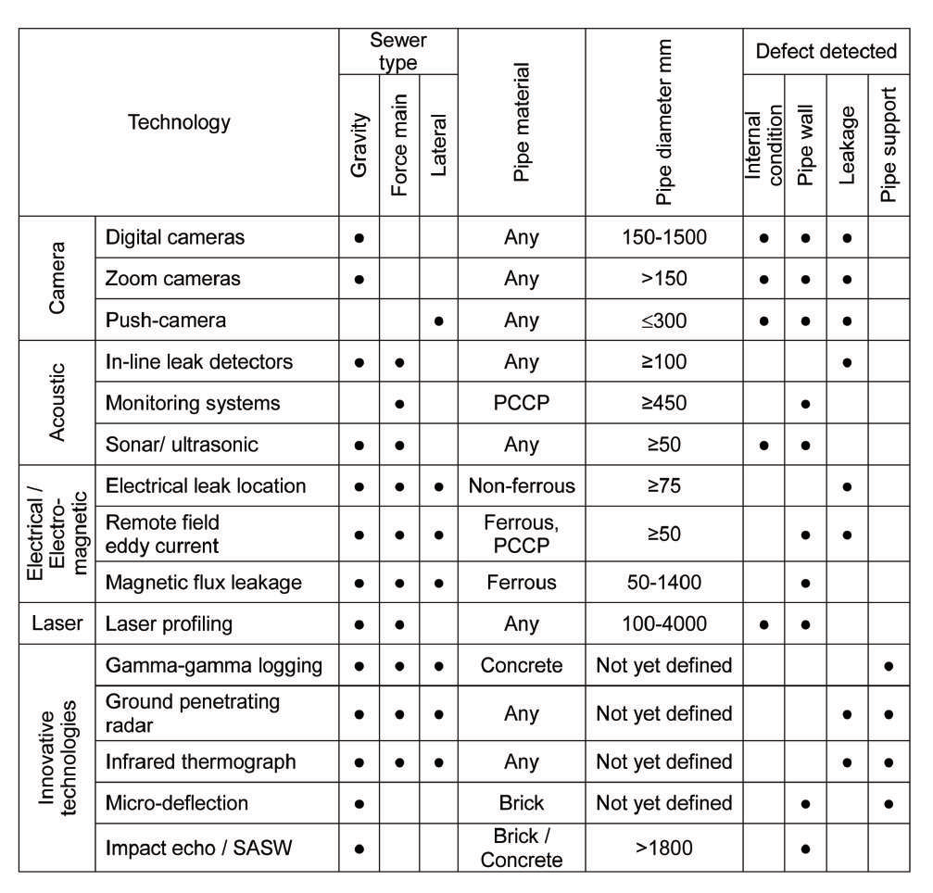

Methods of indirect inspection and examination of the sewers Source: EPA/600/R-09/049 | May 2009 ([**https://cpheeo.gov.in/upload/uploadfiles/files/operation_chapter2.pdf**](https://cpheeo.gov.in/upload/uploadfiles/files/operation_chapter2.pdf))

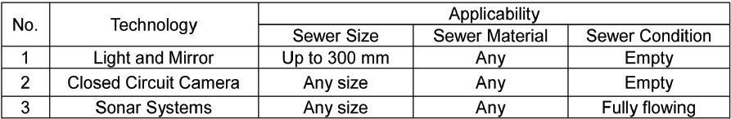

Sewer System Inspection Technologies considered applicable to Indian conditions

([**https://cpheeo.gov.in/upload/uploadfiles/files/operation_chapter2.pdf**](https://cpheeo.gov.in/upload/uploadfiles/files/operation_chapter2.pdf))

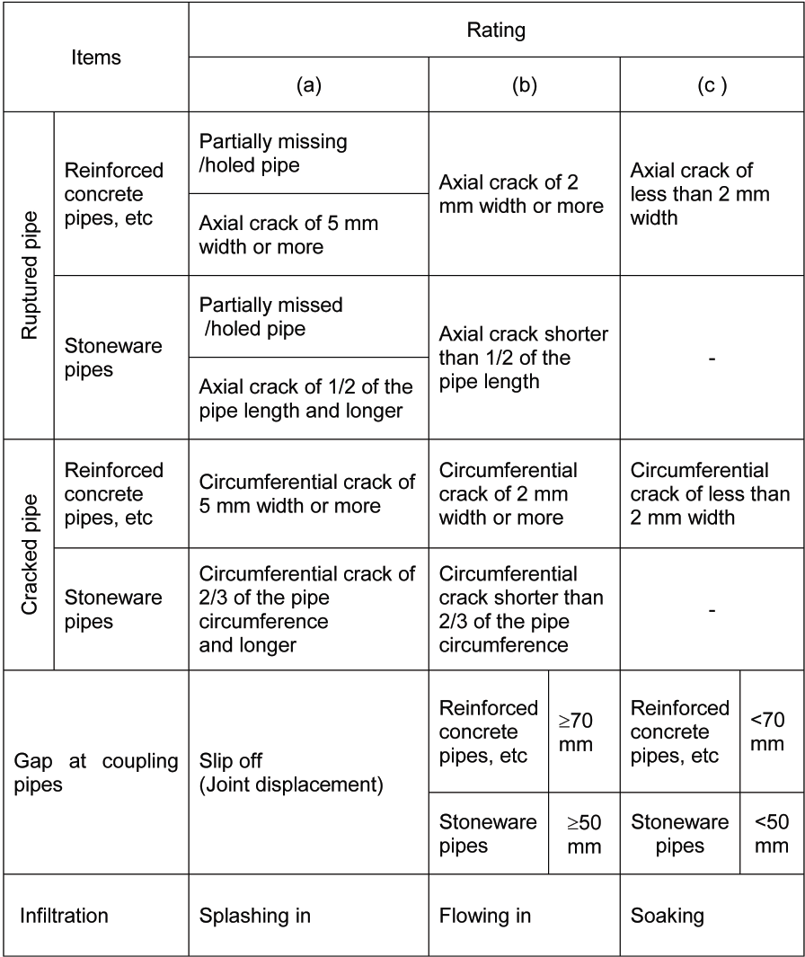

Testing criteria for each pipe of sewer Source: JASCOMA, 2007([**https://cpheeo.gov.in/upload/uploadfiles/files/operation_chapter2.pdf**](https://cpheeo.gov.in/upload/uploadfiles/files/operation_chapter2.pdf))

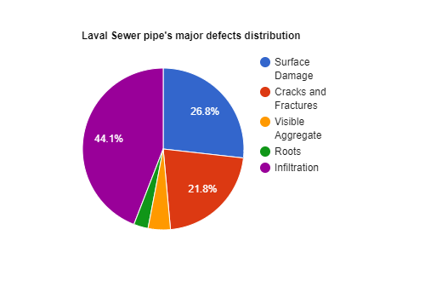

(https://www.researchgate.net/publication/301570683_Condition_Prediction_for_Chemical_Grouting_Rehabilitation_of_Sewer_Networks)

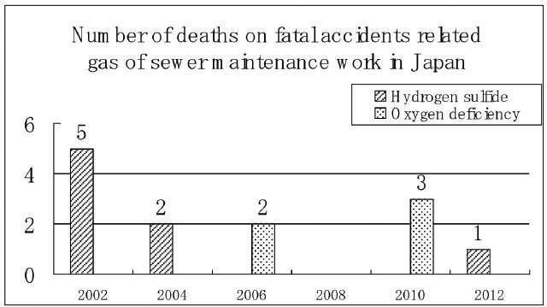

Fatal accidents due to gases from sewerage system between 2002 and 2012 Source: JASCOMA,2012 ([**https://cpheeo.gov.in/upload/uploadfiles/files/operation_chapter2.pdf**](https://cpheeo.gov.in/upload/uploadfiles/files/operation_chapter2.pdf))

1. **Solution**
2. A ROV can also be used for sewage inspection so as to spare humans from entering potentially dangerous places and also thoroughly inspect nooks and crannies of drains thus saving time and human effort. ​
3. Manual inspections with outdated equipment result in a slow inspection rate with higher probabilities of errors.​
4. On the other hand, using ROV equipped with cameras can go into areas inaccessible to humans and detect corrosion and even expose structural problems and damages in drains and pipes.​

​

​

1. Using computer vision the ROVs can analyse and process the video stream and detect the structural integrity of the sewage pipelines. ​
2. Sensors can be fitted into the ROV to measure to detect the existence of harmful gases and substances. ​
3. The ROVs can survey a large area in a relatively short period of time and can process and send the information using embedded systems in a relatively short period of time thus resulting in planning of an effective rescue operation whenever necessary. ​
4. Smaller ROVs i.e. mini drones have the added advantage of being able to fit into smaller places where humans can't therefore produce more data for processing and even capturing higher quality images of every small fault in the sewage drains. ​
5. This also results in production of a large amount of data for image processing and for future reference.​
6. **Conclusion**
7. Lastly, our team would like to conclude that, living in the 21st century, we can utilise the concept of ROV , which will be able to detect any sort of failure in underground tunnels and be very well used for sewage inspection.
8. In a country like India we need a upgradation to a level of benefit, to make the impossible happen with a very cost effective price for the government or the investor to invest in. The concept of making a water resistant mini ROV is what makes our project , our research work , our mission stay out of the crowd in the world of ROVs when it comes to our country, India. We often have come across many such ROVs for limited purposes, but here we want to come up with a concept that every country should put their investment in for a better, smart and a sustainable future. ​
9. Our goal is to make an ROV , rather a sustainable one for our future generation to rely on in a quick and effective manner. ​

​

​

​

**ATTACH THE REFERENCES HERE!**

**250 words short abstract**

Problem statement- To navigate sewers to find structural faults/cracks and also to lay pipes for cleaning.

ROV can be used, rather a mini version for sewage inspection so as to spare humans from entering potentially dangerous places and also thoroughly inspect nooks and crannies of drains thus saving time and human effort. Manual inspections with outdated equipment result in a slow inspection rate with higher probabilities of errors. On the other hand, using drones equipped with cameras can go into areas inaccessible to humans and detect corrosion. It will even expose structural problems and damages in drains and pipes.

Using computer vision the ROVs can analyse and process the video stream and detect the structural integrity of the sewage pipelines. Sensors can be fitted into the ROV to detect and measure the existence of harmful gases and substances. All the data will be transmitted to a software or an application where the ROVs can survey a large area in a relatively short period of time and can process and send the information using embedded systems in a relatively short period of time thus resulting in planning of an effective operation whenever necessary for an inspection on underground channels. Smaller ROVs i.e. mini ones have the added advantage of being able to fit into smaller places where humans can't therefore produce more data for processing and even capturing higher quality images of every small fault in the sewage drains. This also results in production of a large amount of data for image processing and for future reference.

**WORD COUNT - 256**