

🔰

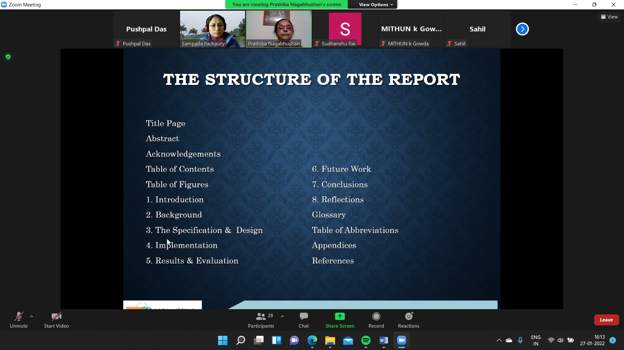

**Triple carry avoidance**

**Abstract**

In many states the traffic signals have been

upgraded into smarter solutions, but real-time

surveillance and regulation of traffic rule offenders is

yet to be seen.

Triple carry is prohibited by law in our country, and

yet the offense is rarely talked about and looked

upon by the traffic police.

It is not only illegal, but also risky and dangerous for

multiple people. The motorcycle driver along with

two riders pose risk to their own lives as well as that of

other people. This is because when a motorcycle

that is meant to carry two people gets the load of

three, it loses its structural balance and the

suspension poses risk ofdamage.

This phenomenon is widely seen in small localities

where people need not travel long distances. Such

a place where we tried to bring smarter surveillance

and regulation was our university campus in Tamil

Nadu, India.

**Introduction**

The university provides guards present at the entry gate to

the campus for identity verification, for safety standards -

like checking body temperature for covid, wearing a

helmet when you are on a two wheeler, and checking

whether there is any triplet on the bike before entering to

the campus.

But it is generally outside the campus at the gates where

one can get access for checking for triple carry and not

inside the campus as it is not possible for guards to check at

each and every turn inside the large area of the campus.

So in most of the cases, for students who carry a third

person on their bikes outside the campus, when they reach

near the checking point on the gate, they drop one and

enter successfully without scrutiny carrying the other

person in their bikes.

On the other hand the other rider enters the campus on

foot and again gets up on the bike, resulting in a triple

carry. Thus, the checking near the entrance gate is not

efficient when it comes to curbingtriple carry.

**Design and Specification**

[aheldc@gmail.com](mailto:aheldc@gmail.com)[dvedprakash2001@gmail.com](mailto:dvedprakash2001@gmail.com)[panakalaryan@gmail.com](mailto:panakalaryan@gmail.com)

**Implementation+ Result and Evaluation**

[dvedprakash2001@gmail.com](mailto:dvedprakash2001@gmail.com)

**Conclusion**

As mentioned, triple carry on two-wheelers has been

made a punishable and fineable offence across the

country and is being enforced strictly.

This is due to various reasons ranging from personal to

civic safety that is endangered by triple riding on a

bike. This makes it all the more important to ensure

that through technology we can help in better and

more efficient enforcement of this law on our

campus.

Our technology can bring down the number of

repeat-offenders. This technology can also be

applied throughout the country and potentially help

in decreasing one of the major causes of bike or

traffic accidents.

**Future work**

[abhisrkr007@gmail.com](mailto:abhisrkr007@gmail.com)

**Acknowledgement**

Our team would like to express our gratitude to SRM Institute of Science and Technology for the support and guidance . Our team would further express our gratitude to Dr K. Kalimuthu, for the time, knowledge and constant encouragement she has lent us for making this project. We express our special thanks to Dr.C.T.Manimegalai and Dr.SabithaGauni for their diligent guidance and for their support during our research work.

**References**