

🔰

**PROFESSOR-IN-CHARGE**

**Dr. K.Kalimuthu-** [kalimutk@srmist.edu.in](mailto:kalimutk@srmist.edu.in)

**MEMBERS**

Aryan -[panakalaryan@gmail.com](mailto:panakalaryan@gmail.com)

Ved -[dvedprakash2001@gmail.com](mailto:dvedprakash2001@gmail.com)

Ahel -[aheldc@gmail.com](mailto:aheldc@gmail.com)

@me, Abhishek -[abhisrkr007@gmail.com](mailto:abhisrkr007@gmail.com) - Real image from cctv to control system, quite an iot based, image to text. prepare for the paper- **CONTROL UNIT**

Dr.SabithaGauni- [sabithag@srmist.edu](mailto:sabithag@srmist.edu)-

Dr.C.T.Manimegalai-[manimegc@srmist.edu.in](mailto:manimegc@srmist.edu.in)-

**ABSTRACT**

Triple riding avoidance.

**THINGS TO DO**

1. **What is the “Problem”?**

**As we know that triple carry is strictly prohibited in our country , and more over after many laws and bills have been passed either the traffic police are bribed or the riders somehow manages to escape , but in many states the traffic signals have been updated and we are moving for a better future for motorcyclist to save themselves from getting prone to road sacciedents.As we know that it is risky and dangerous enough for a triple carry in a road where people are being less concerned about their own safety and goes under the nose of law. So the same thing happens to our campus SRM Institute of science and technology , ktr.**

1. **Causes of the problem.**

**SRM have guards present in the gate, for identity verification , for safety standards , like checking body temperature for covid, wearing a helmet when you are on a two wheeler , checking whether there is any triplet on the bike before entering to the campus. But again it is outside the campus where one can get access for checking for triple carry not inside the campus, even if it happens it occurs quite rare as it is not possible for guards to check at each and every point inside such a huge area of campus.So in maximum of the cases students do take a triple carry outside the campus and when they reach near the checking point on the gate , they drop one of the member and enters successfully carrying two people in a bike, and the left out member enters the campus and again that bike gets inside the campus , resulting in a triple carry which is strictly prohibited. So ultimately strict checking near the entrance gate fails when it's on triple carry, not fully efficient.**

1. **Write the “PROBLEM STATEMENT”**

* **Triple carry on two-riders in the SRM campus**
* **Identify bikes with triple riders by running DIP edge detection algorithm in particular image frames taken from the cctv footage**
* **If triple-riding is detected, try to extract the number plate text of the same bike**
* **The bike should be registered with SRM institution**
* **The phone number and email id registered corresponding to the number plate number of the offender is searched from database and a notice is sent at once**
* **To avoid repeat offenders, the offender’s number plate details is stored in the database and the fee amount is progressively increased for successive offense.**
* **There may also be people who are not registered with the institution(like visitors, delivery persons, hospital-goers, etc. Offenders among them should be held at the gate before they leave for payment of fine.**
* **Offense should be extended to people not wearing helmets**

1. **Graphical analysis**

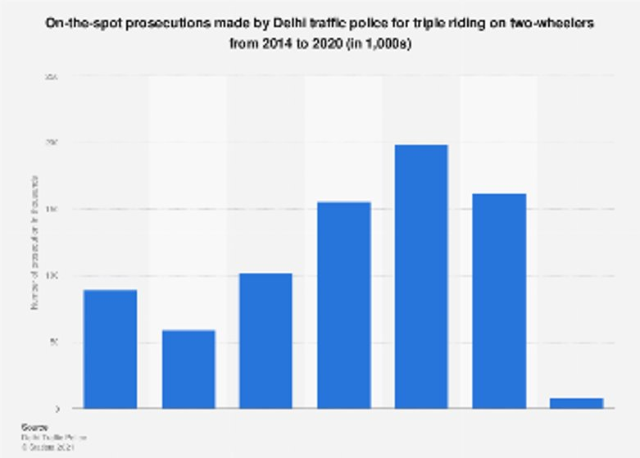

1. **Solution.**

**A good solution could be to check number plates that have previous records of rule breaking.**

**If however capturing number plates of the two wheelers is not feasible, then colour of vehicle,colour of helmets(if rider is not wearing helmets then we should be more concerned about that issue, not just the triple riding :) ), colour of shirt(not sure how effective tallying colour of shirt can be, because I once wore a gorgeous red shirt to college which looked so unique, only to realise that at least 5 other people have a similar shirt), posture of the rider, etc can be used to predict if the bike has previous records of triple riding. For that we can use Digital Image Processing to set up a model that can help in predicting the probability that a particular two wheeler will be used for carrying 3 people inside campus.**

**The best solution however is not to allow two wheelers at all. For example, in our college, people are poor and cannot afford bikes. So they use cycles. And triple riding on a cycle is too painful. If there will be no bike inside the campus, there will be no rider, if there will be no rider then there will be no triple riding. Problem solved :)**

1. **Conclusion**

**As mentioned above it is evident that triple carry on two-wheelers has been made a punishable and fineable offence across the country and is being enforced strictly. This is due to various reasons ranging from personal to civic safety that is endangered by triple riding on a bike. This makes it all the more important to ensure that through technology we can help in better and more efficient enforcement of this law on our campus. Our technology could also hamper repeating offenders. In the future this same technology could also potentially be applied throughout the country and help in decreasing one of the major causes of bike or traffic accidents.**

Aryan -[panakalaryan@gmail.com](mailto:panakalaryan@gmail.com) - **3**

Abhishek -[abhisrkr007@gmail.com](mailto:abhisrkr007@gmail.com)- **4**

Ved -[dvedprakash2001@gmail.com](mailto:dvedprakash2001@gmail.com)- **6**

Ahel -[aheldc@gmail.com](mailto:aheldc@gmail.com)- **5**

@me **- 1,2**

**ATTACH THE REFERENCES HERE!**

[**• India: triple riding prosecutions by Delhi traffic police 2020 | Statista**](https://www.statista.com/statistics/1082087/india-triple-riding-prosecutions-delhi-traffic-police/)**​**

**​**

[**Mission Road Safety on Twitter: "Tripple riding is not only dangerous for whoever rides but also to the other people around them. Don't indulge in tripple riding or over loading on two wheelers. https://t.co/CvVa1qxx77" / Twitter**](https://twitter.com/missionroadsafe/status/1156759515238244354)**​**

**​**

[**SRM Institute of Science and Technology releases engineering rank list | The News Minute**](https://www.thenewsminute.com/article/srm-institute-science-and-technology-releases-engineering-rank-list-130496)**​**

**​**

[**Stanley focuses on the future of remote monitoring | SecurityWorldMarket.com**](https://www.securityworldmarket.com/int/News/Business-News/stanley-focuses-on-the-future-of-remote-monitoring)**​**

**​**

**​**

**​**

**250 words short abstract**

Problem statement- Triple carry on two wheeler inside SRM Institute of Science and Technology, Kattankulathur.

A viable solution could be to checking the number plates and punishing the repeat offenders or warning triplets on their first entry to the database of offenders.​

The notice can be sent to the respective students by message or e-mail. If the surveillance system is unable to capture the number plate of the vehicle, then other information like the colour and model of the motorcycle, colour of helmets and clothing, posture of the rider, etc can be used to predict if the bike has previous records of triple riding. If the rider is not wearing helmets then the same system can issue a notice to them.​

To achieve this we use Digital Image Processing algorithms and process real-time CCTV footage for checking if a two-wheeler has three riders or if a biker is not wearing a helmet. A local database is maintained with the details of the motorcycles and the riders, segregated into first-time offenders and repeat-offenders. A notice is immediately sent to those caught in the act.​

A separate solution is to introduce bicycles for rent inside the campus and ban motorcycles altogether.​This makes it all the more important to ensure that through technology we can help in better and more efficient enforcement of this law on our campus. Our technology can bring down the number of repeat-offenders. This technology can also be applied throughout the country and potentially help in decreasing one of the major causes of bike or traffic accidents.​

**WORD COUNT - 260**

​