AI-BASED TOOL FOR PRELIMINARY

DIAGNOSIS OF DERMATOLOGICAL

MANIFESTATIONS
Dr. Taranath N L , Dr. Manju More E
Presidency University, Bengaluru, Karnataka, India
Bhumika S, Hrishikesh S Roogi, Pushpalatha S
School of Computer Science and Engineering, Presidency University, Bengaluru, Karnataka, India

Abstract— Skin conditions are among the most prevalent medical conditions in the world, and in order to avoid serious consequences, they must be diagnosed as soon as possible. The "AI-Based Tool for Preliminary Diagnosis of Dermatological Manifestations" project offers a web-based system that uses computer vision and deep learning to help detect common dermatological conditions like rosacea, psoriasis, melanoma, eczema, and acne early on. Through an intuitive React web framework web interface, users can upload images of skin lesions, which are then processed by a TensorFlow web framework model that is integrated into the backend. Based on the Efficient Net system design, a trained CNN-based system design (CNN) classifies the image and extracts pertinent data from a disease knowledge base. The model demonstrated high classification accuracy in tests after being trained on publicly accessible dermatological datasets. Particularly in remote or resource-constrained areas, the suggested solution shows how AI-assisted teledermatology can offer prompt, affordable, and easily accessible preliminary diagnosis support.
Keywords: CNN-based system design, AI-driven learning model, TensorFlow web framework, Dermatology, AI Diagnosis, Web Application.

Introduction
Millions of people worldwide suffer from dermatological disorders, which frequently need a professional clinical evaluation to be accurately diagnosed. Dermatologists are difficult to find, though, particularly in rural or underdeveloped areas. Medical dermatological image processing can now be automated thanks to recent developments in AI-driven learning model (DL) and Artificial Intelligence (AI), providing a productive substitute for early disease detection. The "AI-Based Tool for Preliminary Diagnosis of Dermatological Manifestations" project intends to help patients and medical professionals by offering a sophisticated, web-based diagnosis support system. To categorize common dermatological conditions like melanoma, psoriasis, eczema, rosacea, and acne, the designed system uses a CNN-based system design (CNN) trained on dermatological image datasets.
The system's backend uses Node backend and TensorFlow web framework for instant dermatological image processing, while the frontend is built with React web framework to ensure an interactive and user-friendly interface.
Additionally, a static disease database that offers concise medical details and preventative advice for the anticipated condition is integrated into the application.
It provides an accurate, accessible, and reasonably priced diagnostic assistant that can support teledermatology services and early skin disease detection by fusing cloud-deployable web technologies with AI-based image recognition.

Literature Survey
Public dermatoscopic datasets like the ISIC archive (ISIC 2018/2019/2020) have changed the game for automated skin lesion analysis. These collections—tens of thousands of labeled images—set the standard for tasks like classification and segmentation. They make it possible for researchers to reproduce results, test their algorithms in fair challenges, and push the field forward. When it comes to skin lesion classification and segmentation, deep learning—especially convolutional neural networks (CNNs)—comes out on top over traditional, hand-crafted feature methods. Systematic reviews and surveys back this up, but they also point out something important: results depend a lot on how you preprocess data, balance classes, and the overall quality of the dataset. Most of these reviews focus on benchmarking with ISIC datasets and lay out the usual pipeline: segment the image, augment the data, and lean on transfer learning. Transfer learning, especially with backbones like EfficientNet, has caught on because it strikes a good balance between accuracy and efficiency. EfficientNet works really well for real-world systems that need models to be both small and precise.
Recent studies using EfficientNet on ISIC data show strong results for both multiclass and melanoma detection. To help clinicians trust these AI systems, researchers often use explainability tools like Grad-CAM, which show where the model is focusing. Still, recent work has flagged some issues with these heatmaps—they’re not always enough. There’s a growing call for deeper, pixel-level interpretability. Even so, Grad-CAM remains a popular choice for dermatology and other medical imaging tasks.
The field looks promising, but there are still major challenges. The literature keeps coming back to issues like how similar some conditions look, biases in datasets (especially around skin tone and the types of imaging devices used), and the need for clinical validation before any system gets released into the wild. To keep things safe and reliable, the best practices are clear: use explainability checks, test across different datasets, and report results for each class—not just the overall numbers.
Existing Methods and Drawbacks

For years, dermatologists have relied on hands-on exams and dermoscopy to figure out what’s going on with your skin. These methods work pretty well, but let’s be real—they take time, you need the right training, and if you’re out in the middle of nowhere, you’re out of luck. Lately, artificial intelligence has jumped into the picture. Researchers have built all sorts of machine learning and deep learning models to spot skin diseases. Even so, most of these systems still struggle. They’re not always accurate, they can be hard to understand, and using them on the spot isn’t always possible. Here’s what people have tried:
• Old-school manual diagnosis—just looking at the skin or checking a biopsy under the microscope.
• Classic machine learning, which means designing features by hand, like color, texture, or shape.
• Deep learning models—think CNN, ResNet, VGG—that classify images automatically. But there are some big problems:
• These models need massive labeled datasets and a ton of computing power.
• They often overfit and don’t adapt well to different skin tones and conditions.
• Doctors and patients don’t always trust them because they can’t explain their decisions.
• Most rely on cloud computing, which isn’t great for privacy or when you need results right away.
• And if you’re offline or need more info about a disease, you’re pretty much stuck.

Proposed Methodology

DermaNav+, the designed system, is an AI-powered web application created to use computer vision and deep learning methods to provide initial diagnoses of dermatological disorders. It enables instant skin disease detection and information retrieval by combining an intuitive web interface with a CNN-based system design (CNN) model trained on dermatological images.
Overview of the System:
• Users use the React web framework-built web interface to upload a skin image.
• The image is processed by the backend, which was created with TensorFlow web framework and Node backend.
• The image is classified into one of several dermatological conditions by the trained CNN model (EfficientNet system design).
• Information from the disease database, including symptoms, causes, and treatments, is retrieved by the application.
• For interpretability, the user is presented with the results and a visual explanation using Grad-CAM heatmaps.
The system has a few main parts that make it work. The frontend uses React as a web framework. It handles image uploading along with an interactive user interface for users. On the backend side, there is a Node setup with Express. That takes care of model inference and processing requests as they come in. The model itself is a CNN based on EfficientNet. It got pre-trained and fine-tuned on datasets focused on dermatology. For storage, they use a static database that holds disease information and medical knowledge. In terms of implementation, the TensorFlow web framework runs inference right on the client side. This keeps data private and makes reactions faster overall.
This kind of design really ensures the whole thing stays lightweight. It is easy to access for most people. Plus, it offers an interpretable AI solution. All that helps with early detection of skin diseases. And it does not need a ton of heavy computational setup.

Feasibility Study
The system feasibility assessment looks at the proposed DermaNav+ system's viability. It also checks effectiveness and sustainability. The study makes sure the project works well in real life. It does this by examining technical factors. It covers economic ones too. Operational and social factors get attention as well.
Technical feasibility comes first. The CNN model stays lightweight. It runs fine in client environments. It handles server ones just as well. The system uses popular tech like the React web framework. Node handles the backend. TensorFlow manages the web framework side. All this ensures easy integration. Scalability follows naturally from it.Low hardware needs mean the system installs on standard PCs. Cloud servers work too. That keeps things practical.
Economic feasibility stands out next. Traditional diagnostic imaging systems cost a lot. This one offers a cheaper AI solution for skin checks. Open-source tools make it possible. Frameworks help lower development costs. Deployment expenses drop because of them.
Operational feasibility fits non-technical users. They upload skin images easily. Analysis happens through the web interface. Instant predictions come quick. Outputs stay simple to grasp. This builds user confidence. Usability improves overall.
Social feasibility rounds it out. The system encourages healthcare access in underserved spots. Rural areas benefit from easier reach. It spreads knowledge on skin disease prevention. Early detection gets promoted too.

Architecture System
To help skin fast, DermaNav+ links pic check to a web page. It has some parts that work as a team: front, back, plan, & store. All help to give quick & true info.
System Parts:
• First part (front):
- Uses React to make a web page. You can put up a skin pic & see what it says.
- Users look at picks & put skin pics in.
• Back part:
- TensorFlow helps make the plan run fast & shows Grad-CAM pics. Node & Express.js run the site & let the plan check pics.
• Smart plan (main):
- Uses CNN & EfficientNet for pics. It can find skin things like bumps, red skin, or itch.
• Skin info store:
- It holds info for each skin thing, like cause, signs, & ways to be safe, in a set file. After checks, users get tips.
How it goes:
• User goes to the page & puts in a pic.
• Back part sends pic to smart plan.
• Plan gives a score & picks which skin thing is there.
• App shows part of the pic hit by the thing in a Grad-CAM shot.
• User sees the info pulled from the store.

System Implementation and Outcomes

We built DermaNav+ with the latest web tech and AI. It’s made to check skin problems fast and give you clear answers. The whole project had two main parts. First, we trained the model. After that, we built everything else around it.
Here’s what’s going on under the hood:
• Frontend: We used React for the interface. Just upload your photo, and you’ll see the results right there. It’s simple and straightforward.
• Backend: Node and Express handle the behind-the-scenes work. The backend takes your photo, runs it through the model, and sends the results back to the frontend.
• Model: We trained a convolutional neural network (CNN) with lots of skin images. The model actually runs in your browser, thanks to TensorFlow tools. That means faster checks and better privacy.
• Frameworks: TensorFlow powers everything right in the browser, so your data stays local and the tool responds fast.
• Database: We keep things simple with a JSON database. It stores signs to look for, possible conditions, and prevention tips.
• Explainability: To make the results clear, we use Grad-CAM. It highlights the exact areas of your skin that the model thinks are a problem.

Results:

Fig. 1: Login and Sign-Up page to DermaScan AI
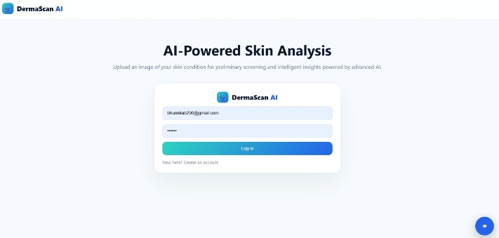
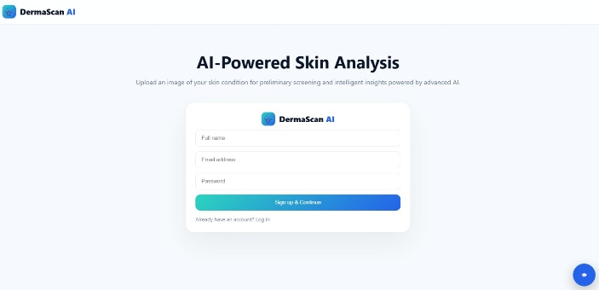

Fig. 2: Chatbot feature assisting users during critical situations.
s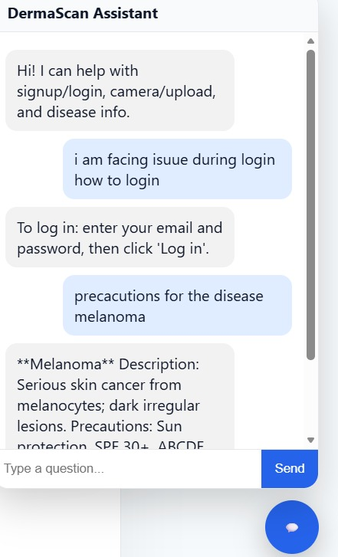

Fig. 3:Dashboard of DermaScan AI
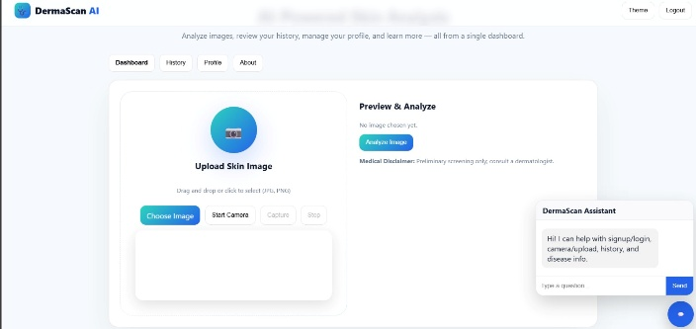

Fig. 4: Analysis of User image
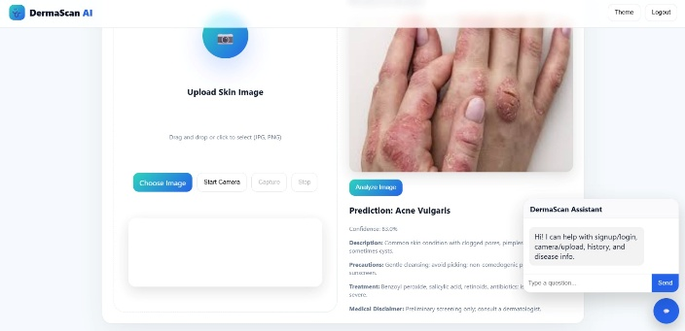

Fig. 5:History of Diseases of user search in application
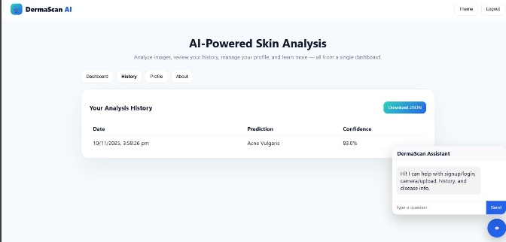

Fig. 6: Login and logout Activity of User to DermaScan AI

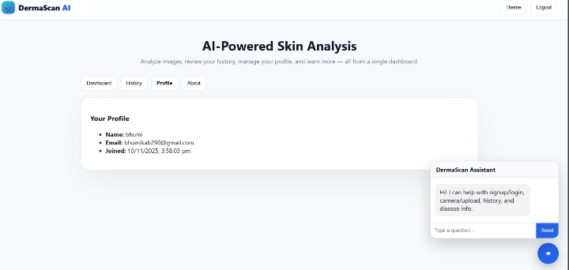

REFERENCES:
1) Debelee T. G. “Skin Lesion Classification and Detection Using Machine Learning Techniques: A Systematic Review.” Diagnostics, vol. 13, no. 19, 2023, Article 3147.
2) Cortes J., Paravar T., Oldenburg R. “Physician Opinions on Artificial Intelligence Chatbots in Dermatology: A National Online Cross-Sectional Survey of Dermatologists.” Journal of Drugs in Dermatology, vol. 23, no. 11, 2024, pp. 972–. doi:10.36849/JDD.8239.
3) Khamaysi Z., Awwad M., Jiryis B., Bathish N., Shapiro J. “The Role of ChatGPT in Dermatology Diagnostics.” Diagnostics, vol. 15, no. 12, 2025, Article 1529. doi:10.3390/diagnostics15121529.
4) Chau C. A., Feng H., Cobos G., Park J. “The Comparative Sufficiency of ChatGPT, Google Bard, and Bing AI in Answering Diagnosis, Treatment, and Prognosis Questions About Common Dermatological Diagnoses.” JMIR Dermatology, vol. 8, 2025, e60827.
5) Kamel Boulos M. N., Dellavalle R. “NVIDIA’s ‘Chat with RTX’ Custom Large Language Model and Personalized AI Chatbot Augments the Value of Electronic Dermatology Reference Material.” JMIR Dermatology, vol. 7, 2024, e58396.
6) Marri S., Albadri W., Hyder M. S., Janagond A. B., Inamadar A. C. (2024). Efficacy of an Artificial Intelligence App (Aysa) in Dermatological Diagnosis: Cross-Sectional Analysis. JMIR Dermatology, 7: e48811.
7) Jin J. Q., Hong J., Elhage K. G., Braun M., Spencer R. K., Chung M., et al. (2023). Development of SkinTracker, an integrated dermatology mobile app and web portal enabling remote clinical research studies. Frontiers in Digital Health, 5: 1228503.
8) Yilmaz A., Gencoglan G., Varol R., Demircali A. A., Keshavarz M., Uvet H. (2022). MobileSkin: Classification of Skin Lesion Images Acquired Using Mobile Phone-Attached Hand-Held Dermoscopes. J. Clin. Med., 11(17): 5102.
9) Wang Y., Wang Y., Lee T. K., Miao C., Wang Z. J. (2022). SSD-KD: A Self-supervised Diverse Knowledge Distillation Method for Lightweight Skin Lesion Classification Using Dermoscopic Images. arXiv preprint.
10) Srinivasu P., et al. (2023). Skin Lesion Classification and Detection Using Machine Learning Techniques: A Systematic Review. Diagnostics, 13(19): 3147.

