BLOCKCHAIN BASED BOTANICAL TRACEABILITY SYSTEM FOR AYURVEDIC HERBS

TARNATH N L
Computer Science &
Engineering Presidency University
Bangalore,India
taranath@presidencyuniversity.in
PUSHPALATHA S
Computer Science &
Engineering Presidency University
Bangalore,India
pushpalathas418@gmail.com

BHUMIKA S
Computer Science & Engineering
Presidency University
Bangalore, India
bhumikab290@gmail.com
HRISHIKESH S ROOGI
Computer Science and Engineering
Presidency University
Bangalore, India roogihrushikesh@gmail.com

Abstract- The Ayurvedic industry is currently facing several issues, including issues of authenticity, quality assurance, and traceability of medicinal herbs. This paper proposes a blockchain-based system for the traceability of medicinal herbs from their source, i.e., farmers or wild collectors of medicinal herbs, until their formulation. This is done through geo-tagging of medicinal herbs. This helps in increasing transparency and ensuring that there is no adulteration of medicinal herbs. This whole process is recorded and can be verified using QR codes. Smart contracts are also used for validation of transactions. This helps in increasing trust among all stakeholders. This also helps in increasing efficiency and ensuring global acceptability of Ayurvedic products.

Index Terms— Blockchain, Ayurvedic Herbs ,Traceability, Smart Contracts, Geo-Tagging, QR Code, Supply Chain, Data Integrity

I .INTRODUCTION
The Ayurvedic medical system is based on herbal products. Therefore, the quality of the herbal product depends on the quality of the source, harvesting, and storage of the herbs. The transparency issue is not considered in the Ayurvedic medical system. Therefore, it has become a problem. Recently, due to the demand for Ayurvedic products in the world market, it is now the responsibility of the Ayurvedic medical system to prove the quality and authenticity of the Ayurvedic product by developing a reliable and secure system of quality and authenticity of the Ayurvedic product.

The traditional method of verifying the quality of the herbs is not reliable. Therefore, any person can verify the quality of the herbs. The blockchain system can be used to develop a reliable and secure system of quality and authenticity of the Ayurvedic product. The blockchain system will ensure the quality of the herbs by using a decentralized system of quality of herbs along with the Geo-tagging system to verify the quality of the herbs.

The main objective of the project is to develop a blockchain-based system of tracking the herbs being used for the production of the Ayurvedic product, as it will not only create a sense of trust among the stakeholders but also enhance the usage of 'Green Technologies,' which is within the regulations.

II. LITERATURE SURVEY
Researchers have conducted several studies on the implementation of blockchain technology in supply chain management. The most important benefits of blockchain include its decentralized and tamper-proof features. These features make blockchain a suitable choice for any business or supply chain where trust and authenticity are of prime importance.

A research paper on blockchain-based supply chain systems discusses the importance of blockchain-based supply chain systems. The paper states that blockchain- based supply chain systems ensure the recording of every transaction within the supply chain. This ensures less room for fraud and higher authenticity of the data. The use of smart contracts within blockchain further automates the supply chain, thus ensuring higher accuracy and less room for human error.

Researchers have also proposed blockchain-based frameworks within the agricultural sector. The proposed frameworks ensure the tracing of food products from the farms to the end consumers. The proposed frameworks make use of IoT and GPS technologies to ensure accurate tracing of food products. The proposed frameworks have shown promising results within the food industry and have ensured higher food quality and safety.

Researchers have proposed several blockchain-based frameworks within the herbal and medicinal products segment. The proposed frameworks make use of geo-tagging to ensure the authenticity of the herbs. The proposed frameworks ensure that herbs are obtained from authentic locations and are harvested following proper guidelines.

Despite the promising results of blockchain within the herbal and medicinal products segment, less research has been conducted on the implementation of blockchain within the Ayurvedic herb segment. The majority of the research papers have proposed blockchain-based frameworks within the traditional medicine segment but have not addressed the requirements of Ayurvedic herbs. This project aims at filling this gap by proposing a blockchain-based framework within the Ayurvedic herb segment.

Therefore, this project aims to bridge this gap by proposing a blockchain-based system tailored for Ayurvedic herbs, integrating geo-tagging, smart contracts, and QR-based verification to ensure complete transparency and trust across the supply chain.

III. EXISTING METHODS AND DRAWBACKS
Existing Methodology Traceability in the supply chain of Ayurvedic herbs largely depends on the use of traditional methods of recording such as paper documentation and centralized digital databases.
Usually, information such as the type of herb, its quality etc. is recorded by the farmers or collectors and these details are then passed on to the intermediaries like suppliers, processors, and manufacturers. In most cases, data entry at different stages like collection transportation processing, and packaging is done manually.
Certain organizations rely on the use of barcode or QR code systems to track the products but these are most of the time connected to centralized databases which are controlled by a single authority.
This makes the system reliant on the faith in that central entity. In some highly developed cases, digital supply chain management systems are utilized to keep track of inventory and the movement of goods.
But such systems generally lack the feature of real-time data vcerification and do not provide any assurance that the I nformation r recorded is accurate and unchanged. Though geo-tagging and GPS Technologies exist, they are not regularly incorporated into the current workflow.
Consequently, the exact location where the herbs originate for om is usually left unknown or, at best, is very difficult to verify.
Drawbacks of Existing System to a certain extent, there is some digitization in the current techniques but still, the methodologies have numerous limitations:
Despite the presence of a certain level of digitalization, certain disadvantages exist in the current system:

- Transparency Deficit: The data is not available for certain stakeholders, i.e., end-consumers.
- Data Manipulation: The data stored in a centralized database is prone to manipulation.
- Lack of Traceability: It is not known where the herbs are being harvested.
- Adulteration: The presence of impurities may lead to adulteration of the herbs.
- Manual Intervention: The presence of human beings is a potential cause for error.
- Lack of Real-Time Verification: The data cannot be verified in real-time.
- Erosion of Trust for Consumers: The end-consumers cannot verify the data themselves.

IV.PROPOSED METHODOLOGY

Overview of the System
The system would be proposed using blockchain technology. This would be helpful in tracing the Ayurvedic herbs from the collection point up to the end of the process where the product is created. The farmers would have to provide information related to the herbs collected along with their location. This information would be stored using blockchain technology. All information related to the process would be stored using blockchain technology.
This would provide reliable information as the information would be stored securely using this technology. Any change would not be allowed. This would provide transparency for all stakeholders so that reliable information can be accessed. A QR code would be generated during the final process so that the information related to the product can be accessed easily by the consumer.

Algorithms/Technologies Used
- Hashing (SHA-256) - This would provide reliable information as the information would be stored securely using this algorithm.
- Consensus Mechanism - This would provide confirmation for the transactions.
- Smart Contracts - This would provide the facility for verification through automation.
- Geo Tagging (GPS) - This would provide accurate location for the collection of the herbs.
- QR Code Generation - This would provide the facility for easy accessibility for the information related to the product.

V. FEASIBILITY STUDY

The proposed blockchain-based system for Ayurvedic herb traceability is feasible across technical,economic,operational and social dimensions.

This solution is viable from the perspective of technology, economy, operation, and social/legal implications.
In terms of technology, the proposed solution can be easily implemented with the help of advanced solutions including blockchain technology, GPS-based geo-location tagging, as well as web/mobility applications. Such technologies are proven, efficient, and effective when it comes to data protection, storage, and traceability throughout the whole process.
With regard to economic viability, the implementation and deployment of the system requires affordable costs due to the application of open-source software. Overall, the solution is quite affordable to develop and deploy in practice.
As for operational feasibility, the proposed platform is quite intuitive and easy to use, especially for end-users, as the application uses QR-based verification. The process itself will not require additional efforts on the part of users, and the solution will be highly convenient.
Finally, social and legal aspects also need to be considered. The system is aimed at ensuring greater transparency, authentication, as well as trustworthiness within the supply chain. In addition, the solution meets rising consumer needs in terms of verified herbal products.

The feasibility analysis confirms that the proposed AyurTrace system can be successfully implemented in real-world scenarios with minimal constraints.

VII. SYSTEM DESIGN AND ARCHITECTURE
The system would be designed in a layered manner. This would enable transparent traceability of the Ayurvedic herbs. During the data collection phase, the data would be input into the system through a mobile/web app designed by the farmer/collection party.
The data would be validated and sent for processing through the blockchain layer. The blockchain layer would enable the recording of all the transactions securely. Each phase of the supply chain, i.e., the processing and the distribution phases, would be recorded as a block of data.
There would be an integration layer for the GPS location tracking and the generation of the QR codes for the final product. A user layer would also be included. This would enable the user to access information pertaining to the product through the QR code.
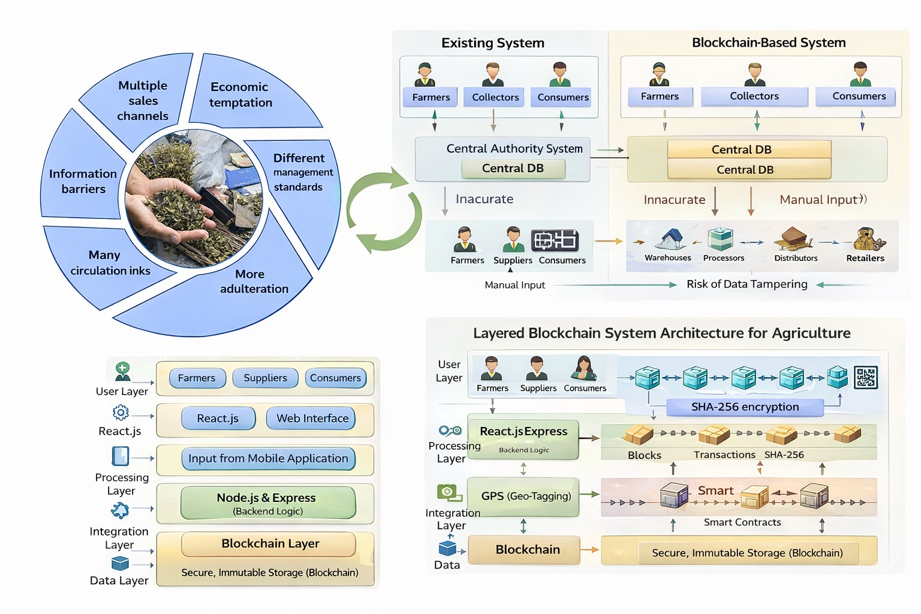
Fig.1: Illustrates Blockchain Improving Transparency and Traceability Over Traditional systems

VI. EXISTING METHODS AND DRAWBACKS

The system can be implemented by using the latest technology’s in the field of web development, as well as blockchain technology for the tracing of Ayurvedic herbs.
- Frontend: The system can be implemented by using the React framework for the frontend part of the project, as it is easy to input the data and verify the data by using the QR codes.
- Backend: The system can be implemented by using Node.js and Express for the backend part of the project, as it is easy to process the data and communicate.
- Blockchain: All the transactions in the chain are safe by using the blockchain technology.
- Smart Contracts: This will help us to execute the smart contracts.
- Geo-tagging: This will help us to geo-tag the herbs.
- QR Code: This will help us to link the final product.

VIII. IMPLEMENTATION AND RESULTS
The implementation of AyurTrace involved the use of blockchain technology, GPS technology, and web technologies to ensure efficiency and security throughout the entire process. The React.js framework was used in developing the front end, whereas Node.js and Express were used in developing the back end. For secure data storage and transaction verification, Solidity technology was used in smart contracts.
The system achieved near real-time performance with response time below 2 seconds and successfully tracked multiple herb batches across different stages of the supply chain
The system ensured 100% data integrity through blockchain-based tamper-proof storage.
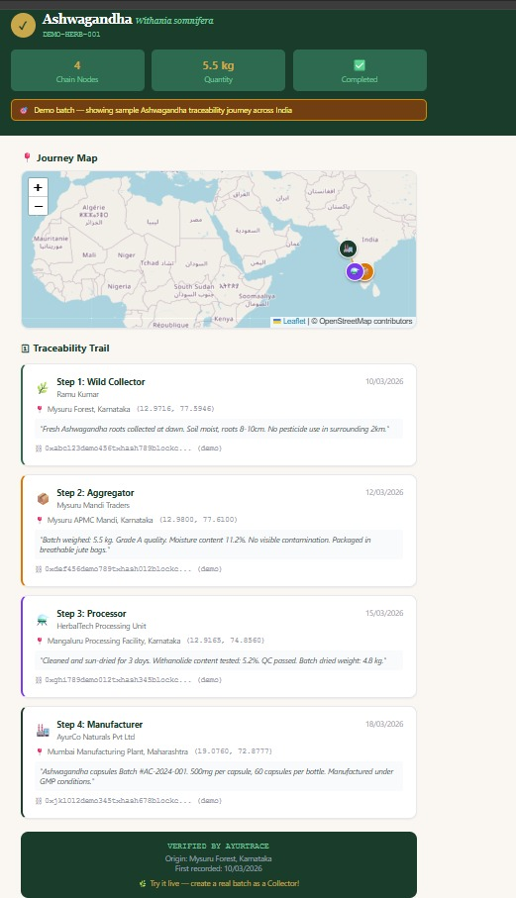
Fig.2: Illustrates the end-to-end traceability of Ashwaganda, displaying geo-tracking and step-by-step supply chain details from collection to manufacturing.

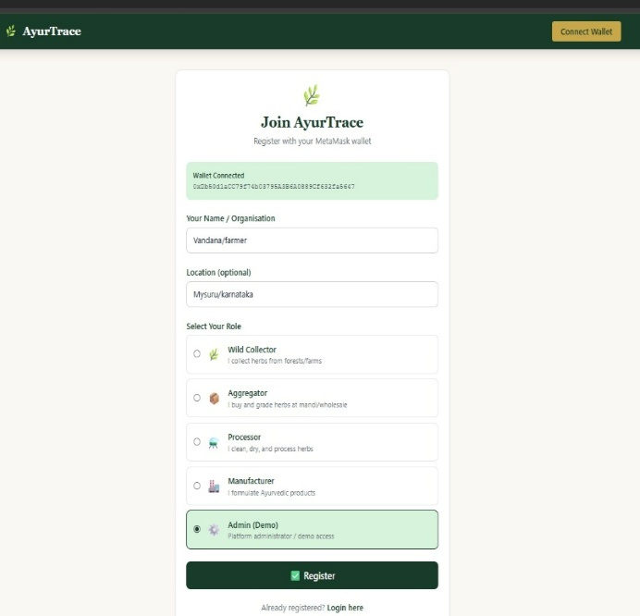

Fig 3: Displays the registration process with metamask wallet integration, user details,and role selection with the system.

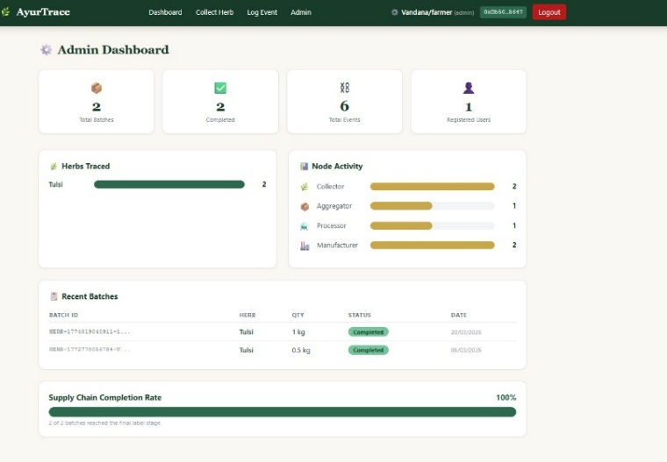
Fig.4: Displays system metrics including traced herbs,node activity.,recent batches,and overall supply chain completion status.

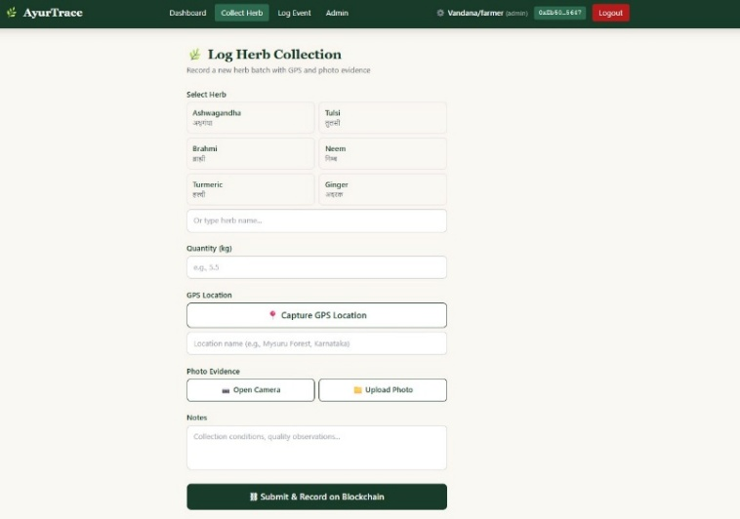
Fig.5: Displays the process of recording herb collection details with GPS location,quantity ,and photo evidence stored on the blockchain.
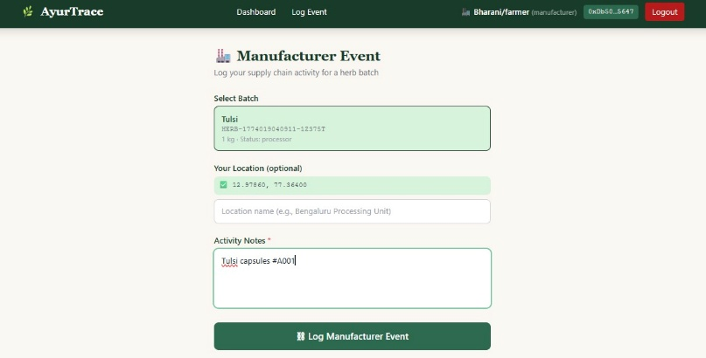
Fig.6: Displays the logging of manufacturing activities,including batch selection.location,and processing details recorded on the blockchain.

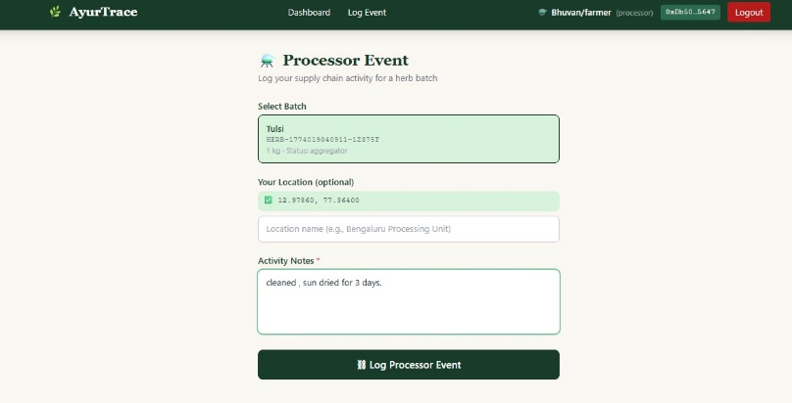
Fig .7: Displays the logging of processing activities,including batch selection.location,and processing notes recorded on the blockchain.

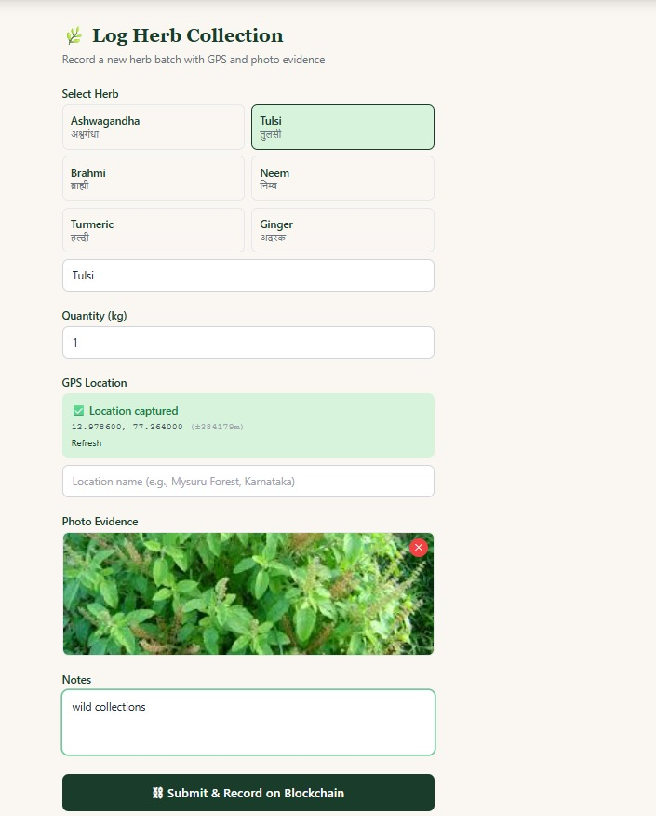
Fig.8: Displays herb collection with GPS location and photo evidence,ensuring authenticated data recording on the blockchain.

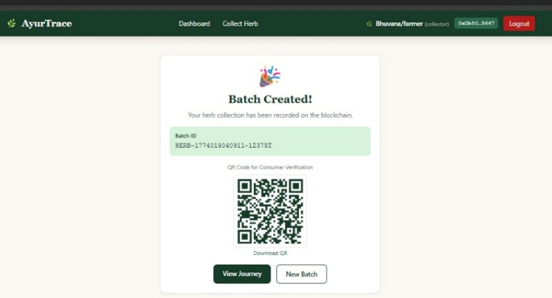
Fig.9: Displays successful batch creation with a unique ID and QR code for consumer verification and traceability.

IX.CONCLUSION
The proposed AyurTrace system leverages blockchain technology, along with geo-tagging, smart contracts, and QR code verification, to ensure secure and transparent traceability of Ayurvedic herbs. It effectively addresses key issues in the traditional supply chain such as data manipulation, lack of transparency, and manual errors. By providing a decentralized and tamper-proof system, it enhances trust among farmers, suppliers, manufacturers, and consumers. Additionally, the system enables easy verification of product authenticity, improving overall efficiency and reliability in the Ayurvedic supply chain. AyurTrace provides end-to-end traceability.

REFERENCES
[1] A. Rashid et al., “Enhancing Fruit Supply Chain Traceability through Blockchain Technology,” 2026
[2] F. Modica, “Blockchain in the Agri-Food Supply Chain: A Game-Changer,” 2026.
[3] “Blockchain Technology in Agriculture: Enhancing Supply Chain Transparency and Traceability,”* 2026.
[4] N. N. Abdullah et al., “Blockchain Adoption in the Supply Chain: Enablers, Barriers, and Opportunities,” 2025
[5] S. G. Stanescu et al., “Digitalization and Blockchain Integration in Agri-Food Supply Chains,” 2025.
[6] D. V. Rajput et al., “Blockchain Technology in the Food Supply Chain,” 2025.
[7] U. M. Gurusamy et al., “Impact of Blockchain Technology in Agriculture Supply Chain,” 2025.
[8] M. Vasileiou et al., “Digital Transformation of Food Supply Chain Management Using Blockchain,” 2025.
[9] A. El Mane et al., “Transforming Agricultural Supply Chains Using Blockchain Technology,” 2024.
[10] R. M. Ellahi et al., “Blockchain-Driven Food Supply Chains: A Systematic Review,” 2024.
[11] U. Gurusamy et al., “Impact of Blockchain Technology in Agriculture Supply Chain: A Comprehensive Review of Applications, Challenges, and Future Directions,” 2025.
[12] Q. Li et al., “Blockchain-Enabled Traceability in Agriculture: A Game-Theoretic Approach,” 2025.
[13] L. Li et al., “Design of Agricultural Product Traceability System Based on Blockchain Technology,” Scientific Reports, 2024.
[14] S. Pang et al., “A Survey on Evaluation of Blockchain-Based Agricultural Traceability Systems,” Computers and Electronics in Agriculture, 2024.
[15] C. Karkanias et al., “Blockchain and Megatrends in Agri-Food Systems,” 2026.

