8.2 Microstructure of Hydrides in Zr-Alloys
Hydrogen absorbed in zirconium alloys precipitates as zirconium hydrides when the local hydrogen concentration exceeds the solubility limit during cooling or service exposure. For the present section, the focus is limited to the microstructure of hydrides, namely their phase, morphology, location, orientation and length-scale-dependent appearance. The detailed consequences of hydrides on reorientation, fracture toughness, delayed hydride cracking, fatigue and impact toughness are discussed in later sections.

8.2.1 Hydride phases, morphology and nucleation sites
Several zirconium hydride phases have been reported in zirconium alloys, including γ-ZrH (face-centred tetragonal, FCT), δ-ZrH_{1.5-1.7} (face-centred cubic, FCC), ε-ZrH₂ (face-centred tetragonal, FCT) and ζ-Zr_{2​}H (trigonal) hydrides [1, 2]. Among these phases, δ-hydride is most commonly observed in reactor-relevant Zr-alloys at room temperature. In contrast, γ-, ε- and ζ-type hydrides are usually reported under more specific conditions related to hydrogen content, cooling history, local precipitation sequence or transformation pathway [1, 2]. Hence, δ-hydride is generally treated as the dominant hydride phase when discussing hydride-related degradation in reactor Zr-alloys.

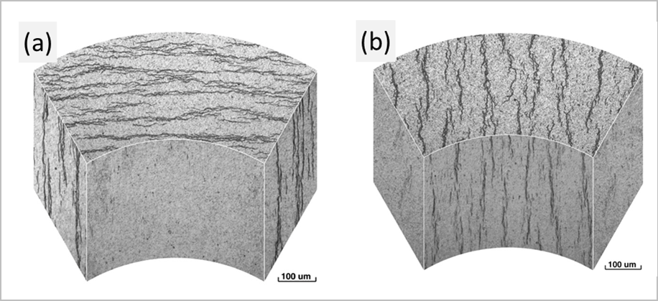
Zirconium hydrides are generally described as plate-like or platelet-shaped precipitates. In polished two-dimensional metallographic sections, these platelets often appear as dark line-like or needle-like traces. A three-dimensional representation of tube-wall sections shows that such line-like traces correspond to hydride platelets arranged either circumferentially or radially in the wall section (Fig. 8.2.1) [3]. Thus, needle-like hydrides observed in polished optical or SEM sections are often two-dimensional traces of platelet-shaped hydrides.
Fig. 8.2.1. Three-dimensional representation of hydride platelet morphology in a zirconium alloy tube-wall section showing: (a) circumferential hydrides and (b) radial hydrides. The figure illustrates that hydrides observed as line-like features in two-dimensional metallographic sections correspond to plate-like hydride features in the tube wall. Adapted from Ref. [3].

8.2.2 Hydride morphology across microstructures and length scales
Hydride morphology in Zr-alloys has been reported to vary with alloy microstructure, crystallographic texture, cooling history and stress state [1, 3, 5, 9]. In Zr-2.5Nb pressure-tube material, hydride orientation is usually described with respect to the circumferential, radial and axial tube directions. In finished pressure tubes, hydrides are generally reported to lie predominantly along the circumferential direction, whereas applied or residual tensile stresses during cooling can promote radial hydride formation [4, 5]. These orientation differences are illustrated schematically in Fig. 8.2.1 and by the predominantly circumferential hydrides shown in Fig. 8.2.2(a). Because the embrittling effect depends not only on the amount of hydrogen but also on how hydrides are spatially arranged, studies on CWSR Zr-2.5Nb pressure-tube alloy have used quantitative descriptors such as radial hydride fraction and hydride continuity coefficient to characterize the severity of radial hydride morphology [6, 7].
The parent microstructure also affects the preferred sites and appearance of hydrides. In Zr-2.5Nb, hydrides have been discussed in relation to α-Zr lath/subgrain regions and α/β interfaces, whereas in Zircaloy-type alloys, hydride precipitation is often described in relation to grain boundaries, intragranular precipitation, crystallographic texture and near-surface hydride enrichment [1, 8]. EBSD and TEM studies on Zircaloy-4 show that hydride precipitation is related to the crystallographic orientation of the α-Zr matrix [9] and clear orientation relationship was observed between hydride phase and α-Zr matrix as shown in Fig. 8.2.2(c) [10].
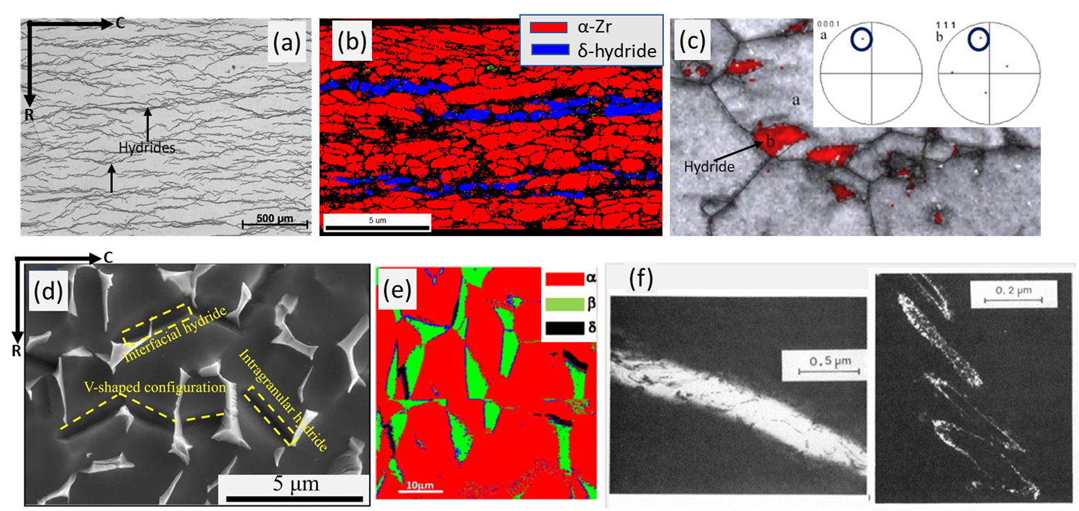
Hydride morphology is also scale-dependent, as summarized in Fig. 8.2.2. Optical microscopy shows the overall distribution and orientation of hydride platelets, as seen in Fig. 8.2.2(a). EBSD phase mapping can show the spatial distribution of α-Zr and δ-hydride when the hydrides are sufficiently resolved and well indexed, as shown in Fig. 8.2.2(b). SEM observations reveal local configurations such as interfacial, intragranular and V-shaped hydrides in Zr-2.5Nb, as shown in in Fig. 8.2.2(d) [11]. In addition, EBSD phase mapping of hydrided Zr-2.5Nb demonstrates that hydride precipitation is strongly influenced by boundary/interface character, not merely by the presence of boundaries. As shown in Fig. 8.2.2(e), interface hydrides are preferentially associated with α/β interfaces that satisfy the Burgers orientation relationship within 10° of the ideal OR, indicating that specific crystallographic boundary types can act as favourable sites for hydride formation [12]. STEM observations reveal still finer features, including plate-like and stacked nanoscale hydride precipitates, as shown in Fig. 8.2.2(f), signifying that observed macroscopic morphology is actually an outcome complex local stacking of smaller hydride plates [13].
Fig. 8.2.2. Hydride morphology across Zr-alloy microstructures and length scales. (a) Optical micrograph showing predominantly circumferential hydride platelets in Zr-2.5Nb. (b) EBSD phase map of hydrided pilgered Zr–2.5Nb showing α-Zr and δ-hydride distribution. (c) EBSD based image and corresponding pole figures showing δ-hydride distribution and its crystallographic orientation relationship with the α-Zr matrix [10]. (d) SEM micrograph showing interfacial, intragranular and V-shaped hydride configurations [11]. (e) EBSD phase map of hydrided Zr-2.5Nb showing α-Zr, β-Zr and δ-hydride phases; the blue-highlighted boundaries correspond to α/β interfaces following the Burgers orientation relationship within 10° of the ideal OR, along which interface hydrides are observed, emphasizing the role of α/β boundary character in hydride precipitation [12]. (f) TEM images showing stacked/clustered fine hydride platelets, illustrating that hydrides observed as line-like features at lower magnification may contain finer platelet substructures at the TEM scale [13]. Panels (c-f) are adapted from Refs. [10]-[13].

8.2.3 Quantification of hydride morphology
Hydride quantification should include size, orientation and connectivity. Useful descriptors include hydride area fraction, length, thickness, aspect ratio, number density, inter-hydride spacing and inclination angle. Area fraction alone is insufficient because two microstructures with similar visible hydride fraction may differ strongly in radial alignment and connectivity.
A simple orientation descriptor is the fractional number, FN = N_{>45°} / N_{total}, where N>45° is the number of hydride components inclined by more than 45° from the circumferential direction and N_{total} is the total number of hydride components. FN is easy to compute but is number-based; it does not account for hydride length, area, clustering or connectivity. Therefore, it should be reported with size- and continuity-based descriptors.
Radial hydride fraction (RHF) is used to express the amount of radially oriented hydrides, while hydride continuity coefficient (HCC) and related continuous-path metrics describe whether radial hydrides form connected brittle paths.
Radial Hydride Fraction (RHF), Hydride Continuity Coefficient (HCC), Radial Hydride Continuity Factor (RHCF), Radial Hydride Continuous Path (RHCP) fail to represent the continuity of hydride networks. Therefore, a new specimen-level descriptor called Hydride Continuity Index (HCI) was developed. HCI utilizes image skeletonization and graph theory to quantify hydride continuity.
The success of the quantification of hydrides through microscopy depends on imaging characteristics (sufficiently good contrast with no artefacts is essential). Some of the recent machine learning and AI based models can be of immense help in circumventing some of the challenges associated with practical sho floor microstructures in getting reliable quantification. Fig 8.3.3 illustrates improved segmenation and consequently better quantification of hydride achieved through deep learning models [].

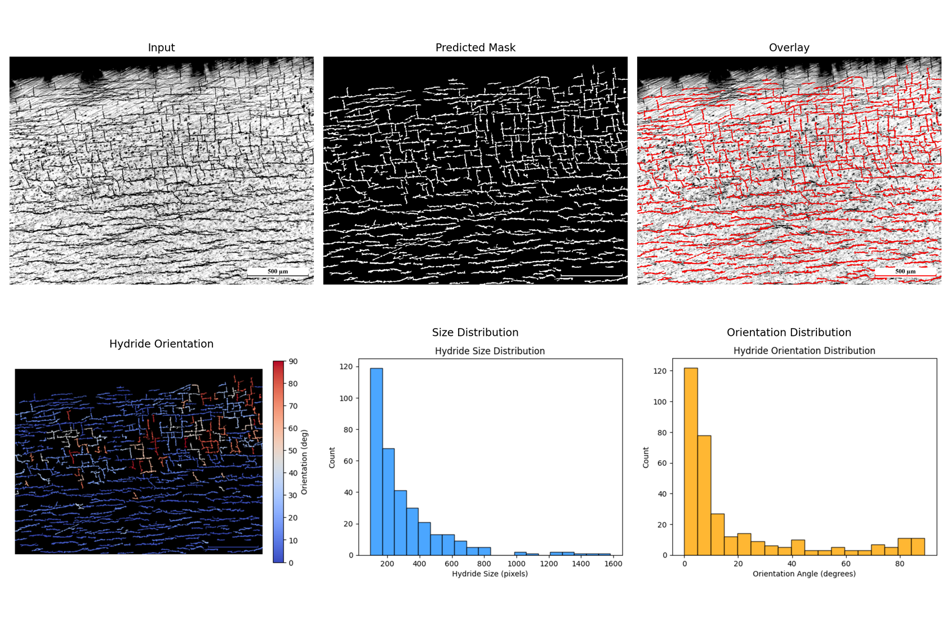
Fig: 8.2.3 Visualization of orientation and quantification of hydrides segmented form a grayscale micrograph using ML model. (a) Input micrograph of zirconium alloy, (b) Predicted hydride mask generated by ML model, (c) Overlay of mask and input image, (d) Color-coded contour map showing hydride orientations with respect to the horizontal axis, (e) Histogram of hydride size distribution and (f) Histogram of hydride orientation distribution.

Using this ML assisted segmentation, a series of samples with different hydrogen content were analyzed and area fraction vs hydrogen content (as determined independently by chemical analysis) was plotted. As can be seen there is a strong correlation of hydrogen content and area fraction of hydrides in optical micrograph. Such curve can be used to determine the samples’ hydrogen content using microstructure analysis.

8.2.4 Summary

Hydrides in Zr-alloys are most commonly observed at room temperature as δ-hydride platelets. The line-like or needle-like features seen in polished optical and SEM sections generally represent two-dimensional traces of three-dimensional platelet-shaped hydrides. Their morphology, spatial distribution and orientation are controlled by several interacting factors, including alloy microstructure, crystallographic texture, cooling history, hydrogen content, applied or residual stress, and the length scale of characterization. Accordingly, different microscopy techniques provide complementary information: optical microscopy captures the overall hydride distribution and preferred orientation; SEM resolves local configurations such as interfacial, intragranular and clustered hydrides; EBSD provides phase and crystallographic-orientation information when hydrides are sufficiently resolved and reliably indexed; and TEM reveals fine plate-like, stacked and interface-scale hydride features. Together, these observations establish the microstructural basis for quantitative assessment of hydride morphology, orientation and continuity, as discussed in Section 8.2.3.

References
[1] A. T. Motta, L. Capolungo, L.-Q. Chen, M. N. Cinbiz, M. R. Daymond, D. A. Koss, E. Lacroix, G. Pastore, P.-C. A. Simon, M. R. Tonks, B. D. Wirth, and M. A. Zikry, “Hydrogen in zirconium alloys: A review,” Journal of Nuclear Materials, vol. 518, pp. 440–460, May 2019, doi: 10.1016/j.jnucmat.2019.02.042.
[2] Y.-J. Jia and W.-Z. Han, “Mechanisms of hydride nucleation, growth, reorientation, and embrittlement in zirconium: A review,” Materials, vol. 16, no. 6, Art. no. 2419, Mar. 2023, doi: 10.3390/ma16062419.
[3] H. C. Chu, S. K. Wu, and R. C. Kuo, “Hydride reorientation in Zircaloy-4 cladding,” Journal of Nuclear Materials, vol. 373, no. 1–3, pp. 319–327, Feb. 2008, doi: 10.1016/j.jnucmat.2007.06.012.
[4] R. N. Singh, R. Kishore, S. S. Singh, T. K. Sinha, and B. P. Kashyap, “Stress-reorientation of hydrides and hydride embrittlement of Zr-2.5 wt% Nb pressure tube alloy,” Journal of Nuclear Materials, vol. 325, no. 1, pp. 26–33, Feb. 2004, doi: 10.1016/j.jnucmat.2003.10.009.
[5] R. N. Singh, R. Lala Mikin, G. K. Dey, D. N. Sah, I. S. Batra, and P. Ståhle, “Influence of temperature on threshold stress for reorientation of hydrides and residual stress variation across thickness of Zr–2.5Nb alloy pressure tube,” Journal of Nuclear Materials, vol. 359, no. 3, pp. 208–219, Dec. 2006, doi: 10.1016/j.jnucmat.2006.09.004.
[6] R. K. Sharma, A. K. Bind, G. Avinash, R. N. Singh, A. Tewari, and B. P. Kashyap, “Effect of radial hydride fraction on fracture toughness of CWSR Zr-2.5%Nb pressure tube material between ambient and 300 °C temperatures,” Journal of Nuclear Materials, vol. 508, pp. 546–555, Sep. 2018, doi: 10.1016/j.jnucmat.2018.06.003.
[7] A. Gopalan, A. K. Bind, S. Sunil, T. N. Murty, R. K. Sharma, A. Samanta, A. Soren, and R. N. Singh, “Effect of radial hydride on room temperature fracture toughness of Zr-2.5Nb pressure tube material,” Journal of Nuclear Materials, vol. 544, Art. no. 152681, Jan. 2021, doi: 10.1016/j.jnucmat.2020.152681.
[8] S. Suman, M. K. Khan, M. Pathak, R. N. Singh, and J. K. Chakravartty, “Hydrogen in Zircaloy: Mechanism and its impacts,” International Journal of Hydrogen Energy, vol. 40, no. 17, pp. 5976–5994, May 2015, doi: 10.1016/j.ijhydene.2015.03.049.
[9] N. A. P. Kiran Kumar, J. A. Szpunar, and Z. He, “Preferential precipitation of hydrides in textured Zircaloy-4 sheets,” Journal of Nuclear Materials, vol. 403, no. 1–3, pp. 101–107, Aug. 2010, doi: 10.1016/j.jnucmat.2010.06.005.
[10] N. A. P. Kiran Kumar and J. A. Szpunar, “EBSD studies on microstructure and crystallographic orientation of δ-hydrides in Zircaloy-4, Zr–1% Nb and Zr–2.5% Nb,” Materials Science and Engineering: A, vol. 528, no. 21, pp. 6366–6374, Aug. 2011, doi: 10.1016/j.msea.2011.05.022.
[11] B. Li, C. Cui, Y. Li, H. Wang, S. Sun, H. Sun, Z. Feng, W. Zhang, and G. Zhang, “Multi-scale microstructural characterization and precipitation mechanism of hydrides in Zr-2.5Nb alloy pressure tube,” JOM, vol. 78, pp. 3408–3423, Apr. 2026, doi: 10.1007/s11837-025-07672-w.
[12] K. V. Mani Krishna, D. Srivastava, G. K. Dey, V. Hiwarkar, I. Samajdar, and S. Banerjee, “Role of grain/phase boundary nature on the formation of hydrides in Zr–2.5%Nb alloy,” Journal of Nuclear Materials, vol. 414, no. 2, pp. 270–275, Jul. 2011, doi: 10.1016/j.jnucmat.2011.04.003.
[13] V. Perovic, G. C. Weatherly, and C. J. Simpson, “Hydride precipitation in α/β zirconium alloys,” Acta Metallurgica, vol. 31, no. 9, pp. 1381–1391, Sep. 1983, doi: 10.1016/0001-6160(83)90008-1.

