**Dependencies Used:**

1. Spring Boot Starter
2. Spring Boot Dev Tools
3. Spring Boot AOP
4. Spring Boot Web

**Custom Annotation**

* Log Request

Created with Custom Annotation with Boolean data type with default value as false.

Created with a Student class with Id, first name, last name, birthdate.

Created 2 POST endpoints, that accepts Student Object. Return status 200 for these endpoints.

End Point URL:

To retrieve the Students information (GET) - <http://localhost:8080/students/>

To retrieve the Students information for particular id (GET) - <http://localhost:8080/students/1>

To insert the record into Student (POST) - <http://localhost:8080/students>

To insert the record into Student (POST) Enabled Logger - <http://localhost:8080/studentsLog>

To Delete the record from Student (Delete) - <http://localhost:8080/students/4>

Printing the Request in Log if the Boolean type is true.

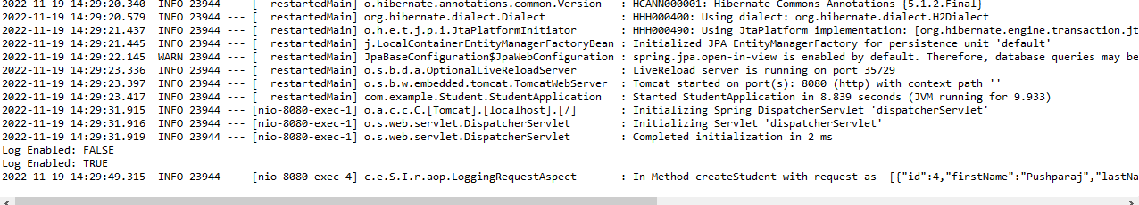

Used Postman tool for testing on the Post Mapping