Question1:

a.Query to display ename and sal of employee whose salary greater than or equal to 2200

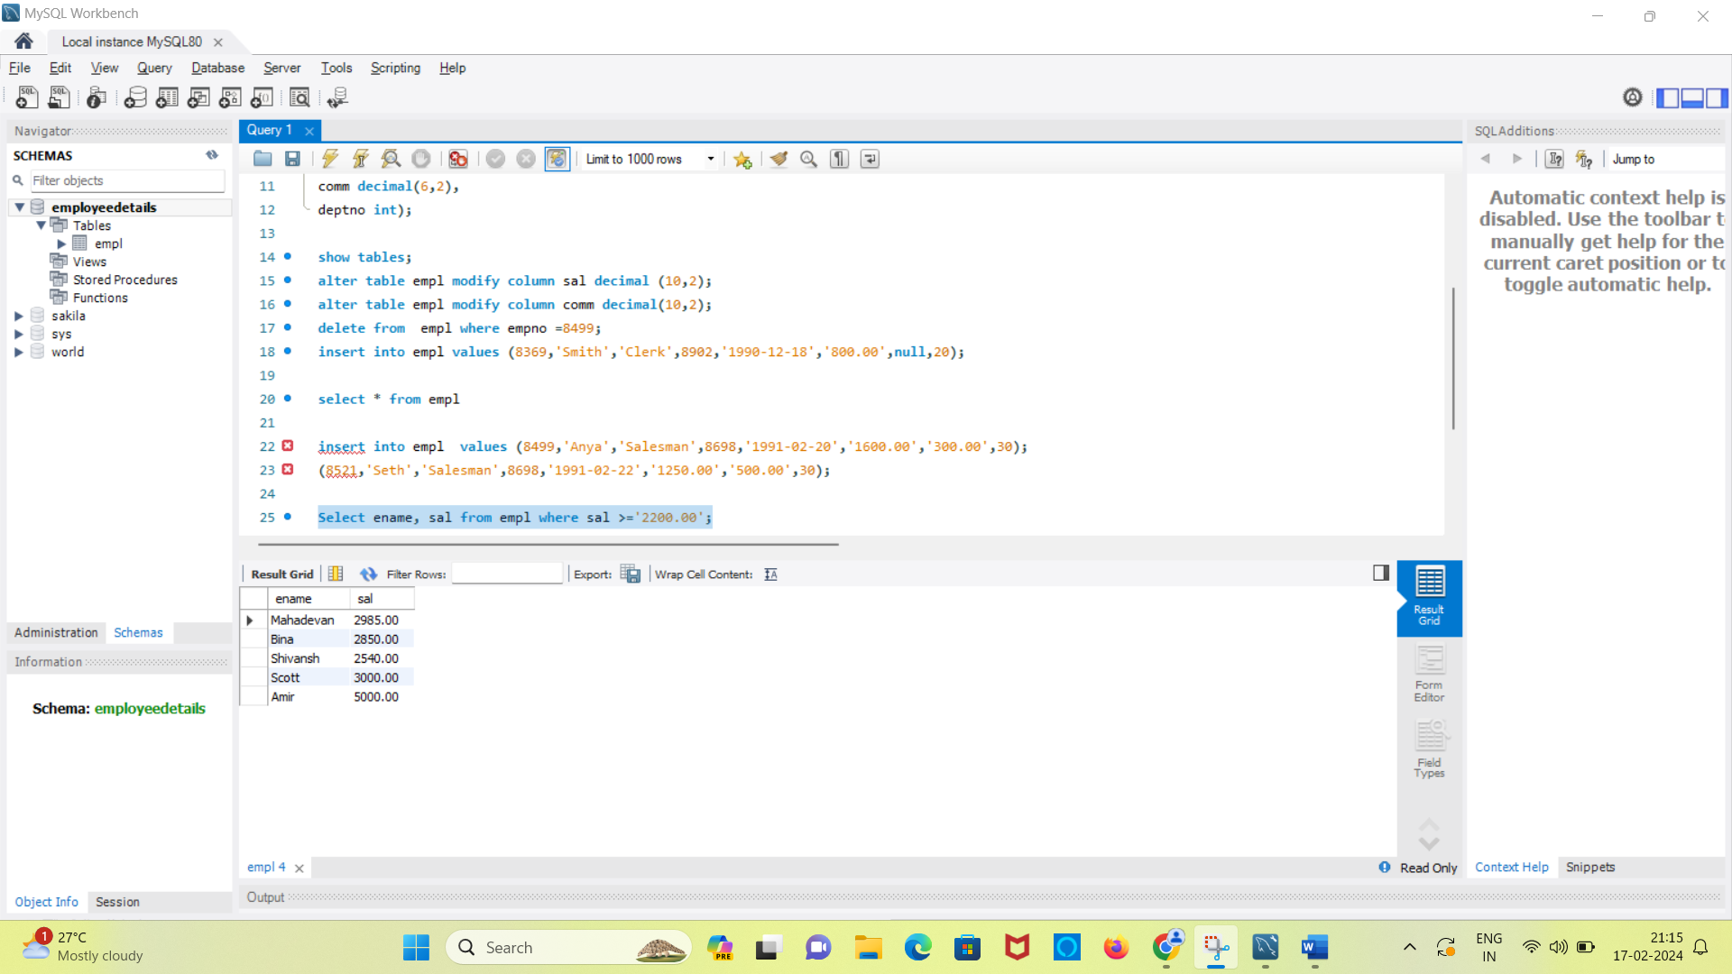

b. Query to display list of emplyees who are not getting commission

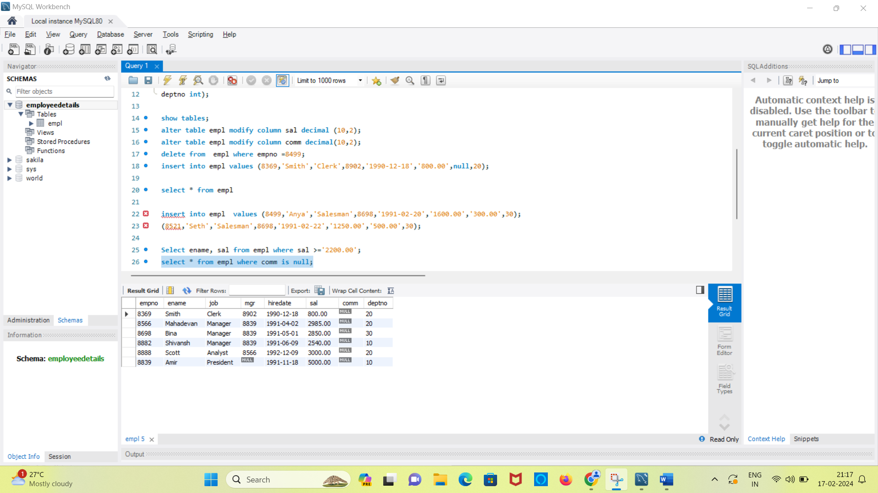

c. Query to display ename and sal of employee who don’t have salary in the range of 2500 to 4000

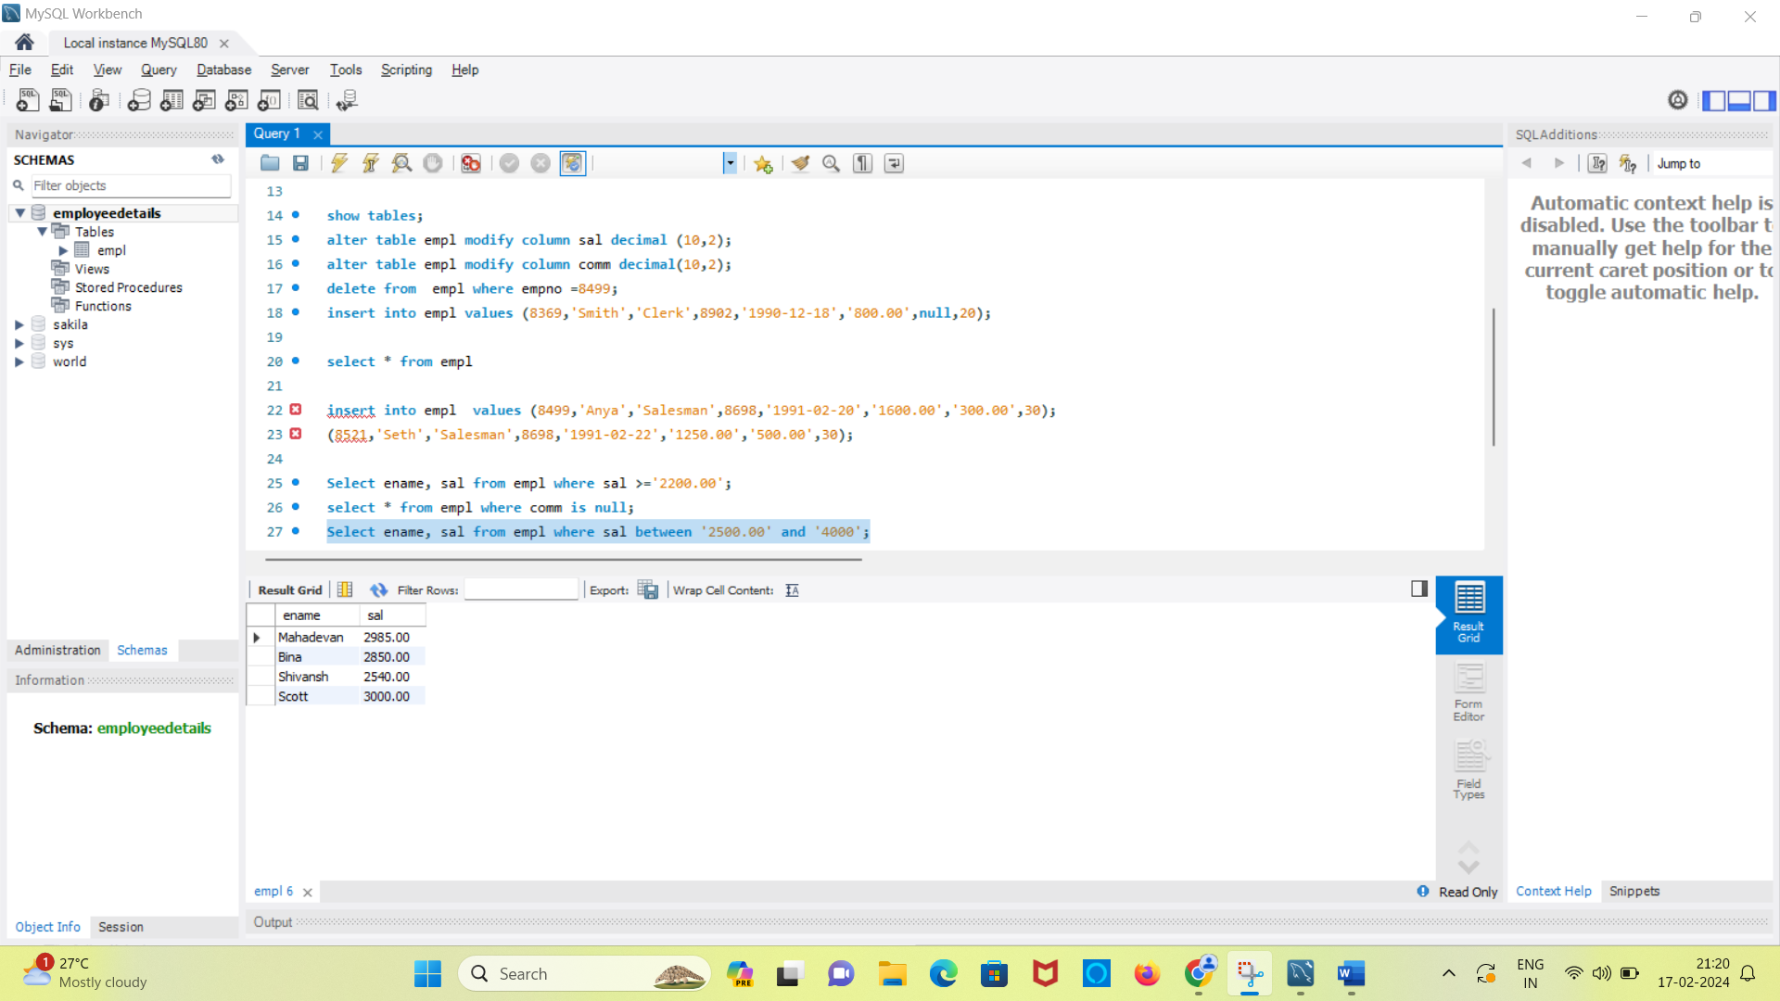

e. query to display emp name whose name contains ‘A’ as third alphabet

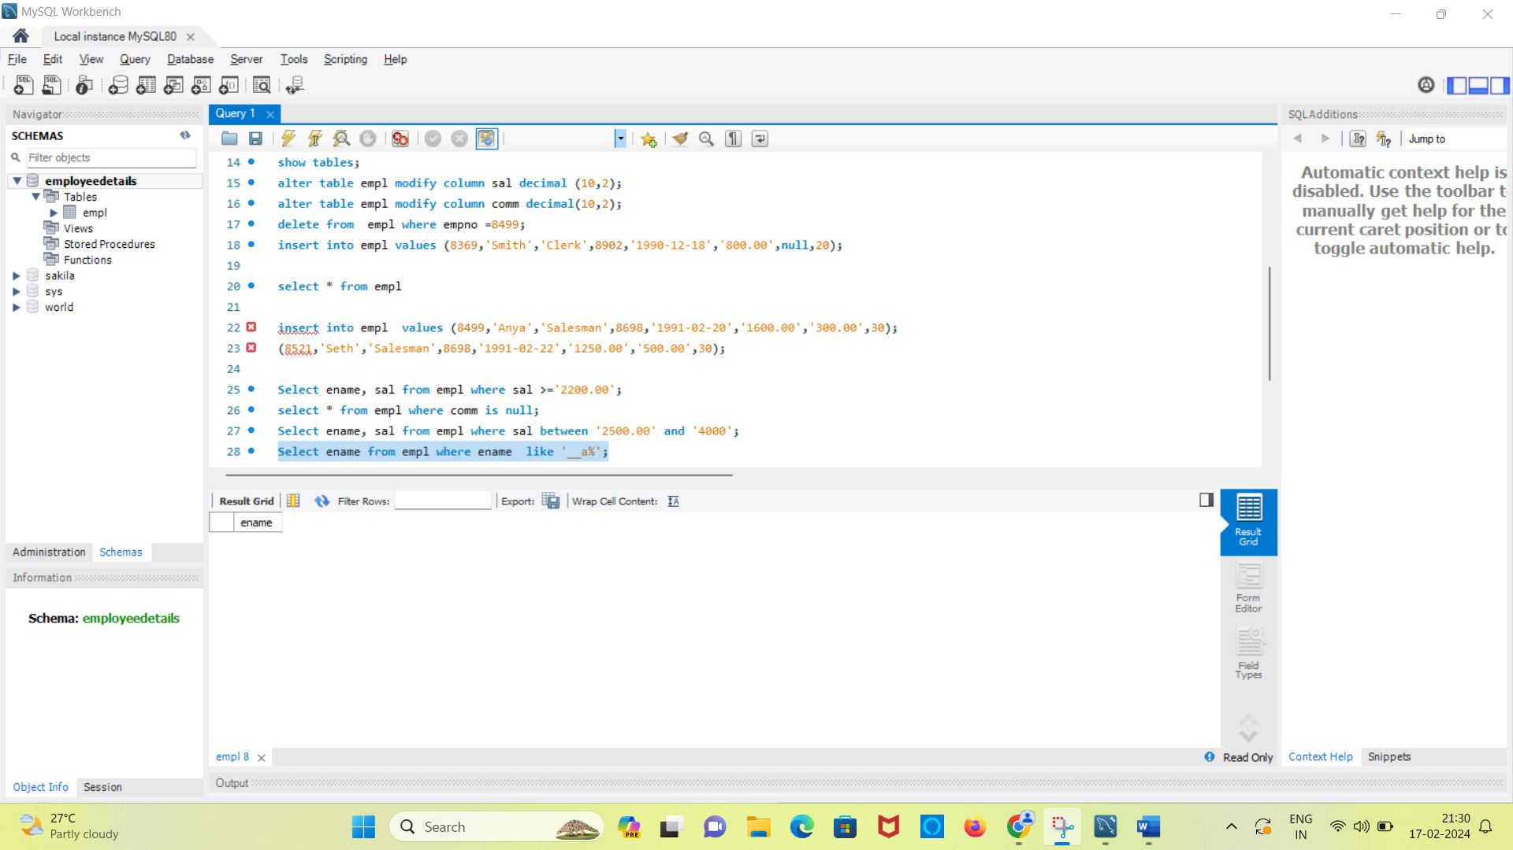

f. query to display emp name whose name has ‘T’ as last alphabet

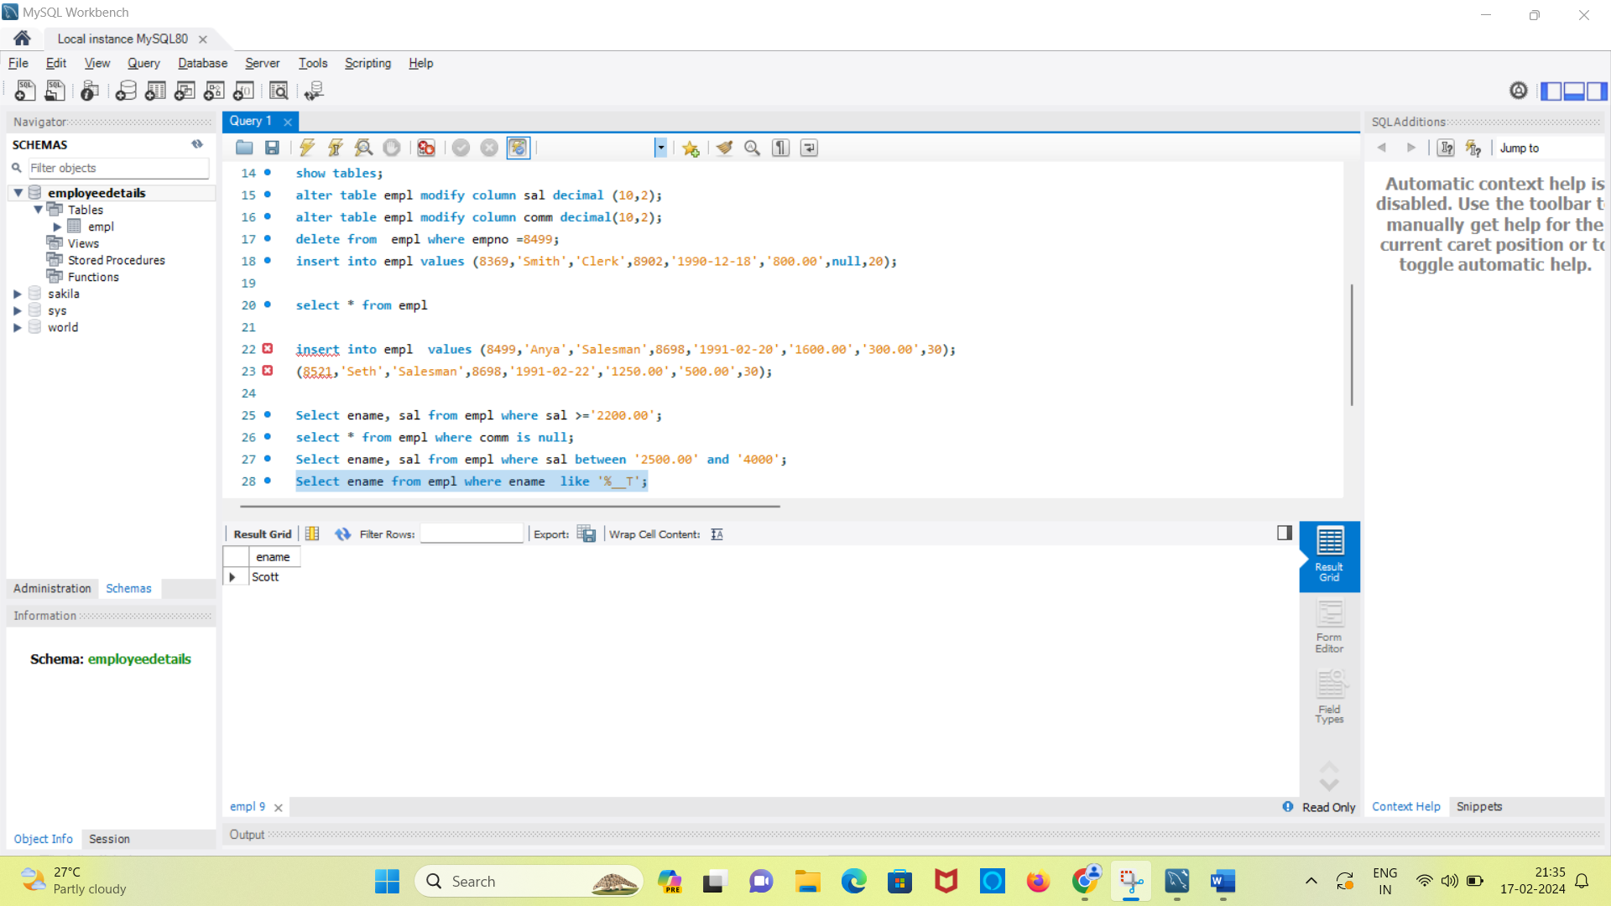

d. employee who don’t have manager.

