

**Port City International University**

**REPORT COVER SHEET**

**Department of Computer Science and Engineering**

|  |
| --- |
| **STUDENT DETAILS** |

Student Name: **Pushpita Shil** Student ID No: **CSE-01306100**

Program: **BSC in CSE**  Batch No: **13th A (DAY)**

|  |
| --- |
| **REPORT DETAILS** |

Name of Report: Banner design in Ai.

Course Title: **Multimedia and System Design Sessional**

Course Code: ***CSE 448***

Date Submitted: ***19-02-2021***

|  |
| --- |
| **SUBMITTED TO** |

Name of Lecturer**: Rabeya Sadia**

Lecturer

Department of **CSE**

Port City International University

Problem no: 01

Problem name:

A banner for Webinar on Image Processing.

Platform:

Adobe Photoshop.

**Instruments or Tools used**:

Shape tool: To draw some shape

Brush tool: To draw some brush stokes on corresponding layer.

Text Tool: To enter text.

Colour palette: To choose colors.

Eyedropper Tool: To pick colour from a object.

Work Process:

The whole work is done by layer after layer. In each layer there is some object. Each layer combined together creates the whole Banner.

The work process is given below step by step:

1. Firstly created an artboard.
2. Then import an image to use as background.
3. Then created some rectangle using rectangle shape tool. Used the rectangle to design the banner template.
4. Then imported 2 PCIU logos.
5. Then entered some text such as (organized by, Port City International University, department) using Text Tool of Adobe Photoshop.
6. Then imported Speakers image by copy pasting and used brush tool to remove unwanted portion of images and shape them as oval. Used eyedropper tool to pick the color from background matches exactly to the lower layer of the images. So that the brush strokes blend with the background.
7. Then again used the Text Tool to enter the Speakers name, designation, Webinar title, Webinar Topic etc.
8. Then finally entered the Date and Time using the Text Tool.

**Snapshots:**

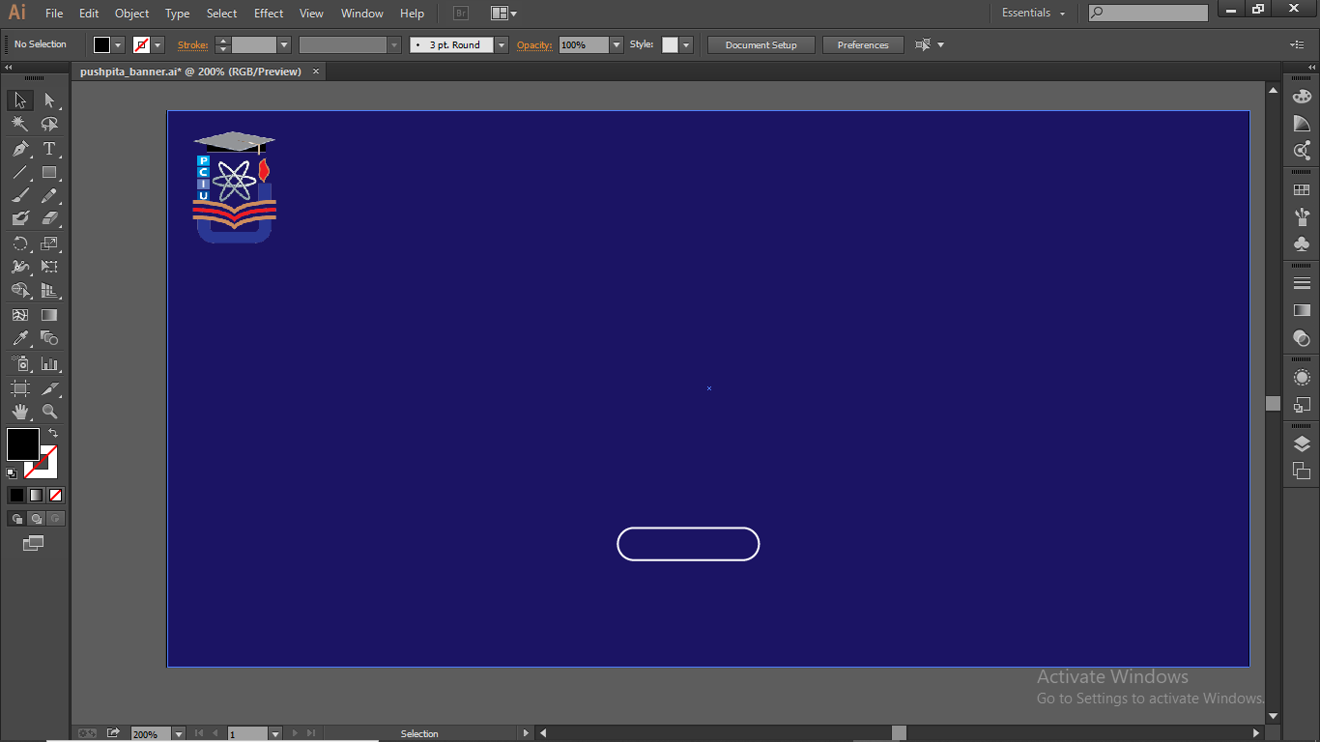

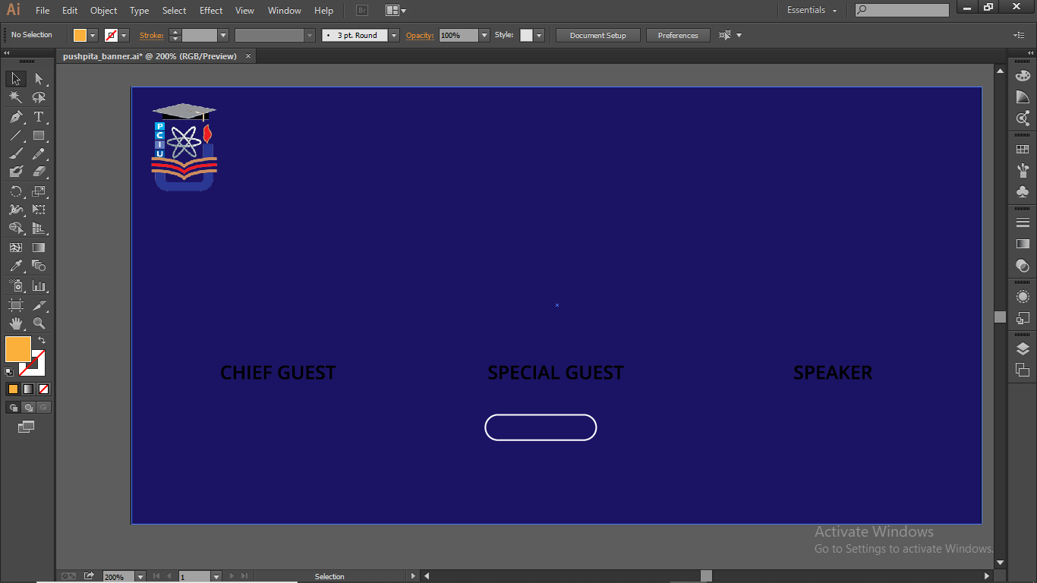

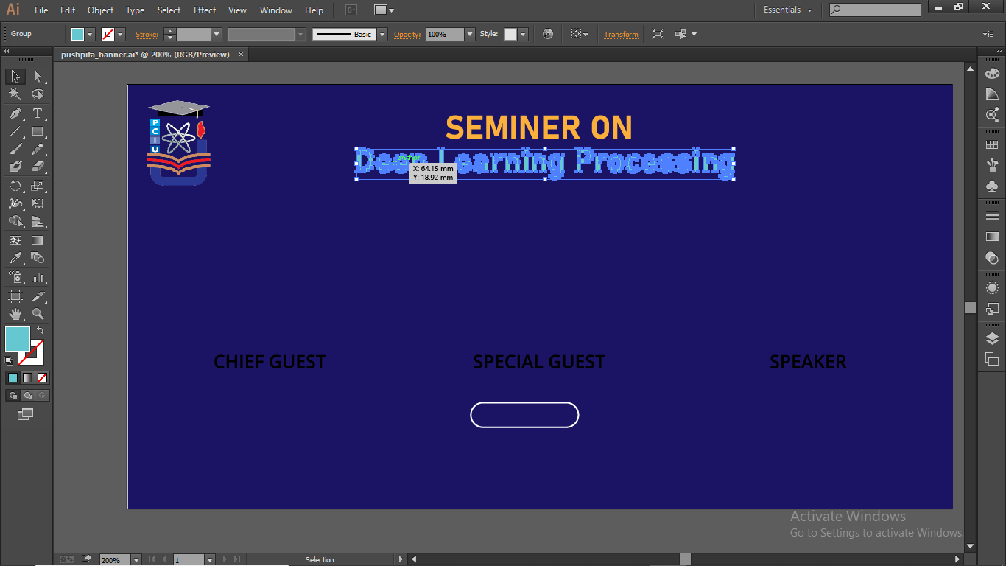

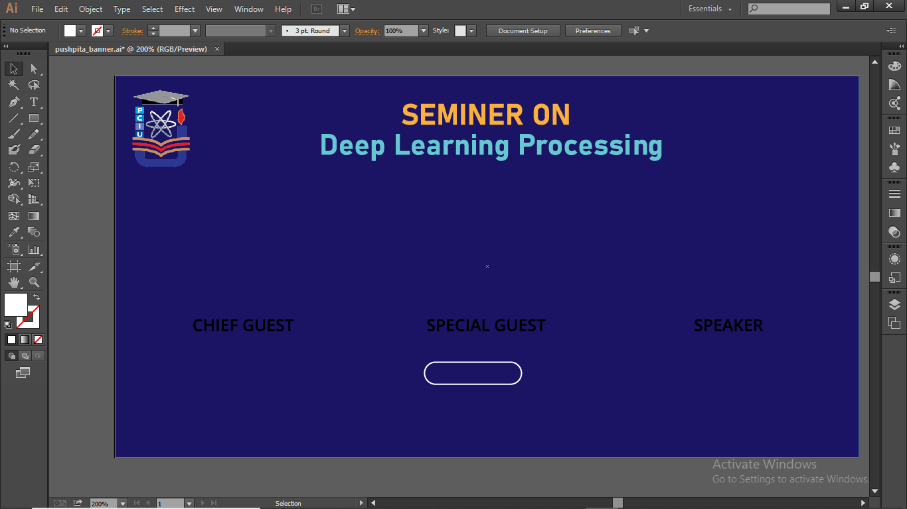

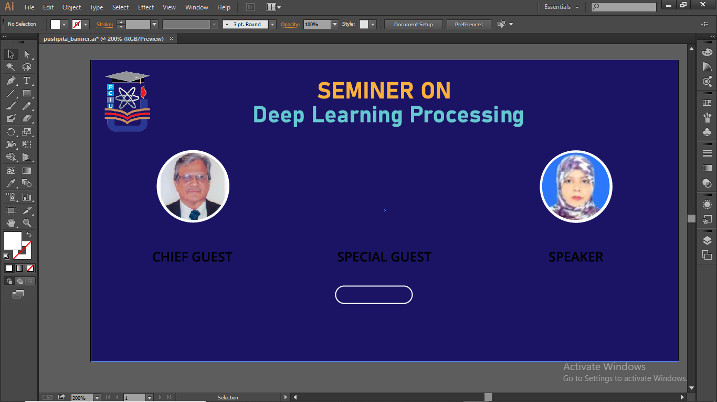

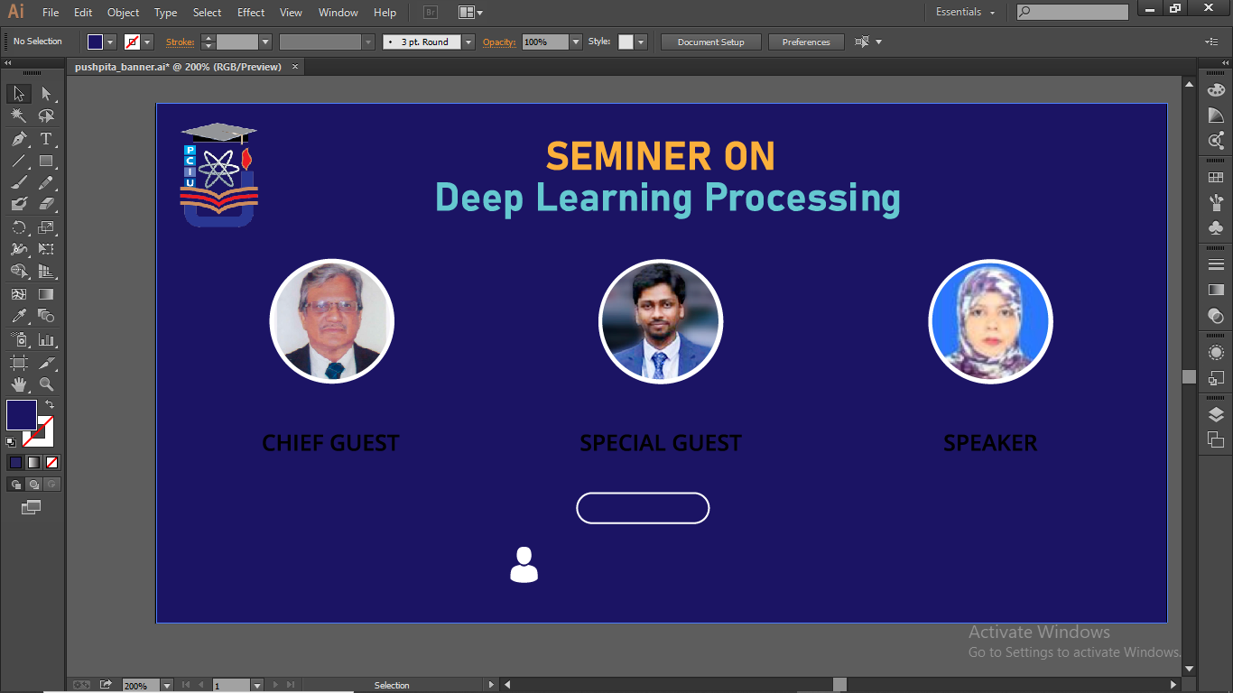

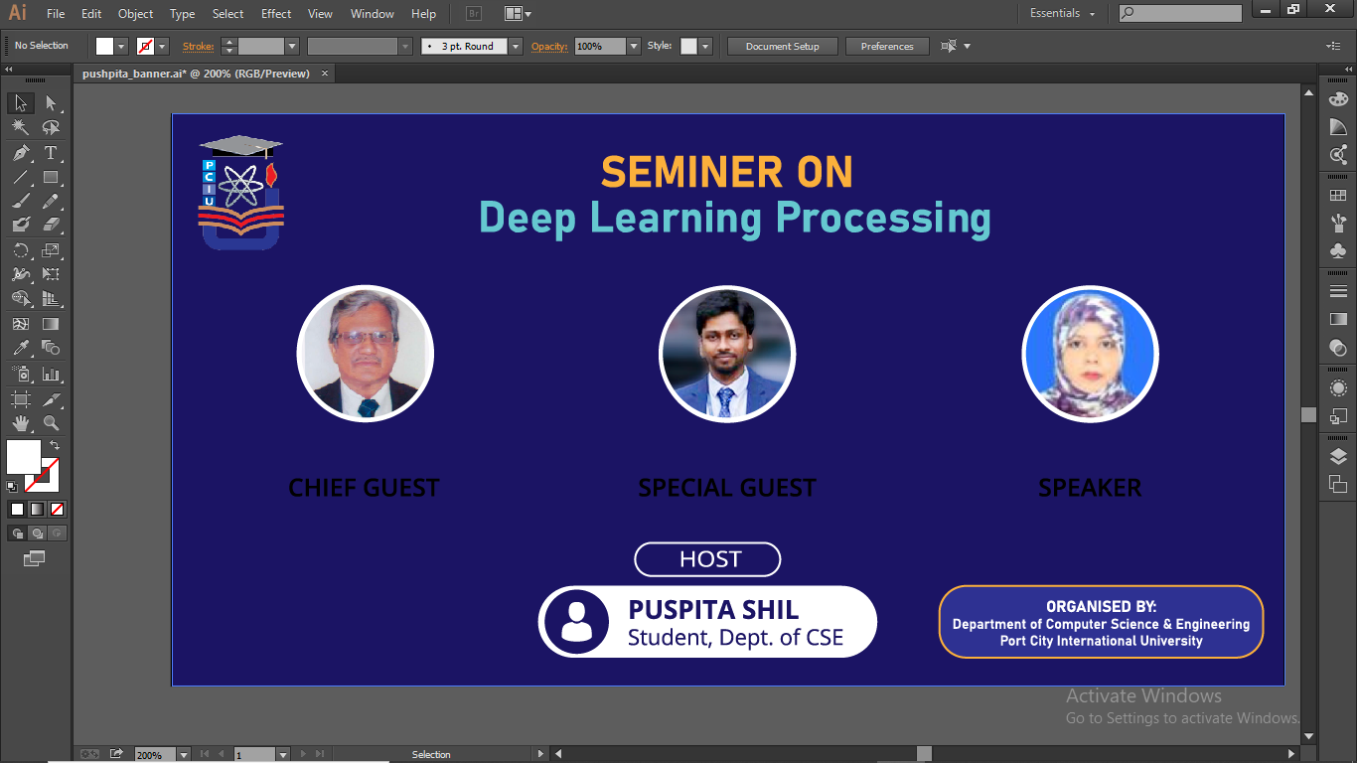

Snapshot of the final result:

