Experiment 9
Name: Pushpit kumar gaur | UID: 24BAI70534
Branch: B.E. CSE (AIML) | Section: 24AIT_KRG-G1
Semester: 4 | Date of Performance: 01.04.2026
Subject Name: Database Management System | Subject Code: 24CSH-298

AIM: To design and implement stored procedures in PostgreSQL for performing Create, Read, Update, and Delete (CRUD) operations on database tables in an efficient and reusable manner.
OBJECTIVES:
- To understand the concept and importance of stored procedures.
- To implement parameterized stored procedures.
- To perform INSERT, UPDATE, DELETE, and SEARCH operations.
- To improve database performance and security.
- To gain industry-relevant procedural SQL experience.
SOFTWARE REQUIREMENTS:
- Database Management System:
  - PostgreSQL Database
- Database Administration Tool / Client Tool:
  - pgAdmin

PRACTICAL/EXPERIMENT STEPS:
- A students table was created to store student details like ID, name, age, and course.
- A stored procedure add_student was implemented to insert new records.
- A function get_students was created to retrieve all records from the table.
- A stored procedure update_student was designed to update existing student data.
- A stored procedure delete_student was implemented to remove records using ID.
- A function search_student was created to search students by name.
- All CRUD operations were tested using procedure calls and SELECT statements.

PROCEDURE:
- PostgreSQL (pgAdmin) was opened and the required database was selected.
- The students table was created using CREATE TABLE with appropriate fields.
- Stored procedures were written using CREATE OR REPLACE PROCEDURE for INSERT, UPDATE, and DELETE operations.
- Functions were created using CREATE OR REPLACE FUNCTION for SELECT and SEARCH operations.
- Parameters were passed to procedures to perform dynamic operations.
- Procedures were executed using CALL and functions using SELECT.
- The output was verified to ensure correct implementation of CRUD operations.
CODE:
-- Create table
CREATE TABLE learners (
learner_id SERIAL PRIMARY KEY,
full_name VARCHAR(120),
learner_age INT,
program VARCHAR(120)
);

-- Insert Procedure
CREATE OR REPLACE PROCEDURE insert_learner(
l_name VARCHAR,
l_age INT,
l_program VARCHAR
)
LANGUAGE plpgsql
AS $$
BEGIN
INSERT INTO learners(full_name, learner_age, program)
VALUES (l_name, l_age, l_program);
END;
$$;

-- Call insert
CALL insert_learner('Alex', 21, 'BTech');
SELECT * FROM learners;

-- Fetch Function
CREATE OR REPLACE FUNCTION fetch_learners()
RETURNS TABLE(
learner_id INT,
full_name VARCHAR,
learner_age INT,
program VARCHAR
)
LANGUAGE plpgsql
AS $$
BEGIN
RETURN QUERY SELECT * FROM learners;
END;
$$;

-- Call fetch
SELECT * FROM fetch_learners();

-- Update Procedure
CREATE OR REPLACE PROCEDURE modify_learner(
l_id INT,
l_name VARCHAR,
l_age INT,
l_program VARCHAR
)
LANGUAGE plpgsql
AS $$
BEGIN
UPDATE learners
SET full_name = l_name,
learner_age = l_age,
program = l_program
WHERE learner_id = l_id;
END;
$$;

-- Call update
CALL modify_learner(1, 'Alex', 23, 'MBA');
SELECT * FROM learners;

-- Delete Procedure
CREATE OR REPLACE PROCEDURE remove_learner(
l_id INT
)
LANGUAGE plpgsql
AS $$
BEGIN
DELETE FROM learners
WHERE learner_id = l_id;
END;
$$;

-- Call delete
CALL remove_learner(1);
SELECT * FROM learners;

-- Search Function
CREATE OR REPLACE FUNCTION find_learner(l_id INT)
RETURNS TABLE(
learner_id INT,
full_name VARCHAR,
learner_age INT,
program VARCHAR
)
LANGUAGE plpgsql
AS $$
BEGIN
RETURN QUERY
SELECT l.learner_id, l.full_name, l.learner_age, l.program
FROM learners l
WHERE l.learner_id = l_id;
END;
$$;

-- Call search
SELECT * FROM find_learner(1);I/O ANALYSIS:
- Create a table
The students table is successfully created with fields such as id, name, age, and course. The id is defined as a primary key with auto-increment, ensuring unique student records.
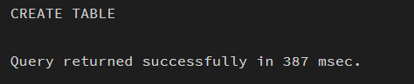
- Creating a Procedure (INSERT)
The stored procedure add_student is created successfully. It accepts parameters (name, age, course) and inserts a new record into the table. A new record is inserted into the students table successfully.
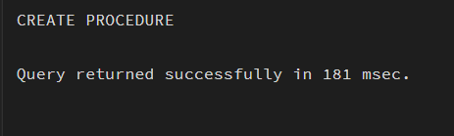
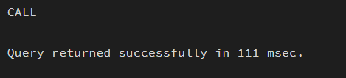
- Creating a Function (READ)
The function get_students is created to fetch all records from the table. Displays all student records present in the table.
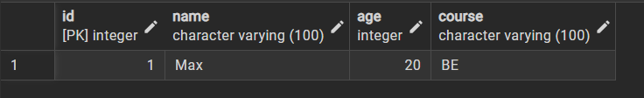
- UPDATE Operation
The stored procedure update_student is created to update existing student details using ID. The record with id = 1 is successfully updated with new values.
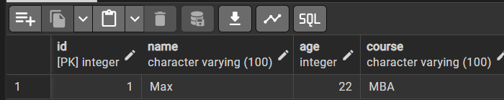
- DELETE Operation
The stored procedure delete_student is created to delete a student record based on ID. The record with id = 1 is removed from the table.

- SEARCH Operation
The function search_student is created to search records using id. It displays records with the given id.


LEARNING OUTCOMES:
    - Gained understanding of stored procedures and functions in PostgreSQL for efficient database operations.
    - Learned to implement CRUD operations (Create, Read, Update, Delete) using parameterized procedures and functions.
    - Developed the ability to improve data handling, reusability, and security in database applications using PL/pgSQL.

