Experiment 8
Name: Pushpit kumar gaur | UID: 24BAI70534
Branch: B.E. CSE (AIML) | Section: 24AIT_KRG-G1
Semester: 4 | Date of Performance: 27.03.2026
Subject Name: Database Management System | Subject Code: 24CSH-298

AIM: To design and implement a stored procedure in PostgreSQL that calculates the number of employees based on gender using input, output, and input-output parameters, and to understand the use of procedural logic in database management.
OBJECTIVES:
- To design and implement a stored procedure in PostgreSQL using PL/pgSQL that utilizes input, output, and input-output parameters to perform conditional data processing—specifically counting employees based on gender—and to understand how procedural constructs enhance modularity, reusability, and efficient database operations.
SOFTWARE REQUIREMENTS:
- Database Management System:
  - PostgreSQL Database
- Database Administration Tool / Client Tool:
  - pgAdmin

PRACTICAL/EXPERIMENT STEPS:
- An employees table was created in the database to store employee details such as ID, name, gender, and salary.
- Sample employee records were inserted into the table for testing the procedure.
- A stored procedure get_Employee_Count_BY_Gender was created using PL/pgSQL with IN, OUT, and INOUT parameters.
- The procedure logic was implemented to count employees based on a specified gender.
- An anonymous DO block was written to call the procedure and pass required parameters.
- The result was displayed using RAISE NOTICE to verify the output and status.

PROCEDURE:
- The pgAdmin (PostgreSQL) environment was opened to access the database.
- The employees table was created with appropriate fields using SERIAL as PRIMARY KEY.
- Sample data was inserted into the table using INSERT statements.
- A stored procedure was created using CREATE OR REPLACE PROCEDURE with IN, OUT, and INOUT parameters.
- The procedure body was defined to calculate the count of employees based on gender and update the status.
- An anonymous block (DO statement) was written to call the procedure and store output values.
- The output was displayed using RAISE NOTICE to observe the result and verify correctness.
CODE:
CREATE TABLE emp_data (
emp_id SERIAL PRIMARY KEY,
emp_name VARCHAR(50),
gender VARCHAR(10),
salary NUMERIC(10,2)
);

INSERT INTO emp_data (emp_name, gender, salary) VALUES
('Ramit', 'Male', 30000),
('Max', 'Female', 35000),
('Johny', 'Male', 28000),
('Karan', 'Female', 40000),
('Abhishek', 'Male', 32000);

CREATE OR REPLACE PROCEDURE get_emp_count_by_gender (
IN p_gen VARCHAR(20),
OUT emp_count INT,
INOUT stat VARCHAR(20)
)
LANGUAGE plpgsql
AS
$$
BEGIN
SELECT COUNT(*)
INTO emp_count
FROM emp_data
WHERE gender = p_gen;

stat := 'OK';
END;
$$;

DO
$$
DECLARE
gen_val VARCHAR(20) := 'Female';
total_emp INT;
status_val VARCHAR(20) := 'Pending';

BEGIN
CALL get_emp_count_by_gender(gen_val, total_emp, status_val);

RAISE NOTICE 'Count of % employees = %, Status = %',
gen_val, total_emp, status_val;
END;
$$;

I/O ANALYSIS:
- Table Data Input
Employee details such as name, gender, and salary are provided as input through INSERT statements into the employees table.

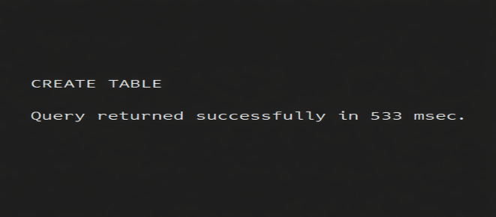
- Procedure Input
The stored procedure takes gender as an input parameter along with a status variable, which is initially set before execution.
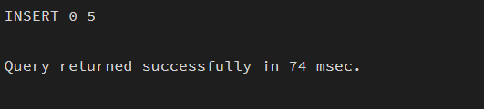
- Procedure Output
The procedure returns the count of employees based on the specified gender through the OUT parameter and updates the status to indicate execution success.
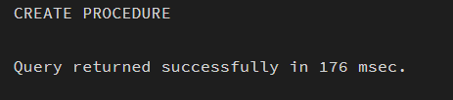
- Execution Output
The final output is displayed using RAISE NOTICE, showing the employee count for the given gender along with the updated status message.
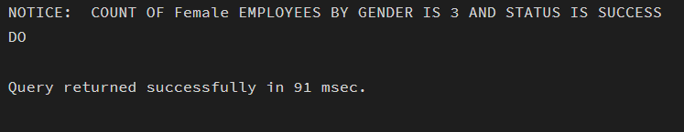

LEARNING OUTCOMES:
- Understand how to create and use stored procedures in PostgreSQL using PL/pgSQL.
- Gain knowledge of parameter types (IN, OUT, INOUT) and their practical usage.
- Develop the ability to implement conditional and aggregate operations within procedures.
- Learn how to execute procedures and display results using anonymous blocks and RAISE NOTICE.

