Experiment 6
Name: Pushpit kumar gaur | UID: 24BAI70534
Branch: B.E. CSE (AIML) | Section: 24AIT_KRG-G1
Semester: 4 | Date of Performance: 13.03.2026
Subject Name: Database Management System | Subject Code: 24CSH-298

AIM: To understand the concept and working of cursors in PL/SQL for row-by-row data processing, and to analyze how implicit cursors, explicit cursors, and cursor attributes are used to implement business logic on multiple rows in a database table.
OBJECTIVES:
- To implement and analyze the use of implicit cursors, explicit cursors, and cursor attributes for processing multiple rows from a database table and applying business logic effectively.
SOFTWARE REQUIREMENTS:
- Database Management System:
  - PostgreSQL Database
- Database Administration Tool / Client Tool:
  - pgAdmin

PRACTICAL/EXPERIMENT STEPS:
- An employees table was created in the Oracle database with columns such as emp_id, emp_name, and emp_sal to store employee details.
- Sample employee records were inserted into the table to provide data for testing cursor operations.
- The concept of implicit cursors was studied to understand how Oracle automatically handles DML operations like UPDATE.
- A PL/SQL block using an implicit cursor was written to update employee salary and verify execution using SQL%FOUND and SQL%ROWCOUNT.
- The concept of explicit cursors was explored to process multiple rows returned by a SELECT query.
- A PL/SQL program using an explicit cursor was written to fetch employee records one by one and apply business logic.
- The programs were executed in Oracle FreeSQL, and the output results were verified for correctness.

PROCEDURE:
- The Oracle FreeSQL environment was opened to access the database.
- A new employees table was created with fields such as emp_id, emp_name, and emp_sal.
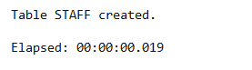
- Sample employee records were inserted into the table using INSERT statements.
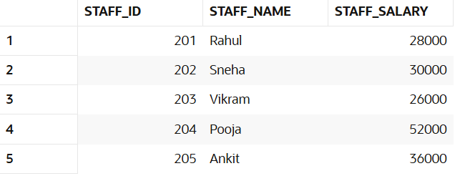
- A PL/SQL block using an implicit cursor was written to update employee salary and check execution status using SQL%FOUND and SQL%ROWCOUNT.
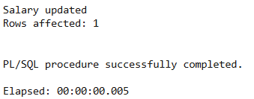
- An explicit cursor was declared to retrieve multiple employee records from the table.
- The cursor was opened, and records were fetched one by one using a LOOP structure, and business logic was applied.
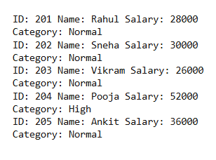
- The cursor was closed after processing all records, and the output was observed and recorded.
CODE:
CREATE TABLE staff (
staff_id NUMBER PRIMARY KEY,
staff_name VARCHAR2(50),
staff_salary NUMBER
);

INSERT INTO staff VALUES (201, 'Rahul', 28000);
INSERT INTO staff VALUES (202, 'Sneha', 47000);
INSERT INTO staff VALUES (203, 'Vikram', 26000);
INSERT INTO staff VALUES (204, 'Pooja', 52000);
INSERT INTO staff VALUES (205, 'Ankit', 36000);

COMMIT;

DECLARE
v_staff_id staff.staff_id%TYPE := 202;
v_updated_salary staff.staff_salary%TYPE := 30000;
BEGIN
UPDATE staff
SET staff_salary = v_updated_salary
WHERE staff_id = v_staff_id;

IF SQL%FOUND THEN
DBMS_OUTPUT.PUT_LINE('Salary updated');
ELSE
DBMS_OUTPUT.PUT_LINE('Record not found');
END IF;

DBMS_OUTPUT.PUT_LINE('Rows affected: ' || SQL%ROWCOUNT);
END;
/

DECLARE
CURSOR staff_cursor IS
SELECT staff_id, staff_name, staff_salary FROM staff;

s_id staff.staff_id%TYPE;
s_name staff.staff_name%TYPE;
s_salary staff.staff_salary%TYPE;
BEGIN
OPEN staff_cursor;

LOOP
FETCH staff_cursor INTO s_id, s_name, s_salary;
EXIT WHEN staff_cursor%NOTFOUND;

DBMS_OUTPUT.PUT_LINE('ID: ' || s_id ||
' Name: ' || s_name ||
' Salary: ' || s_salary);

IF s_salary > 42000 THEN
DBMS_OUTPUT.PUT_LINE('Category: High');
ELSE
DBMS_OUTPUT.PUT_LINE('Category: Normal');
END IF;

END LOOP;

CLOSE staff_cursor;
END;
/

I/O ANALYSIS:
- Implicit Cursor Output

Displays messages indicating whether the employee salary was successfully updated and shows the number of rows affected using SQL%FOUND and SQL%ROWCOUNT.


- Explicit Cursor Output

Displays employee details (ID, Name, Salary) for each record fetched from the table.

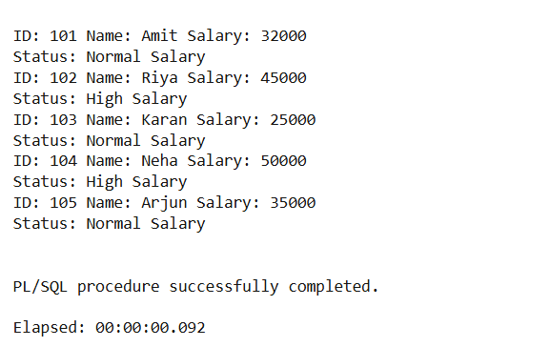
- Business Logic Result
Shows classification of employees based on salary (e.g., “High Salary” or “Normal Salary”) for each row processed.
LEARNING OUTCOMES:
- Understood the role of cursors in PL/SQL for handling multi-row query results.
- Differentiated between implicit cursors and explicit cursors.
- Used cursor attributes such as %FOUND, %NOTFOUND, %ROWCOUNT.
- Developed PL/SQL programs that process database records row by row.
- Applied cursor-based logic to real-world business scenarios.

