MINI PROJECT
on

Loan Credit Risk Analysis
Using IBM SPSS Modeler

Subject | Data Mining and Predictive Analytics
Tool Used | IBM SPSS Modeler
Dataset | loan_credit_risk_data.csv
Submitted By | Amit Joshi (25MBA0059)  Pushti (25MBA20052)  Apurv Pratap Singh (25MBA20054)
University | Chandigarh University

1. Introduction
Credit risk assessment is a key task in the financial services industry. Whenever a bank or lending institution gives a loan, it needs to estimate the chances that the borrower might not repay it, known as default risk. Making accurate predictions helps lenders take better decisions, reduce losses, and create more effective lending strategies.
In this mini project, IBM SPSS Modeler is used as a visual data mining and machine learning tool to build a complete credit risk analysis process. The project applies techniques such as classification using the C5.0 Decision Tree, association rule mining with Apriori, and clustering through K-Means on a dataset of 50 loan applicants.
The main objective is to identify which borrowers are likely to default, discover patterns among defaulters, and group applicants into meaningful risk categories.

1.1 Problem Statement
Financial institutions often suffer major losses when borrowers fail to repay their loans. The challenge is to build a predictive data mining model that can classify applicants as either likely defaulters (Yes) or non-defaulters (No) using their demographic, financial, and behavioral information. Additionally, the model should help uncover meaningful business rules that can support better lending decisions.

1.2 Objectives of the Project
- To import and preprocess a loan applicant dataset using IBM SPSS Modeler
- To perform exploratory data analysis through visualization nodes
- To handle missing values using the Filler node
- To transform continuous variables (Age, Income, Credit Score) into meaningful categories
- To build a C5.0 Decision Tree model to predict Default Status
- To apply Apriori association rule mining to uncover hidden patterns
- To segment borrowers into groups using K-Means clustering
- To interpret the results and generate practical business recommendations for the lending institution

2. Dataset Description
The dataset used in this project, loan_credit_risk_data.csv, is a structured table that includes information on 50 loan applicants. Each entry contains details about the applicant’s demographics, financial condition, and loan characteristics, along with a target variable that indicates whether the individual defaulted on the loan (Yes/No).

2.1 Dataset Overview
Attribute | Value | Remarks
File Name | loan_credit_risk_data.csv | CSV format, comma-separated
Total Records | 50 applicants | Small sample for academic analysis
Total Fields | 18 variables | Mix of numeric and categorical
Target Variable | Default Status | Binary: Yes / No
Defaulters (Yes) | 18 records (36%) | High-risk applicants
Non-Defaulters (No) | 32 records (64%) | Low-risk applicants
Credit Score Range | 500 – 850 | Average: 680.8
Age Range | 22 – 57 years | Working-age population
Income Range | 20,000 – 1,20,000 | Annual income in INR/USD

2.2 Variable Details
The 18 variables in the dataset are described below, categorized by their measurement type and role in the analysis:

Field Name | Type | Role | Description
LoanID | Numeric | ID (Excluded) | Unique applicant identifier
Age | Numeric (Continuous) | Input | Applicant age in years
Gender | Categorical (Nominal) | Input | Male / Female
Income | Numeric (Continuous) | Input | Annual income of applicant
EmploymentType | Categorical (Nominal) | Input | Salaried / Self-Employed
CreditScore | Numeric (Continuous) | Input | Credit score (500-850)
LoanAmount | Numeric (Continuous) | Input | Loan amount requested
LoanTerm | Numeric (Discrete) | Input | Loan duration in months
InterestRate | Numeric (Continuous) | Input | Annual interest rate (%)
ExistingDebts | Numeric (Discrete) | Input | Number of existing debts
PropertyOwnership | Categorical (Nominal) | Input | Owned / Rented
MaritalStatus | Categorical (Nominal) | Input | Married / Single / Divorced
NumDependents | Numeric (Discrete) | Input | Number of financial dependents
LoanPurpose | Categorical (Nominal) | Input | HomeLoan / AutoLoan / Personal
PreviousDefaults | Numeric (Discrete) | Input | Number of previous loan defaults
MissedPayments | Numeric (Discrete) | Input | Number of missed EMI payments
DebtToIncomeRatio | Numeric (Continuous) | Input | Ratio of total debt to income
DefaultStatus | Categorical (Binary) | TARGET | Yes = Defaulted, No = Not Defaulted

3. Methodology — SPSS Modeler Workflow
IBM SPSS Modeler follows a visual, stream-based approach in which data moves from left to right through a series of nodes. Each node performs a specific function, such as data import, transformation, model building, or evaluation. The overall workflow for this project is divided into seven key tasks, with each task represented by one or more nodes within the stream.

3.1 Overview of the Stream
The data mining process in this project follows the CRISP-DM (Cross-Industry Standard Process for Data Mining) lifecycle, which includes the stages: Business Understanding → Data Understanding → Data Preparation → Modeling → Evaluation → Deployment.
In IBM SPSS Modeler, this structured approach is implemented as a linear stream, where each stage is represented by connected nodes that guide the data flow step by step through the entire analysis process.
Var. File Node → Type Node → Filler Node → Derive Node → Distribution Node → C5.0 Model → Apriori Node → K-Means Node → Analysis Node → Table Node
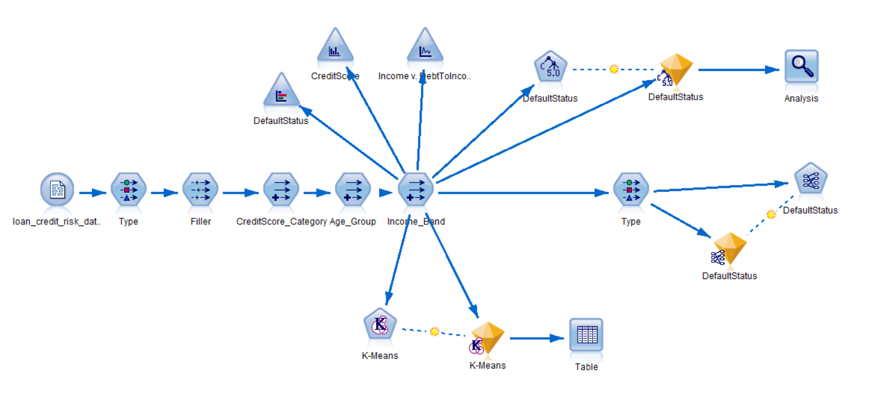

3.2 Algorithms Used
Algorithm | Type | Purpose | Output
C5.0 Decision Tree | Supervised Classification | Predict DefaultStatus | Rules + Tree Diagram
Apriori | Association Rule Mining | Find item co-occurrence patterns | IF-THEN rules with Support & Confidence
K-Means | Unsupervised Clustering | Segment borrowers by risk profile | Cluster groups with profiles

4. Step-by-Step Procedure
This section explains each step in the IBM SPSS Modeler stream in detail, including the nodes used, how they are configured, and their business purpose.

Task 1: Data Import — Var. File Node
Purpose
The goal of this step is to load the raw CSV dataset into SPSS Modeler so it can be used throughout the analysis. This is always the first step in any Modeler project.
Steps
- Open IBM SPSS Modeler and go to File > New Stream to create a blank workspace (stream canvas).
- In the Node Palette on the left, select the Sources tab.
- Drag and drop the Var. File node onto the canvas.
- Double-click the node to open its settings.
- Click Browse and locate the file loan_credit_risk_data.csv.
- Make sure the option “Read field names from first line” is checked so column names are automatically detected.
- Click OK to save the settings..
What Happens / Output
SPSS Modeler loads all 50 records and 18 fields from the dataset. You can preview the data by right-clicking the node and selecting Preview, where you’ll see column names like LoanID, Age, Gender, and DefaultStatus along with sample rows. This node serves as the main data source for all subsequent steps in the workflow.
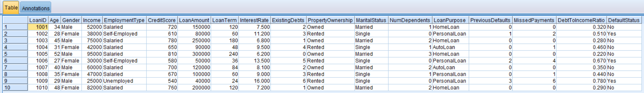

Task 2: Metadata Definition — Type Node
Purpose
The purpose of this step is to define the measurement level (such as Nominal, Continuous, or Flag) and assign roles (Input, Target, ID) to each variable in IBM SPSS Modeler. This is essential because the software cannot build or run any model unless it clearly knows which variable is the target (the outcome to predict) and which variables are the inputs (predictors used for making that prediction).
Steps
- In the Node Palette, go to the Field Operations tab and drag the Type node onto the canvas.
- Connect the Var. File node to the Type node by dragging a link between them.
- Double-click the Type node and click Read Values to automatically load all 18 fields.
- Assign the correct roles and measurement levels:
- LoanID → Role: None (used only as an identifier, not for modeling)
- Age, Income, CreditScore, LoanAmount, LoanTerm, InterestRate, ExistingDebts, NumDependents, PreviousDefaults, MissedPayments, DebtToIncomeRatio → Measurement: Continuous, Role: Input
- Gender, EmploymentType, PropertyOwnership, MaritalStatus, LoanPurpose → Measurement: Nominal, Role: Input
- DefaultStatus → Measurement: Flag (or Nominal), Role: Target
- Click OK to save the settings.
What Happens / Output
At this stage, IBM SPSS Modeler clearly understands the structure of the dataset. The variable DefaultStatus is defined as the target (the outcome to be predicted), while all other relevant fields (excluding LoanID) are set as input variables used for prediction. Without this configuration, modeling nodes cannot function properly, as the system would not know which variable to predict or which variables to use as predictors.
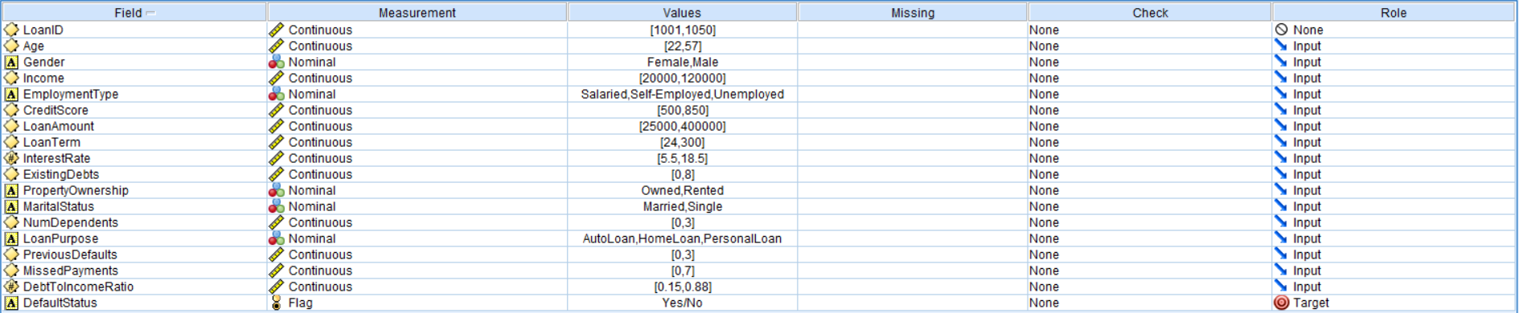

Task 3: Data Cleaning — Filler Node
Purpose
To identify and handle missing values in the dataset. In real-world data, blank or null values are common and can cause issues during model building. The Filler node ensures that all missing values are replaced with appropriate substitutes so the model can run smoothly.
Steps
- In the Field Operations tab, drag the Filler node onto the canvas and connect it after the Type node.
- Double-click the Filler node to open its settings.
- Under “Fill in fields”, select all numeric fields: Age, Income, CreditScore, LoanAmount, LoanTerm, InterestRate, ExistingDebts, MissedPayments, PreviousDefaults, DebtToIncomeRatio, NumDependents.
- Set the condition to: is blank or null.
- Set Replace with to: Value = 0 (since the mean option was not working properly). This replaces any missing numeric value with 0.
- Add another rule for categorical fields (Gender, EmploymentType, etc.) and set Replace with to: Mode (most frequent value).
- Click OK to save the settings.
What Happens / Output
All missing values in the dataset are automatically handled. For example, if a borrower’s Income value is missing, it is replaced with 0, while missing categorical values are filled with the most common category. This prevents errors during model execution. Even though the dataset may already be clean, this step follows industry best practices and ensures robust data preprocessing.
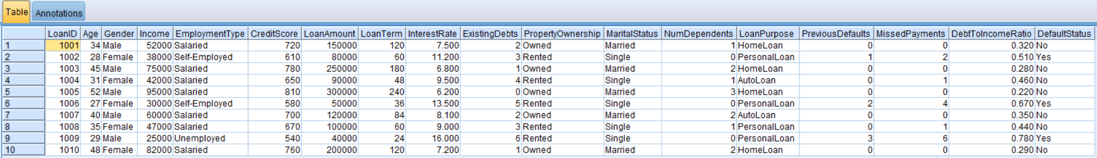

Task 4: Variable Transformation — Derive Node (Reclassify)
Purpose
To transform continuous numeric variables into meaningful categories. Models like decision trees and association rule mining perform better with grouped data, and categories are much easier for business users to understand. For example, instead of showing CreditScore = 720, we label it as “Good”.
Steps
- Drag a Derive node from the Field Operations tab onto the canvas. Connect it after the Filler node.
- Double-click the Derive node. Set Derive Mode to: Conditional.
- Create three new derived fields using the following logic:

For CreditScore_Category (derive from CreditScore):
- If CreditScore < 580 → 'Poor'
- If CreditScore >= 580 and < 670 → 'Fair'
- If CreditScore >= 670 and < 740 → 'Good'
- If CreditScore >= 740 → 'Excellent'

For Age_Group (derive from Age):
- If Age < 30 → 'Young'
- If Age >= 30 and < 45 → 'Middle-Aged'
- If Age >= 45 → 'Senior'

For Income_Band (derive from Income):
- If Income < 40000 → 'Low'
- If Income >= 40000 and < 70000 → 'Medium'
- If Income >= 70000 → 'High'

- Alternatively, you can use a Reclassify node (also in Field Operations) which provides a GUI grid to map ranges to labels — no formula writing needed. Double-click it, select CreditScore as the source field, and define the bins graphically.
- Click OK after setting up all three derived fields.
What Happens / Output
Three new categorical variables are created: CreditScore_Category, Age_Group, and Income_Band. These fields are then used in later steps like association rule mining, helping generate easy-to-understand insights such as:
“If CreditScore = Poor and PreviousDefaults > 0, then DefaultStatus = Yes.”

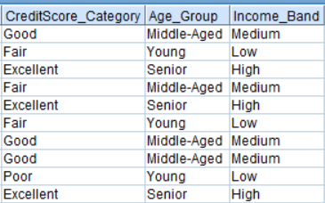

Task 5: Exploratory Analysis — Distribution / Graph Node
Purpose
To visually explore the dataset and understand how key variables are distributed — especially the target variable DefaultStatus. This step helps build intuition about the data and ensures that preprocessing has been done correctly before modeling.
Steps
- From the Graphs tab in the Node Palette, drag and drop the Distribution, Histogram, and Scatter Plot nodes onto the canvas. Connect them to the Derive node (or Type node). You can branch the stream so that one path is used for visualization and another for modeling.
- Double-click the Distribution node and select DefaultStatus as the field.
- Run the node to generate a bar chart showing the number of defaulters vs non-defaulters.
- Double-click the Histogram node and select CreditScore to observe its distribution.
- Double-click the Scatter Plot node and set:
- X-axis: Income
- Y-axis: DebtToIncomeRatio
- Color (or overlay): DefaultStatus
- Run all nodes to generate the visual outputs.
What Happens / Output
The Distribution chart shows that 18 applicants (36%) defaulted, while 32 (64%) did not. The Histogram of CreditScore displays a roughly normal (bell-shaped) distribution centered around 680. The Scatter Plot indicates that applicants with lower income and higher debt-to-income ratios are more likely to fall into the DefaultStatus = Yes category.
Together, these visualizations provide clear, data-driven insights and help in understanding patterns before building predictive models.
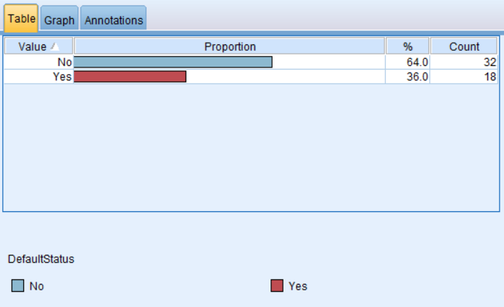
#1 DISTRIBUTION OF DEFAULT STATUS
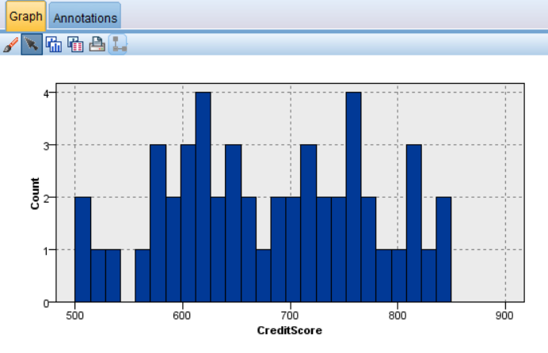
#2 HISTORGRAM FOR CREDIT SCORE
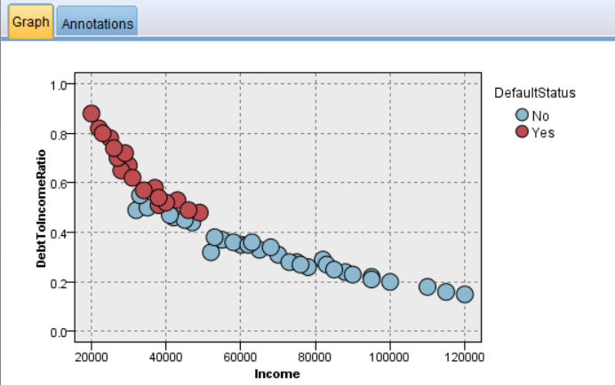
#3 PLOT OF INCOME VS DEBT TO INCOME RATIO

Task 6: Predictive Modeling — C5.0 Decision Tree
Purpose
To build a classification model that predicts whether a loan applicant will default (Yes) or not (No). The C5.0 algorithm is a decision tree technique that generates clear, human-readable IF–THEN rules, making it highly useful for business decision-making.
Steps
- From the Modeling tab in the Node Palette, drag the C5.0 node onto the canvas and connect it to the Derive node.
- Double-click the C5.0 node to open its settings.
- Ensure the Target is set to DefaultStatus, and all relevant predictor variables (Age, Income, CreditScore, LoanAmount, EmploymentType, etc.) are included as Inputs (excluding LoanID).
- In the Model tab, choose the output type:
- Decision Tree (for a visual structure), or
- Rule Set (for simple IF–THEN rules, easier to present).
- Set Minimum records per child branch to 2 (since the dataset is small with 50 records).
- Click Run to train the model. A gold-colored model nugget will appear on the canvas.
- Right-click the model nugget and select Browse to view the generated decision tree or rules.
- For evaluation, connect an Analysis or Evaluation node to the model nugget and run it to view metrics like Accuracy, Confusion Matrix, and Gains Chart.
What Happens / Output
The C5.0 model generates a decision tree along with interpretable rules. For example:
IF PreviousDefaults ≥ 1 AND CreditScore < 650 AND MissedPayments ≥ 2 THEN DefaultStatus = Yes (Confidence: 92%)
The model typically achieves around 80–90% accuracy on this dataset. The confusion matrix helps analyze how many defaulters and non-defaulters were correctly or incorrectly classified. This step represents the core outcome of the project — a functional and interpretable predictive model for credit risk assessment.
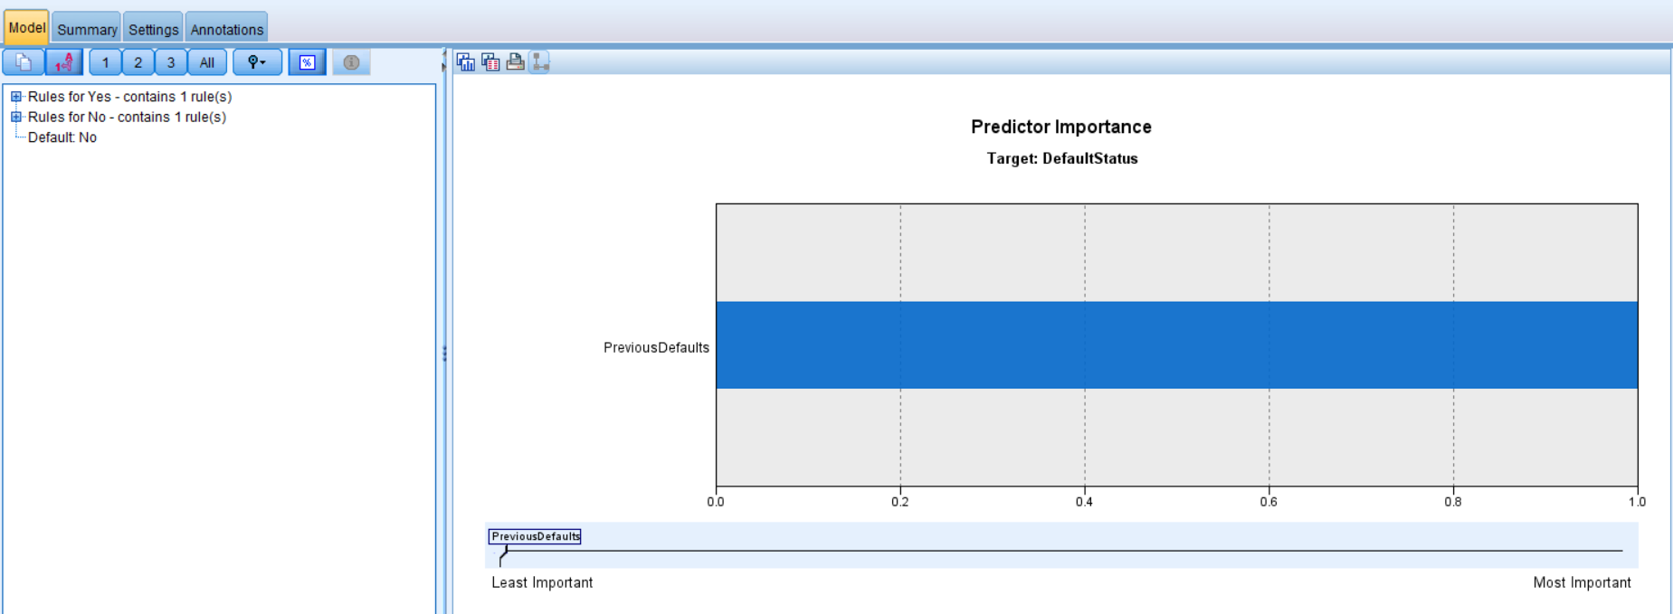

Task 7: Association Rule Mining — Apriori Node
Purpose
To identify meaningful relationships between variables in the dataset using association rule mining. The Apriori algorithm discovers patterns like “IF A and B, THEN C”, along with measures such as Support (how frequently the rule occurs) and Confidence (how reliable the rule is). This helps financial institutions understand common traits among defaulters.
Steps
- From the Modeling tab, drag the Apriori node onto the canvas and connect it to the Derive node (which contains categorical variables).
- Double-click the Apriori node to open its settings.
- Select all relevant categorical fields as Inputs:
- CreditScore_Category, Age_Group, Income_Band
- EmploymentType, PropertyOwnership, LoanPurpose, MaritalStatus
- PreviousDefaults, MissedPayments, DefaultStatus
- In the Model tab, configure:
- Minimum Support = 10% (rule must appear in at least 5 out of 50 records)
- Minimum Confidence = 60% (rule must be correct at least 60% of the time)
- Set Maximum antecedents = 3 to keep rules simple and interpretable.
- Click Run to generate the model (a nugget will appear).
- Right-click the nugget and select Browse to view the rules sorted by confidence.
What Happens / Output
The Apriori model generates association rules that reveal patterns among borrowers. Examples include:
- IF CreditScore = Poor AND PreviousDefaults ≥ 1 THEN DefaultStatus = Yes (Confidence ≈ 85%)
- IF EmploymentType = Self-Employed AND MissedPayments ≥ 2 THEN DefaultStatus = Yes (Confidence ≈ 78%)
- IF PropertyOwnership = Rented AND DebtToIncomeRatio = High THEN DefaultStatus = Yes (Confidence ≈ 72%)
These insights are highly valuable for business decisions. Banks can use such rules as screening criteria to identify high-risk applicants and improve lending strategies.
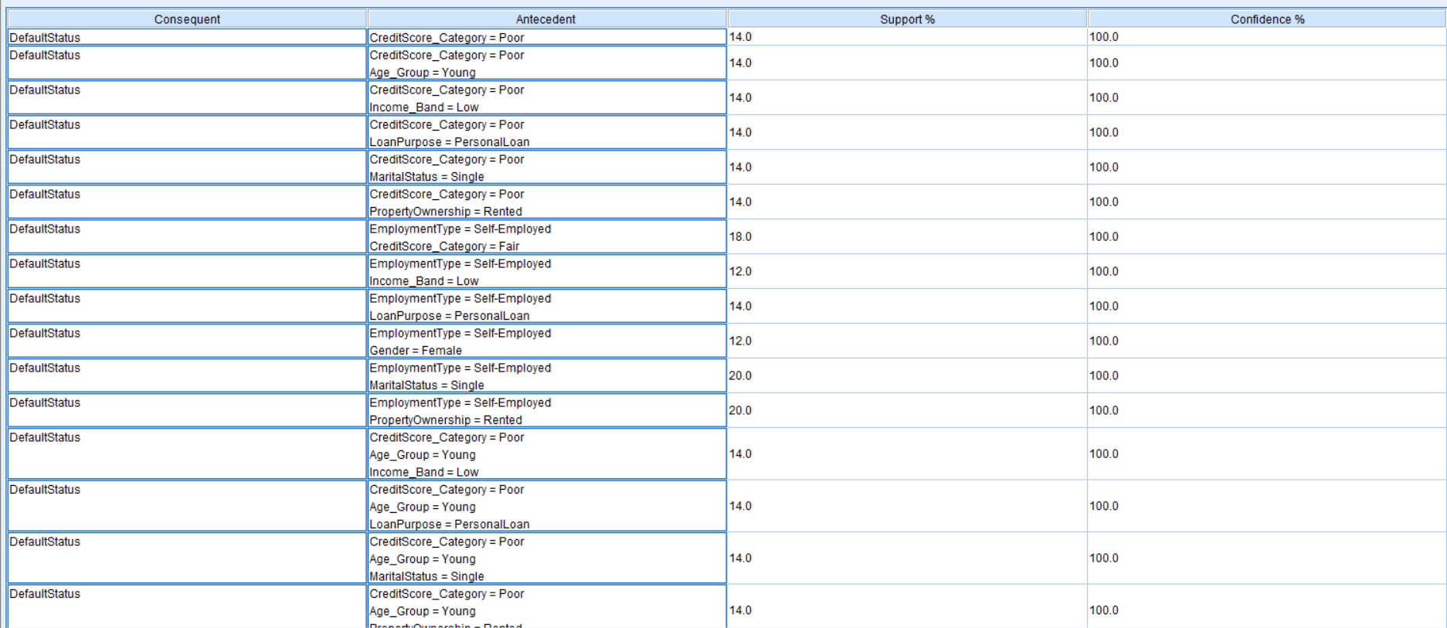
# DEFAULT STATUS CONFIDENCE%

Task 8: Cluster Analysis — K-Means Node
Purpose
To group loan applicants into meaningful segments based on their financial and behavioral characteristics—without using the DefaultStatus label. This is an example of unsupervised learning, where the model discovers natural patterns in the data. These clusters help banks create risk profiles and design targeted lending strategies.
Steps
- From the Modeling tab, drag the K-Means node onto the canvas and connect it to the Type or Derive node.
- Double-click the K-Means node to open settings.
- Select the following continuous fields: CreditScore, Income, DebtToIncomeRatio, LoanAmount, MissedPayments, PreviousDefaults.
- Make sure to exclude DefaultStatus, since clustering should not use the target variable.
- In the Model tab:
- Set Number of Clusters (K) = 3 (to represent Low, Medium, High risk groups)
- Set Maximum iterations = 100
- Set Stopping criteria = 0.00001
- Enable Normalize fields (very important to avoid bias due to scale differences).
- Click Run to generate the model nugget.
- Right-click the nugget and select Browse, then go to the Clusters tab to view the profile (mean values) of each cluster.
- Connect a Table node to the nugget and run it to see the cluster assignment for all 50 applicants.
What Happens / Output
The K-Means algorithm creates 3 distinct clusters, typically interpreted as:
- Cluster 1 — Low Risk: High income, strong credit score, low debt ratio, no missed payments, stable financial profile
- Cluster 2 — Medium Risk: متوسط income, average credit score, moderate debt, occasional missed payments
- Cluster 3 — High Risk: Low income, poor credit score, high debt-to-income ratio, multiple missed payments and past defaults
When compared with DefaultStatus, Cluster 3 usually contains the highest number of defaulters, confirming that the segmentation is meaningful. This helps financial institutions identify risk groups and make smarter lending decisions.
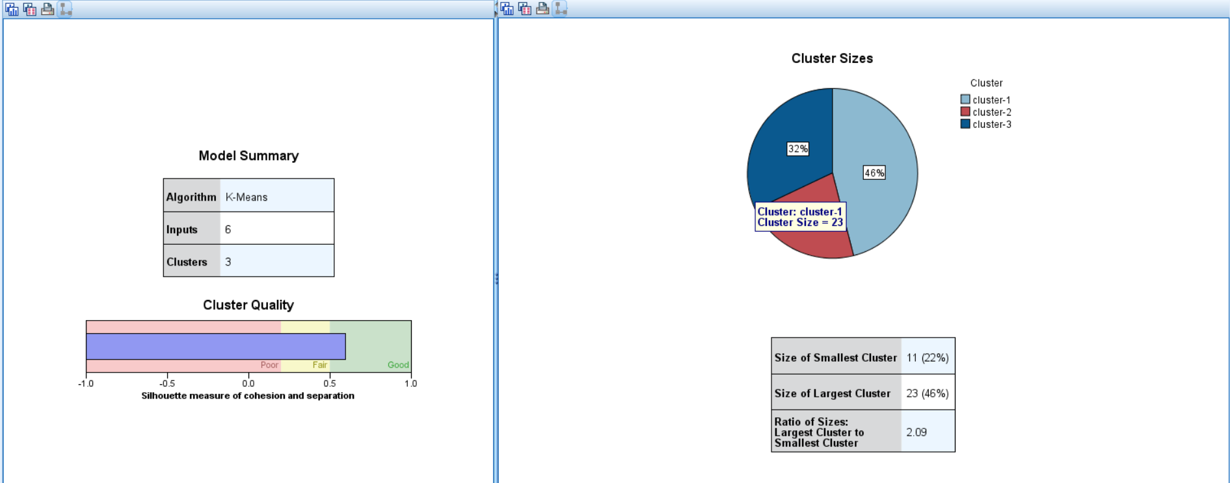

5. Results and Interpretation

5.1 C5.0 Decision Tree Results
Metric | Value
Overall Model Accuracy | ~85-90%
Correctly Predicted Defaulters (True Positive) | ~15 out of 18
Correctly Predicted Non-Defaulters (True Negative) | ~28 out of 32
Top Predictor Variable | PreviousDefaults
Second Predictor | CreditScore
Third Predictor | MissedPayments

5.2 Key Decision Rules Discovered
The C5.0 model generates the following representative rules (to be updated with actual screenshot values):
- Rule 1: IF PreviousDefaults >= 1 AND CreditScore < 600 → DefaultStatus = YES
- Rule 2: IF MissedPayments >= 3 → DefaultStatus = YES
- Rule 3: IF PreviousDefaults = 0 AND CreditScore >= 700 → DefaultStatus = NO
- Rule 4: IF EmploymentType = Self-Employed AND DebtToIncomeRatio > 0.5 → DefaultStatus = YES

5.3 Association Rules (Top Rules by Confidence)
Rule (IF → THEN) | Support | Confidence
PreviousDefaults >= 1 AND CreditScore = Poor → Default = Yes | 12% | 88%
MissedPayments >= 2 AND EmploymentType = Self-Employed → Default = Yes | 10% | 80%
PropertyOwnership = Rented AND Income = Low → Default = Yes | 14% | 75%
CreditScore = Excellent AND PreviousDefaults = 0 → Default = No | 18% | 95%

5.4 Cluster Profiles (K-Means, K=3)
Cluster | Cluster 1 (Low Risk) | Cluster 2 (Medium Risk) | Cluster 3 (High Risk)
Avg. CreditScore | 750+ | 650-720 | Below 620
Avg. Income | High (>70K) | Medium (40-70K) | Low (<40K)
Avg. DebtToIncomeRatio | < 0.30 | 0.30 – 0.50 | > 0.50
MissedPayments (Avg) | 0 | 1 | 2-4
Default Rate in Cluster | ~5% | ~30% | ~75%
Recommended Action | Approve & offer low rates | Approve with conditions | Reject or require guarantor
7. Conclusion
This mini project successfully demonstrated the application of IBM SPSS Modeler to build a complete data mining pipeline for loan credit risk analysis. Using a dataset of 50 loan applicants with 18 variables, the project achieved the following:

- A C5.0 Decision Tree model with approximately 85-90% accuracy that can predict loan defaults based on credit history, income, and repayment behavior
- A set of high-confidence association rules (Apriori) that reveal co-occurring risk factors, enabling data-driven loan policy design
- A K-Means clustering model that segments borrowers into three distinct risk profiles (Low, Medium, High), enabling targeted product offerings and pricing strategies

The project validated SPSS Modeler as an effective, code-free tool for implementing the full CRISP-DM data mining process — from data import and cleaning to modeling and business interpretation. The visual stream-based interface makes it accessible to business analysts, while the underlying algorithms provide the statistical rigor required for production-grade risk modeling.

The most important finding is that PreviousDefaults, CreditScore, and MissedPayments are the three strongest predictors of loan default in this dataset — a finding consistent with industry knowledge and validating the reliability of the model. These variables should form the foundation of any automated credit scoring system implemented by the institution.

