Week 2 NLP Project Report
Duplicate Question Detection using NLP
Internship Report | Week 2 | Hugging Face Quora Duplicate Questions Dataset

1. Abstract
Week 2 established a strong classical baseline for duplicate question detection using TF-IDF features with Logistic Regression and Linear SVM. On 404,290 Quora question pairs, the best model achieved 74.16% accuracy. The analysis shows that classical NLP is effective for word overlap, however it fails to generalize well when duplicate questions are phrased differently.

2. Introduction
The objective is to identify semantically equivalent questions so duplicate answers can be consolidated and search results can be improved. This is a standard text similarity task where lexical overlap provides useful signal, but semantic understanding remains necessary for paraphrased questions.

3. Dataset & Preprocessing
- Dataset source: sentence-transformers/quora-duplicates on Hugging Face.
- Dataset size: 404,290 question pairs.
- Class balance: 63.1% non-duplicates and 36.9% duplicates.
- Preprocessing: removed nulls, removed duplicate rows, lowercased text, removed special characters, and prepared cleaned question pairs.
Text preprocessing converted the raw question text into a consistent format before modeling. TF-IDF vectorization was then applied with unigrams and bigrams so the model could capture both individual words and short phrase patterns. The question pairs were represented as separate TF-IDF vectors and concatenated into a sparse feature matrix. The dataset was split using an 80/20 stratified train-test split, and Logistic Regression plus Linear SVM were trained on the same training set for a fair comparison.
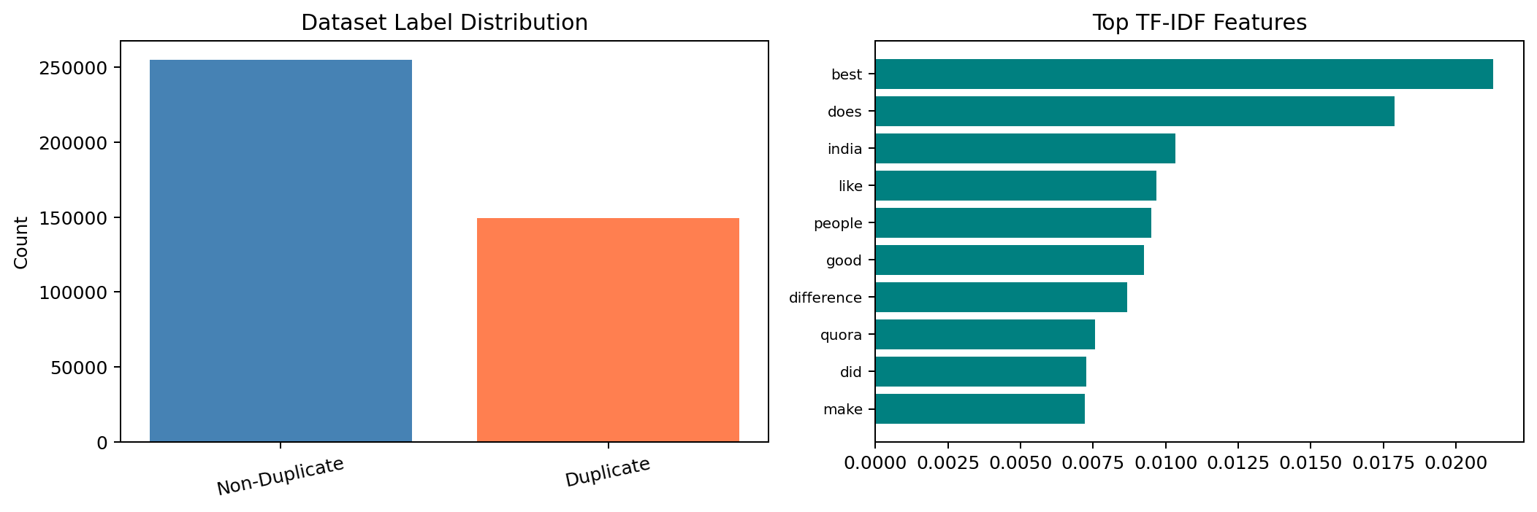
Figure 1. Dataset label distribution and top TF-IDF features.

4. Methodology
- TF-IDF with unigrams and bigrams was used to capture both single-word signals and short phrase context.
- Logistic Regression was used as a fast, interpretable binary classifier.
- Linear SVM was used because it performs well on sparse, high-dimensional text features.

5. Key Results
Logistic Regression achieved 74.16% accuracy and an F1 score of 0.5906. Linear SVM achieved 74.03% accuracy and an F1 score of 0.5866. Logistic Regression is the best-performing model in this Week 2 comparison, but the difference is small.
Model | Accuracy | Precision | Recall | F1 Score
TF-IDF + Logistic Regression | 0.7416 | 0.71 | 0.50 | 0.5906
TF-IDF + Linear SVM | 0.7403 | 0.71 | 0.50 | 0.5866
Both models perform similarly because they use the same TF-IDF representation and linear decision boundaries. The feature space already captures most of the useful signal, so the choice between Logistic Regression and Linear SVM changes the result only marginally. TF-IDF remains effective for lexical matching, however it fails to capture semantic similarity when two questions use different vocabulary.
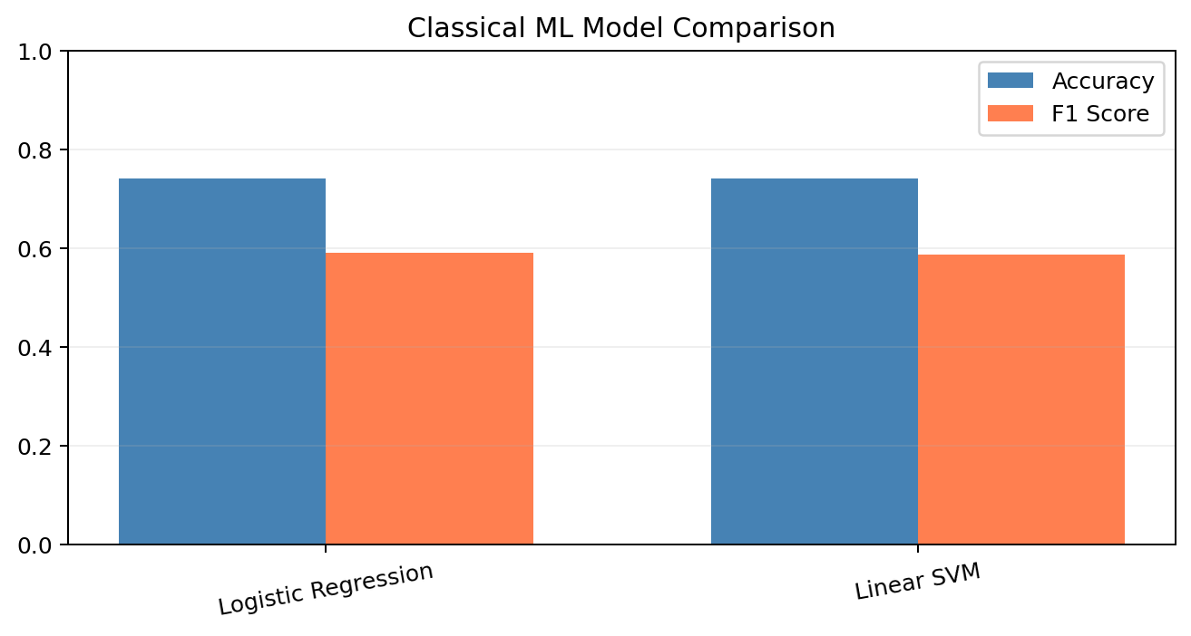
Figure 2. Classical ML model comparison chart.
Embedding baseline note: a Word2Vec prototype was also implemented in the notebook, but Week 2 focused on TF-IDF-based classical models because they produced the strongest and most reliable baseline. Embedding-based methods will be explored further in Week 3.

6. Confusion Matrix
For the best model (Linear SVM), the confusion matrix is: TN = 44,959, FP = 6,046, FN = 14,955, TP = 14,898. True negatives are the largest group, while false negatives remain substantial. This is the primary limitation of the Week 2 approach because it means many true duplicates are still missed.
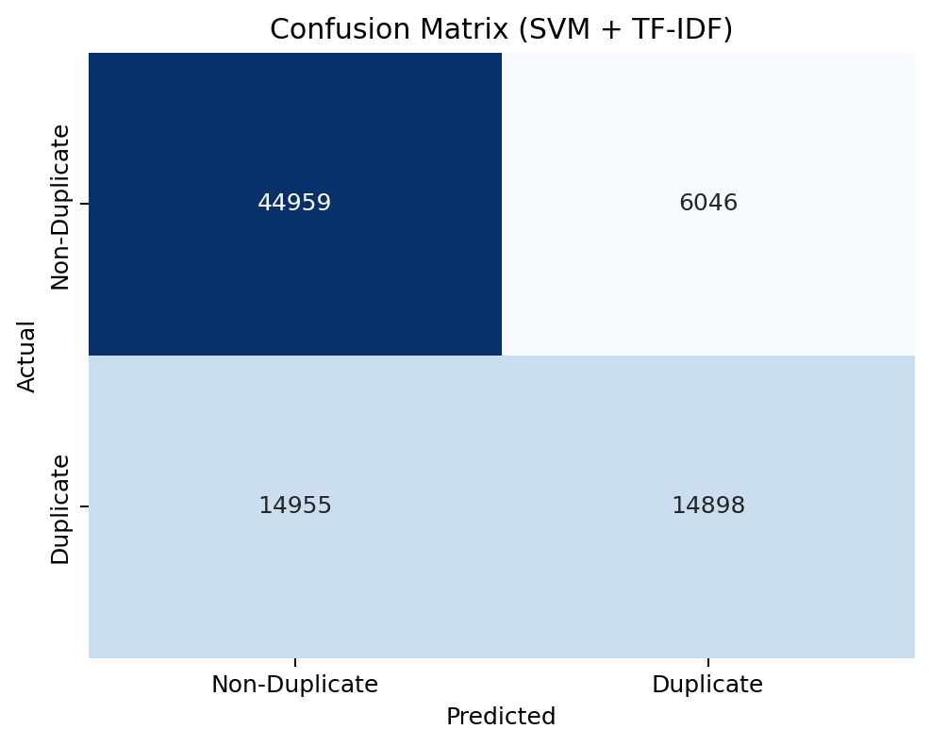
Figure 3. Confusion matrix for the best TF-IDF model (Linear SVM).

7. Error Analysis
Five misclassified examples are shown below. The main failure mode is vocabulary mismatch across paraphrases or shared words with different intent.
Type | Question 1 | Question 2 | Why it failed
False Negative | When will India get fgfa (Fifth Generation Fighter... | Is india developing any 5th generation fighter... | Vocabulary mismatch despite same meaning
False Negative | How can I lose weight quickly in 2 weeks? | What are the best ways to lose a lot of weight as... | Vocabulary mismatch despite same meaning
False Positive | How can I know if I'm brainwashed and how do I stop... | How do I know if I am an introvert or an extrovert? | Shared terms, but different intent
False Negative | How do hackers hack banks? | How can I hack bank? | Vocabulary mismatch despite same meaning
False Negative | Why do I laugh when people get hurt? | Why do we sometimes laugh when we see other people... | Vocabulary mismatch despite same meaning
These errors reflect the semantic limitations of TF-IDF. Questions can be paraphrases even when they share few surface words, and questions can also share vocabulary while asking about different things. This is the key reason classical word-based features struggle to generalize on duplicate-question detection.

8. Key Insights
- TF-IDF provides a strong classical baseline, but it is still limited by surface-level word overlap.
- Logistic Regression slightly outperformed Linear SVM, but the gap is minimal.
- Recall of 0.50 means the model misses a large number of duplicates.
- Word2Vec was prototyped, but TF-IDF remains the stronger Week 2 baseline.
- Transformer models will be needed to capture paraphrase-level meaning more reliably.

9. Conclusion & Week 3 Roadmap
Week 2 delivered a clear classical baseline for duplicate question detection. Logistic Regression is the best-performing model at 74.16% accuracy, with Linear SVM very close behind. The main limitation is semantic generalization, so Week 3 will explore transformer-based models such as DistilBERT and BERT for better paraphrase understanding.

