Quora Duplicate Questions EDA & Baseline Model Report
Project: Quora Duplicate Questions EDA & Baseline Model Student Name: 24CE052, 24CE062, 24CE065

Introduction
This project studies the Quora duplicate questions dataset to understand how question pairs can be separated into duplicate and non-duplicate classes using a compact NLP workflow and a simple classification baseline.
Dataset description: each record contains two user questions (sentence1 and sentence2) and a binary label indicating whether the pair is semantically duplicate.
Objective: perform concise EDA, prepare cleaned text features, and evaluate a baseline logistic regression model built on TF-IDF representations.

Dataset Statistics
Metric | Value | Notes
Rows | 404,290 | Original dataset size
Columns | 3 | sentence1, sentence2, label
Missing values | 0 | No missing values in key fields
Duplicate rows | 0 | Removed during cleaning
Target variable | label | 0 = non-duplicate, 1 = duplicate

Data Cleaning & Preprocessing
  - Null value handling: rows with missing question text were removed before analysis.
  - Duplicate removal: exact duplicate rows were dropped to avoid bias in the baseline model.
  - Text cleaning: questions were lowercased, punctuation was removed, and repeated spaces were collapsed.
  - Tokenization: word-level tokenization was used to inspect common vocabulary and text structure.
  - TF-IDF preprocessing: cleaned text was transformed into sparse TF-IDF vectors with unigram and bigram features.

Exploratory Data Analysis (EDA)
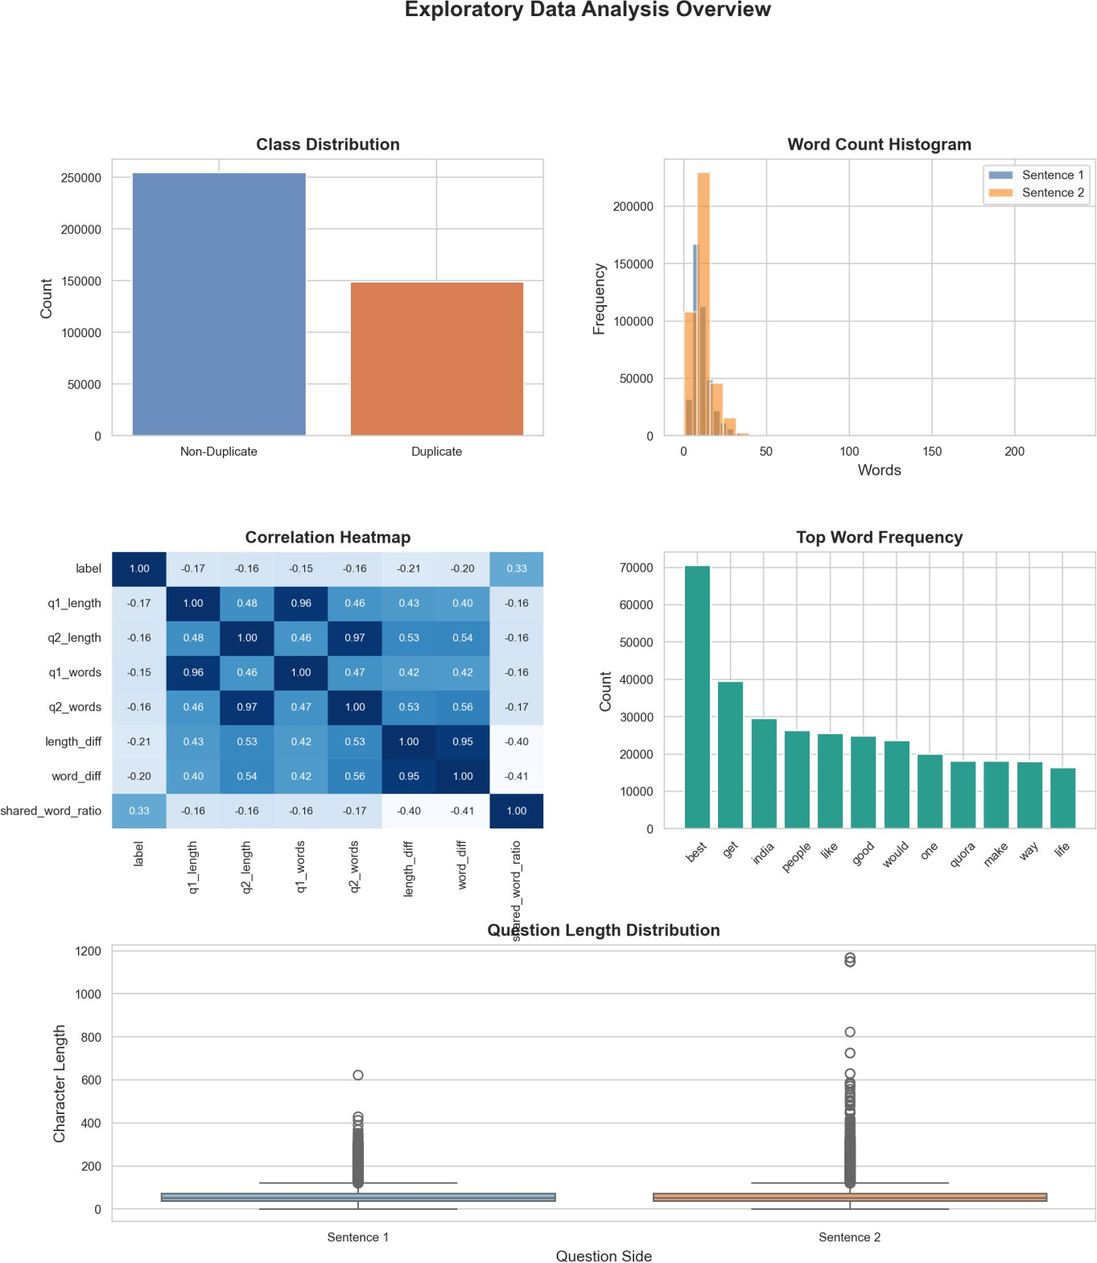

Figure 1. Compact EDA summary across class balance, length patterns, frequency patterns, and correlation structure.
  - Class balance is moderate, but the duplicate class remains slightly less common than the non-duplicate class.
  - Question lengths vary widely, which supports the use of length-based and sparse text features.
  - Correlation is strongest among the derived length features; the raw target has only weak linear relationships with text length.
  - Common words are dominated by generic question terms, so stopword removal is important before feature extraction.
  - Length distributions for the two question sides are similar, suggesting that pairwise text similarity is more useful than a single question-length rule.

Feature Engineering / NLP
  - TF-IDF vectorization converts cleaned text into weighted sparse features that capture informative terms while down-weighting common words.
  - Tokenization helps inspect the question vocabulary and supports a clearer text-cleaning workflow.
  - Feature extraction combines both questions in each pair, allowing the model to learn patterns from each side of the duplicate relationship.

Machine Learning Model
  - Model used: Logistic Regression on TF-IDF features.
  - Reason selected: a strong and interpretable baseline for sparse text classification.
  - Train-test split: 80% training and 20% testing, with stratification to preserve class balance.

Model Evaluation
Model | Accuracy | Precision | Recall | F1
TF-IDF + Logistic Regression | 0.7425 | 0.7130 | 0.5064 | 0.5922
The TF-IDF + Logistic Regression model achieved good baseline performance for duplicate question detection and effectively captured textual similarity patterns.
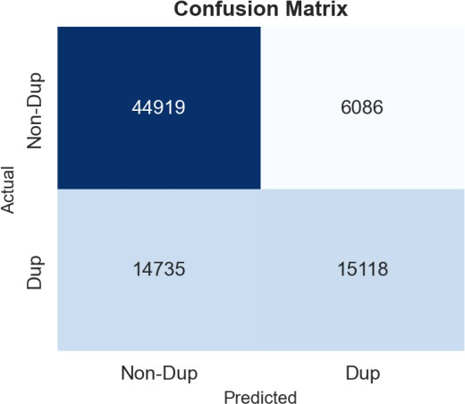

Figure 2. Confusion matrix for the logistic regression baseline.

Key Observations
  - Duplicate questions often share similar vocabulary and comparable length patterns.
  - Text cleaning and stopword removal are essential because generic question words appear very frequently.
  - Derived features such as length difference and shared-word ratio add useful signal beyond raw text length alone.
  - The confusion matrix indicates borderline semantic pairs remain the primary error source.

Conclusion
This project performed EDA and NLP classification on the Quora Duplicate Questions dataset (404,290 pairs). After text cleaning, tokenization, and TF-IDF vectorization, a Logistic Regression model achieved 74.25% accuracy and F1 Score of 0.59 on duplicate detection. The analysis revealed moderate class imbalance, clean data quality, and a clear length difference between duplicate and non-duplicate pairs. The model performs well on non-duplicates but struggles with paraphrased questions that share meaning but differ in vocabulary. Future work should explore Sentence-BERT or transformer-based models to improve semantic understanding and duplicate recall.

