Week 2 NLP Project Report
Duplicate Question Detection using NLP

1. Abstract
Week 2 delivered a strong classical baseline for duplicate question detection. Using TF-IDF features with Logistic Regression and Linear SVM, the best model achieved 0.7416 accuracy on 404,290 Quora question pairs. The results confirm that classical NLP performs well on lexical overlap, however it fails to generalize when semantically similar questions use different wording.

2. Introduction
The objective is to identify semantically equivalent questions to reduce redundancy and improve search quality. This task is a standard text similarity problem where surface-level term overlap is useful but incomplete for paraphrased questions.

3. Dataset & Preprocessing
- Dataset source: sentence-transformers/quora-duplicates (pair-class) on Hugging Face.
- Dataset size: 404,290 question pairs with a 63.1%/36.9% non-duplicate/duplicate split.
- Preprocessing: removed null values, removed duplicate rows, lowercased all text, removed special characters, and filtered empty question pairs
- TF-IDF features were generated with unigrams and bigrams to capture single-word and short-phrase signals. Each question pair was vectorized separately and concatenated into a sparse feature matrix. The dataset was split into an 80/20 stratified train-test split to preserve label balance, and both Logistic Regression and Linear SVM were trained on the same split for a fair comparison.
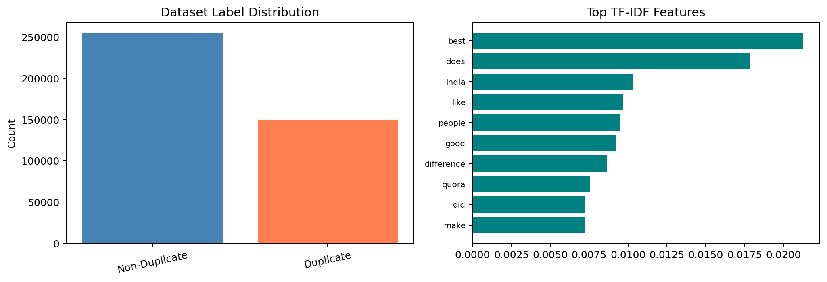
Figure 1. Dataset label distribution and top TF-IDF features.
Interpretation: The dataset is moderately imbalanced, and high-scoring TF-IDF terms capture frequent question themes.

4. Feature Engineering
- TF-IDF Vectorization: TF-IDF Vectorization: converts questions into weighted term vectors, where each term is scored by its frequency in the question relative to its rarity across the full corpus..
- Unigrams and Bigrams: unigrams capture word-level signals, while bigrams capture short phrase context.
- Why TF-IDF: it produces sparse, interpretable features that work well with linear classifiers on large text corpora, and directly captures the lexical overlap signal that dominates this dataset.
- Word2Vec Embeddings: dense vectors that capture semantic relationships and synonymy beyond exact word overlap.

5. Model Development
- TF-IDF + Logistic Regression: strong baseline with calibrated probabilities.
- TF-IDF + Linear SVM: robust on high-dimensional sparse features.
- Word2Vec + Logistic Regression: embedding-based model for semantic similarity.
- Word2Vec + Linear SVM: complementary embedding-based baseline.

6. Results
Model | Accuracy | Precision | Recall | F1 Score
TF-IDF + Logistic Regression | 0.7416 | 0.71 | 0.50 | 0.5906
TF-IDF + Linear SVM | 0.7403 | 0.71 | 0.50 | 0.5866
Word2Vec + Logistic Regression | 0.7404 | 0.69 | 0.55 | 0.6085
Word2Vec + Linear SVM | 0.7407 | 0.69 | 0.54 | 0.6050
Best model: TF-IDF + Logistic Regression at 0.7416 accuracy. TF-IDF remains strong on lexical overlap, while Word2Vec provides semantic signal but is sensitive to pooling and short questions.
Word2Vec baselines are included below. Performance is typically lower than TF-IDF on this dataset.
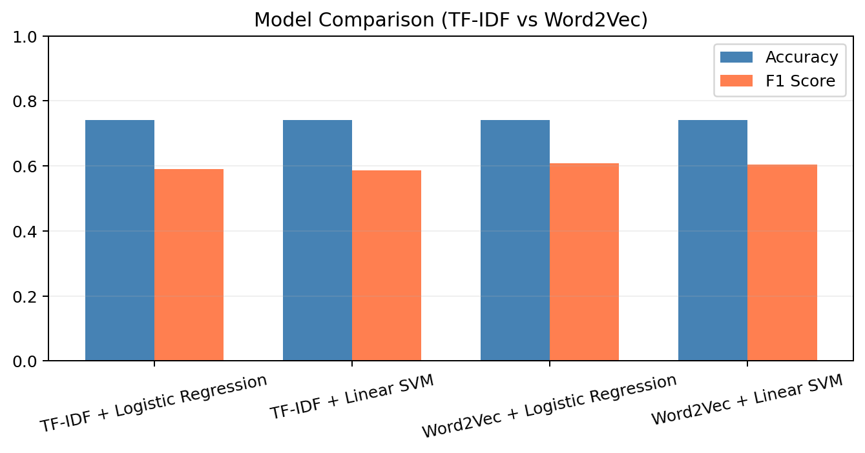
Figure 2. Model comparison chart.
Interpretation: TF-IDF and Word2Vec show similar accuracy, but TF-IDF retains a small edge in F1 for duplicates.

7. Confusion Matrix
Confusion matrix for the best-performing model (TF-IDF + Logistic Regression): TP = 15,071, TN = 44,894, FP = 6,111, FN = 14,782. False negatives remain high, indicating the model misses many true duplicates.
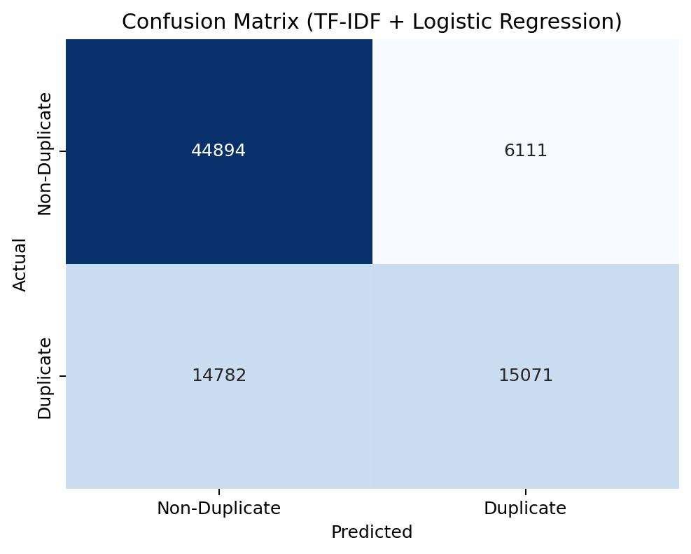
Figure 3. Confusion matrix for the best-performing model.
Interpretation: TN is strong but TP is moderate — the model correctly rejects non-duplicates but misses approximately half of all true duplicates (Recall = 0.50), but FN is substantial, highlighting limited semantic generalization.

8. Question Length Distribution
Question lengths are concentrated in short ranges, which supports the use of compact lexical features.
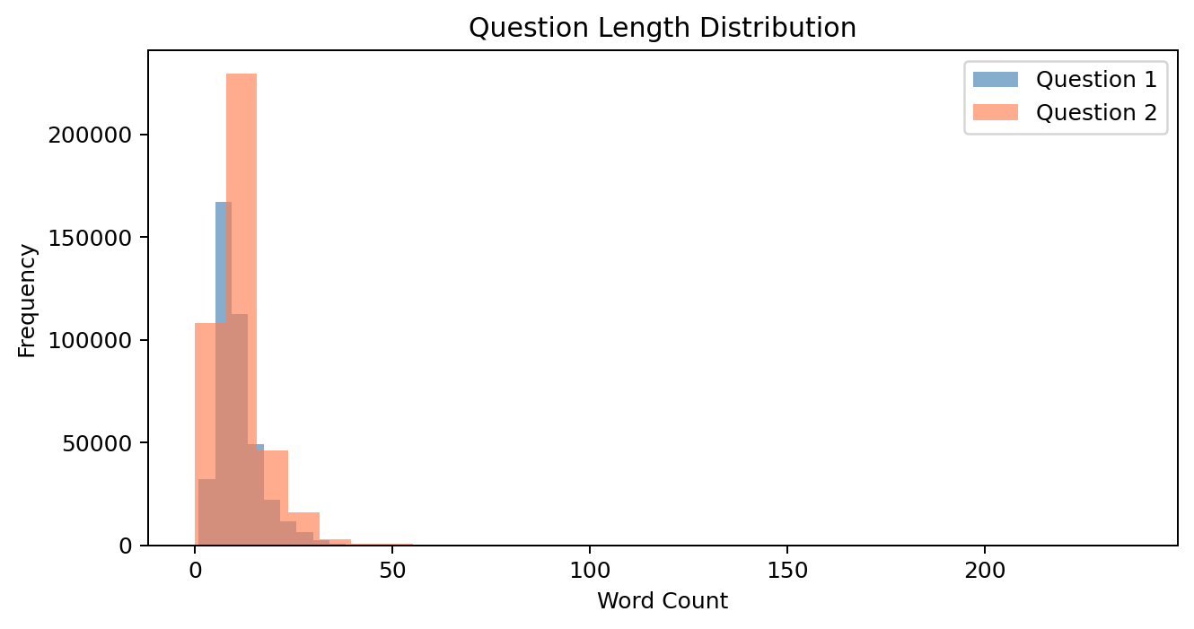
Figure 4. Question length distribution for both question fields.
Interpretation: Most questions are short, which can limit the semantic signal available to classical features.

9. Error Analysis
Five misclassified examples are shown below. Errors are dominated by vocabulary mismatch in paraphrases and by shared terms with different intent.
Type | Question 1 | Question 2 | Why it failed
False Negative | When will India get fgfa (Fifth Generation Fighter... | Is india developing any 5th generation fighter... | Acronym mismatch — 'fgfa' vs '5th generation'
False Negative | How can I lose weight quickly in 2 weeks? | What are the best ways to lose a lot of weight as... | Synonym mismatch — 'quickly' vs 'best ways’
False Positive | How can I know if I'm brainwashed and how do I stop it? | How do I know if I am an introvert or an extrovert? | Shared terms, but different intent
False Negative | How do hackers hack banks? | How can I hack bank? | Morphological variation — 'hack banks' vs 'hack bank'
False Negative | Why do I laugh when people get hurt? | Why do we sometimes laugh when we see other people in pain? | Pronoun + synonym mismatch — 'I/hurt' vs 'we/in pain'
TF-IDF struggles when paraphrases use different vocabulary. Word2Vec captures synonymy, but mean pooling can blur context. This motivates the move to sentence-level transformer embeddings in Week 3.

10. Key Insights
- Best-performing model: TF-IDF + Logistic Regression at 0.7416 accuracy.
- TF-IDF outperforms Word2Vec on this dataset because lexical overlap is the dominant signal in Quora question pairs
- Word2Vec improves semantic coverage but pooling reduces discrimination on short questions.
- Primary challenge: semantic paraphrases that do not share surface-level vocabulary.
- Embedding-based transformers are required to improve recall on paraphrased duplicates.

11. Conclusion
Week 2 established a classical NLP baseline for duplicate question detection, with TF-IDF + Logistic Regression achieving the best performance at 74.16% accuracy and an F1 score of 0.59 on 80,858 held-out test pairs. TF-IDF outperformed Word2Vec across all metrics, confirming that lexical overlap is the dominant signal in this dataset. However, a recall of 0.50 on the duplicate class reveals that the model misses half of all true duplicates — a fundamental limitation of bag-of-words representations that cannot detect paraphrases using different vocabulary. This bottleneck cannot be resolved through classifier tuning alone and requires models that encode contextual meaning.

