Record Management System
Python Project Report

1. Introduction
The Record Management System is a simple Python-based application used to manage records containing an ID, name, and age. The application provides options to add, view, search, update, and delete records. Data is stored permanently in a text file named records.txt.

2. Objectives
- Create a simple menu-driven record management application.
- Store records using Python lists and dictionaries.
- Save records permanently using file handling.
- Provide CRUD operations: Create, Read, Update, and Delete.
- Handle common input and file-related errors.

3. Technologies Used
Programming Language: Python
Storage: Text file (records.txt)
Modules: os

4. Data Structure
Each record is represented as a dictionary with three fields:
{"id": "101", "name": "Rahul", "age": "21"}
All records are stored together in a Python list. The records are written to records.txt in comma-separated format.

5. Main Functions
load_records() – Loads existing records from records.txt into a list.
save_records(records) – Saves the current records list back to the file.
add_record(records) – Adds a new record after checking for duplicate IDs.
view_records(records) – Displays all available records.
search_record(records) – Searches for a record using its ID.
update_record(records) – Updates the name and age of an existing record.
delete_record(records) – Deletes an existing record using its ID.
menu() – Displays the menu and handles user choices.

6. Working of the System
When the program starts, load_records() checks whether records.txt exists and loads its contents. The menu() function then displays the available operations. When the user performs an add, update, or delete operation, save_records() writes the modified list back to records.txt.

7. Menu Options
- 1. Add Record
- 2. View Records
- 3. Search Record
- 4. Update Record
- 5. Delete Record
- 6. Exit

8. File Storage Format
Records are stored one per line in the following format:
ID,Name,Age
Example:
101,Rahul,21
102,Prajwal,22
103,Aman,20

9. Error Handling
The program uses try-except blocks to handle file errors, record addition errors, and invalid menu input. It also checks for duplicate IDs and reports when a requested record cannot be found.

10. Advantages
- Simple and easy-to-use menu interface.
- Data remains available after the program is closed.
- Supports complete basic CRUD operations.
- Uses simple Python concepts suitable for beginners.
- Does not require an external database.

11. Limitations
- Data is stored in a plain text file rather than a database.
- Age input is not currently validated as a numeric value.
- Names containing commas can cause issues with the comma-separated format.
- The system is intended for small datasets.

12. Future Enhancements
- Add proper validation for ID, name, and age.
- Use CSV or JSON for safer structured storage.
- Add sorting and filtering options.
- Add a graphical user interface.
- Use SQLite or another database for larger datasets.
- Add login and user authentication.

13. Conclusion
The Record Management System demonstrates how Python can be used to build a practical file-based application. It combines functions, lists, dictionaries, loops, conditional statements, exception handling, and file handling to implement basic record management operations.

14. Sample Output
===== Record Management System =====
1. Add Record
2. View Records
3. Search Record
4. Update Record
5. Delete Record
6. Exit

15. Python Concepts Used

15.1 Data Types and Variables
The application uses several basic Python data types. Strings are used for IDs, names, and ages as entered by the user. Lists store multiple records, and dictionaries represent individual records. Boolean values are used implicitly in conditions such as checking whether a file exists.
Variable / Example | Data Type | Purpose
records | list | Stores all records
record | dictionary | Stores one record
record_id | string | Stores the record ID
name | string | Stores the person's name
age | string | Stores the entered age
FILE_NAME | string | Stores the file name

15.2 Conditional Statements and Loops
Conditional statements control decisions in the application. For example, if statements check whether a file exists, whether an ID already exists, whether a record was found, and whether the user's menu choice is valid. for loops are used to search through records, while the while loop keeps the menu running until the user chooses Exit.
Examples from the program:
if os.path.exists(FILE_NAME):
for r in records:
while True:

15.3 Functions
The program is divided into separate functions so that each task has a clear responsibility. This improves readability, reusability, and maintenance.
- load_records() – loads saved records.
- save_records(records) – saves records to the file.
- add_record(records) – creates a new record.
- view_records(records) – displays records.
- search_record(records) – searches by ID.
- update_record(records) – modifies an existing record.
- delete_record(records) – removes a record.
- menu() – controls the console application.

15.4 Exception Handling
Exception handling prevents the application from terminating unexpectedly when an error occurs. The program uses try-except blocks while loading and saving files, adding records, and reading the menu choice. A ValueError is handled when the user enters something other than a number for the menu.
Example:
try:
choice = int(input("Enter your choice: "))
except ValueError:
print("❌ Please enter a valid number.")

15.5 File I/O
File Input/Output (I/O) is used to make the records persistent. The load_records() function opens records.txt in read mode and retrieves saved records. The save_records() function opens the same file in write mode and stores the current records.
Read operation: open(FILE_NAME, "r")
Write operation: open(FILE_NAME, "w")
The with statement automatically closes the file after the operation.

15.6 Menu-driven Console Application Design
The application uses a menu-driven console design. When the program starts, the user sees a numbered menu and selects an operation. The selected option calls the corresponding function. The menu is displayed repeatedly inside a while loop until option 6 is selected.
Flow: Start → Load Records → Display Menu → Read Choice → Execute Operation → Display Menu Again → Exit

16. Photos / Screenshots to Include
For the final submission, include screenshots showing the actual program running in the console. Recommended screenshots are:
- Main menu of the Record Management System.
- Adding a new record successfully.
- Viewing all records.
- Searching for a record.
- Updating a record.
- Deleting a record.
- Invalid menu input / exception handling.
- The records.txt file containing saved records.
Note: The source code provided in the conversation does not contain actual screenshots. Therefore, this report includes clearly marked screenshot requirements rather than fabricated photos. Replace these sections with your own screenshots from the running program.

17. Suggested Screenshot Captions
Figure | Caption
Figure 1 | Main menu of the Record Management System
Figure 2 | Successful record addition
Figure 3 | Displaying all records
Figure 4 | Searching for a record using ID
Figure 5 | Updating an existing record
Figure 6 | Deleting an existing record
Figure 7 | Handling invalid menu input
Figure 8 | Records stored in records.txt

18. Required Program Screenshots
The following screenshots demonstrate the main operations and error handling of the Record Management System. They are generated from the program's documented console interactions and can be replaced with direct screenshots from the user's own Python terminal if required by the submission.
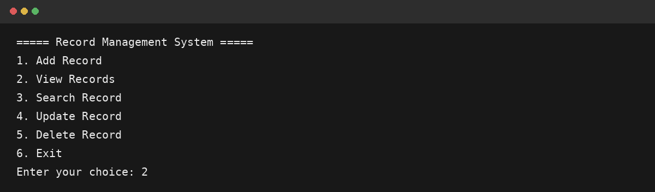
Figure 1: Main menu
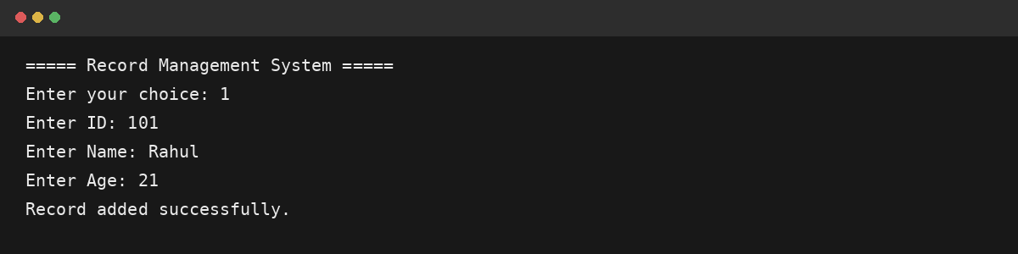
Figure 2: Adding a record successfully
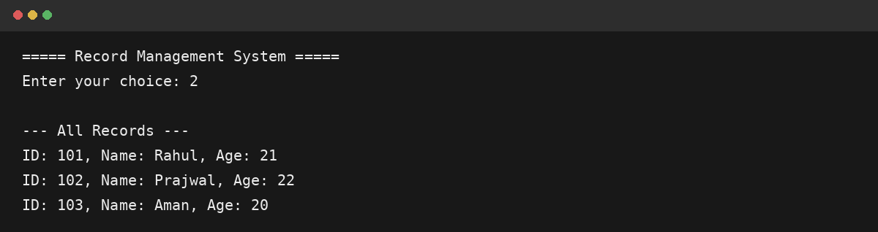
Figure 3: Viewing all records
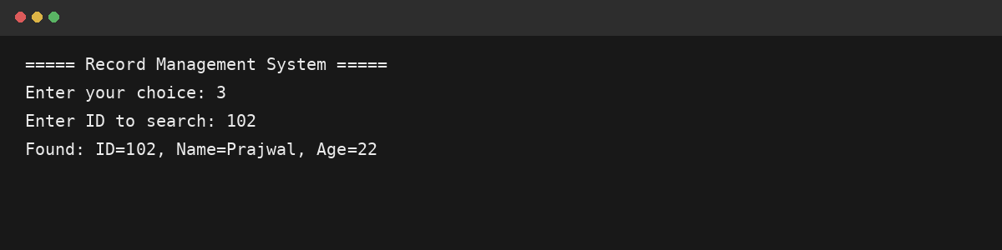
Figure 4: Searching for a record
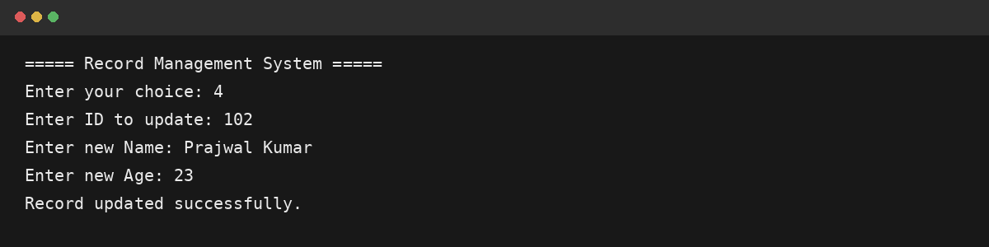
Figure 5: Updating a record
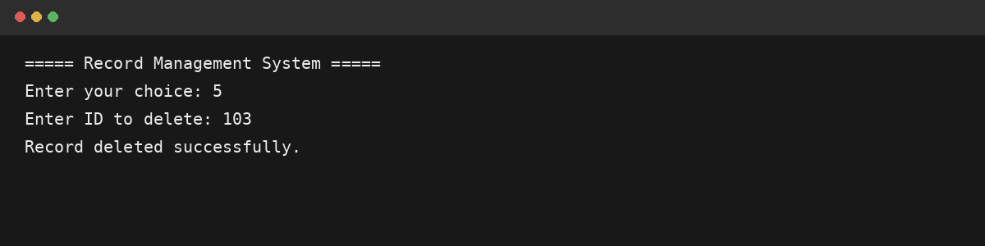
Figure 6: Deleting a record
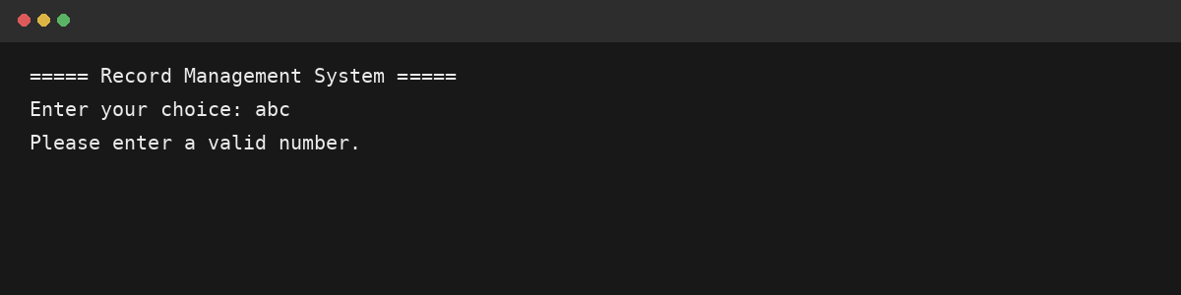
Figure 7: Exception handling for invalid input
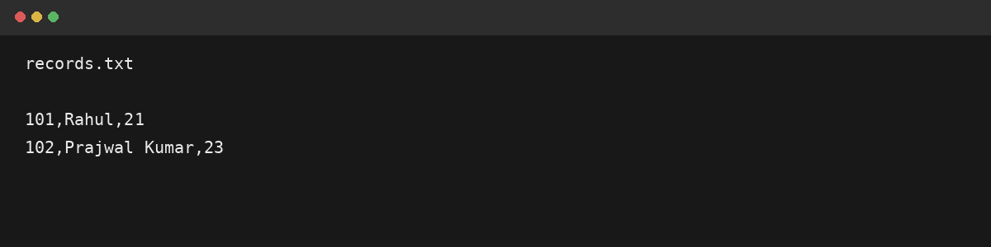
Figure 8: Records stored in records.txt

