Group: Project 12

Member: Leo Puso

I work in manufacturing, and we currently use Microsoft Excel to record downtime. Each department will document their own data. Some will share one file while others have their own. All these excel files are saved in the network drive. This introduces quite a few problems. If the file is accidently deleted, all the data is lost; there is a backup, but it will not be current. Occasionally, if one person has the file open, someone else cannot access that same file. So, I believe a database would be better suited for this type of data acquisition tasks.

Here are the documentation for the proposed solution:

**EER Diagram**

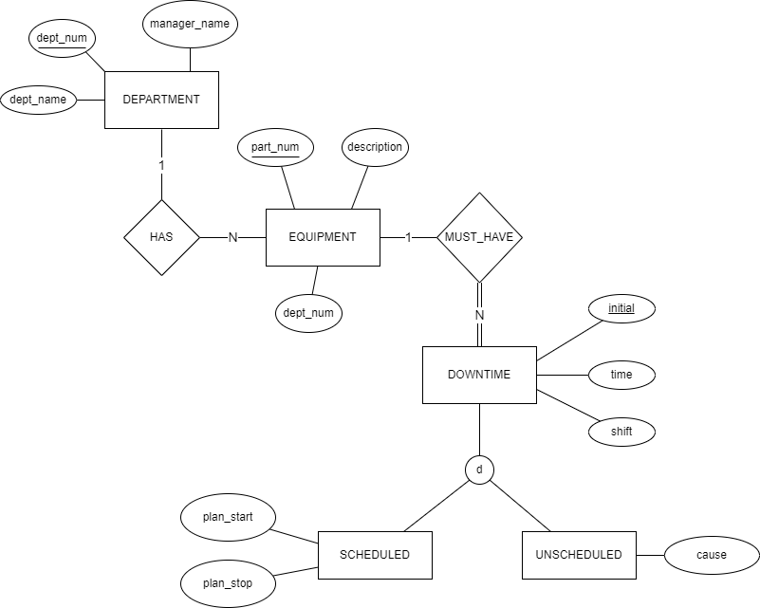

**Relational Diagram**

DOWNTIME

|  |  |  |  |  |  |  |  |
| --- | --- | --- | --- | --- | --- | --- | --- |
| initial | time | shift | downtime_type | plan_start | plan_stop | cause | equipment_num |

EQUIPMENT

|  |  |  |  |
| --- | --- | --- | --- |
| part_num | description | dept_name | dept_num |

DEPARTMENT

|  |  |  |
| --- | --- | --- |
| dept_name | dept_num | manager_name |

**SQL Statements:**

/**** MySQL 5.7.37 ****/

create table DEPARTMENT

(dept_num int not null,

dept_name varchar(10),

manager_name varchar(30),

primary key(dept_num)

);

create table EQUIPMENT

(part_num int not null,

description varchar(30),

dept_num int,

primary key(part_num),

foreign key(dept_num) references DEPARTMENT(dept_num)

);

create table DOWNTIME

(initial char(3) not null,

time int,

shift varchar(5),

equipment_num int,

downtime_type enum('Scheduled', 'Unscheduled'),

-- no downtime, make downtime_type null

-- if downtime_type is null make plan_start/stop and cause into null

plan_start time,

plan_stop time,

cause varchar(30),

primary key(initial),

foreign key(equipment_num) references EQUIPMENT(part_num);