Architecture Design

# Deloitte Case Study

|  |  |
| --- | --- |
| **Written By** | Author 1, Author 2 |
| **Document Version** | 0.3 |
| **Last Revised Date** |  |

**DOCUMENT CONTROL**

## Change Record:

|  |  |  |  |
| --- | --- | --- | --- |
| **VERSION** | **DATE** | **AUTHOR** | **COMMENTS** |
| 0.1 | 20- April-  2024 | Author 1 | Introduction and architecture defined |
| 0.2 | 20- April -  2024 | Author 2 | Architecture & Architecture description appended and  updated. |
|  |  |  |  |
|  |  |  |  |

**Reviews:**

|  |  |  |  |
| --- | --- | --- | --- |
| **VERSION** | **DATE** | **REVIEWER** | **COMMENTS** |
| 0.2 | 22- April -  2021 | Author 2 | Unit test cases to be added |

**Approval Status:**

|  |  |  |  |  |  |
| --- | --- | --- | --- | --- | --- |
| **VERSION** | **REVIEW**  **DATE** | **REVIEWED BY** |  | **APPROVED BY** | **COMMENTS** |
|  |  |  |  |  |  |

**Contents**

1. Introduction 04
   1. What is Architecture Design Document? 04
   2. Scope 04
2. Architecture 05
   1. Power BI Architecture 05
   2. Power BI Server Architecture 05
   3. Gateway/Load Balancer 06
   4. Application Server 06
   5. VIZQL Server 07
   6. Data Engine 07
   7. Backgrounder 07
   8. Data Server 07
   9. Power BI Communication Flow 07
3. Deployment 08
   1. Deployment Options in Tableau 09
   2. Single Node Architecture 10
   3. Three Node Architecture 11
   4. Five Node Architecture 12

# Introduction

## What is Architecture design document?

Any software needs the architectural design to represents the design of software. IEEE defines architectural design as “the process of defining a collection of hardware and software components and their interfaces to establish the framework for the development of a computer system.” The software that is built for computer-based systems can exhibit one of these many architectures.

Each style will describe a system category that consists of :

* A set of components (eg: a database, computational modules) that will perform a function required by the system.
* The set of connectors will help in coordination, communication, and cooperation between the components.
* Conditions that how components can be integrated to form the system.
* Semantic models that help the designer to understand the overall properties of the system.

## Scope

Architecture Design Document (ADD) is an architecture design process that follows a step-by-step refinement process. The process can be used for designing data structures, required software architecture, source code and ultimately, performance algorithms. Overall, the design principles may be defined during requirement analysis and then refined during architectural design work.

# Architecture

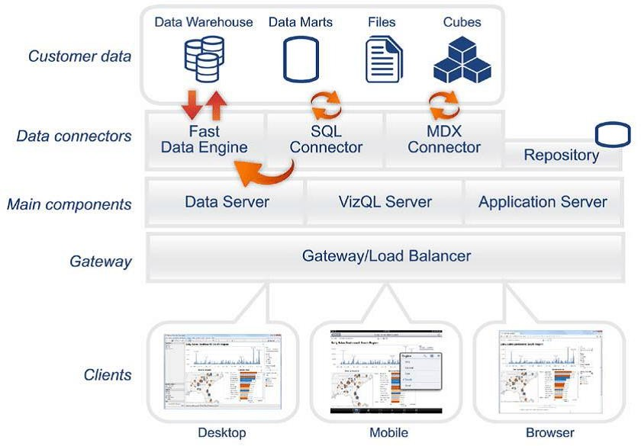

**Power BI Server Architecture**

Tableau has a highly scalable, n-tier client-server architecture that serves mobile clients, web clients and desktop-installed software. Tableau Server architecture supports fast and flexible deployments.

### Shape Description automatically generated with low confidenceARCHITECTURE DESIGN

**6**

The following diagram shows Power BI Server’s architecture:

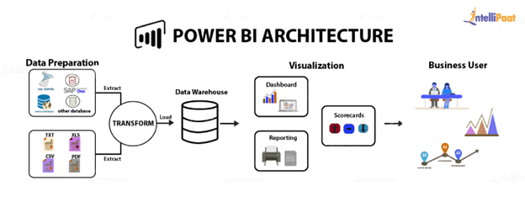

**1. Gateway/Load Balancer**

It acts as an Entry gate to the Tableau Server and also balances the load to the Server if multiple Processes are configured.

**2) Application Server:-**

Application Server processes (wgserver.exe) handle browsing and permissions for the Power BI Server web and mobile interfaces. When a user opens a view in a client device, that user starts a session on Tableau Server. This means that an Application Server thread starts and checks the permissions for that user and that view.

1. **Repository:-**

Power BI Server Repository is a PostgreSQL database that stores server data. This data includes information about Power BI Server users, groups and group assignments, permissions, projects, data sources, and extract metadata and refresh information.

1. **VIZQL Server:-**

Once a view is opened, the client sends a request to the VizQL process (vizqlserver.exe). The VizQL process then sends queries directly to the data source, returning a result set that is rendered as images and presented to the user. Each VizQL Server has its own cache that can be shared across multiple users

1. **Data Engine:-**

It Stores data extracts and answers queries.

1. **Backgrounder:-**

The backgrounder Executes server tasks which includes refreshes scheduled extracts, tasks initiated from tabcmd and manages other background tasks.

1. **Data Server:-**

Data Server Manages connections to Power BI Server data sources

It also maintains metadata from Power BI Desktop, such as calculations, definitions, and groups.

## 8) Power BI Communication Flow

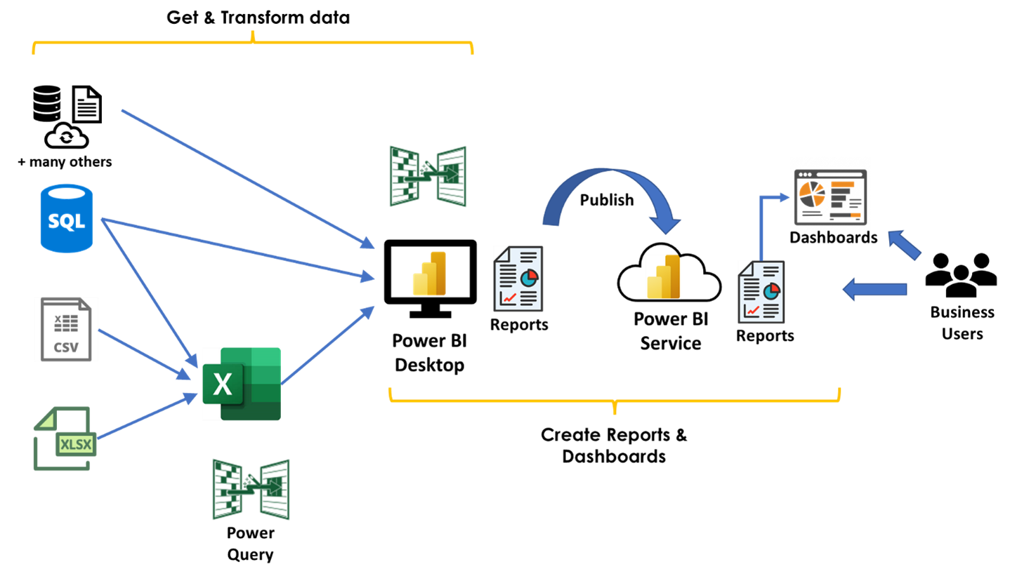

1. **Deployment Description**

## Deployment options in Power BI

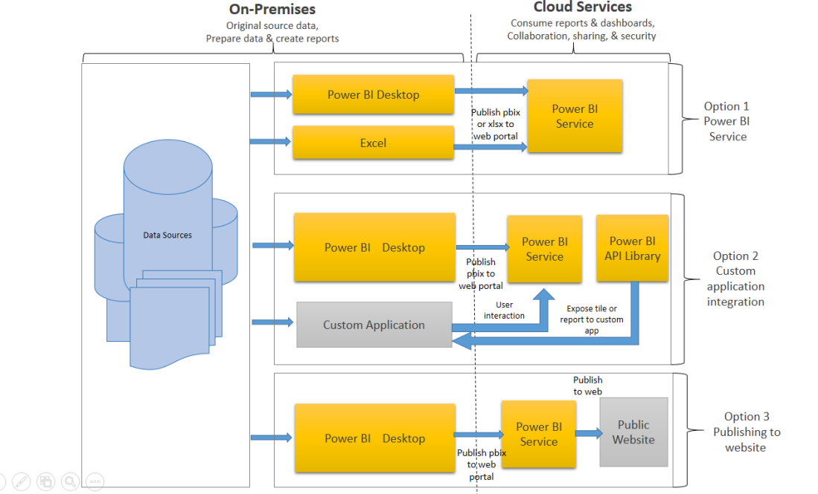

In Power BI, there are several deployment options available depending on your needs. Here are the main deployment options:

1. **Power BI Service**:
   * **Cloud-based**: The Power BI Service is a cloud-based platform where you can publish, share, and collaborate on reports and dashboards.
   * **Web-based Access**: Accessible through a web browser, you can view, edit, and manage your reports and dashboards online.
   * **Power BI Pro**: Offers collaboration and sharing features, including content creation and collaboration.
2. **Power BI Report Server**:
   * **On-Premises**: Power BI Report Server is an on-premises solution for reporting and business intelligence.
   * **Hybrid Deployment**: You can use a combination of cloud-based Power BI Service and on-premises Power BI Report Server to create a hybrid deployment.
3. **Embedded Analytics**:
   * **Embed Reports**: Allows you to embed Power BI reports and dashboards into custom applications, websites, or portals.
   * **Power BI Embedded**: Provides API-based access to integrate Power BI capabilities directly into applications for a seamless user experience.
4. **Publish to Web**:
   * **Public Sharing**: You can publish reports and dashboards to the web to share them publicly. This option is best for non-sensitive data as it makes the content accessible to anyone with the link.
5. **Export Options**:
   * **Export to PDF**: You can export individual reports or dashboards to PDF format for sharing or printing.
   * **Export to PowerPoint**: You can export reports to PowerPoint format, maintaining the layout and visualizations for presentations.

When deploying your Power BI solutions, consider factors such as data sensitivity, collaboration needs, and accessibility requirements to choose the right deployment option for your organization.

## Single Node Architecture

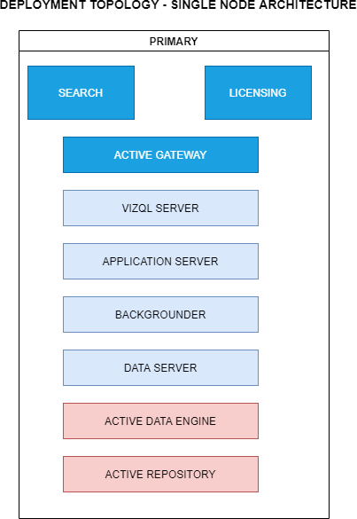

This architecture is a single node architecture. This is the most simple deployment topology.

## 3 Node Architecture

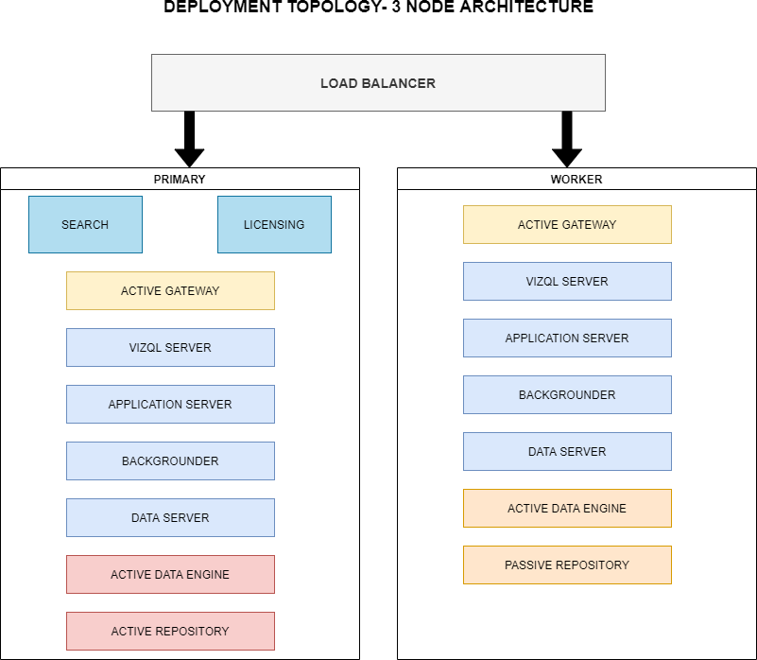

This architecture is a 3 Node Architecture which is more capable to handle concurrent requests.

If we need failover or high availability, or want a second instance of the repository, we must install Power BI Server on a cluster of at least three computers. In a cluster that includes at least three nodes, you can configure two instances of the repository, which gives our cluster failover capability.

## 5 Node Architecture

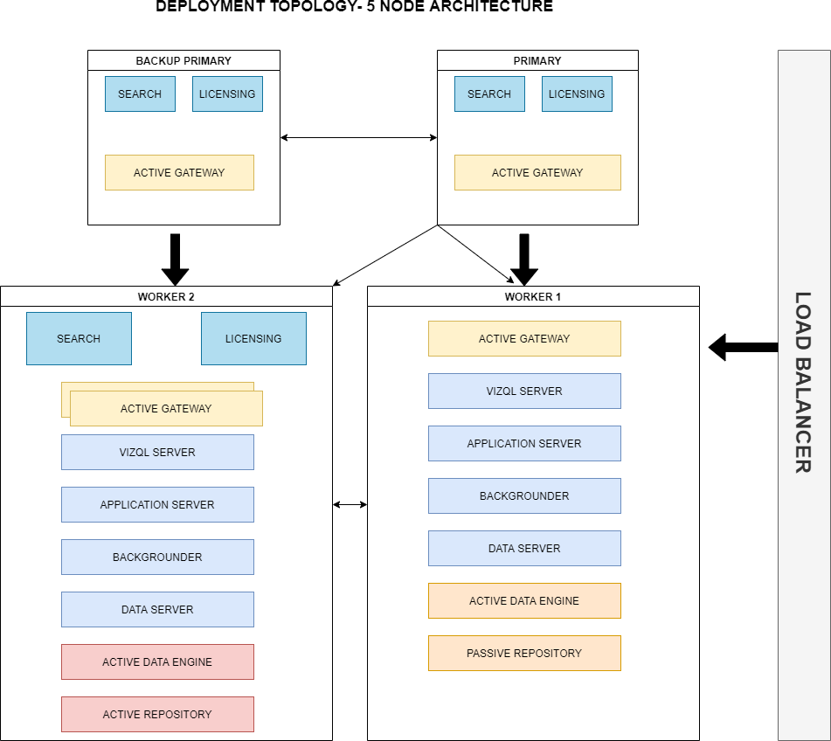

When we install Power BI Server on a Five-node cluster, we can install server processes on one or both nodes. A five-node cluster can improve the performance of Power BI Server, because the work is spread across multiple machines.

Note the following about five-node clusters:

* + - A five-node cluster does not provide failover or support for high availability.
    - You can't install more than one instance of the repository on a two-node cluster, and the repository must be on the initial node.