GHARVADA

A Summer Internship Report submitted in partial fulfillment of the requirements for the award of degree of

BACHELOR OF TECHNOLOGY
In
COMPUTER SCIENCE AND ENGINEERING

Submitted
by

PUSPENDRA BIRAJEE
22A91A05J7



DEPARTMENT OF COMPUTER SCIENCE AND ENGINEERING
ADITYA UNIVERSITY
(Formerly Aditya Engineering College (A))
2025-2026


DEPARTMENT OF COMPUTER SCIENCE AND ENGINEERING

CERTIFICATE

This is to certify that the Internship report entitled “GHARVADA” is being submitted by PUSPENDRA BIRAJEE (22A91A05J7) in partial fulfillment of the requirements for award of the B.Tech., degree in COMPUTER SCIENCE AND ENGINEERING for the academic year 2025-20256.

Internship Coordinator Head of the Department
Dr. Jalaiah Saikam, _{M.Tech., Ph.D.} Dr. T. Sudha Rani, _{M.Tech., Ph.D.}
Assistant professor, Assistant Professor,
Department of CSE Department of CSE

DECLARATION

I hereby declare that the internship report entitled “GHARVADA” is a genuine report. This work has been submitted to the ADITYA UNIVERSITY, Surampalem, in partial fulfillment of the B.Tech., degree. I further declare that this report has not been submitted in full or part of the award of any degree of this or any other educational institutions.

by

PUSPENDRA BIRAJEE
(22A91A05J7)

Internship Completion Certificate

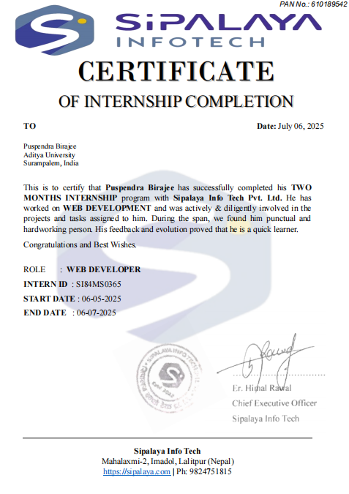

ACKNOWLEDGEMENT

First, I would like to thank the Director of Organization SIPALAYA INFO TECH PVT. LTD., KATHMANDU for giving me the opportunity to do an internship within the organization. I also would like all the people that worked with me in SIPALAYA INFO TECH PVT. LTD., KATHMANDU with their patience and openness they created an enjoyable working environment.
It is with immense pleasure that we would like to express my indebted gratitude to our internship coordinator Dr. Jalaiah Saikam, Assistant Professor in CSE who has guided us a lot and encouraged us in every step of the intern project work, his valuable moral support and guidance throughout the Intern project helped us to a greater extent.
I am grateful to Dr. T. Sudha Rani, Assistant Professor and HOD for inspiring us all the way and for arranging all the facilities and resources needed for my intern project work.
I wish to thank our Dr. M.V. Rajesh, Associate Dean for his encouragement and support during the course of my intern project work.

I would like to extend my sincere thanks to Dr. G. Suresh, Registrar; Dr. A. Ramesh, Pro Vice-Chancellor, E&S; Dr. S. Rama Sree, Pro Vice-Chancellor, Academics; Dr. M.B. Srinivas, Vice-Chancellor, Dr. M. Sreenivasa Reddy, Deputy Pro Chancellor and Management, Aditya University for unconditional support for providing me the best infrastructural facilities and state of the art laboratories during my intern project work.
Not to forget, Faculty, Lab Technicians, Non-Teaching Staff and our Friends who have directly or helped and supported us in completing my intern project work in time.

ABSTRACT

GharVada is a digital platform designed to facilitate affordable and flexible housing solutions across Nepal. By connecting property owners with potential tenants, it aims to streamline the rental process, offering a range of listings from furnished rooms to entire homes. Each listing provides detailed information, including pricing, location, and amenities such as electricity, water, and Wi-Fi. This approach empowers individuals to find accommodations that suit their needs and budgets, promoting accessibility and convenience in the housing market.The platform also allows property owners to list their available spaces, contributing to a dynamic and transparent rental ecosystem. With its user-friendly interface and comprehensive listings, GharVada is poised to become a valuable resource for both renters and property owners in Nepal.For more information or to explore available listings, visit GharVada.

Learning Objectives/Internship Objectives

- Internships are generally thought of to be reserved for college students looking to gain experience in a particular field. However, a wide array of people can benefit from Training Internships in order to receive real world experience and develop their skills.
- An objective for this position should emphasize the skills you already possess in the area and your interest in learning more.
- Internships are utilized in a number of different career fields, including architecture, engineering, healthcare, economics, advertising and many more.
- Some internships are used to allow individuals topper form scientific research while others are specifically designed to allow people to gain first-hand experience working.
- Utilizing internships is a great way to build your resume and develop skills that can be emphasized in your resume for future jobs. When you are applying for a Training Internship, make sure to highlight any special skills or talents that can make you stand apart from the rest of the applicants so that you have an improved chance of landing the position.

WEEKLY OVERVIEW OF INTERNSHIP ACTIVITIES

1stWEEK | DATE | DAY | NAME OF THE TOPIC/MODULE COMPLETED
1stWEEK | 05/05/25 | Monday | Reporting at office, document verification, and  internship orientation
1stWEEK | 06/05/25 | Tuesday | Introduction to GharVada project scope and objectives
1stWEEK | 07/05/25 | Wednesday | Studying existing property rental systems and identifying limitations
1stWEEK | 08/05/25 | Thursday | Requirement gathering and understanding project modules
1stWEEK | 09/05/25 | Friday | Preparation of Software Requirement Specification (SRS)
1stWEEK | 10/05/25 | Saturday | Planning development phases and assigning tasks

2nd WEEK | DATE | DAY | NAME OF THE TOPIC/MODULE COMPLETED
2nd WEEK | 12/05/25 | Monday | System analysis and feasibility study (technical, operational, economic)
2nd WEEK | 13/05/25 | Tuesday | Designing use case diagrams for user, owner, and admin roles
2nd WEEK | 14/05/25 | Wednesday | Creating Data Flow Diagrams (DFD) Level 0 and Level 1
2nd WEEK | 15/05/25 | Thursday | Designing MongoDB database schema (users, listings, reviews, sessions)
2nd WEEK | 16/05/25 | Friday | Finalizing ER diagram and defining relationships
2nd WEEK | 17/05/25 | Saturday | Creating sample database entries and connection testing

3rdWEEK | DATE | DAY | NAME OF THE TOPIC/MODULE COMPLETED
3rdWEEK | 19/05/25 | Monday | Setting up Node.js and Express.js backend environment
3rdWEEK | 20/05/25 | Tuesday | Developing user registration and login routes with validation
3rdWEEK | 21/05/25 | Wednesday | Implementing authentication using sessions and bcrypt
3rdWEEK | 22/05/25 | Thursday | Building property CRUD (Create, Read, Update, Delete) operations
3rdWEEK | 23/05/25 | Friday | Testing backend APIs with Postman and fixing logic errors
3rdWEEK | 24/05/25 | Saturday | Improving validation and backend response handling

4thWEEK | DATE | DAY | NAME OF THE TOPIC/MODULE COMPLETED
4thWEEK | 26/05/25 | Monday | Creating EJS templates for homepage and property listings
4thWEEK | 27/05/25 | Tuesday | Designing property detail page with booking option
4thWEEK | 28/05/25 | Wednesday | Developing owner property upload feature using Multer
4thWEEK | 29/05/25 | Thursday | Linking uploaded images with property listings
4thWEEK | 30/05/25 | Friday | Testing EJS dynamic rendering with MongoDB data
4thWEEK | 31/05/25 | Saturday | Debugging and improving frontend-backend integration

5thWEEK | DATE | DAY | NAME OF THE TOPIC/MODULE COMPLETED
5thWEEK | 02/06/25 | Monday | Implementing property search and filter functionality
5thWEEK | 03/06/25 | Tuesday | Adding review and rating module for users
5thWEEK | 04/06/25 | Wednesday | Integrating booking and availability modules
5thWEEK | 05/06/25 | Thursday | Creating owner dashboard for managing properties
5thWEEK | 06/06/25 | Friday | Testing booking workflow and fixing logic issues
5thWEEK | 07/06/25 | Saturday | Enhancing form validations and data accuracy

6thWEEK | DATE | DAY | NAME OF THE TOPIC/MODULE COMPLETED
6thWEEK | 09/06/25 | Monday | Designing user dashboard and profile management page
6thWEEK | 10/06/25 | Tuesday | Implementing contact and feedback modules
6thWEEK | 11/06/25 | Wednesday | Integrating Google Maps for location display
6thWEEK | 12/06/25 | Thursday | Improving responsiveness using Tailwind CSS
6thWEEK | 13/06/25 | Friday | Conducting functional testing for all modules
6thWEEK | 14/06/25 | Saturday | Fixing UI and logic bugs identified during testing

7thWEEK | DATE | DAY | NAME OF THE TOPIC/MODULE COMPLETED
7thWEEK | 16/06/25 | Monday | Deploying backend on Render and database on MongoDB  Atlas
7thWEEK | 17/06/25 | Tuesday | Testing live server and resolving deployment issues
7thWEEK | 18/06/25 | Wednesday | Linking environment variables for secure connections
7thWEEK | 19/06/25 | Thursday | Conducting user acceptance testing (UAT)
7thWEEK | 20/06/25 | Friday | Debugging data flow between server and database
7thWEEK | 21/06/25 | Saturday | Version control update and backup on GitHub

8thWEEK | DATE | DAY | NAME OF THE TOPIC/MODULE COMPLETED
8thWEEK | 23/06/25 | Monday | Performance optimization and database indexing
8thWEEK | 24/06/25 | Tuesday | Adding session-based authentication improvements
8thWEEK | 25/06/25 | Wednesday | Implementing owner verification and email notifications
8thWEEK | 26/06/25 | Thursday | Final end-to-end testing of GharVada system
8thWEEK | 27/06/25 | Friday | Conducting security checks and input sanitization
8thWEEK | 28/06/25 | Saturday | Preparing system for deployment demo and internal review

INDEX

SNo |  | Contents | Page
1. |  | Introduction | 1
2. |  | Objective | 2
3. |  | Technologies Used | 3-4
4. |  | Front-end Development (EJS Templates) | 5
5. |  | Back-end Development (Node.js & Express) | 6
6. |  | Database (MongoDB) | 7
7. |  | Project Implementation | 8-9
8. |  | Workflow | 10
9. |  | Deployment | 11
10. |  | Summary | 12
11. |  | MongoDB Collections | 13
12. |  | Result | 14-15
13. |  | Challenge Faced | 16
14. |  | Conclusion & Futute Scope | 17
15. |  | Reference | 18

INTRODUCTION

GharVada is a comprehensive full-stack property rental platform designed to simplify the process of listing, searching, and renting homes and other spaces. Developed using Node.js, Express.js, MongoDB, EJS, and JavaScript, the platform delivers an engaging and reliable experience for both property owners and renters. Users can effortlessly browse through available rental listings, explore detailed property information with integrated map locations, and read or share reviews to make well-informed decisions.After signing up and logging in, users gain access to various features such as browsing the homepage, viewing available rentals, adding new properties, checking map views, reading and posting reviews, managing their profiles, and logging out. Registered users have the ability to post their own properties for rent, while all listings remain accessible to visitors for easy exploration.
GharVada is designed to bridge the gap between property owners and prospective renters by offering a seamless and interactive platform that caters to the needs of both parties. By centralizing property listings in one accessible location, it reduces the hassle and time typically involved in finding suitable rental options. The platform’s user-friendly interface ensures that even those with minimal technical experience can navigate, search, and list properties with ease, making it an inclusive solution for a wide range of users.In addition to simplifying property rentals, GharVada emphasizes building a community-based ecosystem where transparency and trust are paramount. The integrated review system allows tenants and visitors to share their experiences, providing valuable insights and helping to maintain high standards among property owners. Combined with features like location-based search via map integration and responsive design, GharVada strives to offer a reliable, engaging, and comprehensive rental experience that adapts to the evolving demands of today’s digital-savvy users.

- OBJECTIVE
The main objective of GharVada is to develop a user-friendly and centralized platform that simplifies the entire rental process for both property owners and renters. By providing a reliable space to list and search for properties, the platform aims to eliminate the traditional barriers of finding suitable rental spaces, making it easier for users to browse, compare, and select properties that meet their specific needs. This objective is driven by the need for transparency, convenience, and efficiency in the rental market.Another important goal of the platform is to enhance user trust and confidence through a community-driven review system. Allowing tenants and visitors to share honest feedback helps future renters make informed decisions and encourages property owners to maintain high standards. This fosters a trustworthy environment, which is essential in building a strong rental ecosystem where both parties feel secure and valued.
GharVada also focuses on delivering a seamless and responsive experience, ensuring that users can access the platform smoothly on any device, be it desktop or mobile. With features like integrated map views, users can visualize property locations easily, further simplifying their search process. The platform’s architecture supports secure user authentication and role-based access control to protect sensitive data and restrict functionalities based on user roles, such as owners or renters.Finally, GharVada aims to provide scalable and efficient property management tools, enabling owners to create, update, and manage their listings effortlessly. The platform’s backend infrastructure is designed to handle growing amounts of data and users without compromising performance. Overall, these objectives combine to offer a comprehensive rental platform that balances usability, security, and community engagement.

- TECHNOLOGIES USED
Technology | Purpose
MongoDB | To store property details, user data, and reviews.
Node.js | Backend runtime for executing server-side code and handling APIs.
Express.js | For routing, middleware, and managing HTTP requests.
EJS Templates | For rendering dynamic frontend pages using server-side data.
Bootstrap | To design and style the website responsively and quickly.
MapTiler | To display property locations interactively on a map.
Postman | For testing backend APIs during development.

- MongoDB
  - A NoSQL database used to store all application data such as property listings, users, and reviews.
  - Stores data in JSON-like documents, making it flexible and easy to manage.
  - Provides fast read/write performance for real-time updates.
- Node.js
  - A server-side JavaScript runtime used to build and run the backend.
  - Handles multiple client requests efficiently with its non-blocking, event-driven architecture.
  - Connects the frontend with the database using APIs.
- Express.js
  - A web framework for Node.js that simplifies backend development.
  - Provides routing, middleware, and HTTP request handling features.
  - Used for login, registration, property management, and booking operations.

- EJS Templates
  - Embedded JavaScript templates used to render dynamic HTML pages.
  - Allows data from the server to be displayed directly on the frontend.
  - Helps maintain a clean separation between logic and presentation.
- Bootstrap
  - A popular CSS framework used for responsive and attractive UI design.
  - Includes prebuilt components like navigation bars, modals, and forms.
  - Ensures the website adapts well across desktops, tablets, and mobiles.
- MapTiler
  - A mapping platform used to display property locations visually on an interactive map.
  - Integrates easily with JavaScript for embedding maps and showing property markers.
  - Enhances user experience by allowing users to view exact property locations and nearby areas.
- Postman
  - A tool for testing backend APIs during development.
  - Helps verify routes such as login, property listing, and contact forms.
  - Ensures backend functions correctly before frontend integration.

- FRONT-END DEVELOPMENT
The frontend of GharVada is developed using EJS (Embedded JavaScript) templates, which allow dynamic generation of web pages directly from the server. This approach helps in displaying real-time data such as property listings, user profiles, and reviews without needing separate frontend frameworks. Each page dynamically renders content fetched from the backend, providing users with updated and relevant information every time they visit or refresh the site.To ensure a clean and responsive interface, Bootstrap has been used for the overall design and layout. Its prebuilt components like cards, forms, and navigation bars help maintain a consistent and user-friendly structure across all pages. The use of reusable EJS partials (such as header, footer, and navigation bar) ensures a uniform design throughout the platform while simplifying maintenance and updates.
The website includes important pages like the Home Page, Login and Registration, Property Listing, Property Details, and Owner Dashboard. These pages are designed to provide an intuitive flow for both renters and property owners. Client-side validation is implemented using JavaScript, allowing instant feedback for inputs such as email, password, or property details before submission.Additionally, MapTiler is integrated into the frontend to display property locations on an interactive map. This feature enhances user experience by helping renters visually locate the property and understand its nearby surroundings. With smooth navigation, responsive layout, and dynamic data rendering, the frontend of GharVada ensures that users can browse, search, and interact with the platform effortlessly on any device.

- BACK-END DEVELOPMENT
The backend of GharVada is built using Node.js and Express.js, providing a fast and scalable environment for managing server-side operations. Node.js, with its event-driven and non-blocking architecture, efficiently handles multiple client requests simultaneously. Express.js acts as the web framework that simplifies routing, middleware integration, and API creation. Together, they ensure smooth communication between the client, server, and database.
All major functionalities such as user authentication, property management, review handling, and data validation are implemented through Express routes. The backend follows a structured MVC (Model-View-Controller) pattern, which separates logic, UI, and database interaction for better maintainability. RESTful APIs are used to exchange data between frontend pages and the database in JSON format. Additionally, error handling and middleware are added to manage user sessions and prevent unauthorized access.Overall, the Node.js and Express-based backend ensures reliability, security, and fast response times, forming the backbone of the GharVada platform.

- DATABASE (MongoDB)
The MongoDB database serves as the core data storage system for GharVada. It stores all essential information such as user accounts, property listings, reviews, and contact details. Using Mongoose, an Object Data Modeling (ODM) library for MongoDB, the project defines structured schemas that help manage data consistency and relationships between users and properties.MongoDB’s flexibility allows storage in JSON-like documents, making it ideal for dynamic web applications like GharVada. This approach enables easy updates and fast retrieval of property details during searches or dashboard operations. Indexing and efficient query mechanisms enhance performance, ensuring quick responses even as the dataset grows.
The database design focuses on scalability, ensuring that future features such as advanced filtering, AI-based property suggestions, and secure payment records can be easily integrated without major changes.

- PROJECT IMPLEMENTATION
The GharVada project is implemented as a full-stack web application that connects property owners and renters through an interactive online platform. The system integrates the frontend (EJS), backend (Node.js + Express), and database (MongoDB) to ensure smooth, transparent, and seamless property renting.

Step 1: User Registration and Login
- Users can register by providing details such as name, email, and password.
- Passwords are securely stored in the MongoDB database after encryption.
- Registered users can log in to manage their properties or browse available rentals.
- Technologies Used: EJS templates (frontend), Node.js + Express.js (backend), MongoDB (database).

Step 2: Property Listing and Management
- Property owners can list new properties by submitting details like title, price, address, description, and images.
- The listings are stored in MongoDB and dynamically displayed on the website for renters to view.
- Owners can edit or delete their listings from their personal dashboard.
- Technologies Used: EJS templates for frontend rendering, Express.js routes for CRUD operations, MongoDB for data storage.

Step 3: Browsing and Searching Properties
- Renters can browse all available properties displayed as cards with images, prices, and location.
- The search bar allows filtering by price, type, and location, providing a personalized experience.
- Property details are fetched from MongoDB and displayed dynamically using EJS templates.
- Technologies Used: EJS for frontend display, Express.js for API requests, MongoDB for data retrieval.

Step 4: Viewing Property Details and Map Integration
- Clicking on a property card opens a detailed page showing images, features, description, owner contact, and map location.
- MapTiler API is used to embed an interactive map showing the exact location of the property.
- This feature improves transparency and helps renters make location-based decisions easily.
- Technologies Used: EJS templates, MapTiler API, Node.js backend.

Step 5: Review and Feedback System
- Registered users can post reviews and ratings for properties they have rented or visited.
- Reviews help maintain credibility and guide future renters in their decision-making.
- The system displays all reviews dynamically on the respective property pages.
- Technologies Used: EJS templates, Express.js backend, MongoDB collections for storing reviews.

Step 6: Owner Dashboard and User Interaction
- Property owners have a dedicated dashboard where they can view, edit, or remove their property listings.
- Renters can contact owners directly via the provided contact information on the property page.
- This direct interaction removes the need for intermediaries, making the process faster and more transparent.
- Technologies Used: Node.js + Express.js for routing and session management, MongoDB for owner data handling.

Step 7: Security and Data Validation
- User credentials are encrypted before being stored in the database.
- Both client-side and server-side validation ensure that invalid or malicious data cannot be submitted.
- Access control ensures that only authenticated owners can modify their own listings.
- Technologies Used: Node.js security libraries, Express.js middleware, MongoDB authentication management.

- WORKFLOW
The workflow of GharVada follows a structured and user-centric process from login to property booking. When a user visits the platform, they can browse available properties directly or register/login to access additional features. Upon login, the server (Node.js + Express) validates credentials through database verification using MongoDB.
Once authenticated, the user can list a property, view available options, or explore detailed property pages. When property data is requested, the backend retrieves it from MongoDB and sends it to the EJS templates, which render the information dynamically on the web page. MapTiler displays the property’s geographical location, helping users make better choices.The entire flow — from frontend interaction to backend processing and database communication — operates seamlessly using REST APIs. This ensures smooth data handling, responsive feedback, and real-time updates, making the rental experience efficient for both property owners and tenants.

9. DEPLOYMENT
The GharVada web application is deployed using a combination of GitHub, Render, and MongoDB Atlas to ensure accessibility, scalability, and reliability. The complete source code is version-controlled and hosted on GitHub at https://github.com/PuspendraBirajee/GharVada, enabling easy collaboration, updates, and maintenance. The backend server built with Node.js and Express.js is deployed on Render, which provides a free and reliable hosting platform suitable for full-stack web applications.
For data storage, MongoDB Atlas — a cloud-hosted NoSQL database — is used to store property details, user accounts, reviews, and other dynamic content securely. Environment variables are configured to connect the Render server with MongoDB Atlas for smooth data flow. This setup ensures that the website remains available 24/7 with minimal downtime. The frontend (EJS templates) and backend communicate through REST APIs hosted on the same Render server, ensuring real-time synchronization between the client and the database. Overall, the deployment architecture makes GharVada easily maintainable, accessible online at https://gharvada.onrender.com, and ready for further scalability in the future.

10. SUMMARY
In summary, GharVada is a fully functional full-stack web application designed to bridge the gap between property owners and renters through a secure, responsive, and user-friendly platform. Built using EJS templates, Node.js, Express.js, and MongoDB, the system ensures smooth data flow from the frontend to the database. It offers essential features such as property listing, searching, reviews, and map integration, all within a single, well-structured interface.
The project demonstrates the successful implementation of key web development concepts like routing, RESTful APIs, authentication, and responsive design. By hosting the application on Render and using MongoDB Atlas for database storage, it ensures online accessibility and real-time updates. Overall, GharVada not only provides a convenient solution for renting and listing properties but also showcases strong full-stack development skills, practical problem-solving, and modern web deployment practices.

- MONGODB COLLECTIONS
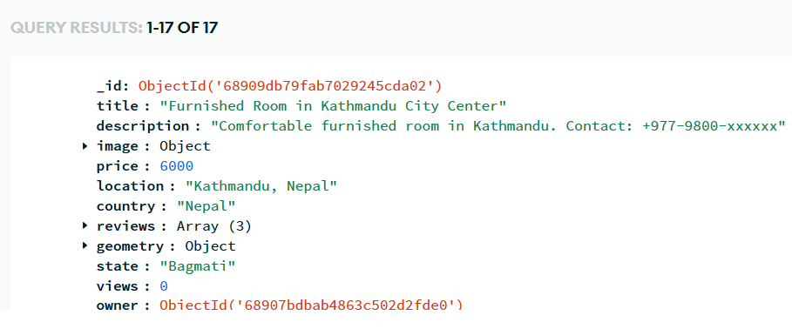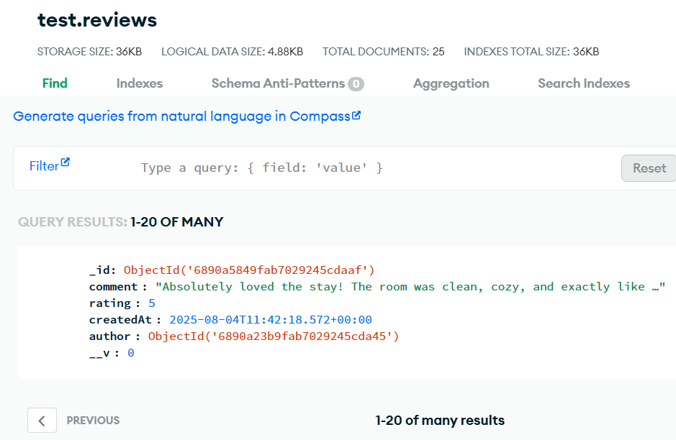
Fig 11.1: Listings Fig 11.2: Reviews
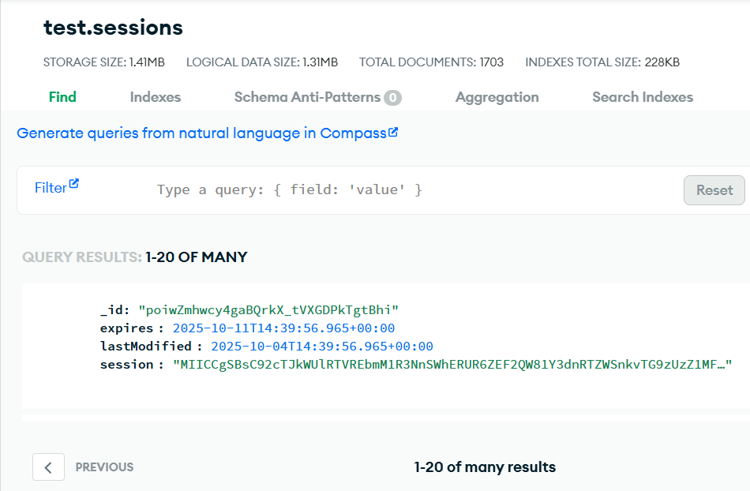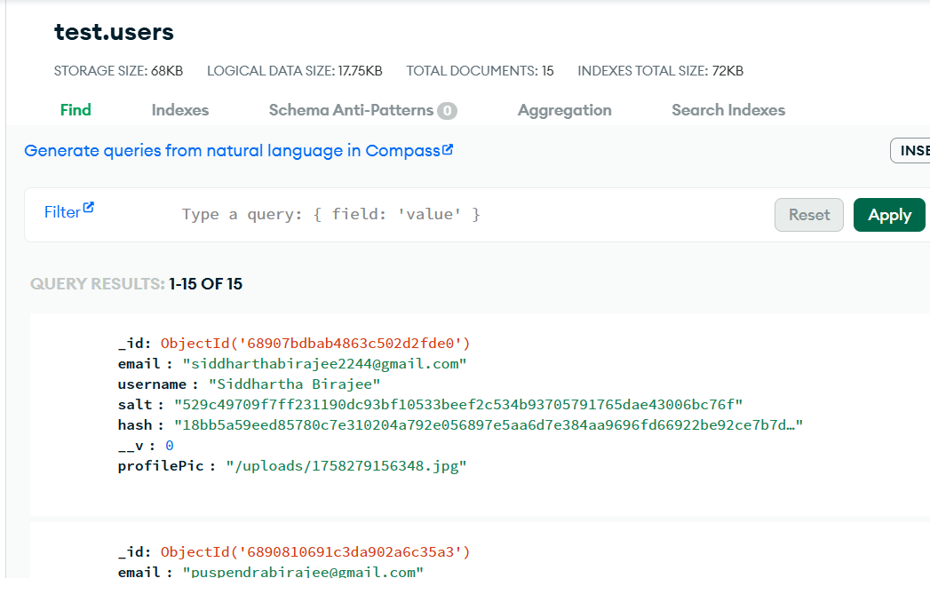
Fig 11.3: Sessions Fig 11.4: Users
12. RESULT

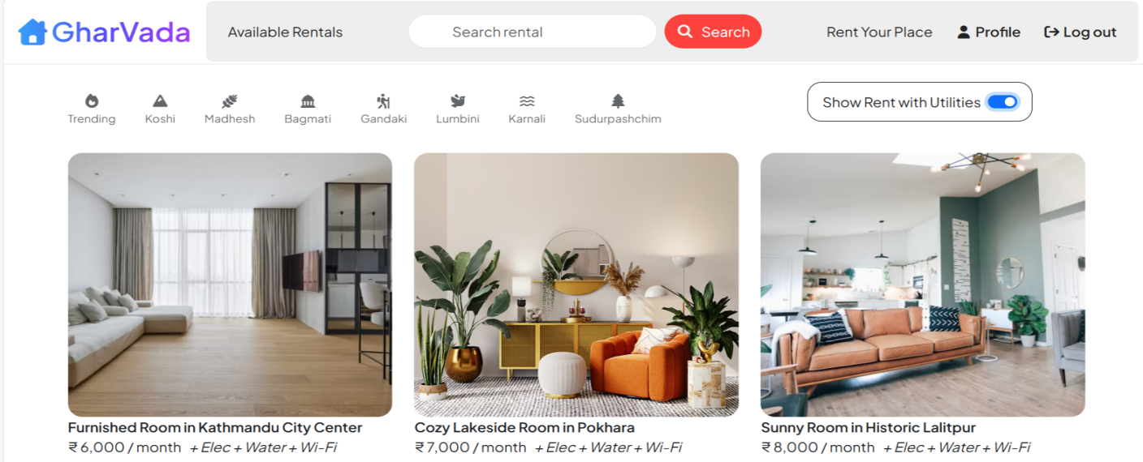

Fig 12.1: Home Page of GharVada

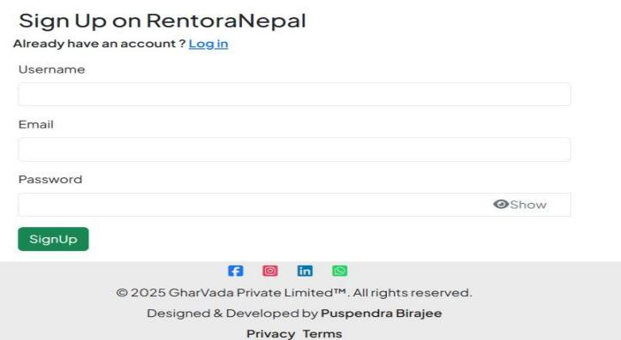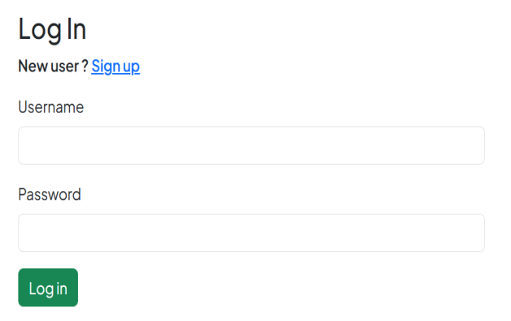

Fig 12.2: Sign up Page Fig 12.3: Log in Page

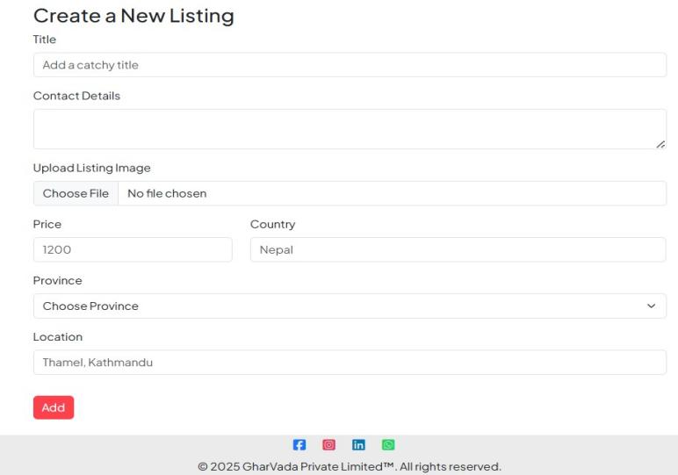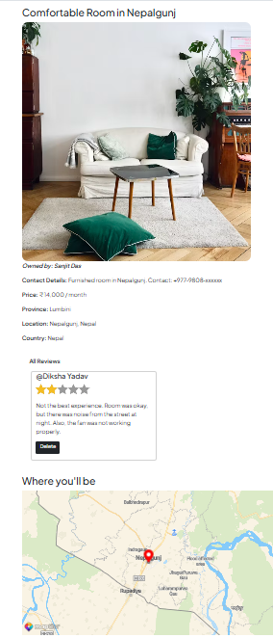

Fig 12.4: Property Listing Page Fig 12.5: Property Details

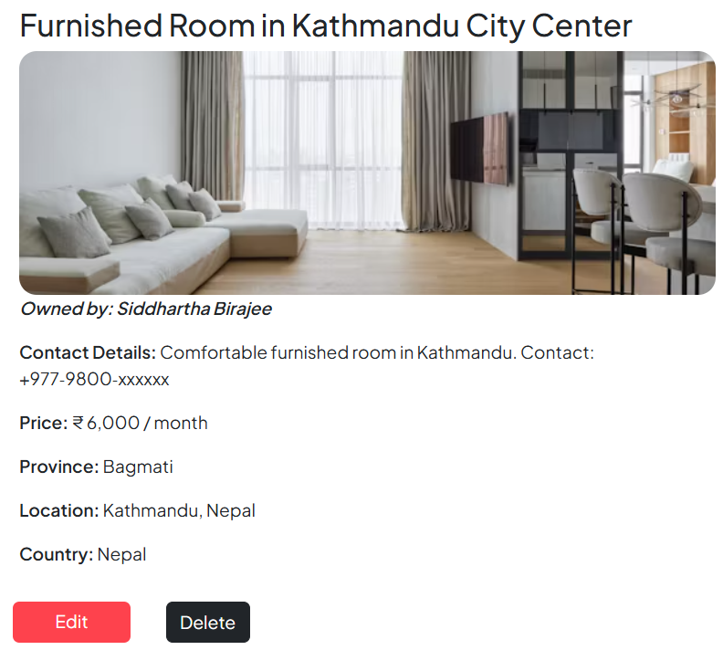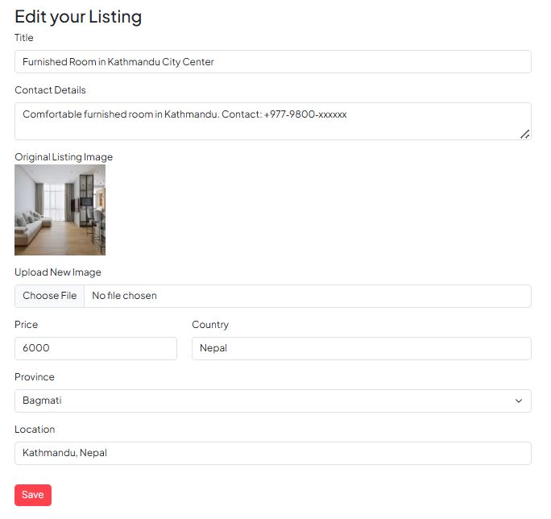

Fig 12.6: Owner Dashboard Page

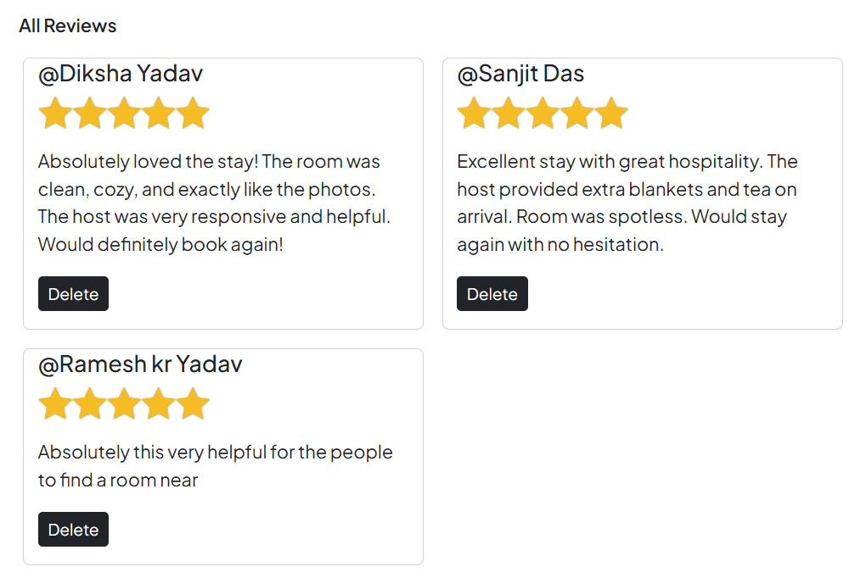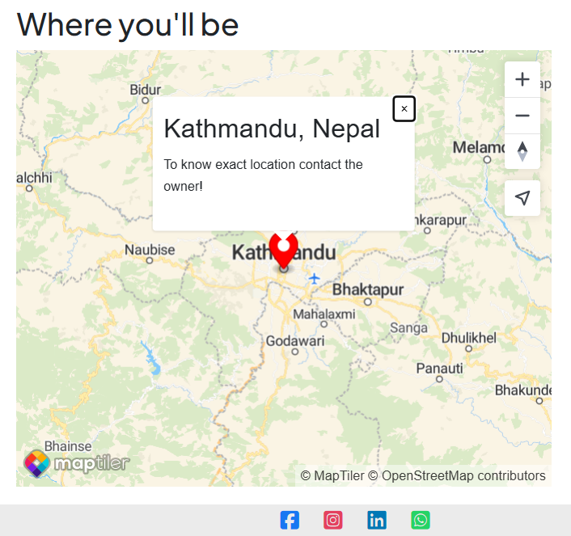

Fig 12.7: Reviews Fig 12.8: Map Location

13. CHALLENGE FACED
During the development of GharVada, several challenges were encountered:
- Integration of Frontend and Backend – Ensuring smooth communication between EJS templates, Node.js, and MongoDB required careful handling of routes and data flow.
- Database Management – Handling dynamic property listings, user profiles, and bookings in MongoDB involved designing efficient schemas and queries.
- File Uploads & Storage – Implementing image uploads for properties and user profiles while managing storage paths and access permissions was tricky.
- Authentication & Security – Ensuring secure user login, signup, and session management required proper encryption and validation.
- Responsive Design – Making all pages, including dashboards and listings, responsive across devices posed design and testing challenges.
- Deployment – Configuring the project for deployment on Render and connecting to MongoDB Atlas required resolving environment variables and server settings.
Despite these challenges, the project was successfully developed, deployed, and is fully functional.

14. CONCLUSION & FUTURE SCOPE
Conclusion:
GharVada is a complete property rental management system that allows users to browse, book, and manage properties seamlessly. The project demonstrates effective use of Node.js, Express, MongoDB, and EJS for building a full-stack web application. It ensures smooth user experience, secure authentication, and real-time property management.
Future Scope:
- React Integration – Converting the frontend to React.js for better performance, component reusability, and enhanced UI/UX.
- Payment Gateway – Integrating online payment options for seamless property booking.
- Advanced Search & Filters – Implementing AI-based recommendations and advanced filtering for faster property discovery.
- Mobile Application – Developing a mobile app for both Android and iOS to expand user accessibility.
- Admin Analytics – Adding dashboards for owners and admins to analyze bookings, user behavior, and property trends.

15. REFERENCES

Websites & Online Resources
- Node.js Official Documentation – Used to understand backend server creation, event-driven architecture, and handling asynchronous operations.
- Express.js Guide – Referred for building RESTful APIs, routing, and middleware implementation.
- MongoDB Documentation – Helped in designing collections, managing queries, and integrating the database using Mongoose.
- EJS Official Documentation – Used to render dynamic web pages and pass backend data to the frontend templates efficiently.
- Bootstrap Documentation – Referred for building a responsive and user-friendly interface with reusable components.
- MapTiler Documentation – Used to integrate interactive maps and display property locations within the website.
- W3Schools – Quick reference for HTML, CSS, and JavaScript fundamentals during frontend design.
- MDN Web Docs – Detailed explanations for JavaScript functions, ES6 syntax, and API usage during development.

Books & Study Material
- Rajiv Chopra, Database Management Systems, McGraw Hill Education – Helped in understanding database models, normalization, and query structures applied in MongoDB.
- E. Balagurusamy, Programming with Java, McGraw Hill Education – Strengthened programming logic and server-side concepts relevant to Node.js and Express.js development.
- Yashavant Kanetkar, Let Us JavaScript – Useful for improving JavaScript fundamentals and client-side scripting used in validation and interactivity.
- Web Development Tutorials by GeeksforGeeks and FreeCodeCamp – Assisted in understanding practical implementation of full-stack development and deployment workflows.

