

Traffic Sign Classification

Submitted by:

Puspraj Kumar

**ACKNOWLEDGMENT**

I am going to mention that all references, first web site is ‘towardsdatascience.com’, ‘researchgate.net’ and some YouTube channel. Sources of data is amazon.com so, these are helped me and guided me in completion of the project.

**INTRODUCTION**

* Business Problem Framing

This problem is related to the real world in this sense, there are several different types of traffic signs like speed limits, no entry, traffic signals, turn left or right, children crossing, no passing of heavy vehicles, etc. Traffic signs classification is the process of identifying which class a traffic sign belongs to.

I tried this through this project with transfer learning, to build a Deep Neural Network model that can classify traffic signs present in the image into different categories. We should be able to read and understand traffic signs which are a very important task for all autonomous vehicles.

* Review of Literature

This is a comprehensive summary of the research done on the topic. I am used for doing this project is InceptionV3, Data augmentation, Hyper tunning. Summary it gives all the information about the data set. Which is I used.

* Motivation for the Problem Undertaken

The objective behind to make this project is how we perform image processing in a better way over deep learning, which is not happen in machine learning. The motivation behind the project is, road accident is largest issue, so this project suggests the autonomous driving. So that is the motivation for the problem undertaken.

**Analytical Problem Framing**

* Data Sources and their formats

Source of data, their origins, and their formats. Data is given by Flip Robo Technology SME in the .zip file. Files have training data and testing data. The training data file has 43 classes in which image data. All images data in ‘.png’ formats.

* Data Pre-processing Done

Data pre-processing done here for doing this project, I have used a Data Augmentation, image data generator, flow from directory and I have used the summary is showing all information yet.

* Data Inputs- Logic- Output Relationships

The relationship behind the data input is, in the train data set we have different categories of data in the format of the folder. Train folder have 43 classes (0-42) total number of images in these classes more than104000. These data folders also in the test data set and total number of images in this more than 23000. Input effects in a way if we have the number of data is too large then we get the best of the best result in CNN

* Hardware and Software Requirements and Tools Used

The hardware and software requirements along with the tools, libraries and packages used. Hardware I have use for doing this project is window 10 operating system. Platform I have used for doing this project is jupyter Notebook. Libraries I have used is TensorFlow and Keras. Packages I have used Image Data Generator, Image and Activation, Max pooling, Flatten, Dense etc.

**Model/s Development and Evaluation**

* Identification of possible problem-solving approaches (methods)

I am going to describe the approaches I have followed, for solving this problem. Firstly, I have used Data Augmentation for obtain the good accuracy, in which function I used Image data generator and flow from directory. Deep learning methods I have used Conv2D, MaxPool2D, Flatten, Dense etc. Then, I have compiled our model through the ‘Adam’ optimizer. Metrics I have used the only accuracy. After, compile I have used an image data generator and finally fit model.

* Testing of Identified Approaches (Algorithms)

For the testing I have used ‘model. fit’ function in which I have train data, test data and number of epochs is 30. Almost every epoch I have got more than 85% of accuracy.

* Run and Evaluate selected model

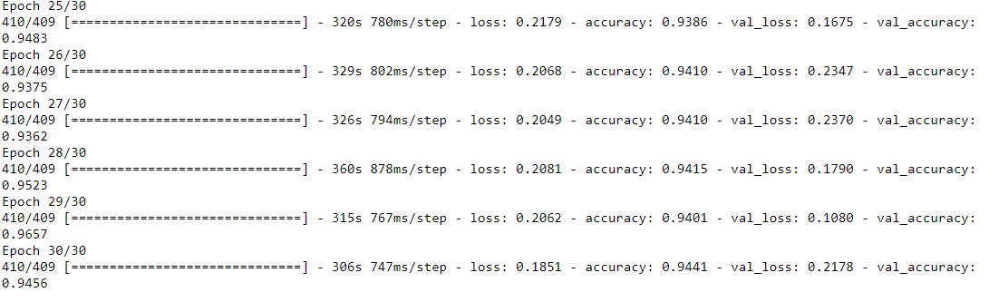Snapshot of their code and what were the results observed over different evaluation metrics.

* Visualizations

The plots made along with their pictures and what were the inferences and observations obtained from those. For plotting I have used matplotlib library from this library I have showed train loss, validation loss and train accuracy and validation accuracy.

* Interpretation of the Results

Summary of what results were interpreted from the visualizations, pre-processing and modelling. From the visualization I have showed the accuracy of our model. I have done here pre-processing is data augmentation. Model I have used sequential model.

**CONCLUSION**

* Key Findings and Conclusions of the Study

I am going to identifies key findings, inferences, observations from the whole problem. Data augmentation is one kye form this project, batch size, layers are other keys form this project.

* Learning Outcomes of the Study in respect of Data Science

Firstly, the power of data augmentation from this we can fluctuate our data accuracy. Challenges I have faced when I don’t use the data augmentation then we get many things like accuracy small and loss is large, overfitting problem, for best accuracy number of the epoch is used too large, which takes more time. When we use data augmentation then we are not facing this type of problem. So, these things I have learned from this.

• Limitations of this work and Scope for Future Work

Limitation for doing this project is that when I have selected all feature but number of data is small then I have got overfitting situation, if we want good accuracy then firstly have to select the number of data is large. If number of data is too large than we obtain very good accuracy small loss.