PUSUNURI SAI RUPIKA
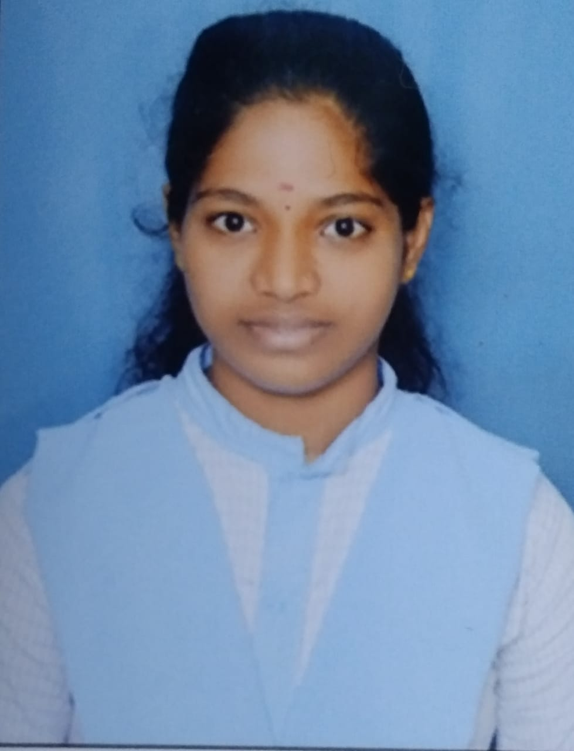
pusunurirupika@gmail.com |+91 8125315679 |Eluru, India – 534004
https://www.linkedin.com/in/sai-rupika-09725a30b

PROFESSIONAL SUMMARY
Enthusiastic and detail-oriented B.Sc (Artificial Intelligence and Robotics) student with strong knowledge of Python, Power BI, and data analytics. Skilled in developing intelligent systems and data-driven solutions. Seeking an entry-level position to apply analytical and programming skills in real-world projects and contribute to organizational growth.

EDUCATION

Aditya Degree College, Eluru
Bachelor of Science (Artificial Intelligence), 2026 GPA: 9.3/10

Sasi Junior College, Eluru Intermediate (MPC), 2023 GPA: 9.4/10

Sri Sanghamitra Vidyalaya EM High School, Dubacherla
Secondary Education (10th Grade), 2021 GPA: 9.5/10

SKILLS
- Programming Languages: Python, Java, C
- Database: SQL
- Web Technologies: HTML, CSS
- Data Tools: Power BI, MS Excel
- Automation Tools: Automation Anywhere (RPA)
- Other Tools: MS Office, Google Sheets

CERTIFICATIONS & WORKSHOPS
- RPA Workshop – Automation Anywhere (Aditya College)
- Power BI Internship – Data Visualization Project
- Python- Creativo E-Learning Ltd

PROJECTS (ACADEMIC)

Face Recognition System
Developed a real-time face recognition system using Python, OpenCV, and face recognition libraries achieving 95% accuracy in identifying individuals. Optimized the system to ensure minimal latency and efficient performance.

Project Title: Semester Results Automation using Automation Anywhere
Description:
Developed a bot using Automation Anywhere to automatically extract students’ semester results from the AKNU university portal and store the data into an Excel sheet for easy analysis and record maintenance.
Tools & Technologies: Automation Anywhere, Excel
Outcome: Reduced manual effort and processing time by automating repetitive result extraction tasks.

Restaurant Billing System
Designed a desktop-based billing application using Python and Tkinter to automate restaurant billing. Enabled real-time calculation of totals and taxes, and generated printable receipts for customers.

RELEVANT STRENGTHS
- Confident speaker with clear pronunciation and customer focus
- Positive attitude under pressure
- Quick learner and adaptable to new tools and shifts

LANGUAGES KNOWN
English, Telugu

HOBBIES
Listening to music, Meditation, Learning new skills through online courses.

DECLARATION
I hereby declare that the information provided above is true to the best of my knowledge and belief.

