Test Plan

Test case ID | Test Function
TC-1 | The customer can register themselves to the system.
TC-2 | The customer can log in to the system.
TC-3 | The customer can update their information.
TC-4 | The customer can see the product by the product catalog.
TC-5 | The customer can see the product by search the product name.
TC-6 | The customer can select a product.
TC-7 | The customer can see the shopping cart.
TC-8 | The customer can see their shopping history.
TC-9 | The customer can continue shopping when they return to the program later.
TC-10 | The customer can check out the shopping cart.
TC-11 | The customer can select payment method.
TC-12 | The customer can log out from the system.
TC-13 | The administrator can login to the system.
TC-14 | The administrator can add the products.
TC-15 | The administrator can edit details of the products.
TC-16 | The administrator can delete the products.
TC-17 | The administrator can log out from the system.
TC-18 | The administrator can see the shopping history of all customers.

Test case of User acceptance Test (UAT)

UAT_TC 1 The customer can register themselves to the system.
Test scenario: URS-1 The customer can register themselves to the system.
Objective: To determine customer register function working correctly.
Description
Customer add information involved name, surname, address, username,password and picture to the system. The system adds customer information into database.

Test Script:

- Customer clicks “Registration” button on homepage.
- Customer inputs name, surname, address, username, password and add picture in customer registration page.

Test Step # | Execution Test Steps | Input Data | Expected Result | Actual Result
1 | Customer clicks “Registration” button on homepage. | - | System display interface for registration.
2 | Customer input name,surname,address,  username,password and picture in customer registration page. | Name,surname,address,username,password and picture | System go to customer page and add customer information into database.

Use case
Case | Description | Input |  |  |  |  |  | Expect Result | Actual Result
Case | Description | Name | Surname | Address | Username | Password | Picture | Expect Result | Actual Result
1 | Test with input all correct data | Jirada | Somanasak | Chiangmai Thailand | jirada | Biw54 |  | The information that customer registered insert into database and show on customer page.
2 | Test with input all correct data format but some data is duplicate | Jirada | Somanasak | Chiangmai Thailand | jirada | Biw54 |  | Show error message and this message are “The username is already existed” After that the system give customer input information again.
3 | Test with input all data is empty | “” | “” | “” | “” | “” | NULL | Show error massage and this message are “Please input information” After that the system give customer input information again.
4 | Test with input some data is empty | Jirada | Somanasak | “” | jirada | Biw54 |  | Show error massage and this message are “Please complete input information” After that the system give customer input information again.
5 | Test with input name is incorrect format | 54ji | Somanasak | Chiangmai Thailand | jirada | Biw54 |  | Show error massage and this message are “The name format should not contain the number,Please input information in correct format” After that the system give customer input information again.
6 | Test with input surname is incorrect format | Jirada | 54somanasak | Chiangmai Thailand | jirada | Biw54 |  | Show error massage and this message are “The surname format should not contain the number,Please input information to correct format” After that the system give customer input information again.
7 | Test with input address is incorrect format | Jirada | Somanasak | 5932382u2ok | jirada | Biw54 |  | Show error massage and this message are “The address format should not contain the number,Please input information to correct format” After that the system give customer input information again.

8 | Test with add picture incorrect format | Jirada | Somanasak | Chiangmai Thailand | jirada | Biw54 |  | Show error message and this message are “The size of picture should not more than 250x400 pixels.” After that the system give customer add picture again.
9 | Test with input username incorrect format | Jirada | Somanasak | Chiangmai Thailand | jiradasomanasakberrybiw | Biw54 |  | Show error message and this message are “The username should The username format must be 4-20 characters ” After that the system give customer input information again.
10 | Test with input password incorrect format | Jirada | Somanasak | Chiangmai Thailand | jirada | berrybiw |  | Show error massage and this message are “The password must contain the upper case letters, lower case letters, numbers and symbols”
11 | Test with input password length more than six character | Jirada | Somanasak | Chiangmai Thailand | jirada | Biw542115009 |  | Show error  massage and this message are “The password format should be length is less than six”

UAT_TC 2 The customer can log in to the system.

Test scenario: URS-2 The customer can log in to the system.
Objective: To determine customer login function working correctly.
Description
Customer add information such as name, surname, username,password and picture to the system. The system adds customer information into database.
Test Script
- Customer open login page
2. Customer input username and password on login page.

Test Step # | Execution test steps | Input Data | Expect result | Actual result
1 | Customer open login page | - | The system provides the login user interface which receive the user name and password.
2 | Customer input username and password on login page | Username, password | The system validate username and password.Then go to customer page

Use case

Case | Description | Input |  | Expected Result | Actual Result
Case | Description | Username | Password | Expected Result | Actual Result
1 | Test with input username and password are correct format | jirada | Biw54 | The system provides the login user interface which receive the user name and password.  Then go to the customer page
2 | Test with input username wrong but password correct. | biwjirada | Biw54 | Show error massage and this message are “Sorry your username or password is incorrect, Please try again”
3 | Test with input password wrong but username correct. | jirada | Biw542115009 | Show error massage and this message are “Sorry your username or password is incorrect, Please try again”
4 | Test with input username and password incorrect. | biwjirada | Biw542115009 | Show error massage and this message are “Sorry your username and password is incorrect, Please try again”

UAT_TC 3 The customer can update their information.

Test scenario: URS-3 The customer can update their information.
Objective: To determine customer update information function working correctly.
Description
The registered customer can update their name, address, password, and picture in the system.
Test Script
1. The customer browses for the editing page
2. The customer input new information to the system
3. The system shows the updated information of customer on the top right of index page.

Test Step # | Execution test steps | Input Data | Expect result | Actual result
1 | Customer browses for the editing page |  | The system provides the registration interface which receive the new information.
2 | Customer input new information to the system | New information (name,surname,address,  password,and picture) | The system update customer information into database.  The system shows the updated information of customer on the top right of index page.

Use case

Case | Description | Input |  |  |  |  | Expected Result | Actual Result
Case | Description | Name | Surname | Address | Password | Picture | Expected Result | Actual Result
1 | Test with input new information with correct format | Jirada | Jaikon | Chiangmai Thailand | Na54 | 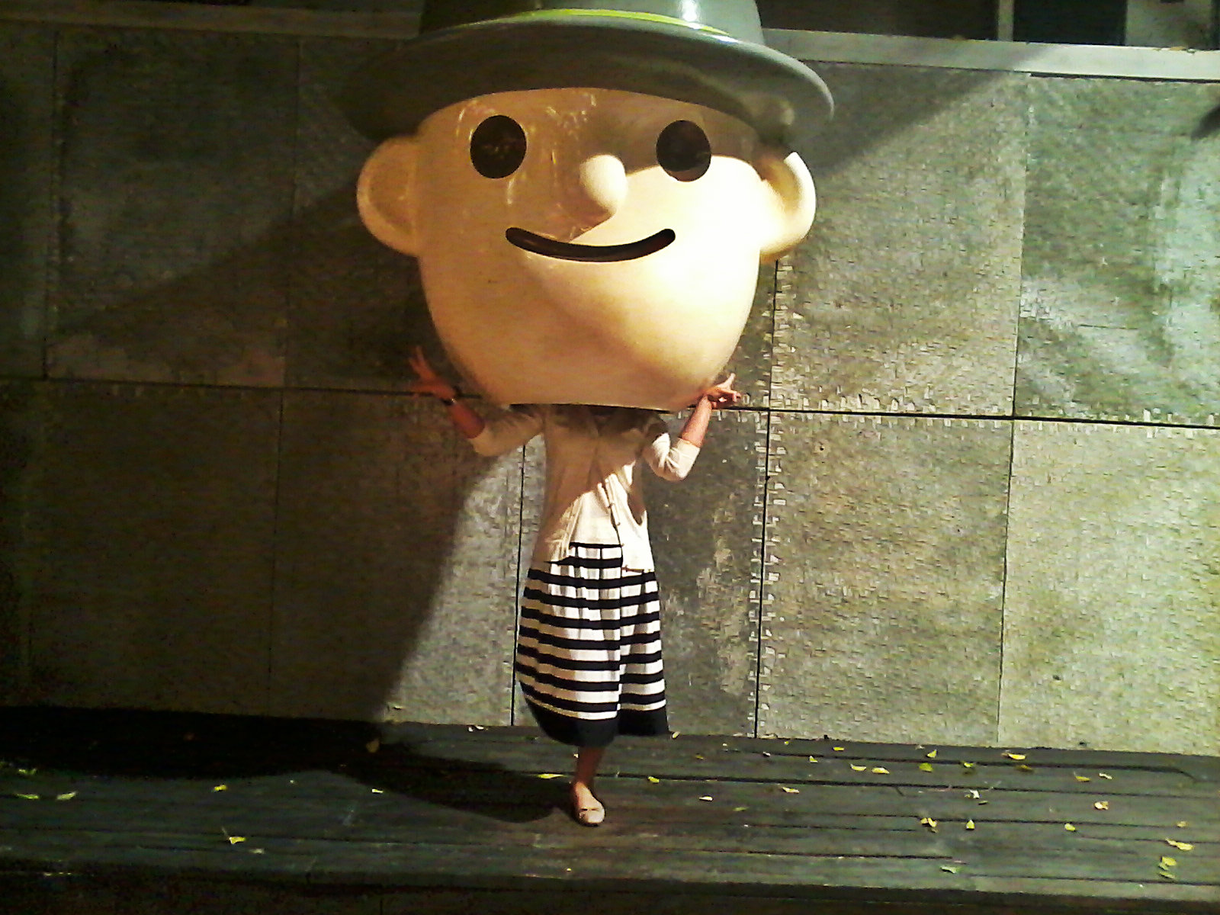 | The system provides the registration interface which receive  new information and the system shows the updated information of customer on the top right of index page.
2 | Test with input new information is duplicate with old information | Jirada | Somanasak | Chiangmai Thailand | Biw54 |  | Show error massage and this message are “your information is duplicate with old information”
3 | Test with input some information is incorrect format | Jirada | Jaikon | Chiangmai Thailand | Na542009 |  | Show error massage and this message are “your input data is incorrect format”

UAT_TC 4 The customer can see the product by the product catalog.

Test scenario: URS-4 The customer can see the product by the product catalog.
Objective: To determine product catalog function are working correctly.
Description
The customer can select the product catalog and see the related product which show name, description, picture, and price of each related product.

Test Script
1. The customer browses to product page.
2. The system provides the product catalog.
3. The customer selects the product catalog.
4. The system shows the related product, which show name, price, description, and picture of each related product

Test Step # | Execution test steps | Input Data | Expect result | Actual result
1 | The customer browses to product page. |  | The system provides the product catalog.
2 | The customer selects the product catalog. | Click “catalog” button on homepage | The system shows the list of product, which show name, price, description, and picture of each related product

Test case

Case | Description | Input | Expected Result | Actual Result
1 | Test with click on “catalog” button on homepage |  | The system provide product UI page that show all product name, description, picture, and price of each product.
2 | Test with select product on catalog page | Click on product picture | The system retrieve product information from database show on catalog page, which relate to the product that customer selected.

UAT_TC 5 The customer can see the product by search the product name

Test scenario: URS-5 The customer can see the product by search the product name
Objective: To determine search product function are working correctly.
Description
The customer can search the product by name and see the related product which show name, description, picture, and price of each related product.

Test Script
1. The customer browses to product page.
2. The system provides the search product interface.
3. The customer searches the product by enter product name or specific word.
4. The system shows the related product, which show name, price, description, and picture of each related product.

Test Step # | Execution test steps | Input Data | Expect result | Actual result
1 | The customer browses to product page. |  | The system provides the  search product interface.
2 | The customer searches the product by enter product name or specific word. | Product name  “iphone” | The system shows the related product, which show name, price, description, and picture of each related product.

Test case

Case | Description | Input | Expected Result | Actual Result
1 | Test with input data on search box are related with name of product in system. | “iphone” | The system shows the product which related “iphone” word. Each product show name, price, description, and picture.
2 | Test with input data on search box are not related with name of product in system. | “Gnet” | The system show message “Sorry! Cannot find the product”
3 | Test with input number on search box | “543221124” | The system show error message  “The input data should be a character”

UAT_TC 6 The customer can select a product

Test scenario: URS-6 The customer can select a product
Objective: To determine select product function are working correctly.
Description
The customer can select the product that their want. Then add to shopping cart with the product id,product name, description, price, and product picture.

Test Script
1. The customer browses to the catalogue page.
2. The system shows all the products on catalog page. In each product show the product id, product name, description and price.
3. The customer select product they want add to the shopping cart

Test Step # | Execution test steps | Input Data | Expect result | Actual result
1 | The customer browses to catalog page. |  | The system shows all the products on catalog page. In each product show the product id, product name, description and price.
2 | The customer select product they want add to the shopping cart | Select product (iphone5s vintage ) | The system add product to the shopping cart.  (When go to shopping cart page, the product that customer selected are shown)

Test case

Case | Description | Input | Expected Result | Actual Result
1 | Test with click on “catalog” button on homepage |  | The system show the catalog page
2 | Test with select product on catalog page | Select “Iphone5s vintage” | The system add product to the shopping cart.

UAT_TC 7 The customer can see the shopping cart
Test scenario: URS-7 The customer can see the shopping cart
Objective: To determine shopping cart function are working correctly.
Description
The customer can see their shopping cart with the list of product and the total price, which the customer gets.
Test Script
1.The customer click “cart” button on homepage
2.The system browses to the cart page.
3. The system shows the list of product which the customer has selected with the total price. In each product show the product id, product name and the price must be shown for each product.

Test Step # | Execution test steps | Input Data | Expect result | Actual result
1 | The customer click “cart” button on homepage |  | The system retrieves the customer shopping cart information from the customer id.
2 | The customer browses to cart page. |  | The system shows the list of product that customer has selected with the total price. In each product show the product id, product name and the price of product.

Test case

Case | Description | Input | Expected Result | Actual Result
1 | Test with click on “cart” button on homepage |  | The system show the catalog page related with the customer id.

UAT_TC 8 The customer can see their shopping history
Test scenario: URS-8 The customer can see their shopping history
Objective: To determine shopping cart history function are working correctly.
Description
The customer can see their buying transaction of the shopping history, which the customer bought.
Test Script
1.The customer browses to the shopping history page
2.The system shows all buying transaction of the shopping history which the customer has bought the products.

Test Step # | Execution test steps | Input Data | Expect result | Actual result
1 | The customer browses to the shopping history page |  | The system retrieves the customer shopping cart history from the customer id.  If the customer has no buying transaction history, the system should provide the prompt message  “The shopping history is empty!!”
2 | The customer select the date that want to see the shopping history information. | Select the date | The system shows all buying transaction of the shopping history which the customer has bought the products related by date.

UAT_TC 9 The customer can continue their shopping when their return to the program later.
Test scenario: URS-9 The customer can continue their shopping when their return to the program later.
Objective: To determine shopping cart function can save the shopping information of customer when not finish shopping.
Description
The customer can continue on the saved shopping cart.
Test Script
1.The customer browses to save shopping cart page.
2.The system provides a list of saved shopping carts from the system database.
3.The customer selects a saved shopping cart which customer wants to continue.
4.The system shows the shopping cart page.

