Use Case Diagram

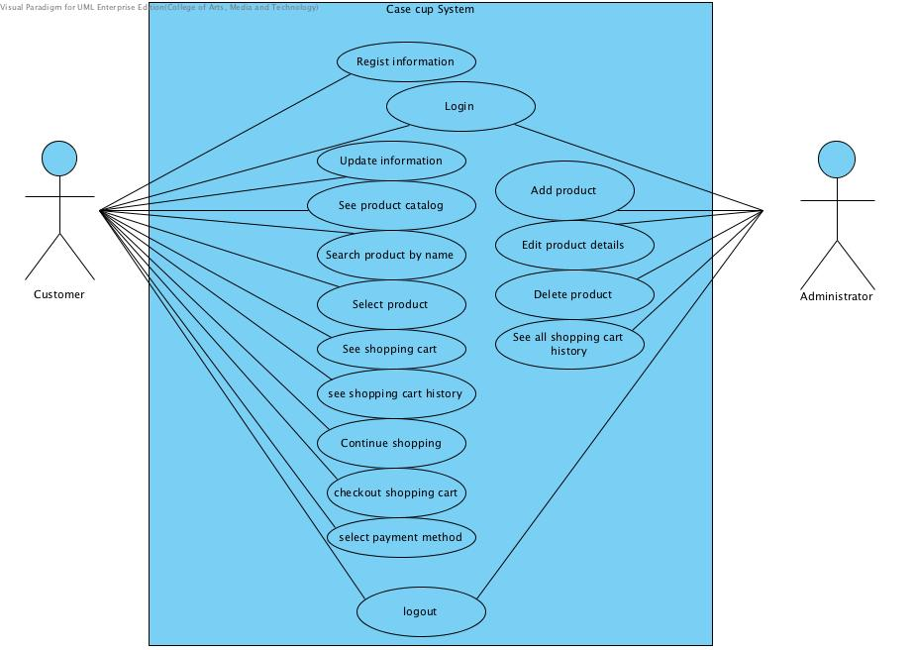

UC-01: Regist information
UC-02: Login
UC-03: Update information
UC-04: See product catalog
UC-05: Search product by name
UC-06: Select product
UC-07: See shopping cart
UC-08: See shopping cart history
UC-09: Continue shopping
UC-10: Checkout shopping cart
UC-11: Select payment method
UC-12: Logout
UC-13: Add product
UC-14: Edit product details
UC-15: Delete product
UC-16: See all shopping cart history

