Method Design
Class name: Admin (CD-01)
Package: entity
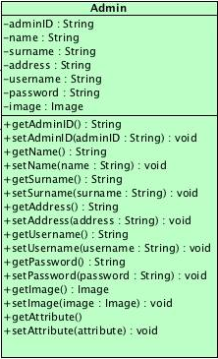

Attribute Detail

ID | Name | Description | Type
1 | adminID | Use to store admin ID | String
2 | name | Use to store administrator name | String
3 | surname | Use to store administrator surname | String
4 | address | Use to store administrator address | String
5 | username | Use to store administrator username | String
6 | password | Use to store administrator password | String
7 | image | Use to store administrator image | Image

Interface name: AdminDAO (CD-02)
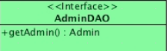
Package: DAO

Method Detail
getAdmin()
public Admin getAdmin ()
Return all admin in database

Parameter:
None
Return:
Admin object

Interface name: AdminCDAO (CD-03)
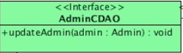
Package: DAO

Method Detail
updateAdmin(Admin admin)
public void updateAdmin (Admin admin)
Update admin in database

Parameter:
admin – A admin object
Return:
None

Class name: AdminDAOImpl (CD-04)
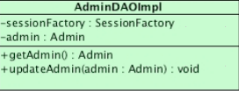
Package: DAO
Attribute Detail
ID | Name | Description | Type
1 | sessionFactory | Use to manipulate data in database | SesstionFactory
2 | admin | Use to store admin object | Admin

Method Detail
getAdmin()
public Admin getAdmin ()
Return all admin in database. This method will be retrieve admin objects by using SessionFactory.

Parameter:
None
Return:
Admin object

updateAdmin(Admin admin)
public void updateAdmin (Admin admin)
Update admin detail in the database. This method will be update the administrator information in database by using SessionFactory.

Parameter:

admin – A admin
Return:
None

Interface name: adminService (CD-05)
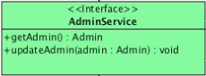
Package: Service

Method Detail
getAdmin()
public Admin getAdmin ()
Return admin in database

Parameter:
None
Return:
Admin object

updateAdmin(Admin admin)
public void updateAdmin (Admin admin)
Update administrator detail in the database

Parameter:
admin– A admin
Return:
None

Interface name: AdminServiceImpl (CD-06)
Package: Service
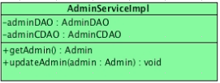
Attribute Detail
ID | Name | Description | Type
1 | adminDAO | Use to connecting with adminDAO | AdminDAO
2 | adminCDAO | Use to connecting with adminCDAO | AdminCDAO

Method Detail
getAdmin()
public Admin getAdmin ()
Return all administrator in database. This method will be call getAdmin() from AdminDAO class to retrieve set of all administrator objects.

Parameter:
None
Return:
Admin object

updateAdmin(Admin admin)
public void updateAdmin (Admin admin)
Update admin detail in the database. This method will be call updateAdmin (Admin admin) from AdminCDAO to update the administrator information in database.

Parameter:
admin – A admin
Return:
None

Class name: AdminController (CD-07)
Package: Controller
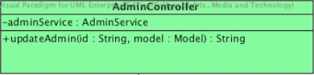

Attribute Detail
ID | Name | Description | Type
1 | adminService | Use to connect with adminService | AdminService

Method Detail
updateAdmin(String id , Model model)
public String updateAdmin (String id , Model model)
This method use to update admin information and call update information page.

Parameter:
model – A model
id – A admin ID
Return:
String name of view file

Class name: Cart (CD-15)
Package: entity
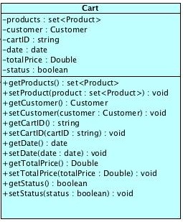
Attribute Detail
ID | Name | Description | Type
1 | product | Use to collect the set of product in the cart | Set<Product>
2 | customer | Used to show ownership of a cart. | Customer
3 | cartID | Use to store the cart number | String
4 | date | Use to keep date of cart | Date
5 | totalprice | Use to show the total price of cart | Double
6 | status | Use to define status of cart | boolean

Interface name: CartDAO (CD-16)
Package: DAO
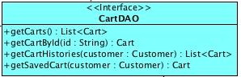
Method Detail
getCarts( )
public List<Cart> getCart ()
Return all carts in database

Parameter:
None
Return:
List of cart object

getCartHistories(Customer customer)
public List<Cart> getCartHistories (Customer customer)
Return all cart history in database

Parameter:
customer – A customer
Return:
List of cart object

getSavedCart(Customer customer)
public Cart getSavedCart(Customer customer)
Return all cart history in database

Parameter:
customer – A customer
Return:
A cart object

Interface name: CartCDAO (CD-17)
Package: DAO
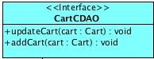
Method Detail
updateCart(Cart cart)
public void updateCart (Customer customer)
Update cart object into database

Parameter:
customer – A customer
Return:
None

addCart(Cart cart)
public void addCart (Customer customer)
Add cart object into database

Parameter:
customer – A customer
Return:
None

Class name: CartDAOImpl (CD-18)
Package: DAO

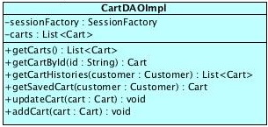
Attribute Detail
ID | Name | Description | Type
1 | sessionFactory | Use to manipulate data in batabase | SessionFactory
2 | carts | Use to store list of cart object | List<Cart>

Method Detail
getCarts( )
public List<Cart> getCart ()
This method will be return all carts in database by using SessionFactory.

Parameter:
None
Return:
List of cart object

getCartById(String id)
public Cart getCartById (String id)
This method will be get cart by looking for the related id by using SessionFactory.

Parameter:
id - A string id used to find the related cart
Return:
A cart object

getCartHistories(Customer customer)
public List<Cart> getCartHistories (Customer customer)
This method will be get history of cart by looking for the related customer by using SessionFactory.

Parameter:
customer – A customer
Return:
List of cart object

getSavedCart(Customer customer)
public Cart getSavedCart(Customer customer)
This method will be get saved cart by looking for the related customer by using SessionFactory.

Parameter:
customer – A customer
Return:
A cart object

updateCart(Cart cart)
public void updateCart (Customer customer)
This method will be update the cart in the database by using SessionFactory.

Parameter:
customer – A customer
Return:
None

addCart(Cart cart)
public void addCart (Customer customer)
This method will be add cart in the database by using SessionFactory.

Parameter:
customer – A customer
Return:
None

Interface name: CartService (CD-19)
Package: Service

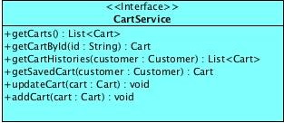

Method Detail
getCarts( )
public List<Cart> getCart ()
Return all carts in database

Parameter:
None
Return:
List of cart object

getCartById(String id)
public Cart getCartById (String id)
Return cart information in database

Parameter:
id - A sequence number of cart in database
Return:
A cart object

getCartHistories(Customer customer)
public List<Cart> getCartHistories (Customer customer)
Return all cart history in database

Parameter:
customer – A customer
Return:
List of cart object

getSavedCart(Customer customer)
public Cart getSavedCart(Customer customer)
Return all cart history in database

Parameter:
customer – A customer
Return:
A cart object

updateCart(Cart cart)
public void updateCart (Customer customer)
Update cart object into database

Parameter:
customer – A customer
Return:
None

addCart(Cart cart)
public void addCart (Customer customer)
Add cart object into database

Parameter:
customer – A customer
Return:
None

Class name: CartServiceImpl (CD-20)
Package: Service
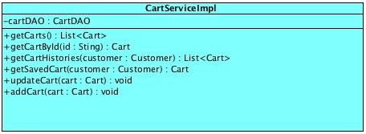
Attribute Detail
ID | Name | Description | Type
1 | cartDAO | Use to connecting with cartDAO object | CartDAO
2 | cartCDAO | Use to connecting with cartCDAO object | CartCDAO

Method Detail
getCarts( )
public List<Cart> getCart ()
Return all carts in database. This method will be call getCart() from CartDAO class to retrieve list of all cart object.

Parameter:
None
Return:
List of cart object

getCartById(String id)
public Cart getCartById (String id)
Return cart information in database. This method will be call getCartById(String id) from CartDAO class to retrieve list of cart object by cart id.

Parameter:
id - A sequence number of cart in database
Return:
A cart object

getCartHistories(Customer customer)
public List<Cart> getCartHistories (Customer customer)
Return all cart history in database. This method will be call getCartHistories (Customer customer) from CartDAO class to retrieve list of cart object by customer object.

Parameter:
customer – A customer
Return:
List of cart object

getSavedCart(Customer customer)
public Cart getSavedCart(Customer customer)
Return all cart history in database. This method will be call getSavedCart(Customer customer) from CartDAO class to retrieve list of cart object by customer object.

Parameter:
customer – A customer
Return:
A cart object

updateCart(Cart cart)
public void updateCart (Customer customer)
Update cart object into database. This method will be call updateCart (Customer customer) from CartCDAO class to update details of cart by cart object.

Parameter:
customer – A customer
Return:
None

addCart(Cart cart)
public void addCart (Customer customer)
Add cart object into database. This method will be call addCart (Customer customer) from CartCDAO class to add cart by cart object.

Parameter:
customer – A customer
Return:
None
Class name: CartController (CD-21)
Package: Controller
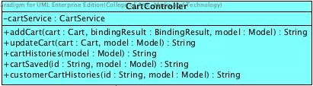

Attribute Detail
ID | Name | Description | Type
1 | cacrtService | Use to connect with CartService | CartService

Method Detail
addCart(Cart cart, BindingResult bindingResult, Model model)
public String addCart(Cart cart, BindingResult bindingResult, Model model)
This method use to call the cart page of the customer and call addCart() from CartService.

Parameter:
cart – A cart
bindingResult – A bindingResult
model – A model
Return:
String name of view file

updateCart(Cart cart , Model model)
public String updateCart (String id , Model model)
This method use to call the update page of the cart and call updateCart() from CartService.

Parameter:
cart – A cart
model – A model
Return:
String name of view file

cartHistories(Model model)
public String cartHistories(Model model)
This method use to call the cart page of the cart and call getCartHistories (Customer customer) from CartService.

Parameter:
model – A model
Return:
String name of view file

cartSaved(String id, Model model)
public String cartSaved(String id, Model model)
This method use to call the cart page of the cart and call getSavedCart(Customer customer) from CartService.

Parameter:
model – A model
id - A string id used to find the related cart
Return:
String name of view file

customerCartHistories(String id, Model model)
public String customerCartHistories(Model model)
This method use to call the cart page of the cart and call getCartHistories (String id, Customer customer) from CartService.

Parameter:
model – A model
id - A string id used to find the related cart
Return:
String name of view file

