**THE LEARNING THROUGH ACTIVITIE SYSTEM**

Project Proposal

**By**

Miss. Jirada Somanasak 542115009

Miss. Putsacha Owatsakul 542115037

Department of Software Engineering

College of Arts, Media and Technology

Chiang Mai University

**Project Advisor**

------------------------------------------------

**Aj. Chartchai Doungsa-ard**

**Document History**

|  |  |  |  |  |  |  |
| --- | --- | --- | --- | --- | --- | --- |
| **Document Name** | **Version** | **Status** | **Date** | **Viewable** | **Editable** | **Responsible** |
| **Documents** | | | | | | |
| **LTAS-Proposal_V.0.1.docx** | - Add Chapter1  - Introduction &Background  - Add Chapter2  - Business Review  - Technology Review  - Add Chapter5 | Draft | 17-02-2014 | Jirada, Putsacha, Aj.Chartchai | Jirada, Putsacha | Jirada, Putsacha |
| **LTAS-Proposal_V.0.2.docx** | - Add Chapter3  - Quality Standards  - Add Chapter4  - Motivation  - Aims and Objectives  - System Architecture  - Deliverables and Limits  - Plan Milestone | Draft | 25-02-2014 | Jirada, Putsacha, Aj.Chartchai | Jirada, Putsacha | Jirada, Putsacha |
| **LTAS-Proposal_V.0.3.docx** | - Add Abstract  - Add Reference  - Edit Chapter2  - Business Review  - Technology Review  - Edit Chapter4  - Deliverables  - Schedule and Milestone | Draft | 2-03-2014 | Jirada, Putsacha, Aj.Chartchai | Jirada, Putsacha | Jirada, Putsacha |
| **LTAS-Proposal_V.1.0.docx** | -Update Chapter4  - Deliverables  - Schedule and Milestone | Release | 4-03-2014 | Jirada, Putsacha, Aj.Chartchai | Jirada, Putsacha | Jirada, Putsacha |

**Table of Contents**

Contents

Chapter One | Introductionand Background 4

Chapter Two | Literature Review 5

2.1 Business Review 5

2.2 Alternative Solution Review 8

2.3 Technology Review 12

Chapter Three | Quality Standard 16

3.1 ISO29110 for Very Small Entity (VSE) 16

Chapter Four | Project Plan 17

4.1 Motivation 17

4.3 System Architecture 18

4.4 Deliverables and Limits 19

4.5 Software process 21

4.6 Schedule & Milestones 22

Chapter Five | References 28

APPENDIX THE PASSPORT BOOK 30

# Chapter One | Introductionand Background

The learning through activities is included in the curriculum of Chiang Mai University because the activities is important for students. The experience that students receive from the activities is necessary and very important in the future. Because society does not only need talent alone, but the society also need people with good knowledge of academic subjects, and able to work with other people. These aspects are what indicate students graduated with quality and ready for the future.

Nowadays, most of the problems about learning through activities in Chiang Mai University come from the traditional procedure. When Chiang Mai University uses the traditional method to assess the students activities, The instructors must sign the signature in the activities passport book to allow the students pass the activities. There are many problems from using the activities passport book, such as students lost their passport book and students ask friends to forge the signatures to sign name for passing the activities. When the instructors use paper for evaluating the grade of activities, it is difficult for the instructors to evaluate score to each student.

To solve these problems, the learning through activities system is proposed. The learning through activities system provides the activities information to the students plan to achieve the courses. In addition, the learning through activities system provides the students information to the instructors to evaluate the student grade. The instructors do not need to use a piece of paper to check the students who have participated the activities. The learning through activities helps the instructors solve the problems of data lost by losing the student grade paper.

Therefore, the learning through activities system aids the people who faces problem when they use the activities passport books. The learning through activities system helps people manage the activities easier. The user can manage the activities whenever he wants.

# Chapter Two | Literature Review

## 2.1 Business Review

**The Learning Though Activities Course**  
 The learning through activities course is a part of the curriculum of Chiang Mai University. There are various assessment techniques for learning through the activity courses in each faculty of Chiang Mai University. Some faculty use the collecting the activities hours and another faculties are just counting the course. Therefore, the instructors evaluate the activities course in deferent way.

In addition, the activities types are different, such as the mandatory activities and the optional activities. As a result, the students cannot have the clear standard used to assess the activities results, and the students cannot plan to achieve the courses.

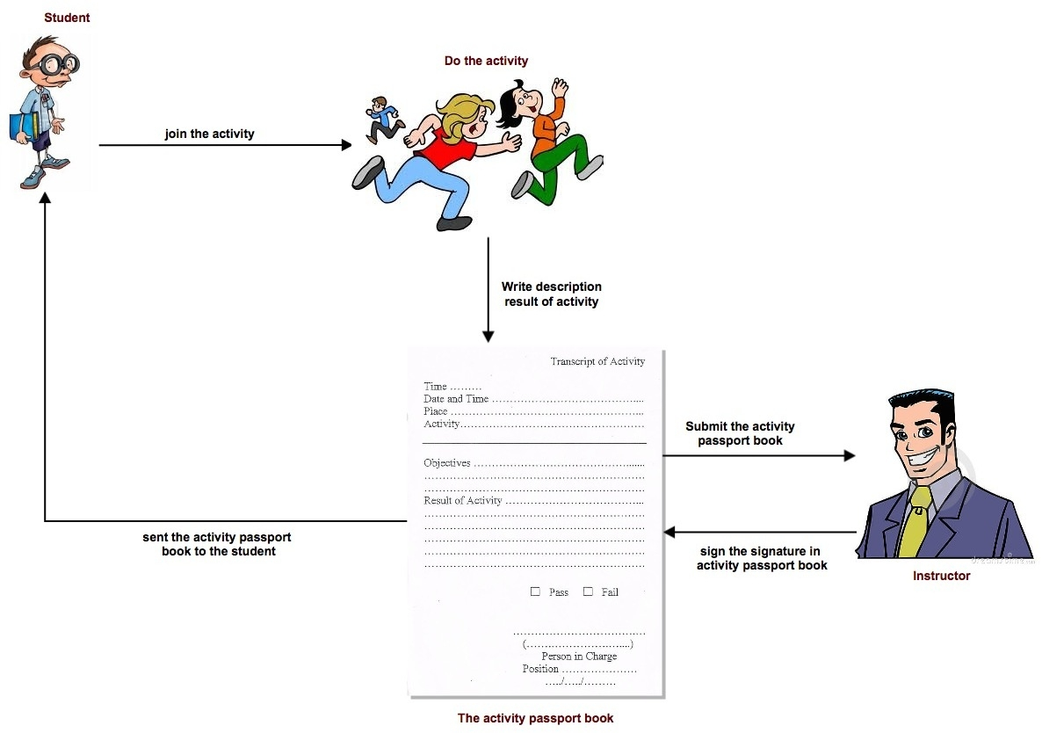

**Figure 1: The activity passport book process**

Figure1 shows the activity passport book process. The activity passport book process. The process start by student go to join the activity. Then, students write description about the results of activity in the activity passport book. The instructor can check the student participation activities through the activities passport book refer in the appendix.

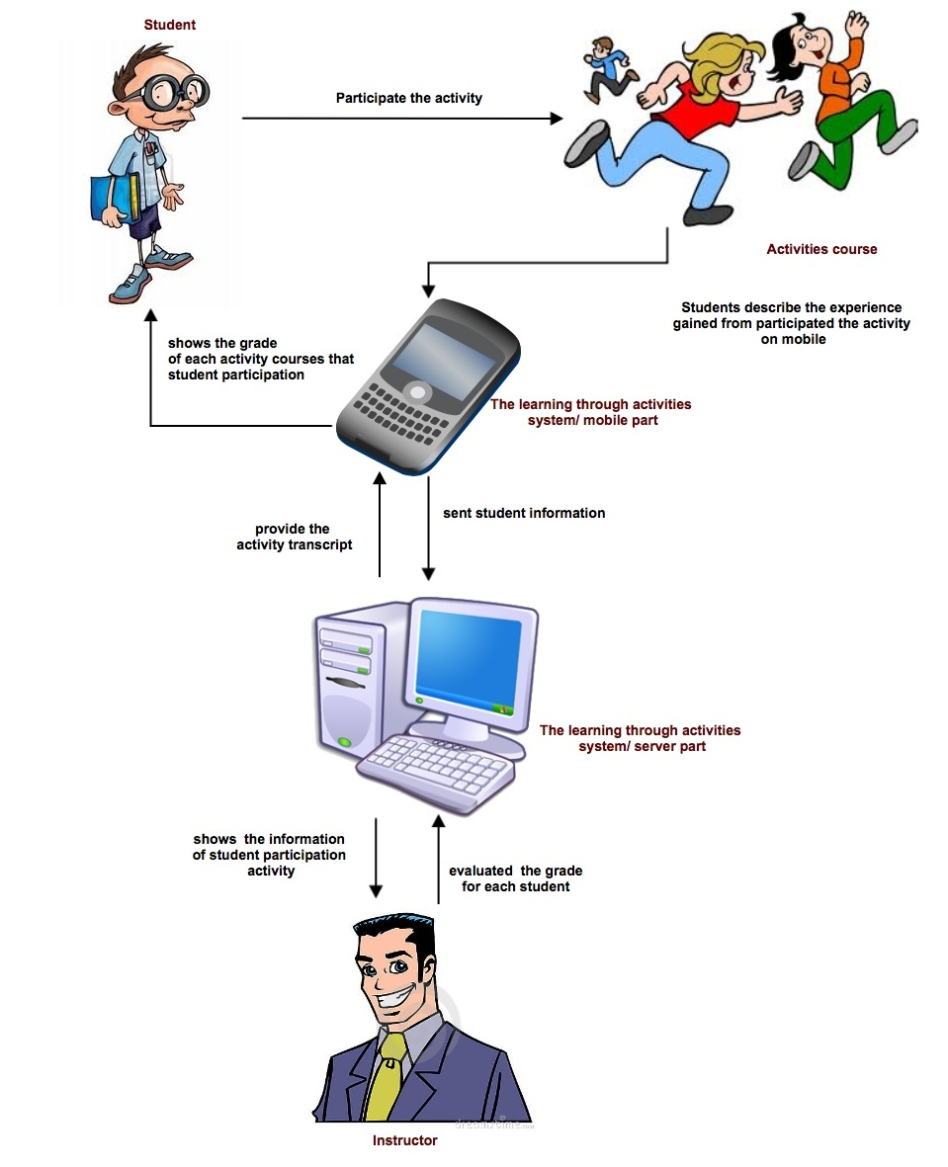

**Figure 2: The learning through activities system process**

Figure 2 shows the learning through activities system process. The process start by student participate the activities and provide the result of activities in the learning through activities system on mobile. Then the mobile part sent the student information to the server. After that, the instructors evaluated the grade for each student on website. Finally, the learning through activity system provide the activity transcript to the student.

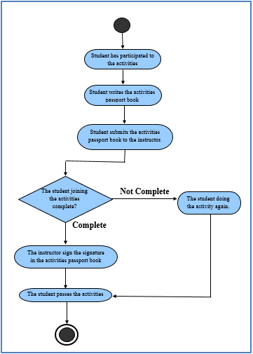

**Figure 3: The work flow of learning though activity in Chiang Mai University**

Figure 3 shows the faculties in Chiang Mai University are using the activities passport book for evaluating the score of the activities. When the students attend the activities,they will receive a passport book for assessing the participate activities. In the activities passport book, the students have to assess they participated. Then, the students submits the passport book to the instructors. After that, the instructors will sign the signature to confirm the participation activities of each student. Then, the instructors provide the grade for students. There are many problems when use the activities passport book. Most problems are the students forget the activities passport book when come to join the activities. Therefore, the learning through activities system provides clear standards used to evaluate the activities results for each faculty has the same understanding.

## **2.2Alternative Solution Review**

2.2.1 Student Information System Chiang Mai University[1]

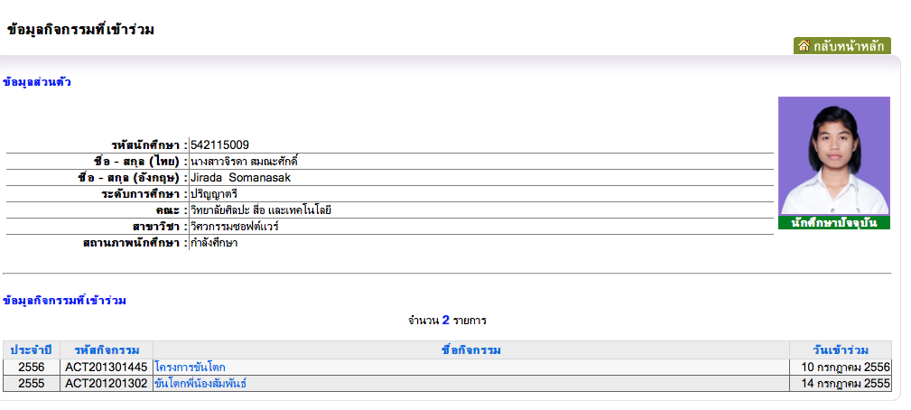The student information system of Chiang Mai University shows the information of activities that students participate. The information of students activities consist of academic year, activity id, name of activities, and date of participate the activities.

**Figure 4: Student activities information of Chiang Mai University**

Figure 4 shows student activities information of Chiang Mai University. The students can views the information of activities that participated. The instructors can view the overall the activities of each advisee.

The disadvantage of student information system is the user interface does not look friendly. This system is difficult to use because it is very hard to find the activities information. In the student information system of the Chiang Mai University show the overall activities that students participated but the system does not provides the details of each activity. The information of each activity is important for students to plan how to achieve the course in the next semester.

**2.2.2Management Information System Prince of Songkla University,   
Pattani campus (MIS Center PSU Pattani)**[2]

The MIS Center System provides the information of activities course for students and instructors. The students can selects the semester and type of the activities. Then, the MIS Center System provides the activities information separate by types that students select. This application contains services for users' management such as the students can change password and update the users' information.

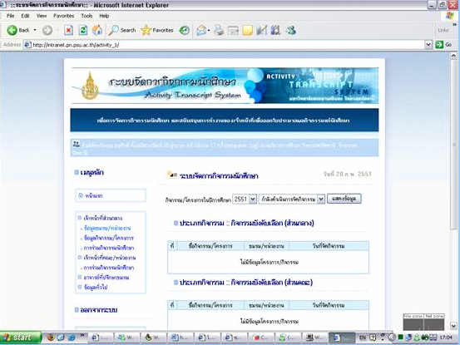

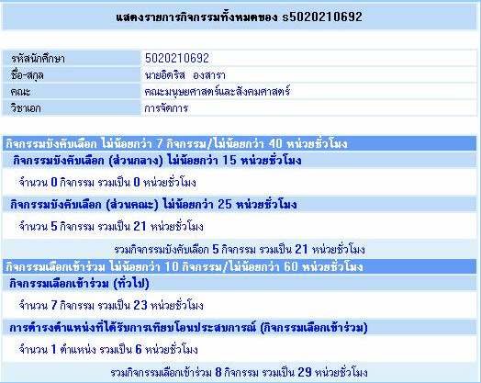

**Figure 5: Student activities information of PSU Pattani.**

Figure 5 shows student activities information of Prince of Songkla University, Pattani campus. Students can view semester activities. The students can select a year, and semester that they want to views and after that an application provides.

The disadvantages of system is the students cannot see information of each activity. So, it cannot help students plan about how to achieve the courses.

**2.2.3Activity Transcript of Sirindhorn International Institute of   
Technology (SIIT) Thammasat University**[3]

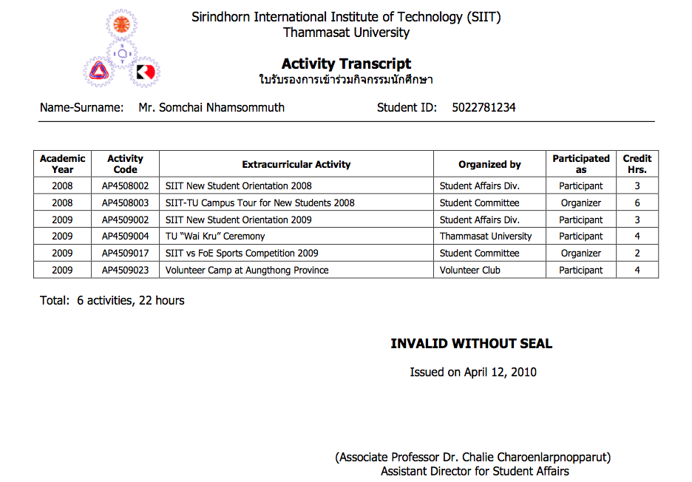 This system provide the activity transcript of Sirindhorn International Institute of Technology(SIIT), Thammasat University provide by show the information of each activity that students participated and show the total time.

**Figure 6: Activity Transcript of SIIT Thammasat University.**

Figure 6 shows activities transcript of each student in Sirindhorn International Institute of Technology, Thammasat University. The activities transcript show academic year, activity code, extracurricular activity, name of organizer and credit hours. The student can view the total activities and total time that student participated.

The disadvantage of the activity transcript of SIIT Thammasat University system is the activity transcript not provides the grade for each course that students joined the activity. So, the students cannot plan for future to achieve the course in the next semester.

**Summarize**  
 From the system that show above, each university has different the learning through activities system. For Chiang Mai University, students and instructors can see only the name of activities. They cannot plan about how to achieve the course. For Prince of Songkla University, Pattani campus. Students can select the semester and type of activities. Then, students can see activities information separate by type of activities. The MIS Center PSU Pattani system has announce about the time of each activity that user must achieve, but it cannot shows the details of each activity. So, the students cannot know what activities that they joined. For Activity Transcript of Sirindhorn International Institute of Technology, Thammasat University show the list of activities that students participated and show the total time, but it does not contain the grade for each activity course that students have. The students cannot plan for achieve the course in the next semester. To solve the problem, The Learning through Activities system will improve the ability that others web cannot do. The Learning through Activities system provides the information of each activity and evaluate the grade for students.

The Learning through Activities system can help students and instructors have clear standards to have the same understanding. Also, the students can plan how to achieve the course.

## 2.3 Technology Review

**2.3.1 Spring MVC Framework**

Spring MVC Framework is an open Source application framework based on Java for building Java web applications. Spring MVC Framework developed by Spring Source Company. Spring provides the support for Hibernate, JSP, struts, JQuery, and many other frameworks. Spring helps the developer to create high performing, easily testable and reusable code [4] [5].

Spring MVC is based on Model-View-Controller (MVC) design pattern which divided into 3 layers. First layer is Presentation Layer (View), which render response to users. Second layer is Business Layer (controller), which receiving the request from the users and handles request. The third layer is Data Layer (Model), which handles data processes or encapsulating the application data[6].

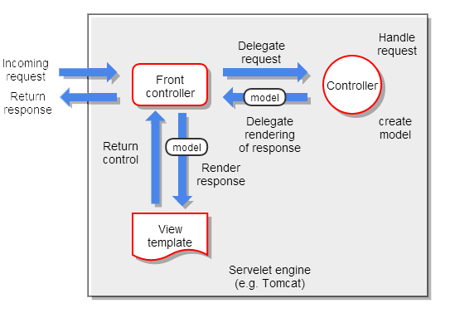

**Figure 7: Spring MVC execution sequence**

Figure 7 shows Spring MVC execution sequence. First, the client send a request to the front controller and it handles the request. Second, the front associates controller. Third, the controller executes the business logic and then the controller returns model and view object to the front controller. Fourth, the front controller passes the model object to the view. Fifth, the view is rendered and then front controller sends the output to servlet container. Finally, the servlet containers send the result back to the client.

**The selection of this technology** We select Spring MVC because it helps the developers to produce high-performance web application. Spring MVC is based on Java platform, which is also used in the project. The other reason of choosing this technology because Spring MVC is free open source software. Developers can go to the community to find how to solve the problem.

**2.3.2 JSF (Java Server Faces)**

JSF (Java Server Faces) is the user interface component based on Java web application framework and JSF as an API for building web user interface component. It simplifies development by providing a component-centric approach to developing Java web user interface. JSF technology also includes UI components, handing events and validator, defining page navigation, and back-end-data integration[9] [10].

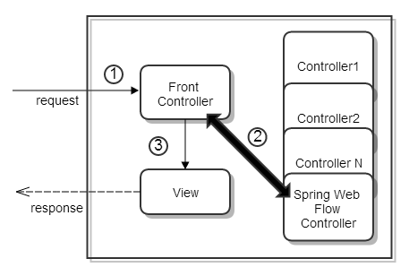 **Figure 8: Java Servlet Faces Implementation of MVC.**

Figure8 shows Java Servlet Faces Implementation of MVC. First, the client sent a request to the front controller and it handles the request. The front controller is a Faces Servlet. Second, Faces Servlet dispatches the request to controller base on mapping some controller are flows. Third, the controllers return control to the Faces Servlet with the model and view to render. Faces Servlet resolves the view (JSF) and ask it to render the model.

**The selection of this technology**

We selectJSF because it uses MVC design pattern, which also uses in this project. The JSF is easy to use and build webpages more responsibility and interactive. An application uses Spring MVC Framework which JSF can integrate with Spring MVC framework. The JSF provides reusable UI components, making easy data transfer between UI components and managing UI state across multiple server requests.

**2.3.3JQuery**

JQuery is a JavaScript framework which contains JavaScript library. It is easy to make JavaScript on website. The JQuery library contains HTML/DOM manipulation, CSS manipulation, HTML event methods, effects and animations, AJAX and Utilities. JQuery is a single file library and very smaller size file for developing JQuery[7].

JQuery is one of the most favorite JavaScript frameworks. Many of the famous companies use JQuery such as Google, Microsoft, IBM and Netflix. JQuery can integrate with many other framework such as PHP, ASP. NET and almost all the web programming languages. JQuery builds web pages good interaction between browser and client [8].

**The selection of this technology**

We selectJQuery because there are many tutorials resources. In addition, JQuery save project memory because the core file’s packed size is small. JQuery helps to build web pages more responsibility and interactive.

**2.3.4 CSS (Cascading Style Sheets)**

CSS is style sheets languages that work for control about design of document on the website. It also improves the look and feel for web page and can modify about font, image, table and etc. Main advantage of CSS, it also make or improve the impression for users when they visit the website [14] [15].

**The selection of this technology** We select CSS because it will allow the developers to be able to customize the user interface easier and more efficiently.

**2.3.5 HTML5**

HTML5 is the new generation of HTML technology standard. It contains the new feature and also improves the efficiency in the old HTML generation. It changed to more easily develop and reduce a complexity in development. It also make more comfortable to the developer, so some syntax has changed or removed from HTML5 [16] [17].

**The selection of this technology**

We selectHTML5 because the project requires developing the web application for the admin part. HTML5 is a new generation technology that make more comfortable for the developer and decrease a complexity in some development.

**2.3.6 MySQL**

MySQL is one of the most popular language for adding, accessing and managing database and provides free open source Relational Database Management System (RDBMS) that uses Structured Query Language (SQL). It provides a quick processing, reliability data, usability, adaptability and high performance. Furthermore, it available on almost all the platforms (UNIX, Windows and Mac) and it is an essential part of almost every open source PHP application [11] [12] [13].

**The selection of this technology**

We select MySQL server because it is an open source and popular database server. It has many tool for more adaptable such as Appserv, PHP MyAdmin, Easy PHP, and My SQL Workbench. MySQL provides many function and service with more efficient of reliability and performance

# Chapter Three | Quality Standard

## 3.1 ISO29110 for Very Small Entity (VSE)

ISO29110 is a guide applies to a Very Small Entity (VSE), enterprise, organisation, department or project up to 25 people, dedicated to software development. The Guide provides Project Management and Software Implementation processes which integrate practices based on the selection of ISO/IEC 12207- *Systems and Software Engineering —Software Life Cycle Processes* and ISO/IEC 15289*Software Engineering – Software Life Cycle Process – guidelines for the content of software life cycle process information products (documentation)* standards elements.

**3.1.1Project Management Process**

The purpose of the Project Management process is to establish and carry out in a systematic way the tasks of the software implementation project, which allows complying with the project’s objectives in the expected quality, time and cost.

**Selected process**

1. Project Planning Process
2. Project Plan Execution Process
3. Project Assessment and Control Process
4. Project Closer Process

**3.1.2Software Implementation Process**

The purpose of the Software Implementation process is the systematic performance of the analysis, design, construction, integration and tests activities for new or modified software products according to the specified requirements.

**Selected process**

1. Software Implementation Initiation Process
2. Software Requirements Analysis Process
3. Software Architectural Design Process
4. Software Construction Process
5. Software Integration and Test Process
6. Software Delivery Process

# Chapter Four | Project Plan

## 4.1 Motivation

Nowadays, Chiang Mai University need to make the students has more than talent. Chiang Mai University needs to make the students with good knowledge of academic subjects, professional in the field, and able to work with other people. So, Chiang Mai University provide the activities for students to participate. Chiang Mai University has various assessment techniques for the Learning through the activities courses in each faculty. Some use the collecting the activity hours, some are just counting the courses. There are also the different activity types such as the mandatory activities, the optional activities. In addition, there are different result as well. As a result, Chiang Mai University have not clear standard to evaluate the score of the activities. Therefor we decide to make the learning through activities system for provides the clear standards used to evaluate the activities results for each faculty has the same understanding.

**4.2 Aims and Objectives**

**4.2.1 Aims**

The learning through activities system aims to manage the activities of every faculties in Chiang Mai University. There are various assessment techniques for the Learning through the activity course in each faculty of Chiang Mai University. Some faculties use the collecting the activities hours and another faculty are just counting attending hours the courses. Therefore, Chiang Mai University has different activity types such as the mandatory activities and the optional activities. In addition, the activities management are different result. As a consequence, the learning through activities system has to gather the activities information, so the students can plan how to achieve the course.

**4.2.2 Objective**

**-** To help student about their activities plan easily.  
 - To help student plan how to achieve the activity course.  
 - The through activities system provide the information of each activity to help  
 student makedecision about participation.  
 - To help adviser track their advisees.

## 4.3System Architecture

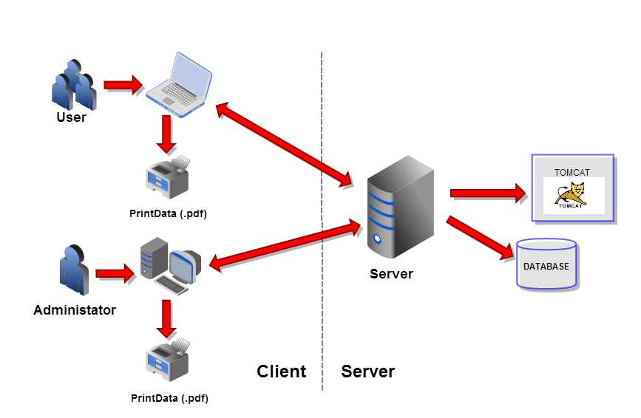  
 **Figure 9:The Leaning Thought Activities System**

Figure9 shows the overall of the learning through activities system. The system consist of Client part and Server part. In the Client part have the user and administrator can connect with the bowser to request the web page from the server and print information to PDF file. The Server part can repose the information to the bowser and save the information via tomcat into the database.

## 4.4 Deliverables and Limits

**4.4.1 Deliverables**

**4.4.1.1 Architecture Overview**

User   
Management

Activity  
Management

Participation History  
Management

Grade  
Management

Activity Transcript  
Management

**Figure 10:Architecture Overview of Learning through activities system**

Figure 10 shows overall of architecture learning through activities system. This system consist of User management, Activity management, Participation History management, Grade management and activity transcript.

***User management*** The user management part allows users involve administrator, student, and instructor to manage own information.

***Activity management*** The activity management part provides the information of each activity such as the name of activity, date, time, place and the description of the activity. The activity management part allows the administrator can fill type of activity Moreover, the administratorcan add the people into the activities.

***Participate Histories Management***  The participate histories management part shows date and the information of each activity that user has to participated. The user can see the list of activities separate by type of activity. The students can write the description about the experience of participating the activities on the website. Moreover, the administrator can see the participation history of all students.

***Grade management*** The grade management part, the system can evaluate the grade of each activityBoth students and instructors can see the grade for each activity course. The learning through activities system provides the grade report. The grade report shows the information such as name of student, grade of each activity course and credit.

***Activity Transcript Management*** The learning through activities system provide a PDF file management for create the activity transcript. In the activity transcript show the name of student, and information of activity such as ID, name, and credit of each activity.

**4.4.1.2 Software Document**

* Project Proposal
* Project Plan
* Software Requirement Specification
* Software Design Document
* Testing Document
* Test Plan  
  - Unit Test Document  
  - System Test Document
* Test Report  
  - Unit Test Document  
  - System Test Document
* Traceability Record
* Progress Status Report
* Self-Assessment Report

**4.4.2 Limits**

* Internet connection is required for using the learning through activities system.
* Web browser is required for using application.
* The student should have CMU account (542115009@cmu.ac.th)

## 4.5 Software process

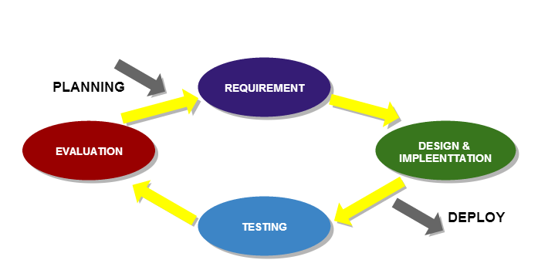

**Figure 11: Iterative development model**

Figure 11 shows a method of software development. Iterative development model is a cyclic software development process developed in response to the weaknesses of the Waterfall model. The model starts with planning and continues through iterative development cycles.

* ***Planning phase****:* Before starting the iteration, make a question, goals, feature of products and scope of work.
* ***Requirement****:* What is the demand of users?
* ***Design&Implementation****:*Design and develop in order to produce a working end product.
* ***Testing****:* Verify the quality of product.
* ***Evaluation****:*Collect feedback from the working group.
* ***Deploy****:* Final product is complete and the user acceptance testing.

**Advantage of Iterative development model**

Iterative development model encourage creating a high-level design of the application. A functioning product is available at the end of iteration. Iterative model less time is spent on documenting and more time is given for designing.

## 4.6 Schedule & Milestones

**4.5.1 Schedule**

The schedule and milestones of the learning through activities system**.** During period of time, there are work terminologies. And the description is shown below that:

**Feature#1:** User Management

**Feature#2:** Activity Management

**Feature#3:** Participate Histories Management

**Feature#4:** Activity Transcript Management

**Feature#5:** Grade management

|  |  |  |  |
| --- | --- | --- | --- |
| **Milestone** | **Task** | **Milestone Criteria** | **Planned date** |
| 1 | Proposal | Topic defined | February |
| 2 | Proposal | - Proposal reviewed  - Proposal submitted  - Proposal presentation | March |
| 3 | Progress Report I | - Software requirement specification  - Feature#1,#2  - Feature designed  - Test planned  - Feature implemented  - Feature tested  - Progress report submitted  - Progress report presentation | Mid May |
| 4 | Progress Report II | - Feature#3,#4  - Feature designed  - Test planned  - Feature implemented  - Feature tested  - Progress report submitted  - Progress report presentation | Mid July |
| 5 | ShowPro | Overall of the system should be higher than75%. | Beginning of September |
| 6 | Progress Report III | - Feature#5  - Integrate and review all documents.  - Integrate and review all documents.  - Tests all features.  - Reviews documents are completed.  - Progress report submitted  - Progress report presentation | End of September |

**4.5.2 Milestones**

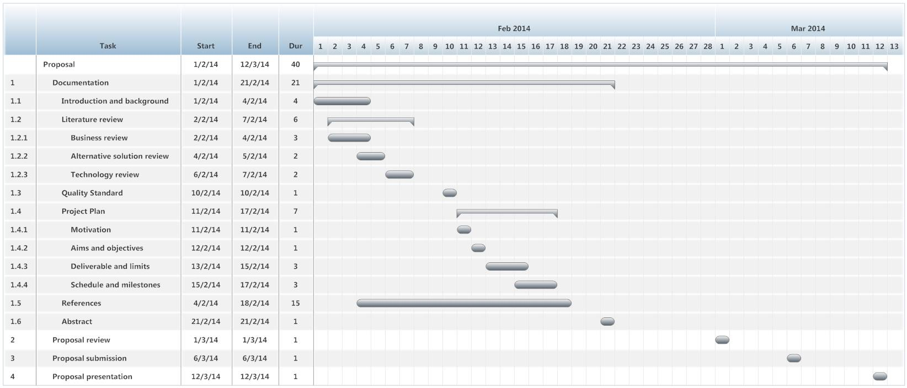

Figure 12: Proposal Milestone

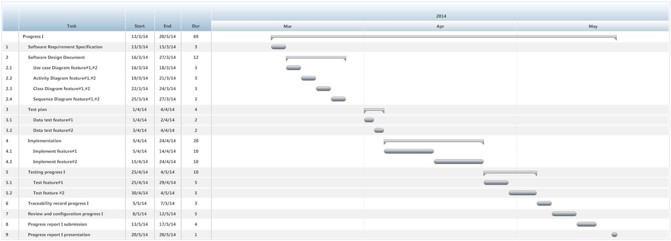

Figure 13: Progress I Milestone

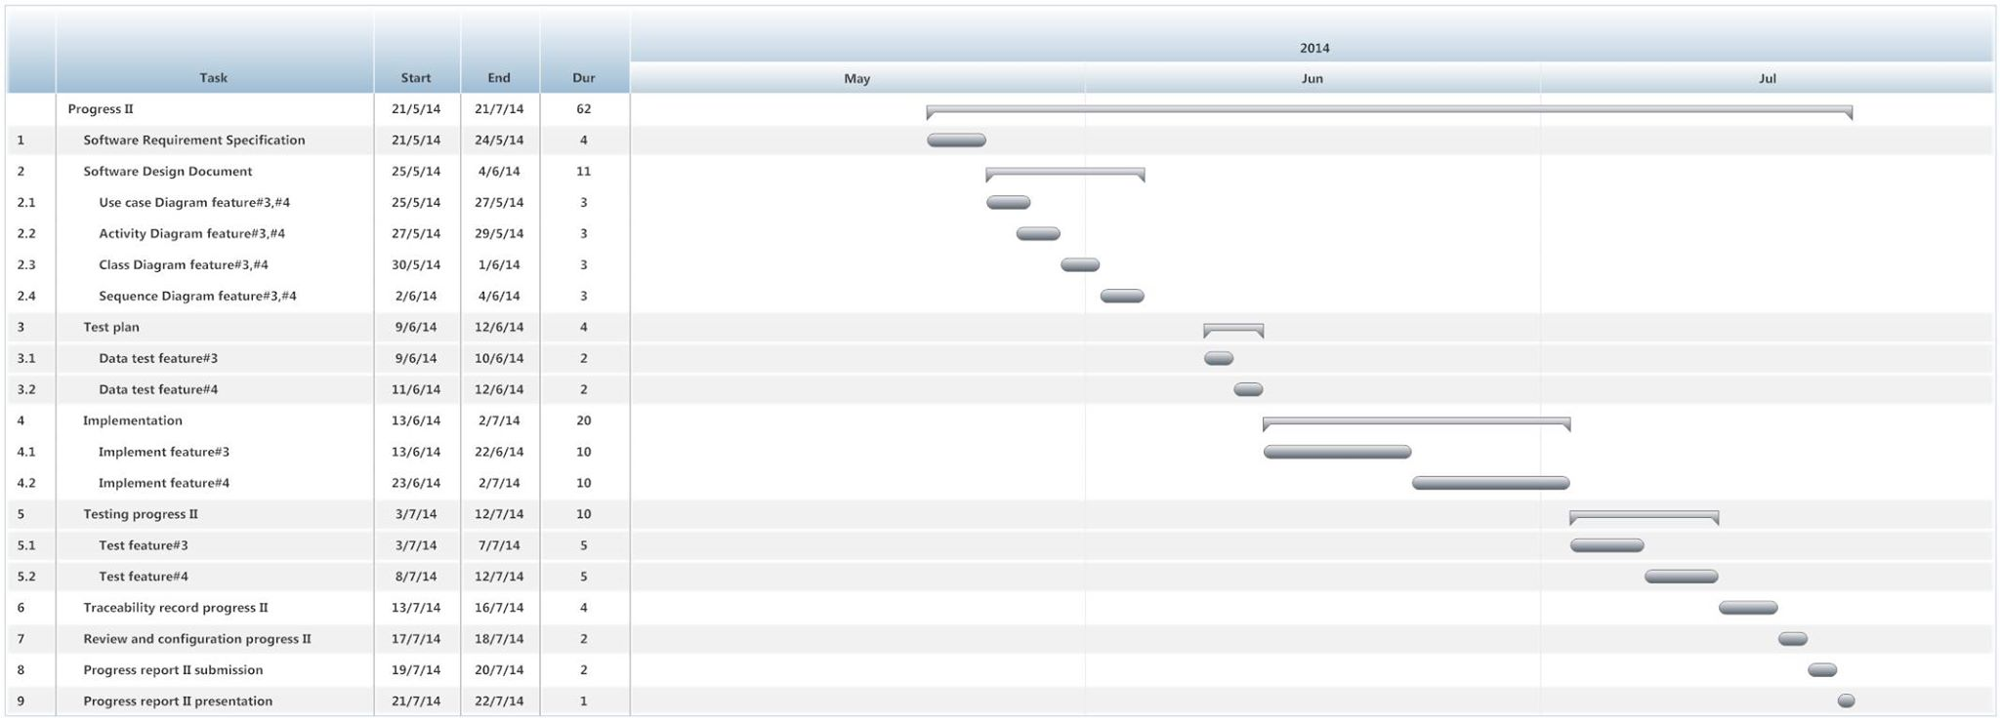

Figure 14:Progress II Milestone

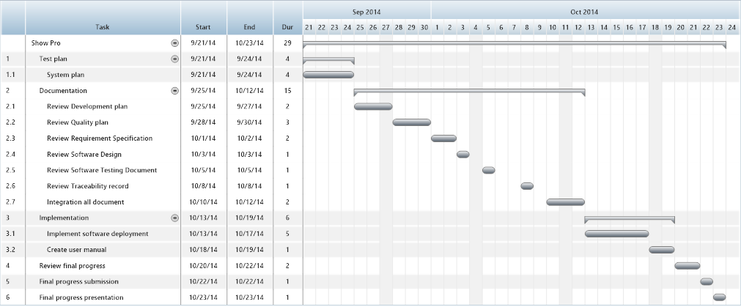

Figure 15:ShowPro Milestone

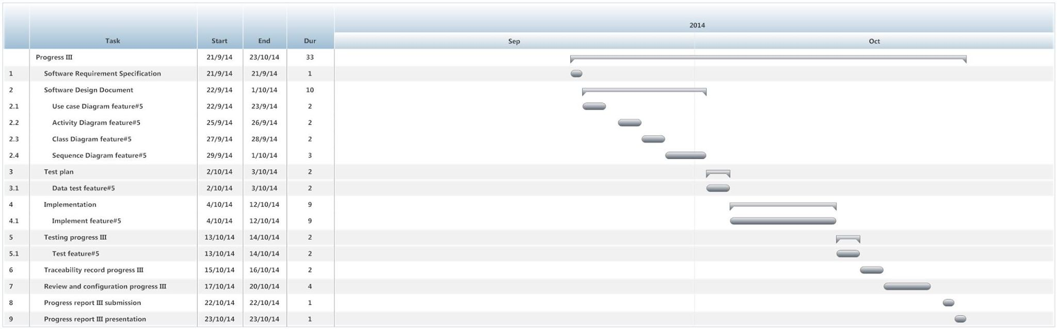

Figure 16:Progress III Milestone

Figure 12-16 shows the milestones of the learning through activities project. The milestones have five part including proposal project plan, progress1, Progress2, show pro, and final progress. In each part shows the task, date and duration.

# Chapter Five | References

[1] Student Information System Chiang Mai University (CMU SIS) [Online]   
- http://mis.cmu.ac.th/cmumis/mainstudentlogin.html

[2] Management Information System Prince of Songkla University, Pattani campus  
 (MIS Center PSU Pattani)[Online]   
- http://studaffairs.pn.psu.ac.th/transcript_pj/news_transcript1.html

[3] Activity Transcript of Sirindhorn International Institute of Technology (SIIT)  
Thammasat University[Online]   
- <http://sa.siit.tu.ac.th/ats/file/sample_acTranscript.pdf>

[4] Spring Framework, Chapter 13, Web MVC framework [Online]   
- http://static.springsourse.org/spring/docs/2.0.x/reference/mvc.html

[5] Viral Patel, Spring 3 MVC – Introduction to Spring 3 MVC Framework [Online]   
- http://viralpatel.net/blogs/tutorial-spring-3-mvc-introduction-spring-mvc-framework

[6] Developer book. Model-View-Controller (MVC) Architecture [Online]   
- <http://www.developerbook.com/articles/MVC-Architecture.php>

[7] W3schools, JQuery Introduction [Online]   
- http://www.w3schools.com/jquery/jquery_intro.asp

[8]joomlaLoginradius, JQuery Introduction [Online]  
- http://www.joomla.loginradius.com/index.php/what-is-loginradius

[9] Vogella, JSF(JavaServer Faces) Tutorial [Online]  
- <http://www.vogella.com/articles/JavaServerFaces/article.html>

[10] Roseindia, What is JSF? [Online]  
- http://www.roseindia.net/jsf/whatisjsf.shtml

[11]Microsoft,Microsoft SQL Server[Online]   
- http://www.microsoft.com/en-us/download/details.aspx?id=29062

[12]Microsoft, Microsoft SQL Server [Online]   
- http://www.microsoft.com/en-us/download/details.aspx?id=29062

[13]SiteGround, Inc.“What is MySQL*”* [Online]   
- http://www.siteground.com/tutorials/php-mysql/mysql.htm

[14][Jennifer Bourn](http://www.bourncreative.com/author/jenbourn/), What are CSS? [Online]

- <http://www.bourncreative.com/what-are-cascading-style-sheets-css-in-website-design/>

[15] CSS Beginner Tutorial [Online]

- http://www.htmldog.com/guides/css/beginner/

[16] Lesson 2:What is HTML? [Online]

- <http://html.net/tutorials/html5/lesson2.php>

[17] HTML Beginner Tutorial [Online]

- <http://www.htmldog.com/guides/html/beginner/>

# APPENDIX THE PASSPORT BOOK

