**Chapter 1**

**Project Proposal**

**Emergency Information on Mobile**

Project Proposal

By

Putchakarn Jaikon 542115031

Sawatdiporn Kitirot 542115065

Department of Software Engineering

College of Arts, Media and Technology

Chiang Mai University

Project Advisor

__________________________________

**Aj.Chartchai Doungsa-ard**

|  |  |  |  |  |  |  |
| --- | --- | --- | --- | --- | --- | --- |
| **Document Name** | **Details** | **Status** | **Date** | **Viewable** | **Reviewer** | **Responsible** |
| **Documents** | | | | | | |
| **EIOM-** **ProjectProposal -V.0.1.docx** | **•** Introduction and background  **•** Technology Reviews | Draft | 5/2/2014 | PJ, SK, CD | PJ, SK | PJ, SK |
| **EIOM- ProjectProposal -V.0.2.docx** | **•** Business Reviews  **•** Technology Reviews  **•** Aims and Objectives | Draft | 20/2/2014 | PJ, SK, CD | PJ, SK | PJ, SK |
| **EIOM- ProjectProposal -V.0.5.docx** | **•** Deliverables and limits  **•** Schedule and Milestones | Draft | 28/2/2014 | PJ, SK, CD | PJ, SK | PJ, SK |
| **EIOM- ProjectProposal -V.1.0.docx** | **Modify**  •    Schedule and Milestones | Draft | 5/3/2014 | PJ, SK, CD | PJ, SK | PJ, SK |
| **EIOM- ProjectProposal -V.1.2.docx** | **Modify**  • Deliverables and limits  • Schedule and Milestones | Draft | 26/12/2014 | PJ, SK, CD | PJ, SK | PJ, SK |

**Document History**

PJ – Putchakarn Jaikon, SK – Sawatdiporn Kitirot, CD – Chartchai Doungsa-ard

**Table of Content**

***Chapter One | Introduction and Background******5***

***Chapter Two| Literature Review******6***

2.1 Literature Review 6

2.2 Technology Review 9

***Chapter Three | Quality Standard******13***

3.1 ISO29110 for Very Small Entity (VSE) 13

3.1.1 Project Management process 13

3.1.2 Software Implementation process 13

***Chapter Four | Project Plan*** *14*

4.1 Motivation 14

4.2 Aims and Objectives 14

4.3 Deliverables and Limits 15

4.3.1 Deliverables 15

4.3.2 Limits 18

4.4 Software process 19

4.5 Schedule & Milestone 20

***Chapter Five| References 26***

**Chapter One | Introduction and Background**

Nowadays, everyone has to travel for working, studying, shopping or holiday to visiting people. Everybody wishes safe travel. However, the problems or unexpected events can happen every time.

When the unexpected events occur, for example, car accident, miscarriage, or the car ran out of fuel, the people might need to find and go to the closest help location.Although, they do not know their current location. They will be a little bit hard to find help locations and their contact information such as a phone number. Nevertheless, they do not know where the nearest and direction to go the help place. They will waste their time if they miscarry and go the wrong direction away from the closest help place.

To solve these problems, the people may call to a help center, but the help center do not know the exact location of the people. The people may receive the information that is not accurate enough. Alternatively, they may use online map application to find the help location. Even though, they can not use the online map if they are in the area that no internet signals.

To solve these problems, the Emergency Information on mobile is proposed. The Emergency Information on mobile is an application on a mobile device, which runs on Android operating system. This application provided the contact information or phone numbers of the nearest help when accident occurred. These places include police stations, hospitals, garages, and highway police stations. In addition, the application provides a map to demonstrate current location, direction, and the nearest location of a specific place. This application can be used the offline mode in case of lost internet connection. Moreover, it collects the data such as name, contract number, address of the help place in area scope around the user automatically. When the user move or change their location out of the setting area scope, the application will update the collected data automatically in order to provide an up to date data to the user all the time.

Therefore, the application aids the people who face the problem when they travel. The application increases confidence of the people. When accidents happen, the people are confident they have at least one thing to help them.

**Chapter Two| Literature Review**

**2.1 Literature Review**

**2.1.1. Nostra Map**

Nostra map is the one of Thailand map of navigation data in Thailand [1]. The Nostra map provides elaborate, spacious and modern map with one million points of interest. There are many information of the street network provided, such as road, highway, toll way, BTS, MRT, and railroad. The map is high resolution compared to general maps of Thailand. The map can show the important positions and including a location rare [2].

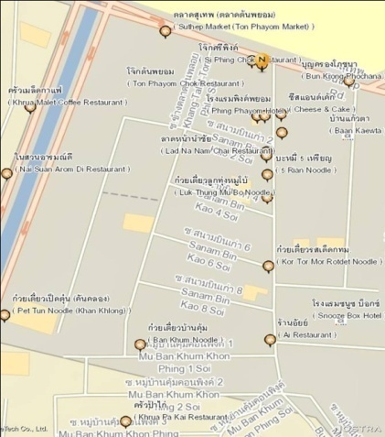

Figure 1 Nostra map in Thailand

Figure 1 shows Nostra Thailand map. User can see places on the map that provides locations are detailed and comprehensive. The map shows icon to distinguish sign.

**Pros**

Nostra map supports the service map for developing application. Nostra map service provides API services, API showcases and web map APIs. They are detailed and cover many places on the map in several provinces [3]. Nostra map is precise especially in Thailand. In addition, Nostra map support about the information of places on the map, for instance, phone number, address and coordinate [4].

**Cons**

Nostra map provides an application that supports only online connection. The phone numbers are text that cannot use to call from the application.

**2.1.2. Google Map**

Google Maps is a web service that provides detailed information about geographical areas and sites around the world [5]. Google Maps offers aerial and satellite views of various position.

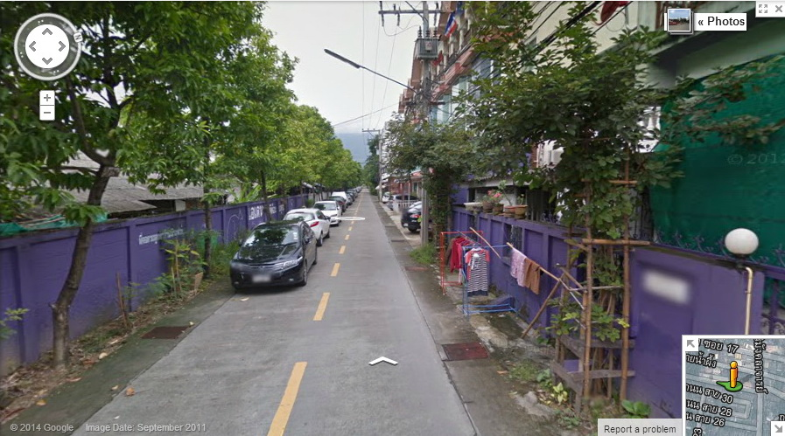

Figure 2 Google street views

Figure 2 presents street views including photographs in each point. Google street view is a technology featured in Google Maps and Google Earth that supplies panoramic views from places in accordance with many roadways in the world [6].

**Pros**

Google maps supports function Google Street View that enables users to view and navigate images of various cities.

**Cons**

Google Maps has not details enough some places in Thailand to show. The offline function of Google maps not provide to use in Thailand.

**2.1.3. Foursquare**

Foursquare is a location-based social computing, mobile computing, and geo location. [7] Users "check in" in places using a mobile website, text messaging or a device specific application by selecting from a list of places the application in the vicinity. Foursquare is an application that uses during on the way, so foursquare is designed for use with mobile phones easily. Foursquare process the GPS coordinates of the location of a mobile phone. Each user will be able to find its current position. Then specify the name of a place or area nearby to the list.

**Pros**

Foursquare is an application that can be used to advertise the business and for fun to share with friends on the social network. The user cans comments about the place that provide on the application [8].

**Cons**

Foursquare is an application that provides many places, for instance, restaurant, gas station, hospital, police station and so forth. So, it exceeds the needs of the user when they need information that can help to solve the problem.

**2.1.4. Bug 1113**

Bug 1113 is a service calls center that provides the information via telephone 24 hours a day. [9] Bug also provides officers to respond any inquiries of the customer. A service that allows customers to call regular telephone numbers, such as business, store, government official, and hotline number.

**Pros**

They have phone number that is easy to remember. Authorities provide 24-hour service.

**Cons**

The service calls center need to charge the phone. Officials do not know the location of the customer on the problem.

**2.1.5. Yellow Pages**

Yellow Pages refers to a telephone directory of businesses [10]. Yellow pages tabulated by category, using alphabetically by business name and in which advertising is sold. Now the yellow pages also applied to online directories of business. Online business directories are known as IYP (Internet yellow pages). All providers of Internet yellow pages propose online advertising. The users of Internet yellow pages have the same intent as the users of print yellow pages.

**Pros**

Yellow pages provide telephone number that is many and widely distributed. Internet yellow pages have more information on business listing than printed yellow pages. The information of phone number is up to date [11].

**Cons**

Yellow pages cannot use without the internet connection.

**2.2 Technology Review**

**2.2.1 Eclipse**

Eclipse is [integrated development environment](http://en.wikipedia.org/wiki/Integrated_development_environment). Eclipse is tool that use for developing application by Java language. Eclipse provides core components called the Eclipse Platform, which provides the main basis for the external tools. Plug-in Development Environment (PDE) is a component of Eclipse, which is used to add capabilities to develop more software [12].

**The selection of this technology**

Eclipse is the open source. Eclipse can be used with all versions of J2SDK. Eclipse supported with many operating systems, such as, Windows, Linux and Mac OS. Eclipse supported ADT (Android Development Tools) plug-in to develop android applications.

**2.2.2 Android Development Tools**

Android Development Tools is a plug-in for Eclipse IDE [13]. The tool is integrated environment in which to build android application. Android Development Tools extends the capabilities of Eclipse to set up new android project, create an application UI and add packages based on the android.

**The selection of this technology**

Android Development Tools is plug-in for Eclipse. It supported Eclipse to build android application.

**2.2.3 Android SDK**

Android SDK is a set of instructions for developing the applications on Android Operating System. The Android SDK includes API libraries, emulator and developer tools. Android SDK used to build, test, and debug the application for Android Operating System [14].

**The selection of this technology**

Android SDK provides emulator that simulates the functionality of the android applications and trial applications. Android SDK supported Eclipse to build android application.

**2.2.4 MySQL**

MySQL is the database management system (RDBMS) and the most popular Open Source SQL database management system [15]. MySQL is the most widely used databases for the site and compatible with popular programming language PHP. MYSQL must run via the MyODBC, ADO, and ADO. NET and so forth.

**The selection of this technology**

MySQL is open sources and easy to manage database. MySQL can work in many platforms and very flexible for the user.

**2.2.5 MapsWithMe API**

MapsWithMe API designed to allow integrating the offline maps with Android Operating System [16]. MapsWithMeAPI enables user to open offline maps. MapsWithMe API is external. MapsWithMe app should be downloaded before opening maps and markers on them. MapsWithMe API provides a marker on the map that receives information about the maker.

**The selection of this technology**

MapsWithMe API is an open source and allows for personal and commercial uses map API. It supports offline map for all countries. MapsWithMe API works on Android device.

**2.2.6 Google Maps Android API**

Google Maps Android API is the map base on Google Maps data. The API automatically handles access to Google Maps server, map display; data downloading and touch gestures on the map [17].

**The selection of this technology**

Google Maps Android API supports calculating distance between locations. Google Maps Android API works with Android SDK and provides longitude and latitude.

**2.2.7 Spring MVC**

Spring MVC is a Java Model-View-Controller web framework that helps in building the web application. Spring MVC helps the developers to develop code as the design pattern.

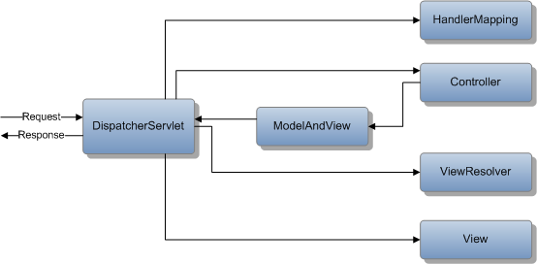

Figure 3 The flow Spring MVC

Figure 3 shows the flow of spring MVC [18]. Dispatcher servlet serves a request and response controls all functions. The handle mapping will control requests what it will go to controller. Next, the controller gets request and group the business process together, and then model and view is an object to return to the dispatcher servlet. View resolver is finder view object then sent back to the dispatcher servlet. Finally, the view part will show the response to the user.

**The selection of this technology**

The spring MVC is very Adaptability, non-intrusiveness, and flexibility. Management support Handle Exception and spring tag library description.

**Chapter Three | Quality Standard**

**3.1 ISO29110 for Very Small Entity (VSE)**

ISO29110 is a guide applies to a very Small Entity (VSE), enterprise, organization, department or project up to 25 people, dedicated to software development. The Guide provides Project Management and Software Implementation process which integrate practices base on the selection of ISO/IEC 12207 - *Systems and Software Engineering -Software Life Cycle Process* and ISO/IEC15289 *Software Engineering – Software Life Cycle Process – guideline for the content of software life cycle process information product (documentation)* standards element.

**3.1.1 Project Management process**

The purpose of the project Management process is to establish and carry out in a systematic way the task of the software implementation project, which allows complying with the project’s objective in the expected quality, time and cost.

Selected process

3.1.1.1 Project Planning Process

3.1.1.2 Project Plan Execution Process

3.1.1.3 Project Assessment and Control Process

3.1.1.4 Project Closer Process

**3.1.2 Software Implementation process**

The purpose of the Software Implementation process is the systematic performance of the analysis, design, construction, integration and tests activities for new or modified software products according to the specified requirement.

**Selected process**

3.1.2.1 Software Implementation Initiation Process

3.1.2.2 Software requirement Analysis Process

3.1.2.3 Software Architectural Design Process

3.1.2.4 Software Construction Process

3.1.2.5 Software Integration and test Process

3.1.2.6 Software Delivery Process Chapter

**Chapter Four | Project Plan**

**4.1 Motivation**

According to the unexpected events, the people may need to find assistance, hospital, police station, and garage, also a direction to go there. Although, they do not know their current location. They will be a little bit hard to find those locations and their contact information such as a phone number. The people may need to go to the closest help location. Nevertheless, they do not know where the nearest place and direction to go there. They will waste their time if they miscarry and go the wrong direction away from the closest help place. This reason leads to a new idea, which is a development of the Emergency Information on mobile.

**4.2 Aims and Objectives**

The aim of this project is to develop the Emergency Information on mobile application in order to aid the user when the emergency situation happened. Furthermore, to reduce the time to find the nearest help place and their contact information. In addition, the development of the offline mode allows the user to use when they lose the internet connection. So that, the user can use the application to find contact information of help places even when they cannot connect to the internet.

**4.3 Deliverables and Limits**

**4.3.1 Deliverables**

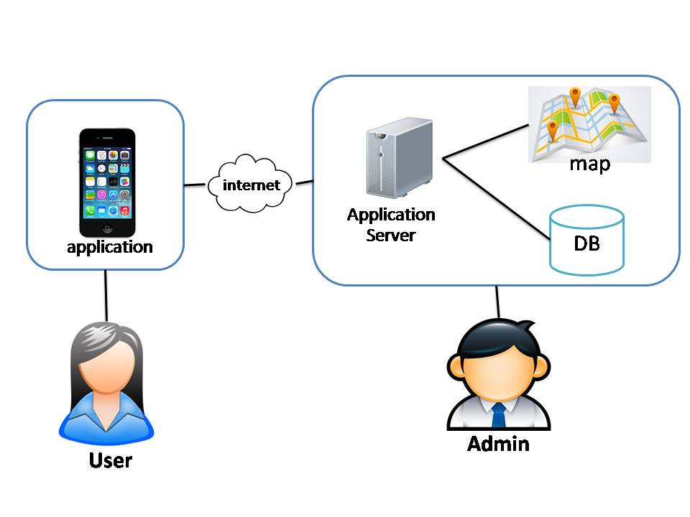

Figure 4 System Architecture of Emergency Information on mobile

Figure 4 presents system architecture including mobile part for the user and server part for the admin. The user uses the application and internet to connect with the application server. The admin manages the help data and updates the data to the application server.

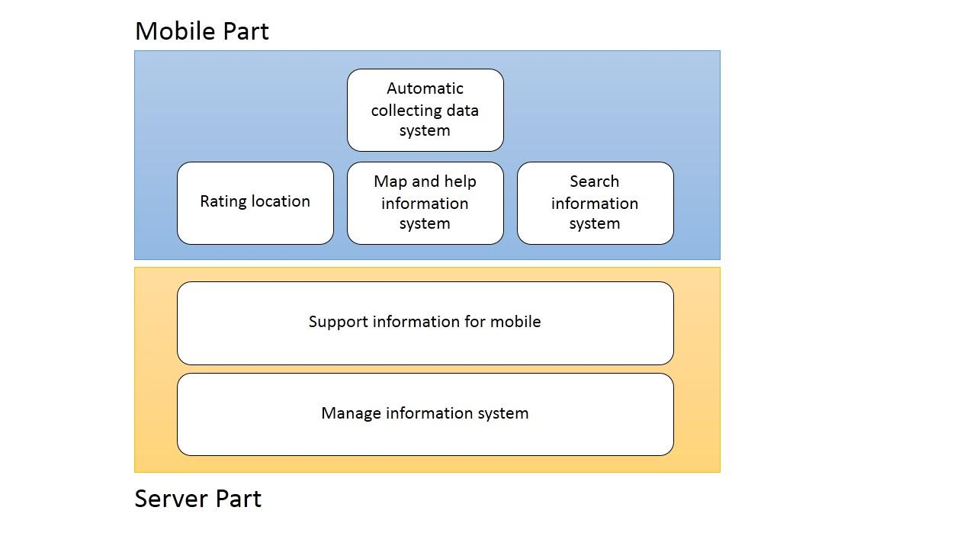

Figure 5 Architecture overview of Emergency Information on a mobile system

Figure 5 shows overall of architecture such as map and help information system, search information system and manage information system.

|  |  |  |  |
| --- | --- | --- | --- |
| **Feature** | **Function name** | **Online** | **Offline** |
| **Feature 1:** Map and help information system | View map with their current location. | √ | √ |
| View the help places | √ | √ |
| View help information of each help place | √ | √ |
| Make emergency call | √ | √ |
| View the route of distance between the current locations of user to the destination | √ |  |
| view details of each point on routing the direction | √ |  |
| **Feature 2:** Search information system | Search help place’s name by keyword | √ |  |
| Find the nearest help place by selection the category | √ | √ |
| **Feature 3:** Rating location | Rate the help place | √ |  |
| View average rating score of each help place | √ | √ |
| **Feature 4:** Automatic collecting data system | Download data of help place automatically | √ |  |
| Set the scope for downloading data | √ |  |
| **Feature 5:** Manage information system | Add help place | √ |  |
| Edit help place | √ |  |
| Remove help place | √ |  |
| View information of the help place | √ |  |
| Browse the help place by category | √ |  |
| Browse the help place by province | √ |  |
| Browse the help place by help place’s category and help place’s province | √ |  |
| Login to the system | √ |  |
| Logout of the system | √ |  |
| Update account’s password | √ |  |
| **Feature 6:** Support information for mobile | Sent nearest help place in JSON form | √ |  |
| Sent list of all help places in JSON form | √ |  |
| Sent list of all help places in setting scope in JSON form | √ |  |
| Retrieve new average rating score | √ |  |

**Mobile Part**

**Feature 1: Map and help information system**

In this feature, the help place will show on the map with their information such as address and phone number. Moreover, the phone number can be called directly on the application.

**Feature 2: Search information system**

Feature 2 provides search help place by keyword or name of help place. Furthermore, the application can show the nearest help place in many categories such as a police station, hospital, and garage.

**Feature 3: Rating location**

In this feature, the user can use the rate function to rate each help place. One user will be count at one for rating each place. The rating location collects the rate and provides the average rate to the user. Furthermore, the rate function will help the user to compose their decision to go among many help places.

**Feature 4: Automatic collecting data system**

Feature 4 will download data of help place around the user automatically and save into a mobile device. So, the information can show without the internet connection. In addition, the user can set the scope of download data.

**Server part**

**Feature 5: Manage information system**

Feature 5 furnishes manage information system to admin. The administrator can add, edit, remove, view information of the help place. Moreover, the administrator can browse the help place by selecting category or province. In addition, the server supports information of help place in JSON form to the mobile application.

**Feature 6: Support information for mobile**

Feature 6 will build information in form of JSON to support the mobile application.

* + 1. **Limits**

• The system shall be run on Android operating system only.

• The system shall show the name, phone number, and address of the help locations when no internet signals.

• The system shall load a data in radius of ten kilometers (default) from the user location.

• The system shall reload a new data when the user changes their location far from the old location in five kilometers (default).

• The system shall limit rating of place, one user will be count at one for rating each help place

**4.4 Software process**

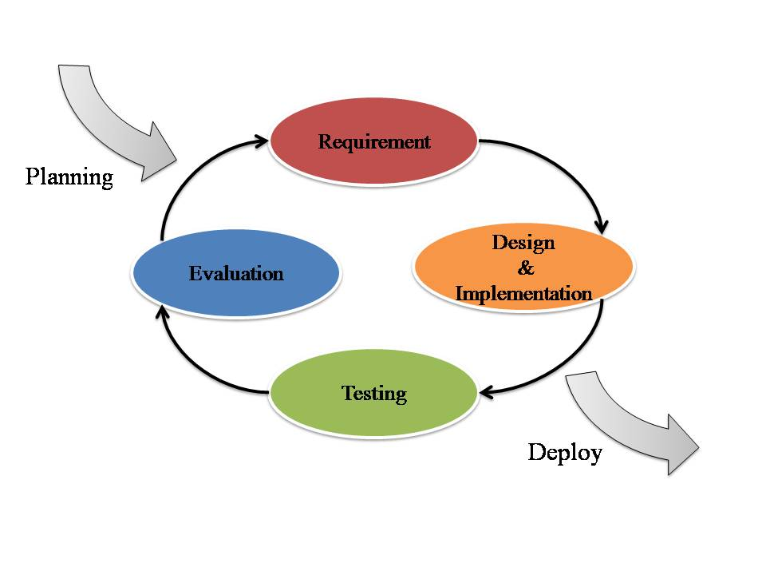

Figure 6 Iterative development models

Figure 6 presents a method of software development. Iterative development model is a cyclic software development process developed in response to the weaknesses of the Waterfall model. The model starts with planning and continues through iterative development cycles.

**Planning phase**: Before starting the iteration, make a question, goals, feature of products and scope of work.

**Requirement**: What is the demand of users?

**Design & Implementation**: Design and develop in order to produce a working end product.

**Testing**: Verify the quality of product.

**Evaluation**: Collect feedback from the working group.

**Deploy**: Final product is complete and the user acceptance testing.

**Advantage of Iterative development model**

Iterative development model encourage creating a high-level design of the application. A functioning product is available at the end of iteration. Iterative model less time is spent on documenting and more time is given for designing.

## 4.5 Schedule & Milestone

**Feature 1:** Map and help information system

**Feature 2:** Search information system

**Feature 3:** Rating location system

**Feature 4:** Automate collecting data system

**Feature 5:** Manage information system

**Feature 6:** Support information for mobile

|  |  |  |  |
| --- | --- | --- | --- |
| **Milestone** | **Task** | **Milestone Criteria** | **Planned date** |
| 1 | Proposal | Topic defined | February |
| 2 | Proposal | - Proposal reviewed  - Proposal submitted  - Proposal presentation | March |
| 3 | Progress Report I | - Software requirement specification  - Feature 1 and Feature 5  - Feature designed  - Test planned  - Feature implemented  - Feature tested  - Progress report submitted  - Progress report presentation | May |
| 4 | Progress Report II | - Feature 2 and Feature 4  - Feature designed  - Test planned  - Feature implemented  - Feature tested  - Progress report submitted  - Progress report presentation | July |

|  |  |  |  |
| --- | --- | --- | --- |
| 5 | Progress Report III | - Feature 3  - Feature designed  - Test planned  - Feature implemented  - Feature tested  - Progress report submitted  - Progress report presentation | October |

**Proposal**

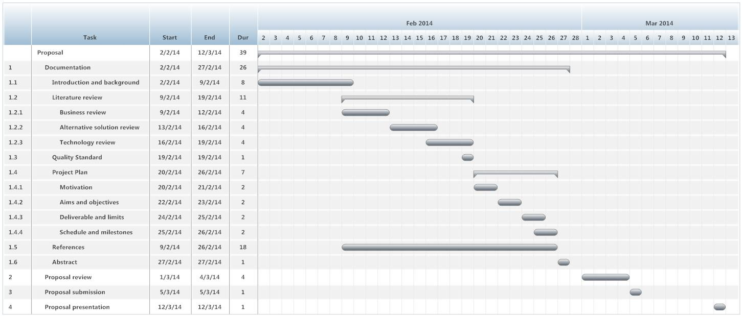

Figure 6 Milestone of proposal

Figure 6 shows duration of the proposal plan

**Progress Report I**

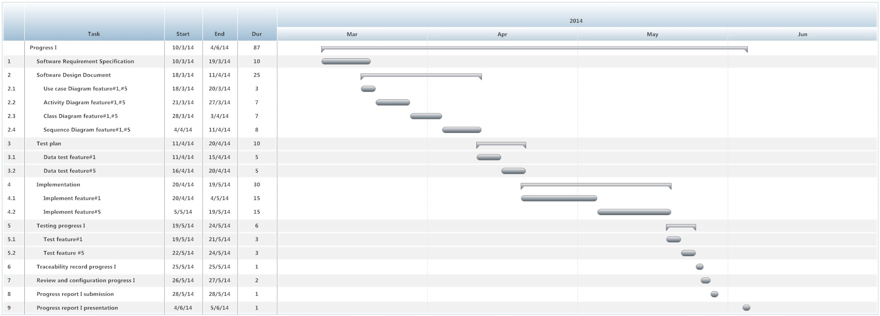

Figure 7 Milestone of progress report I

Figure 7shows duration of the progress report I

**Progress Report II**

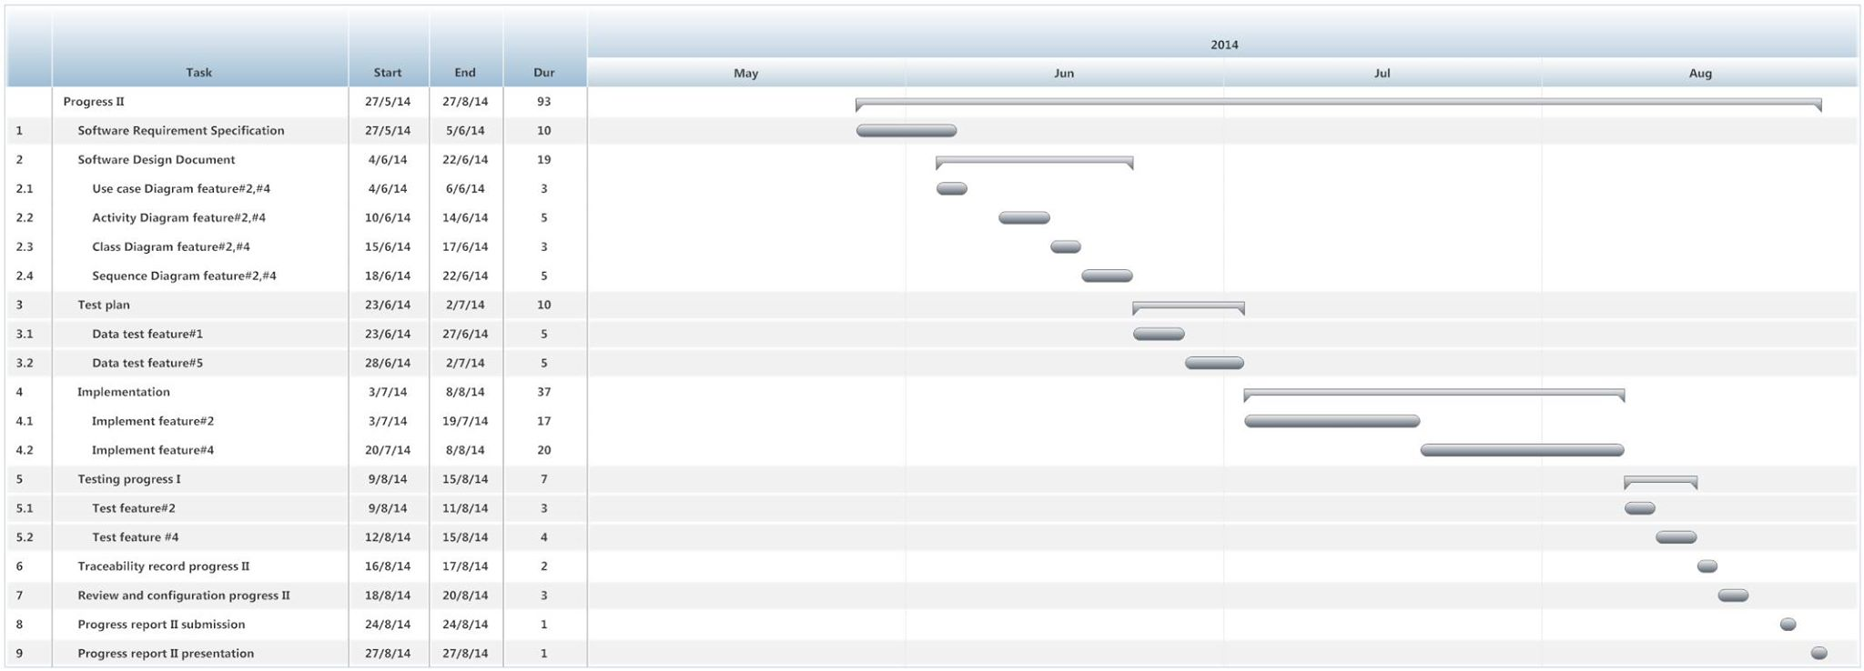

Figure 8 Milestone of progress report II

Figure 8 shows duration of the progress report II

**Progress Report III**

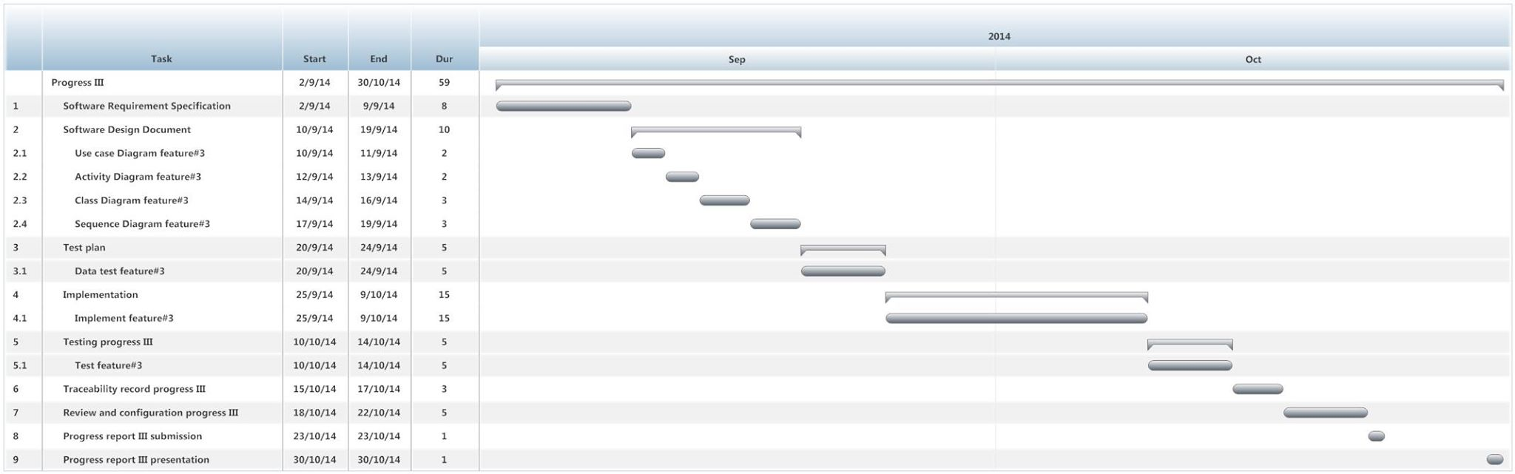

Figure 9 Milestone of progress report III

Figure 9 shows duration of the progress report III

**Chapter Five| References**

[1] Nostramap, about Nostramap

Retrieved from <http://www.nostramap.com/EN/PersonalNostraApp.aspx>

[2] Nostramap, about Nostramap

Retrieved from <http://www.macthai.com/2013/11/27/review-nostra-map-the-best-maps-data-for-thai-user/>

[3] Nostramap, about Nostramap

Retrieved from <http://www.nostramap.com/TH/business_map_service.aspx>

[4] Nostramap, about Nostramap

Retrieved from <http://www.iphonemod.net/review-nostra-map-thailand.html>

[5] Google map

Retrieved from http://whatis.techtarget.com/definition/Google-Maps

[6] Goole Street View

Retrieved from <http://en.wikipedia.org/wiki/Google_Street_View>

[7] Foursquare, about Foursquare

Retrieved from http://en.wikipedia.org/wiki/Foursquare

[8] Foursquare, about Foursquare

Retrieved from <http://lekasina.wordpress.com>

[9] Product & Service Bug 1113

Retrieved from <http://www.samartmultimedia.com/product_bug1113_eng.htm>

[10] The article about Yellow pages

Retrieved from <http://en.wikipedia.org/wiki/Yellow_pages>

[11] Benefits of YellowPages

Retrieved from <http://www.yellowpages.sc/en/home/benefits_of_yellowpages.sc.php>

[12] [Eclipse Introduction – What is eclipse](http://www.1stwebdesigner.com/design/html5-introduction/)

Retrieved from http://www.oknation.net/blog/print.php?id=111548

[13] ADT Plugin

Retrieved from http://developer.android.com/tools/sdk/eclipse-adt.html

[14] Android SDK

Retrieved from http://developer.android.com/sdk/index.html

[15] What is MySql

Retrieved from http://dev.mysql.com/doc/refman/4.1/en/what-is-mysql.html

[16] MapWithMe API

Retrieved from <http://mapswith.me/en/api>

[17] Developers Google Maps Android API

Retrieved fromhttps://developer.android.com/guide/topics/location/index.html

[18] Short Note Spring MVC part

Retrieved from http://phamonyut.blogspot.com/2008/10/short-note-spring-mvc.html