មេរៀនទី៥
Data Manipulation Language for Relational Database
SQL (Structure Query Language) គឺជាភាសាមួយដែលត្រូវបានប្រើនៅក្នុង DBMS សំរាប់បង្កើត Database បង្កើត Table និង ដំណើរការទិន្នន័យក្នុង Table។ ជាទូទៅ SQL ចែកចេញជាបីប្រភេទគឺៈ
- DDL (Data Definition Language) មាននាទីដូចជាៈ Create Table, Drop Table, Alter Table
- DML (Data Manipulation Language) មាននាទីដូចជាៈ Insert Into, Select Into, Update, Delete, Select
- DCL (Data Control Language) មាននាទីដូចជាៈ Alter Database, Create Group, Drop Group, Create User, Alter User, Drop User, Add User, Grant Privilege and Revoke Privilege
១. Data Definition Language
Data Definition Language (DDL) គឺជាភាសាកុំព្យូទ័រមួយប្រភេទដែលត្រូវបានគេ ប្រើសំរាប់បង្កើត Tables និង បង្កើត Relationship រវាង Table និង Table។
១.១. Creating Table
CREATE TABLE tablename
(
Column1 Data_Type1 Field​ Size [col_constraint1],
Column2 Data_Type2 Field​ Size [col_constraint2],
.............................................................................
ColumnN Data_TypeN Field​ Size [col_constraintN],
[, table_constraint1]
[, table_constraint2]
............................................................................
[, table_constraintN]
);
- ដើម្បីបង្កើត Table យើងដាច់ខាតត្រូវតែកំនត់ឈ្មោះ Table, Column ​names, Data Type, and Field sizes។
Data Type | Description
Decimal | -10^28-1 to 10^28-1
Float | Stores double-precision floating-point values
Integer | -2,147,483,648 to 2,147,483,647
Real | Stores single-precition floating-point values
Smallint | -32,768 to 32,767
TinyInt | 0 to 255
Char | 255 Characters
Text | 255 Characters
BIT | True/False, Yes/No, On/Off
Counter | Automatically increments
Date | 100 to 9999
Image | Pictures, Audio, and Video
Money
Currency
Memo | 1 to 65,536 Characters
Number

Constraint | Description
NULL/NOT NULL | Used to indicate if a field can be left blank when records are entered into a table.
PRIMARY KEY | Used to uniquely identify every record in a table.
FOREIGN KEY | Used to link records of a table to the records of another table.
UNIQUE | Used to ensure that every value in a column is different.
CHECK | Used to set criterion for the data entered into a column.

Example1:
ចូរបង្កើត Tables មួយចំនួនដែលមាន Fields និង Data Type ដូចខាងក្រោមៈ Data Dictionary
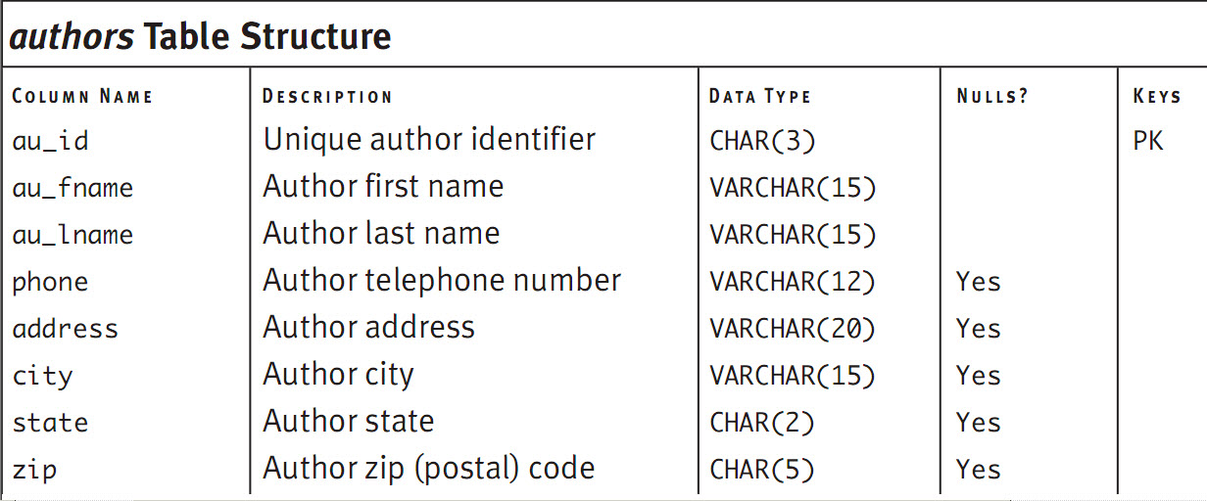

CREATE TABLE Authors
(
au_id CHAR(3) NOT NULL,
au_fname VARCHAR(15) NOT NULL,
au_lname VARCHAR(15) NOT NULL,
phone VARCHAR(15) ,
address VARCHAR(20) ,
city VARCHAR(15) ,
state VARCHAR(2) ,
zip CHAR(5) ,
CONSTRAINT pk_authors PRIMARY KEY (au_id)
)
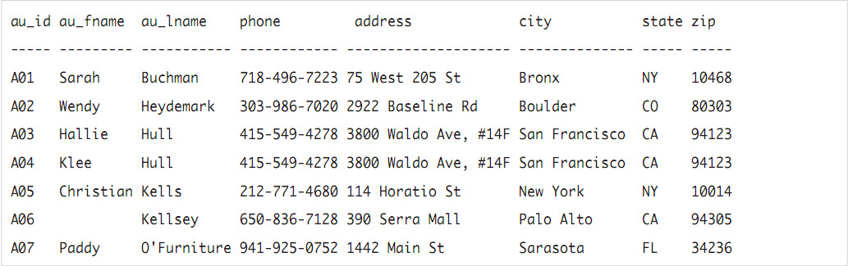
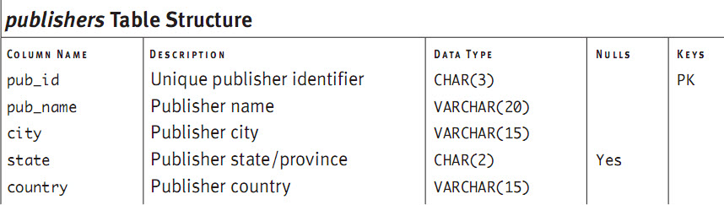
CREATE TABLE Publishers
(
pub_id CHAR(3) NOT NULL,
pub_name VARCHAR(20) NOT NULL,
city VARCHAR(15) NOT NULL,
state VARCHAR(2) ,
country VARCHAR(15) NOT NULL,
CONSTRAINT pk_publishers PRIMARY KEY (pub_id)
)
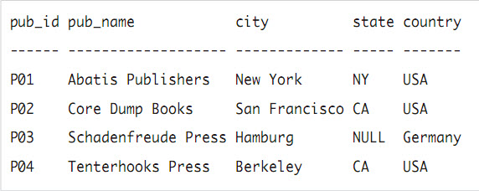
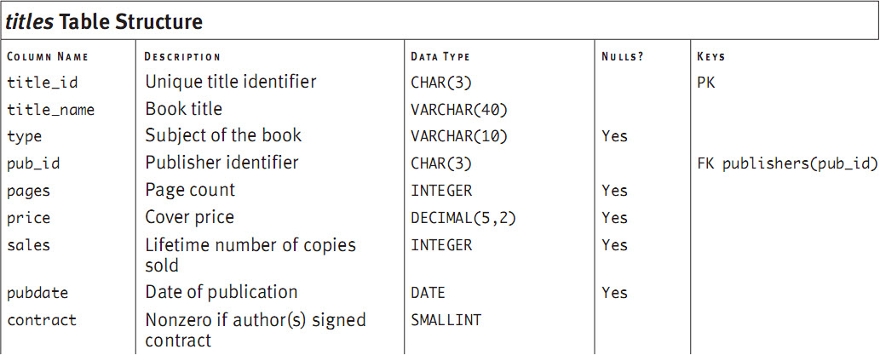
CREATE TABLE Titles
(
title_id CHAR(3) NOT NULL ,
title_name VARCHAR(40) NOT NULL ,
type VARCHAR(10) ,
pub_id CHAR(3) NOT NULL ,
pages INTEGER ,
price DECIMAL(5,2) ,
sales INTEGER ,
pubdate DATE ,
contract SMALLINT NOT NULL ,
CONSTRAINT pk_titles PRIMARY KEY (title_id),
CONSTRAINT pk_publishers FOREIGN KEY (pub_id) REFERENCES Publishers (pub_id)
ON UPDATE CASCADE
ON DELETE CASCADE
)
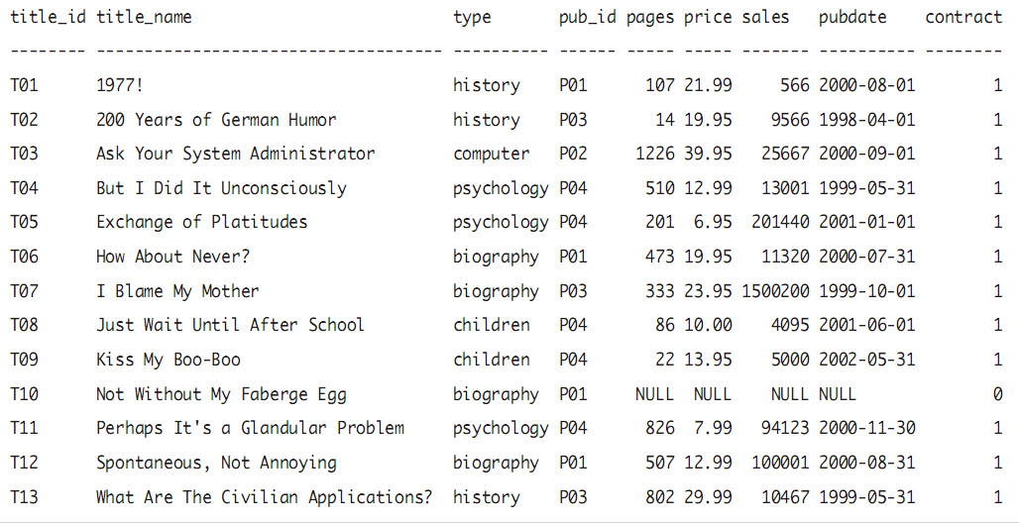
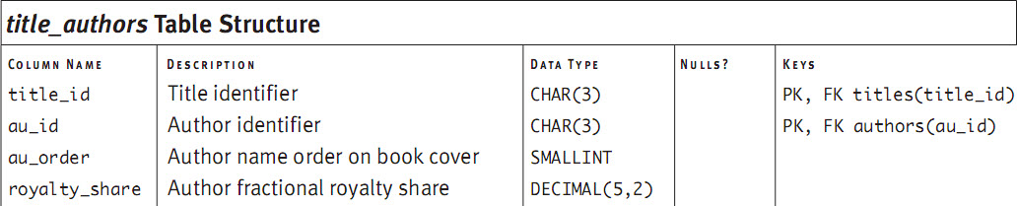
CREATE TABLE Title_Authors
(
title_id CHAR(3) NOT NULL,
au_id CHAR(3) NOT NULL,
au_order SMALLINT NOT NULL,
royalty_share DECIMAL(5,2) NOT NULL,
CONSTRAINT pk_title_author
PRIMARY KEY (title_id, au_id),
CONSTRAINT fk_titles FOREIGN KEY (title_id) REFERENCES titles (title_id)
ON UPDATE CASCADE
ON DELETE CASCADE,
CONSTRAINT fk_authors FOREIGN KEY (au_id) REFERENCES authors (au_id)
ON UPDATE CASCADE
ON DELETE CASCADE
)
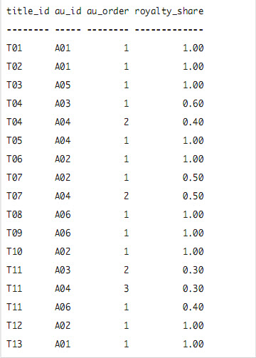
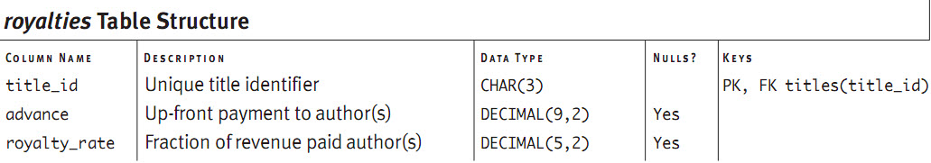
CREATE TABLE Royalties
(
title_id CHAR(3) NOT NULL ,
advance DECIMAL(9,2) ,
royalty_rate DECIMAL(5,2) ,
CONSTRAINT pk_royalties PRIMARY KEY (title_id),
CONSTRAINT fk1_title FOREIGN KEY (title_id) REFERENCES titles (title_id)
ON UPDATE CASCADE
ON DELETE CASCADE
)
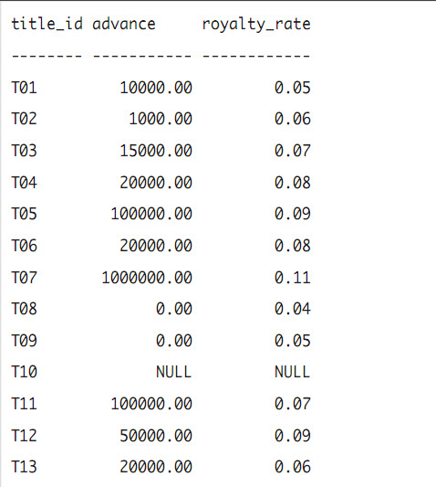
១.២. Dropping a Table
Syntax:
DROP TABLE Table_Name;
Example1:
DROP TABLE authors;
DROP TABLE publishers;
DROP TABLE titles;
DROP TABLE royalties;
DROP TABLE title_authors;

១.៣. Select Statement
Select Statement មានទ្រង់ទ្រាយដូចខាងក្រោមៈ
Syntax:
SELECT column(s) FROM table(s);
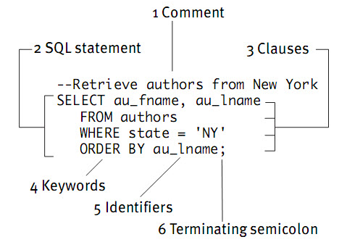
Example1: List the cities in which the authors live.
SELECT city FROM authors;
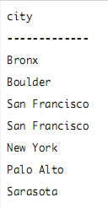
Example2: List each author’s first name, last name, city and state.
SELECT au_fname, au_lname, city, state FROM authors;
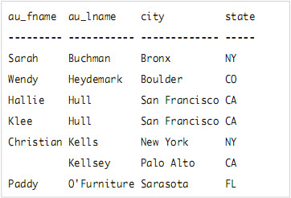

Example3: List all the columns in the table authors.
SELECT * FROM authors;
Example4: List each publisher’s city, state, and country
SELECT city, state, country FROM publishers;
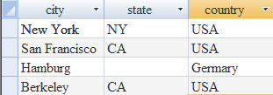
Creating Column Aliases with [AS]
Syntax:
SELECT column1 [AS] alias1,
column2 [AS] alias2,
................................
columnN [AS] aliasN,
FROM table;
Example5:
SELECT au_fname AS [First Name],
au_lname AS [Last Name],
city AS City,
zip AS [Postal Code]
FROM authors;
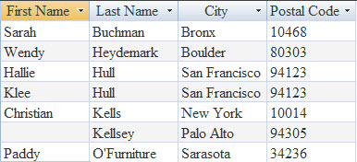

Eliminating Duplicate Rows with Distinct
Syntax:
SELECT DISTINCT column
FROM table;
Example6: List the states in which the authors live.
SELECT state FROM authors;
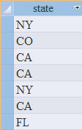
Example6.1: List the distinct states in which the authors live
SELECT DISTINCT state FROM authors;
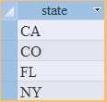
Example7: List the cities and states in which the authors live.
SELECT city, state FROM authors;
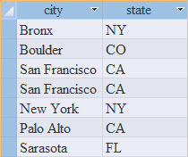
Example7.1:List the distinct cities and states in which the authors live
SELECT DISTINCT city, state FROM authors;
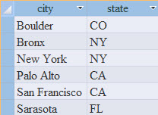

Sorting Rows with Order By
Syntax:
SELECT columns FROM table
ORDER BY sort_column [ASC|DESC];
Example8: List the author’s first names, last names, cities, and states, sorted by ascending last name.
SELECT au_fname, au_lname, city, state FROM authors
ORDER BY au_lname ASC;
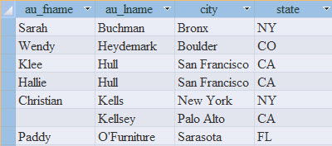

Example9: List the author’s first names, last names, cities, and states, sorted last name by descending
SELECT au_fname, au_lname, city, state FROM authors
ORDER BY au_fname DESC;
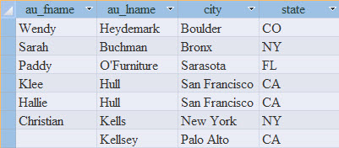
To Sort by Multiple Columns
Syntax:
SELECT columns FROM table
ORDER BY sort_column1 [ASC|DESC],
sort_column2 [ASC|DESC],
.........................................
sort_columnN [ASC|DESC]; ‘
Example10: List the author’s first names, last names, cities, and states, sorted state by ascending and city by descending
SELECT au_fname, au_lname, city, state FROM authors
ORDER BY state ASC, city DESC;
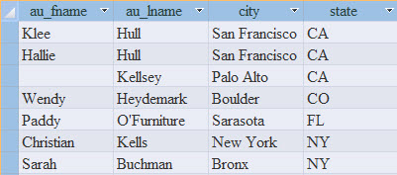
Example11: List the author’s first names, last names, cities, and states, sorted state by ascending and au_lname by descending.
SELECT au_fname, au_lname, city, state FROM authors
ORDER BY state ASC, au_lname DESC;
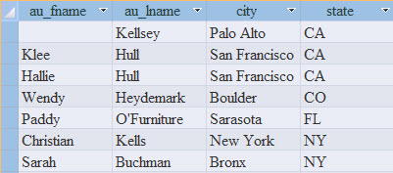
Example12:
Syntax:
MID(string, start [,length])

SELECT au_id, phone FROM authors
ORDER BY MID(phone, 1, 3)
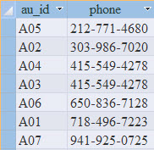
Example13: List the author’s first names, last names, cities, and states, sorted state, au_fname and au_lname by ascending
SELECT au_fname AS [First Name], au_lname AS [Last Name],
state FROM authors
ORDER BY state ASC,
au_fname ASC,
au_lname ASC;
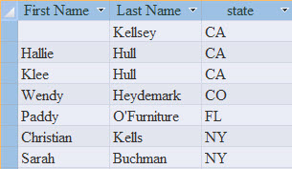
Example14: List title_id, price, sales and revenue and sort revenue by DESC
SELECT title_id, price, sales, price*sales AS Revenue
FROM titles
ORDER BY price*sales DESC;
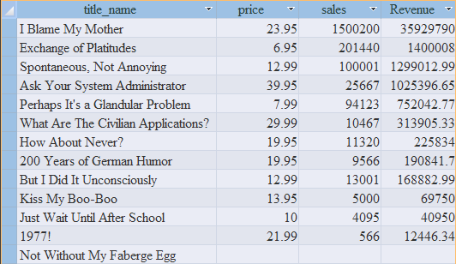
Filtering Rows with Where
Syntax:
SELECT columns FROM table
WHERE test_column op value;
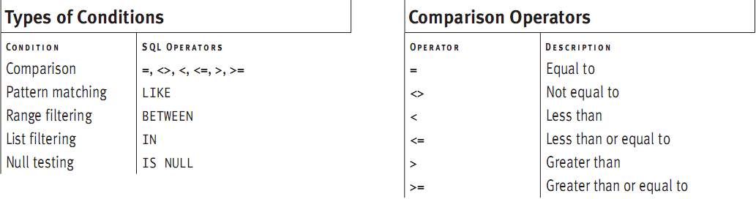
Example15: List the authors whose last name is not Hull
SELECT au_id, au_fname, au_lname
FROM authors
WHERE au_lname <> ‘Hull’
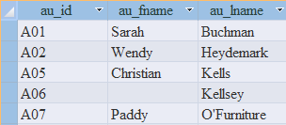
Example16:List the titles for which there is no signed contract
SELECT title_name, contract
FROM titles
WHERE contract=0
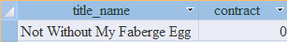
Example17: List the titles published in 2001 and later
SELECT title_name, pubdate
FROM titles
WHERE pubdate>=#01/01/2001#
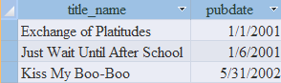
Example18:List the titles that generated more than $1million revenue
SELECT title_name, price*sales AS Revenue
FROM titles
WHERE price*sales>=1000000
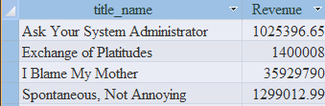
Combining and Negating Conditions with AND, OR, and NOT
Example19: List the biographies that sell for less than $20
SELECT title_name, type, price
FROM titles
WHERE type=’biography’ AND price<20;
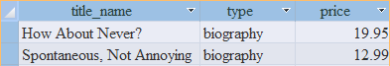

Example20: List the authors whose last names begin with one of the letters “H” through “Z” and who don’t live in California.
SELECT au_fname, au_lname
FROM authors
WHERE au_lname>='H' AND au_lname<='Z' AND state <>'CA'
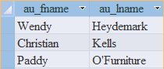
Example21: List the authors who live in New York State, Colorado, or San Francisco.
SELECT au_fname, au_lname, city, state
FROM authors
WHERE (state='NY') OR (state='CO') OR (city ='San Francisco')
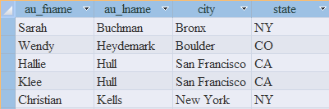
Example22: List the publishers that are located in California or are not located in California.
SELECT pub_id, pub_name, state, country
FROM publishers
WHERE (state='CA') OR (state<>'CA')
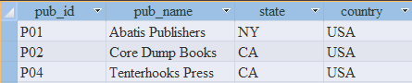
Example23: List the authors who don’t live in California.
SELECT au_fname, au_lname, state
FROM authors
WHERE NOT (state='CA')
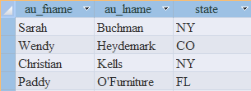

Example24: List the titles whose price is not less than $20 and that have sold more than 15,000 copies.
SELECT title_name, sales, price
FROM titles
WHERE (price>20 AND sales>15000)
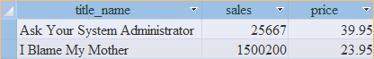
Example25: List history and biography titles with priced less than $20.
SELECT title_id, type, price
FROM titles
WHERE (type='history' OR type='biography') AND price<20
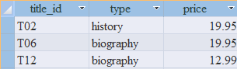
Matching Patterns with LIKE
Syntax:
SELECT columns
FROM table
WHERE test_column [NOT] LIKE ‘pattern’;
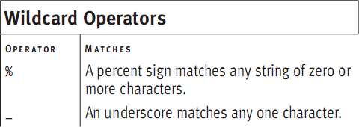
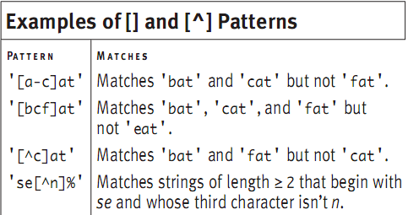
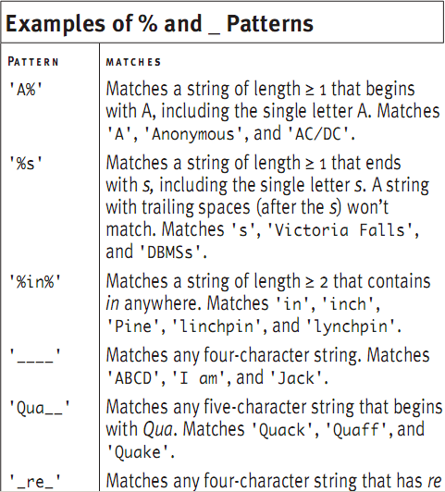
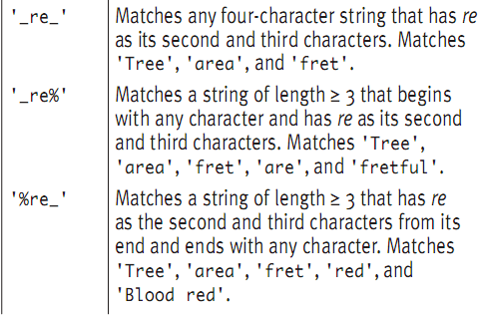

Example26: List the authors whose last names begin with Kel.
SELECT au_fname, au_lname
FROM authors
WHERE au_lname LIKE 'Kel%'
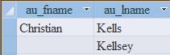
Example27: List the authors whose last names have ll as the third and fourth characters.
SELECT au_fname, au_lname
FROM authors
WHERE au_lname LIKE '__ll%'
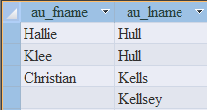
Example28: List the authors who have zip codes in the area begin with 94.
SELECT au_fname, au_lname, city, state, zip
FROM authors
WHERE zip LIKE '94___'
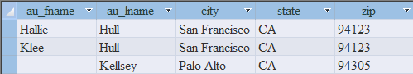
Example29: List the authors who live outside the 212, 415, and 303 area codes.
SELECT au_fname, au_lname, phone
FROM authors
WHERE phone NOT LIKE '212-___-____'
AND phone NOT LIKE '415-___-%'
AND phone NOT LIKE '303-%'
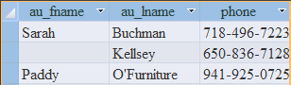
Range Filtering with BETWEEN
Syntax:
SELECT columns
FROM table
WHERE test_column BETWEEN low_value AND high_value
Example30: List the authors who live outside the zip range 20000-89999.
SELECT au_fname, au_lname, zip
FROM authors
WHERE zip NOT BETWEEN '20000' AND '89999'
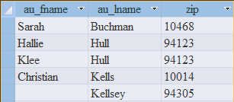
Example31: List the titles priced between $10 and $19.95, inclusive.
SELECT title_id, price
FROM titles
WHERE price BETWEEN 10 AND 19.95
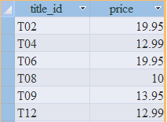
Example32: List the titles published in 2000.
SELECT title_id, pubdate
FROM titles
WHERE pubdate BETWEEN #01-01-2000# AND #31-12-2000#
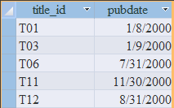
Example33: List the titles priced between $10 and $19.95, exclusive.
SELECT title_id, price
FROM titles
WHERE price NOT BETWEEN 10 AND 19.95
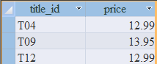
To filter rows by using a list
Syntax:
SELECT columns
FROM table
WHERE test_column [NOT] IN
(value1, value2,...)
Example34: List the authors who don’t live in NY, NJ or CA.
SELECT au_fname, au_lname, state
FROM authors
WHERE state NOT IN ('NY', 'NJ', 'CA')
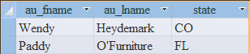
Example35: List the titles for which advance of $0, $1000 or $5000 were paid.
SELECT title_id, advance
FROM royalties
WHERE advance IN (0.00, 1000.00, 5000.00)
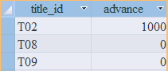
Example36: List the titles published on the first day of the year 2000, 2001 or 2002.
SELECT title_id, pubdate
FROM titles
WHERE pubdate IN (#01-01-2000#, #01-01-2001#, #01-01-2002#)
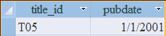
To retrieve rows with nulls or non-null values.
Syntax:
SELECT columns
FROM table
WHERE test_column IS [NOT] NULL
Example37: List the biographies whose publication dates are known.
SELECT title_id, type, pubdate
FROM titles
WHERE type='biography' AND pubdate IS NOT NULL

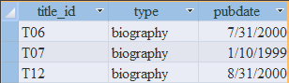
Using Aggregate functions
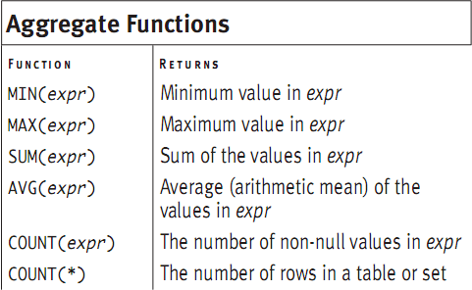

NOTE: SUM() and AVG() work with only numeric data types. MiN() and MAX() work with character, numeric, and datetime data types. COUNT(expr) and COUNT(*) work will all data types.
Finding a minimum and maximum with MIN() and MAX()
Syntax:
MIN(expr)
MAX(expr)
expr: is a column name or expression
Example38: List the price of the lowest-priced book
SELECT MIN(price) as [MIN Price]
FROM titles;
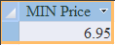
Example39: List the earliest publication date.
SELECT MIN(pubdate) as [Earliest PubDate] FROM titles;
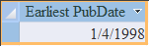
Example40: List the number of pages in the shortest history book.
SELECT MIN(pages) AS [MIN history pages]
FROM titles WHERE type = 'history'
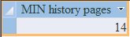
Example40a: List the author’s last name that is last alphabetically.
SELECT MAX(au_lname) AS [MAX Last Name]
FROM authors.
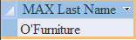
Example41: List the prices of the cheapest and most expensive books, as well as the price range.
SELECT MIN(price) AS [MIN Price],
MAX(price) AS [MAX Price],
MAX(price) – MIN(price) AS [Range]
FROM titles;
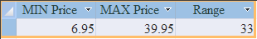
Example42: List the highest revenue(=price*sales) among the history books.
SELECT MAX(price*sales) as [MAX history revenue]
FROM titles
WHERE type = ‘history’;
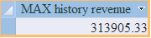
Calculating a Sum with SUM()
Syntax:
SUM(expr)
expr: is a column name or expression
Example43: List the total advances paid to all authors.
SELECT SUM(advance) AS [Total advances] FROM Royalties;
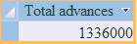
Example44: List the total sales of books published in 2000.
SELECT SUM(sales) AS [Total sales (2000 books)]
FROM titles
WHERE pubdate BETWEEN #01/01/2000# AND #31/12/2000#
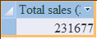
Example45: List the total price, sales, and revenue(=price*sales) of all books.
SELECT SUM(price) AS [Total price],
SUM(sales) AS [Total sales],
SUM(price*sales) AS [Total revenue]
FROM titles;
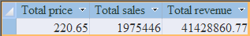
Calculating an Average with AVG()
Syntax:
AVG(expr)
expr: is a column name or numeric expression.
Example46: List the average price of all books if prices were double.
SELECT AVG(price*2) AS [Price * 2] FROM titles;
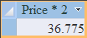
Example47: List the average and total sales for business books.
SELECT AVG(sales) AS [AVG(sales)],
SUM(sales) AS [SUM(sales)]
FROM titles WHERE type='business'
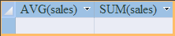
Note: Both calculations are null (not zero), because the table contains no business books.
Counting Rows with COUNT()
- COUNT(expr): returns the number of rows in which expr is not null
- COUNT(*): returns the count of all rows in a set, includng nulls and duplicates.
Syntax:
COUNT(expr): expr is a column name or expression. The result is an integer greater than or equal to zero.
COUNT(*): The result is an integer greater than or equal to zero.
Example48:
SELECT COUNT(title_id) AS [COUNT(title_id)],
COUNT(price) AS [COUNT(price)], COUNT(*) AS [COUNT(*)]
FROM titles;
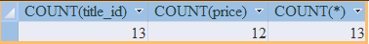
Example49:
SELECT COUNT(title_id) AS [COUNT(title_id)],
COUNT(price) AS [COUNT(price)], COUNT(*) AS [COUNT(*)]
FROM titles WHERE price IS NULL;

Example50:
SELECT COUNT(title_id) AS [COUNT(title_id)],
COUNT(price) AS [COUNT(price)], COUNT(*) AS [COUNT(*)]
FROM titles WHERE price IS NOT NULL;
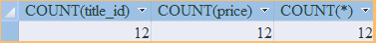
Example51:
SELECT
((COUNT(*)-COUNT(price))*100)/COUNT(*) AS [% of null]
FROM titles
Example52:
SELECT COUNT(*)-COUNT(price) AS [Number of null]
FROM titles
Grouping Rows with GROUP BY
Syntax:
SELECT columns FROM table
[WHERE search_condition]
GROUP BY grouping_columns
[ORDER BY sort_columns]
Example53: List the number of books each author wrote.
SELECT au_id, COUNT(*) AS Num_books
FROM title_authors GROUP BY au_id;
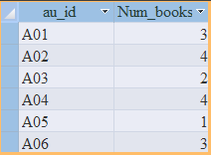
Example54:
SELECT state, COUNT(state) AS [Count(state)],
COUNT(*) AS [COUNT(*)] FROM publishers GROUP BY state;
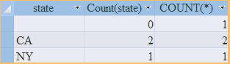
Example55:
SELECT type, SUM(sales) AS [SUM(sales)],
COUNT(sales) AS [COUNT(sales)], COUNT(*) AS [COUNT(*)],
FORMAT(SUM(sales)/COUNT(sales), "0.00") AS [SUM/COUNT(sales)],
FORMAT(SUM(sales)/COUNT(*), "0.00") AS [SUM/COUNT(*)],
FORMAT(AVG(sales), "0.00") AS [AVG(sales)]
FROM titles
GROUP BY type;
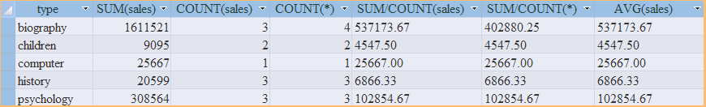
Example56:
SELECT type, SUM(sales) AS [SUM(sales)],
FORMAT(AVG(sales), "0.00") AS [AVG(sales)],
COUNT(sales) AS [COUNT(sales)]
FROM titles GROUP BY type;
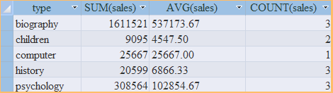
Example57:
SELECT type, SUM(sales) AS [SUM(sales)],
FORMAT(AVG(sales), "0.00") AS [AVG(sales)],
COUNT(sales) AS [COUNT(sales)]
FROM titles WHERE price>=13
GROUP BY type ORDER BY SUM(sales) DESC;
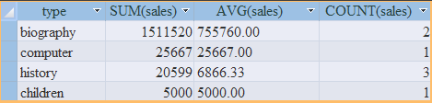
Example58: List the number of books of each type for each publishers, sorted by descending count within ascending publisher ID.
SELECT pub_id, type, COUNT(*) as [COUNT(*)]
FROM titles
GROUP BY pub_id, type
ORDER BY pub_id ASC , COUNT(*) DESC;
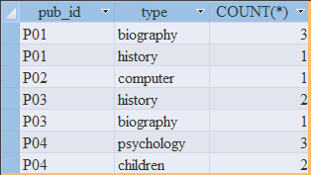
Example59: List the average sales for each price, sorted by ascending price.
SELECT price, AVG(sales) AS [AVG(sales)]
FROM titles WHERE price IS NOT NULL
GROUP BY price ORDER BY price ASC
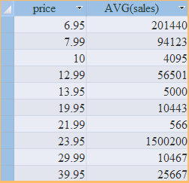
Filtering Groups with HAVING
Syntax:
SELECT columns
FROM tables
[WHERE search_condition]
[GROUP BY grouping_columns]
HAVING search_condition
[ORDER BY sort_columns]
Example60: List the number of books written by each author who has written 3 or more books.
SELECT au_id, COUNT(*) AS [Num_books]
FROM title_authors
GROUP BY au_id
HAVING COUNT(*)>=3
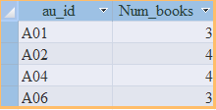
Example61: List the number of titles and average revenue for the types with average revenue more than $1 million.
SELECT type, COUNT(price) AS [Count(price)],
FORMAT(AVG(price*sales), "0.00") AS [AVG_revenue]
FROM titles
GROUP BY type
HAVING AVG(price*sales) >1000000
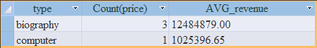

Example62: List the number of books of each type for each publisher, for publishers with more than one title of a type.
SELECT pub_id, type, COUNT(*) AS [Count(*)]
FROM titles
GROUP BY pub_id, type
HAVING COUNT(*)>1
ORDER BY pub_id ASC, COUNT(*) DESC
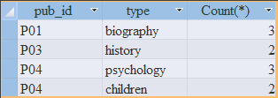
Example63: For books from publishers PO3 and P04, list the total sales and average price by type, for types with more than $10,000 total sales and less than $20 average price.
SELECT pub_id, type, SUM(sales) AS [SUM(sales)],
AVG(price) AS [AVG(price)]
FROM titles
WHERE pub_id IN ('P03', 'P04')
GROUP BY pub_id, type
HAVING SUM(sales) >10000 AND AVG(price)<20
OR
SELECT pub_id, type, SUM(sales) AS [SUM(sales)],
AVG(price) AS [AVG(price)]
FROM titles
GROUP BY pub_id, type
HAVING SUM(sales) >10000 AND AVG(price)<20
AND pub_id IN ('P03', 'P04')
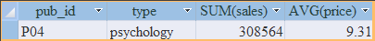
Using JOIN
SELECT columns
FROM table1 join_type table2 ON join_conditions
[WHERE search_condition]
[GROUP BY grouping_columns]
[HAVING search_condition]
[ORDER BY sort_column]
To qualify a column name:
Syntax:
table.column
The SQL JOIN clause is used whenever we have to select data from 2 or more tables.
There are 2 types of SQL JOINS – INNER JOINS and OUTER JOINS.

INNER JOIN
Syntax:
SELECT columns
FROM table1 INNER JOIN table2
ON join_conditions
Example64: List the authors firstname, lastname and city who live in the same city as some publishers.
SELECT au_fname, au_lname, authors.city
FROM authors INNER JOIN publishers
ON authors.city=publishers.city
OR
SELECT au_fname, au_lname, authors.city
FROM authors, publishers
WHERE authors.city=publishers.city
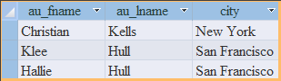
Example65: List each book’s title ID and each book’s author id, firstname and lastname, sorted by ascending au_id and title_id.
SELECT a.au_id, a.au_fname, a.au_lname, ta.title_id
FROM authors a INNER JOIN title_authors ta
ON a.au_id = ta.au_id
ORDER BY a.au_id ASC, ta.title_id ASC
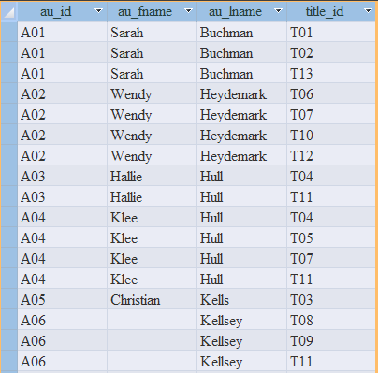
Example66: List each book’s title name and ID and each book’s publisher name and ID, sorted by ascending title_name.
SELECT t.title_id, t.title_name, t.pub_id, p.pub_name
FROM titles t INNER JOIN publishers p
ON p.pub_id=t.pub_id
ORDER BY t.title_name ASC
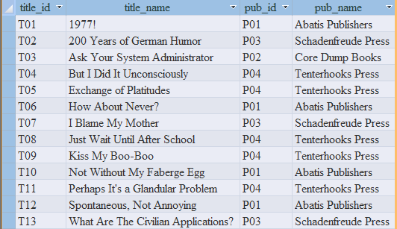
Example67: List the authors who live in the same city and state in which a publisher is located.
SELECT a.au_id, a.au_fname, a.au_lname, a.city, a.state
FROM authors a INNER JOIN publishers p
ON a.city = p.city AND a.state = p.state
ORDER BY a.au_id
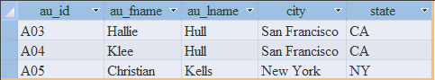
Example68: List the books published in California or outside USA, CANADA and MEXICO.
SELECT t.title_id, t.title_name, p.state, p.country
FROM titles t INNER JOIN publishers p
ON t.pub_id=p.pub_id
WHERE p.state='CA' OR
p.country NOT IN ('USA', 'CANADA', 'MEXICO')
ORDER BY t.title_id ASC
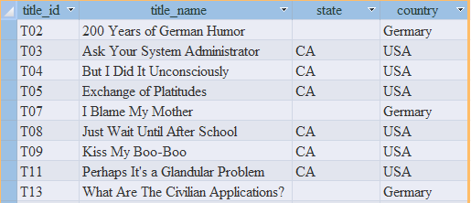
Example69: List the number of books that each author wrote.
SELECT a.au_id, COUNT(ta.title_id) AS [Num_books]
FROM authors a INNER JOIN title_authors ta
ON a.au_id = ta.au_id
GROUP BY a.au_id ORDER BY a.au_id ASC
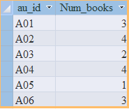
Example70: List the advance paid for each biography.
SELECT t.title_id, t.title_name, r.advance
FROM royalties r INNER JOIN titles t
ON r.title_id = t.title_id
WHERE t.type = 'biography' AND r.advance IS NOT NULL
ORDER BY r.advance DESC
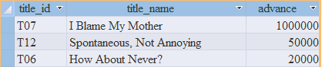
Example71: List the count and total advance paid for each type of book.
SELECT t.type, COUNT(r.advance) AS [COUNT(advance)], SUM(r.advance) AS [SUM(advance)]
FROM royalties r INNER JOIN titles t ON r.title_id=t.title_id
WHERE r.advance IS NOT NULL
GROUP BY t.type ORDER BY t.type ASC
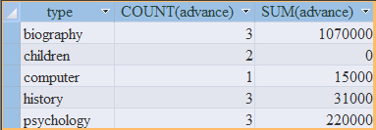
Example72: List the number of co-authors of each book written by two or more authors.
SELECT ta.title_id, COUNT(ta.au_id) AS [NUM authors]
FROM authors a INNER JOIN title_authors ta ON a.au_id=ta.au_id
GROUP BY ta.title_id
HAVING COUNT(ta.au_id)>1
ORDER BY ta.title_id ASC
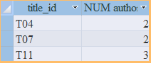
Example73: List each book whose revenue is at least 10 times greater than its advance.
SELECT t.title_id, t.title_name, r.advance, t.price * t.sales AS Revenue
FROM titles t INNER JOIN royalties r ON t.price*t.sales > r.advance*10 AND t.title_id=r.title_id
ORDER BY t.price * t.sales DESC
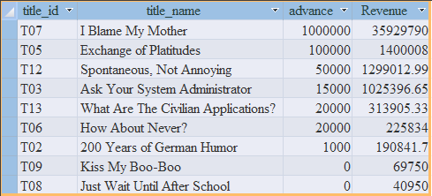
Example74: List the authors names and the names of the books that each author wrote (or cowrote).
SELECt a.au_fname, a.au_lname, t.title_name
FROM titles t INNER JOIN (authors a INNER JOIN title_authors ta ON a.au_id=ta.au_id) ON t.title_id = ta.title_id
ORDER BY a.au_lname, a.au_fname, t.title_name
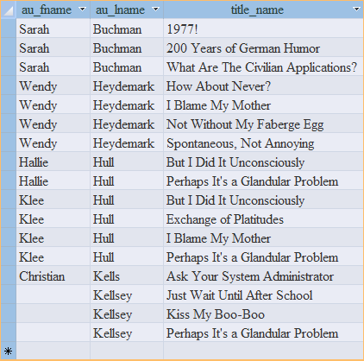
Example75: List the authors names, the names of the books that each author wrote (or cowrote), and the publisher names.
SELECT a.au_fname, a.au_lname, t.title_name, p.pub_name
FROM (publishers p INNER JOIN titles t ON p.pub_id=t.pub_id)
INNER JOIN (authors a INNER JOIN title_authors ta ON a.au_id=ta.au_id) ON t.title_id=ta.title_id
ORDER BY a.au_lname, a.au_fname, t.title_name
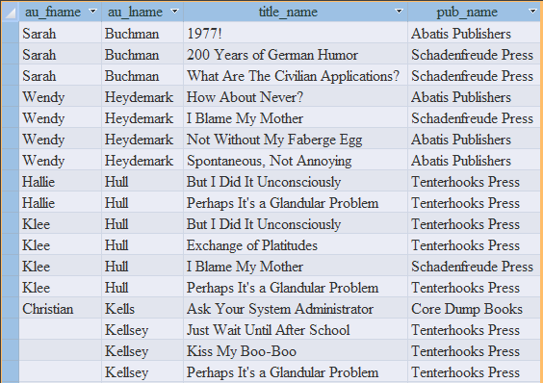
OUTER JOIN
Syntax:
SELECT columns
FROM table1 OUTER JOIN table2
ON join_conditions
- Left OUTER JOIN
SELECT columns
FROM left_table
LEFT OUTER JOIN right_table ON join_conditions
- Right OUTER JOIN
SELECT columns
FROM left_table
RIGHT OUTER JOIN right_table ON join_conditions
Example76: List all authors in the result, regardless of whether a publisher is located in the same city.
SELECT a.au_fname, a.au_lname, p.pub_name, p.state
FROM authors a LEFT OUTER JOIN publishers p ON a.city = p.city
ORDER BY p.pub_name, a.au_lname, a.au_fname
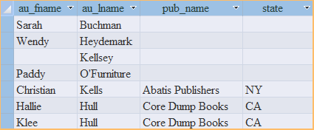
Example77: List all publishers, regardless of whether an author lives in the publisher’s city.
SELECT a.au_fname, a.au_lname, p.pub_name, p.state
FROM authors a RIGHT OUTER JOIN publishers p ON a.city = p.city
ORDER BY p.pub_name, a.au_lname, a.au_fname
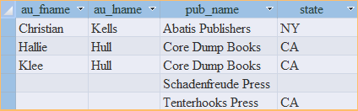
Example78: List the number of books that each author wrote, including authors who have written no books.
SELECT a.au_id, COUNT(ta.title_id) AS [Num Books]
FROM authors a LEFT OUTER JOIN title_authors ta
ON a.au_id=ta.au_id
GROUP BY a.au_id ORDER BY a.au_id
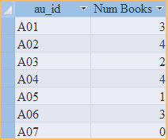
Example79: List the authors who haven’t written a book.
SELECT a.au_id, a.au_fname, a.au_lname
FROM authors a LEFT OUTER JOIN title_authors ta
ON a.au_id=ta.au_id
WHERE ta.au_id IS NULL
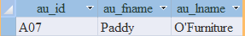
SUBQUERY SYNTAX
- WHERE test_expr op (subquery)
- WHERE test_expr [NOT] IN (subquery)
- WHERE test_expr op ALL(subquery)
- WHERE test_expr op ANY (subquery)
- WHERE [NOT] EXISTS (subquery)
Example80: List the authors who live in the same city in which a publisher is located.
SELECT au_id, city
FROM authors
WHERE city IN (SELECT city FROM publishers)
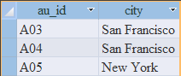
Example81: List the authors who haven’t written a book.
SELECT au_id, au_fname, au_lname
FROM authors
WHERE au_id NOT IN (SELECT au_id FROM title_authors)
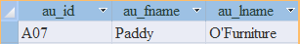
Example82: List the authors who live in the same state as author A04.
SELECT au_id, au_fname, au_lname, state
FROM authors
WHERE state IN (SELECT state FROM authors WHERE au_id='A04')
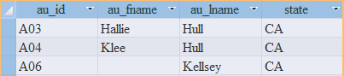
Example83: List all books whose price equals the highest book price.
SELECT title_id, price
FROM titles
WHERE price= (SELECT MAX(price) FROM titles)
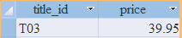
Example84: List the books that have sales greater than or equal to the average sales of books of its type.
SELECT candidate.title_id, candidate.type, candidate.sales
FROM titles candidate
WHERE sales>=
(SELECT AVG(sales)
FROM titles average
WHERE average.type=candidate.type)
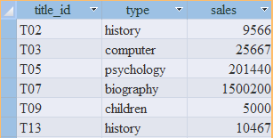

Inserting Row With Insert
Syntax
INSERT INTO table
VALUES(value1, value2,...,valueN)
Ex1: INSERT INTO authors VALUES('A08', 'Michael', 'Polk', '512-953-1231', '4028 Guadalupe St', 'Austin', 'Tx', '78701')
Syntax
INSERT INTO table (column1, column2,...,columnN)
VALUES(value1, value2,...,valueN)
Ex2: INSERT INTO authors
(au_id, au_fname, au_lname, phone, address, city, state, zip)
VALUES ('A09', 'Irene', 'Bell', '415-225-4689', '810 Throckmorton Ave', 'Mill Valley', 'CA', '94941')
Ex3: INSERT INTO authors(au_id, au_fname, au_lname, phone)
VALUES('A11', 'Max', 'Allard', '212-502-0955')
Ex4: INSERT INTO authors(zip, phone, address, au_lname, au_fname, state, au_id, city)
VALUES('60614', '312-998-0020', '1937 N. Clark St', 'Weston', 'Dianne', 'IL', 'A10', 'Chicago')
To Insert rows from one table into another table
Syntax:
INSERT INTO table [(column1, column2,...,columnN)]
subquery
Ex5: INSERT INTO publishers
SELECT pub_id, pub_name, city, state, country FROM new_publishers
WHERE city='Los Angeles'
Ex6: INSERT INTO publishers(pub_id, pub_name, city, state, country)
SELECT pub_id, pub_name, city, state, country FROM new_publishers
WHERE country<>'USA'
Updating Row With UPDATE
Syntax:
UPDATE table
SET column=expr
[WHERE search_condition]
Ex1: Change the value of contract to zero in every row.
UPDATE titles SET contract=0
Ex2: Double the price of history books.
UPDATE titles SET price=price*2.0 WHERE type='history'
Ex3: For psychology books, set the type to ‘self help’ and the number of pages to ‘NULL’.
UPDATE titles SET type='Self help', pages=NULL
WHERE type='psychology'

Ex4: Cut the sales of books with above average sales in half.
UPDATE titles SET sales=sales*0.5
WHERE sales>(SELECT AVG(sales) FROM titles)
Ex5: Change the publication date of all of Sarah Buchman’s books to January 1, 2003.
UPDATE titles SET pubdate=#01/01/2003# WHERE title_id IN
(SELECT title_id FROM title_authors WHERE au_id IN
(SELECT au_id FROM authors WHERE au_fname='Sarah' AND au_lname='Buchman'))
Deleting Row With DELETE
Syntax:
DELETE FROM table
[WHERE search_condition]
Ex1: Delete all rows from the table royalties.
DELETE FROM royalties;
Ex2: Delete the rows in which the author’s last name is Hull from the table authors.
DELETE FROM authors WHERE au_lname='Hull'
Ex3: Delete the rows for books published by publisher P01 or P04 from the table title_authors.
DELETE FROM title_authors
WHERE title_id IN (SELECT title_id FROM titles
WHERE pub_id IN('P01', 'P04'))

SELECT columns
FROM table1
INNER JOIN (table2
INNER JOIN (table3
INNER JOIN (table4
INNER JOIN ...)
ON table3.column3 op table4.column4)
ON table2.column2 op table3.column3)
ON table1.column1 op table2.column2;

