3GPP TSG RAN WG1 Meeting #88bis R1-1705082
Spokane, USA, 3rd - 7th April 2017

Agenda Item: 8.1.2.6
Source: Huawei, HiSilicon
Title: Discussion on phase3 system-level calibration for NR-MIMO
Document for: Discussion and decision

Introduction
In 3GPP RAN1#88 meeting, the summary of NR MIMO calibration was agreed as below.
Agreements:
- System level and link level NR MIMO calibration has been conducted through the following phased approaches:
  - Phase 1: Calibration is to check the link and system level channel models with basic beamforming behavior in terms of SNR/SINR distribution.
  - Phase 2: Calibration is to check the link/system level performance through observing the metrics of BLER, spectrum efficiency and outage.
  - Phase 3: Calibration is to check the additional link (if necessary)/system-level features including UE movement, UE rotation and channel blockage in terms of coupling loss, ASA, SINR and spectral efficiency.
  - Capture following simulation assumptions and results in TR 38.802.
    - R1-1701823 Evaluation assumptions for Phase 1 NR MIMO link level calibration
    - R1-1703534 Evaluation assumptions for Phase 1 NR MIMO system level calibration
    - R1-1703535 Evaluation assumptions for Phase 2 NR MIMO link level calibration
    - R1-1703536 Evaluation assumptions for Phase 2 NR MIMO system level calibration
    - R1-1701828 Evaluation assumptions for Phase 3 NR MIMO system level calibration
    - R1-1701829 Calibration results for Phase 1 NR MIMO link level calibration
    - R1-1701830 Calibration results for Phase 1 NR MIMO system level calibration

For phase3, the introduction of additional features and UE movement makes the calibration campaign more challenging. Therefore, some algorithm independent metrics, e.g., the distribution of coupling loss becomes more important as the alignment of these metrics forms the foundation of the following calibration tasks.
In this contribution, we provided initial system level calibration results in terms of the mentioned metric for phase3, focusing on the impact of additional features including spatial consistency, blockage and UE rotation.

System level calibration results
In the following, system level calibration results are attached for urban macro scenario, considering the impact of additional features.

UE movement and spatial consistency
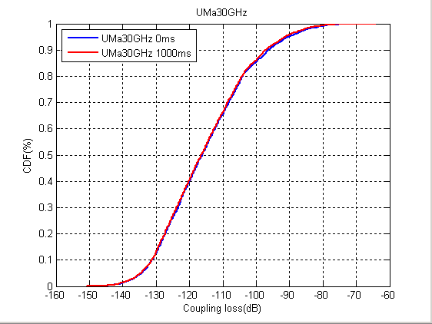
Figure 1: Coupling loss of Uma with/without UE movement and spatial consistency

Channel blockage
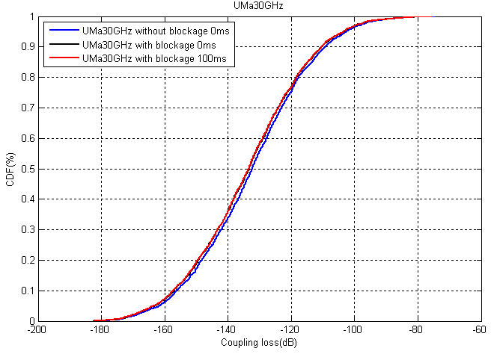
Figure 2: Coupling loss of Uma with/without channel blockage

UE rotation

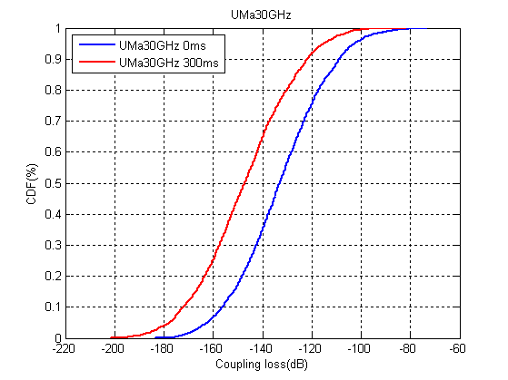
Figure 3: Coupling loss of Uma with/without UE rotation

Conclusion
In this contribution, we provided system level calibration results of NR MIMO phase3 with detailed evaluation parameters attached in the appendix. It was observed that the introduction of new additional features would impact the MIMO performance in terms of coupling loss. All proponents are encouraged to take these results and assumptions into account in the calibration campaign.

Appendix A
Table 1: Basic simulation assumptions
Parameter | Values or assumptions
Scenario | Urban Macro
Layout | Single layer  Macro layer: Hex Grid
ISD | 500m
Carrier Frequency | 30GHz
System bandwidth and carrier spacing | 40 MHz(60 kHz/RE)
Channel model | 5GCM UMa
BS Tx power | 43dBm
BS Antenna Configuration | (M,N,P,Mg,Ng) = (4,8,2,2,2)  (dH,dV) = (0.5, 0.5)λ  (dg,H,dg,V) = (4.0, 2.0)λ  a single TXRU is mapped per panel per polarization
UE Configuration | (M, N, P, Mg, Ng) = (2, 4, 2, 1, 2); (dV,dH) = (0.5, 0.5)λ. (dg,V,dg,H) = (0, 0)λ. Θmg,ng=90; Ω0,1=Ω0,0+180;  Notes: the polarization angles are 0 and 90
UE array orientation | Ω_{UT,α} uniformly distributed on [0,360] degree, Ω_{UT,β} = 0 degree, Ω_{UT,γ} = 0 degree  38.802: UE orientation for mobile device (Ω0,0, Θ0,0)=(U(0,360), 90)  The antenna elements of the same polarization of the same panel is virtualized into one TXRU
BS antenna pattern
UE antenna pattern | Follow TR 38.802
BS antenna height | 25m
UE antenna height | Follow TR36.873
BS antenna element gain | 8dBi
UE antenna element gain | 5dBi
UE receiver noise figure | 10dB
O2I penetration loss | 50% low loss and 50% high loss
Analog beam set | Direction of BS beams cover [-60, 60] degrees in azimuth domain and [90, 160] degrees in zenith domain.  -- Azimuth angle [-5*pi/16 -3*pi/16 -pi/16 pi/16 3*pi/16 5*pi/16]  -- Zenith angle [5*pi/8 7*pi/8]  Direction of UE beams cover [-90, 90] degrees in azimuth domain and [0, 180] degrees in zenith domain.  -- Azimuth angle [-3*pi/8 -pi/8 pi/8 3*pi/8]  -- Zenith angle [pi/4 3*pi/4]
UE attachment | Based on post-beamforming RSRP
Handover margin | 0dB

Table 2: Simulation assumptions for UE movement calibration
Parameter | Values or assumptions
Configurations for UE movement | UE is moving with random direction per drop based on spatial consistency feature in TR38.900 with fixed speed stated in TR 38.802 system evaluation assumptions for the corresponding scenario*;
Spatial consistency between NLOS and LOS | LOS/NLOS status is kept unchanged per simulation drop, i.e., without considering optional soft LOS state
Shadow fading with UE movement | Shadow fading is kept unchanged per simulation drop;
TRP reselection; | Collect the UE data without TRP reselection
UE distribution | 100% UE is outdoor in car
Updating interval for small scale parameters | The updating interval for small scale parameters is 1ms
Spatial consistency model | Spatial consistency model- procedure A in TR 38.900
* Each UE determines a moving direction randomly at the beginning and maintain the direction during the simulation

Table 3: Simulation assumptions for UE rotation calibration
Parameter | Values or assumptions
UE distribution | 20% Outdoor in cars: 30km/h,  80% Indoor in houses: 3km/h  10 users per TRP
Configurations for UE rotation | UE is rotating with random direction only for bearing angle per drop based on UE rotation feature in TR38.900 with fixed speed of 50 rpm.

Table 4: Simulation assumptions for channel blockage
Parameter | Values or assumptions
UE distribution | 20% Outdoor in cars: 30km/h,  80% Indoor in houses: 3km/h  10 users per TRP
Configurations for channel blockage | Blockage Model-A K=5 in TR38.900 for calibration
Time-domain properties of blockage model | Channel blockage is time invariant, i.e., the speed of the moving blocker = 0, and occurs only at the beginning of simulation drop.

