JDBC
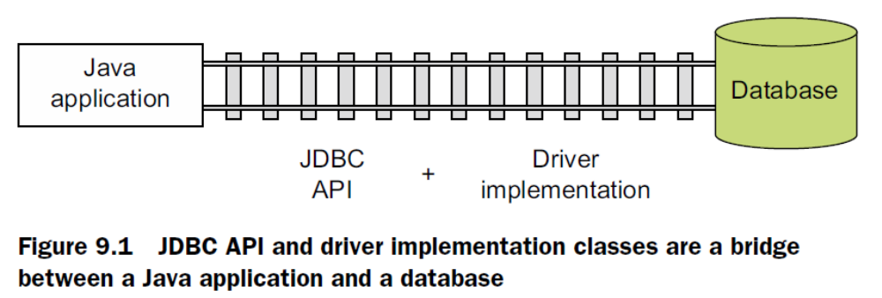

The JDBC API defines multiple interfaces, which are implemented by the database
vendor or a third party that your Java application is connecting with. The implementation
of these interfaces is bundled in a driver and made available to the Java application.
JDBC calls from your Java applications are converted to database calls by a driver.

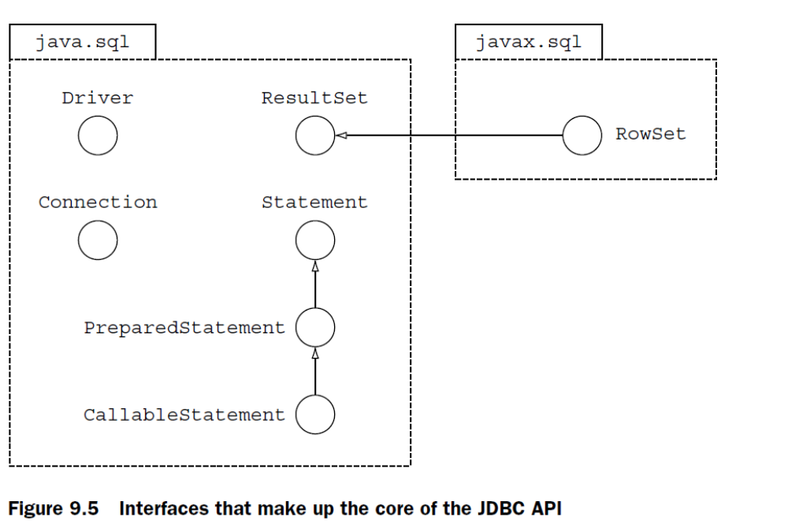

java.sql.Driver

When a database vendor
or third party develops a JDBC driver, it must implement this interface. When a class
implementing this interface is loaded into memory, it must create an instance of itself
and register itself with class DriverManager. It does this by defining a static initializer
block, which instantiates it and registers itself with class DriverManager.

You can manually load and register a driver by calling method forName() from
class java.lang.Class.

Class.forName("com.mysql.jdbc.Driver");

Manual loading of the drivers was required until JDBC version 3.0. Starting with
JDBC 4.0 and later, Java applications can automatically load and register the drivers
using the Service Provider Mechanism (SPM), introduced with Java 6 and JDBC 4.0.

For SPM, the driver needs to include the configuration file META-INF/services/java.sql.Driver in the .jar file. This file contains the name of the JDBC driver’s implementation
of java.sql.Driver.

java.sql.Connection

The interface java.sql.Connection represents a connection session with the specified
database.

- “Connection” – object which is returned if successfully connected to db

Interface java.sql.Statement

The interface java.sql.Statement is used to create and execute static SQL statements
and retrieve their results.

The interface Statement is extended by interfaces java.sql.PreparedStatement
and java.sql.CallableStatement. Objects of both of these subinterfaces represent
precompiled SQL statements, which execute faster than their uncompiled counterparts.
They can also be used to execute SQL statements with placeholders, using ?.
CallableStatements are used to execute database-stored procedures.
- “Statement” object is created from Connection
Interface java.sql.ResultSet

The interface java.sql.ResultSet is retrieved as a result of executing a SQL
SELECT statement against a database. It represents a table of data. The ResultSet
object can be read-only, scrollable, or updatable. By default, a ResultSet object is
only read-only and can be traversed in only one (forward) direction. You can create
a scrollable ResultSet (that can be traversed forward and backward) and/or an
updatable ResultSet by passing the relevant parameters during the creation of a
Statement object.

All together

Class java.sql.DriverManager talks with the JDBC driver to
return a Connection object, which can be used by your Java classes for all further communication
with the database.

A JDBC
driver is a set of classes provided by the database vendor, or a third party,
usually in a .jar or .zip file, to support the JDBC API. A Driver class is an
implementation of the interface java.sql.Driver in a JDBC driver.
To connect with a database, you need class DriverManager only once. When a JDBC
client needs to connect with a database, it connects with class DriverManager, which
finds an appropriate driver, establishes a connection with the database, and returns
the Connection object to the JDBC client.

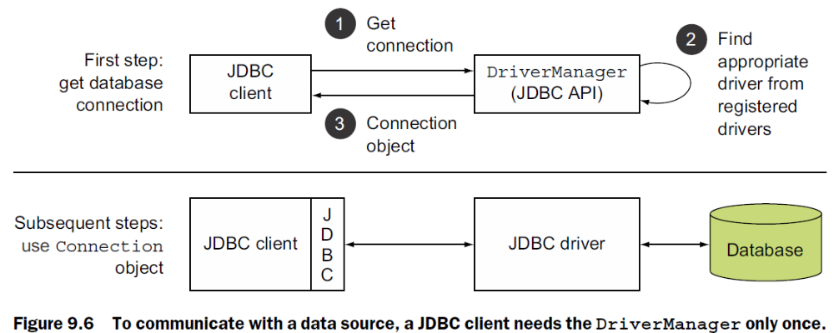

There are two ways to connect to a database: by using class java.sql.Driver-
Manager or the interface javax.sql.DataSource. Class DriverManager was
included in the JDBC API since its beginning and the interface DataSource was
added later in JDBC version 2.0. Class DriverManager is the preferred class to
establish database connections with Java SE applications because DataSource
works with the Java Naming and Directory Interface (JNDI). JNDI is usually supported
by Java applications with a container that supports JNDI like Java Enterprise Edition
Server. For the exam, you must only know how to establish a connection using a
DriverManager.

Method executeUpdate() is used to execute SQL queries to
insert new rows in a table, and update and delete existing rows. It’s also
used to execute DDL queries, such as the creation, modification, and deletion
of database objects like tables. If you use method executeQuery() for
any of these operations, you’ll get a SQLException at runtime.
The SQL statements that you include in your code are defined as string
values. This essentially means that even if any of the SQL statements are
invalid, the code compiles successfully. The Java application passes the
SQL statements to the database, which determines whether the SQL is
formed correctly or not. When a database receives an incorrect SQL statement,
it notifies the Java application with an appropriate exception and
message at runtime.

Because the interfaces Connection, Statement, and Result-
Set extend the interface AutoCloseable, you can create their instances in
a try-with-resources statement.

Method executeQuery() is used for SQL SELECT statements.

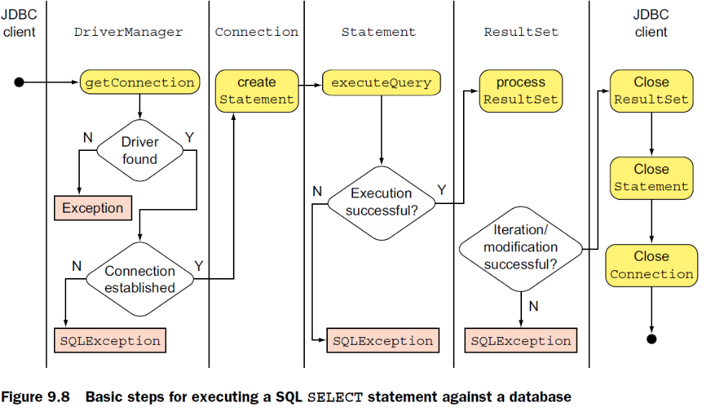

You need to call method executeUpdate() on Statement and not execute-
Query() to execute a Data Definition Language (DDL) request.

If your SQL statement doesn’t return any rows, the ResultSet
object doesn’t point to a null value. In this case, you’ll get a ResultSet
object that won’t include any rows.
rowset

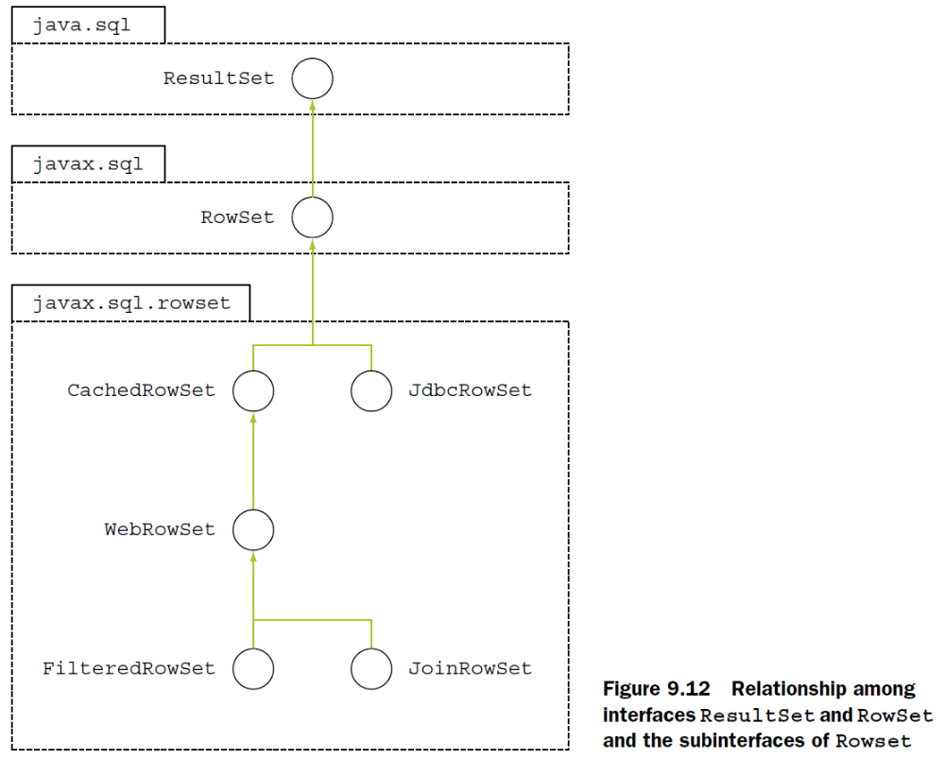
Interface RowSetFactory

The interface javax.sql.rowset.RowSetFactory defines the implementation of a
factory that can be used to obtain different types of RowSet implementations. Table 9.3
lists its methods.
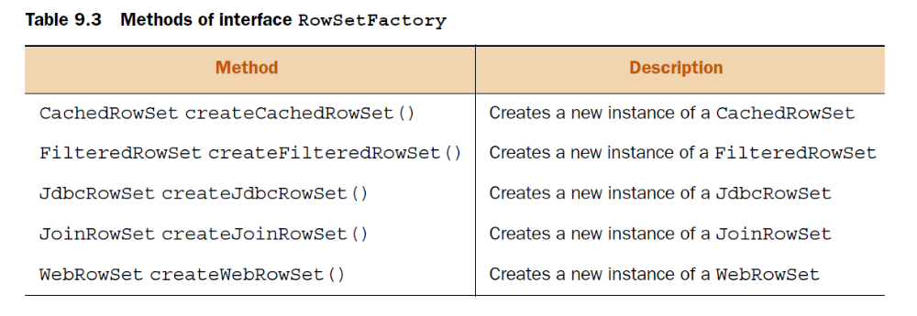
To get access to an object of RowSetFactory, you can use class RowSetProvider

Class RowSetProvider
Class javax.sql.rowset.RowSetProvider defines factory methods to get a RowSet-
Factory implementation. The RowSetFactory can then be used to create objects of
different types of RowSet implementations. Here’s how you can create an instance of
this default implementation and a JdbcRowSet using it:

RowSetFactory rowsetFactory = RowSetProvider.newFactory();
JdbcRowSet crs = rowsetFactory.createJdbcRowSet();

You can also specify a custom factory implementation by specifying its name.

static RowSetFactory newFactory()
static RowSetFactory newFactory(String factoryClassName, ClassLoader cl)

For example

RowSetFactory rowsetFactory = RowSetProvider.newFactory(
"com.ejava.sql.rowset.CustomRowSetFactory", null);

JdbcRowSet object accomplishes the following:

It establishes a connection with a database (so you don’t need a separate
Connection object).
■ It creates a PreparedStatement object for the query to execute (so you don’t
need a separate Statement object).
■ It executes the SQL statement to create a ResultSet object.

If the execute method isn’t successful, you can only call
execute and close methods on it. The rest of the methods will throw an
exception.

PREPARED Statement
If the execute method isn’t successful, you can only call
execute and close methods on it. The rest of the methods will throw an
exception.

