Collections
- Interfaces—Multiple interfaces like List, Set, Deque, and Map model the data structures used for storing, accessing, and manipulating a collection of data.
- Implementations—Concrete classes like ArrayList, HashSet, and TreeMap implement the interfaces
- Algorithms—Classes like Collections and Arrays contain utility methods like sort() and search() for sorting and searching List objects or arrays.

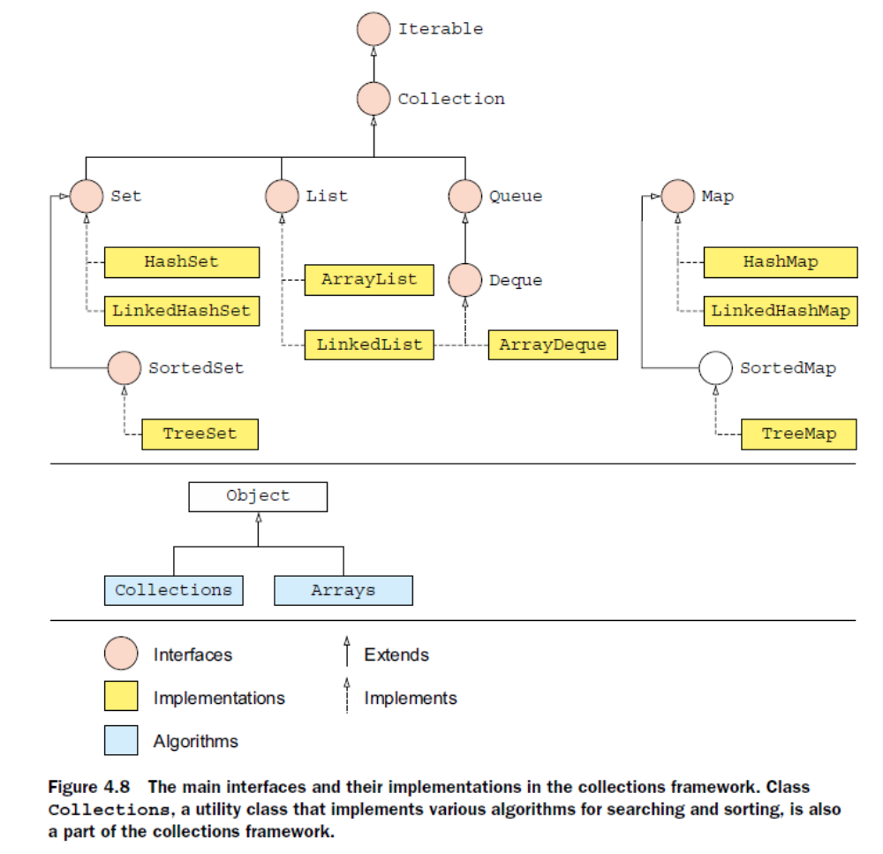

- Don’t confuse the interface Collection with the class Collections. Collection is the base interface in the collections framework that is extended by most of the other interfaces. Class Collections defines utility methods to operate on or return collections.

- All the collection classes are generic; they all define type parameters. Watch out for exam questions that use them without type parameters; these are referred to as raw types.

- Only the Map interface doesn’t extend the core Collection interface

Collection Interface

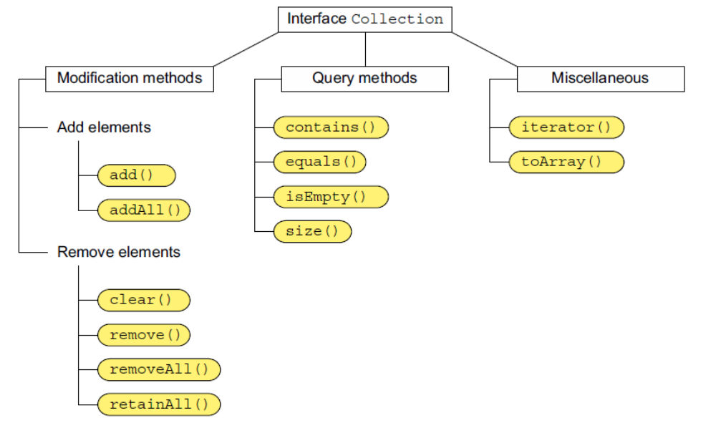

- Iterator is fail-fast.This implies that if you try to modify thestructure of a collection by adding or removing elements from it, after the Iterator iscreated, the Iterator will throw the exception ConcurrentModificationException. But this doesn’t happen if you modify the collection by using the Iterator’s own add or remove methods.

- Implementing classes provide two constructors: no-arguments, single argument type collection
- It is not synchronized
- You can control the position where to store the elements

List Interface

- Allows duplicate
- Allows nulls
- Retains order of insertion

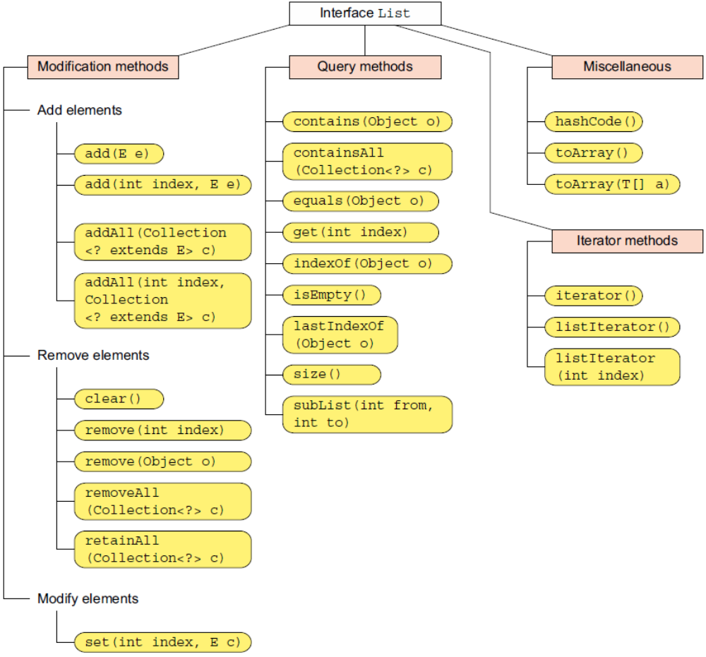

ArrayList Class

- Apart from two metioned constructors it implements one with initial capacity
- It is a resizable array
- To use remove() or to call method contains() it uses method equals()

  - list.add(0, "Paul"); -- adds to first position, shifts the rest
  - String oldValue = list.set(0, "Shreya"); - replaces and retrives

Watch out remove methods:
- remove(Int index) x remove(Object obj)

For an ArrayList of Integer objects, calling remove(20) will remove its element at position 20. It won’t remove an Integer object with value 20 from the ArrayList.

Deque
- queue is a lineral collection of objects
- deque is double-ended. You can remove objects from beginning and end, so it works as queue and stack

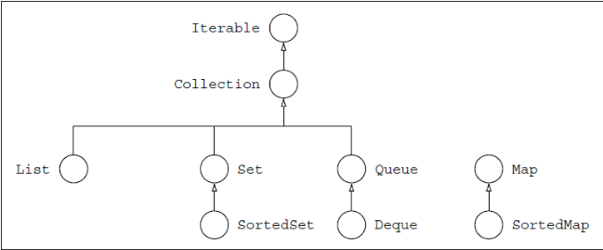
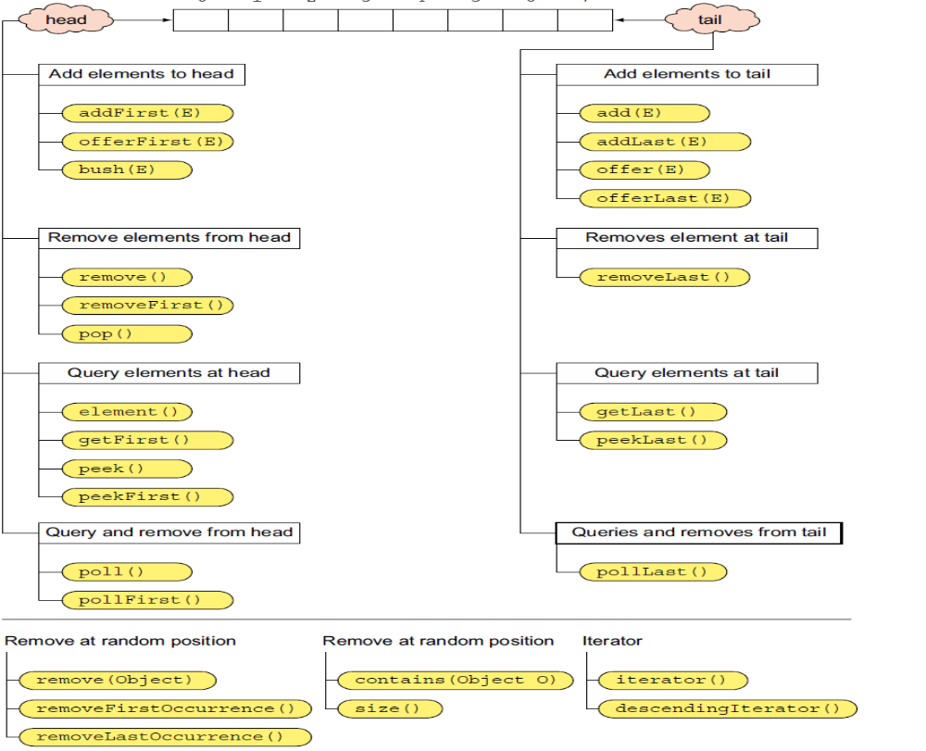

ArrayDeque

- also has constructor with initial capacity
- does not allow nulls

  - push - adds to beginning
  - offer - adds to end
  - pop - removes the first at beginning (same as remove)
  - add - adds to end
  - peek - queries at beginning
  - poll - queries and removes element from beginning. If the list is empty it returns null, while remove throws runtimeException

LinkedList

- implements Deque and List
- allows nulls

Difference in internal manipulation

A LinkedList doesn’t move a set of elements when you add a new element
to it. It modifies the value of the reference variables prev and next, for adjacent
elements, to keep track of its sequence of elements.

This is unlike ArrayList orArrayDeque, which copy a set of array elements to the right or left, when elements areadded to or removed from it.

LinkedList is usefulwhen you need fast insertion or deletion, but iteration might be slower than anArrayList.

Set

- The Set interface doesn’t allow duplicate elements and theelements are returned in no particular order.
- Uses hashCode() and equals() to determine uniqueness
- Indirectly implements iterator

HashSet

- returns false if adding duplicates
- Allows storing of one null object. All other nulls you try to add are considered duplicates

LinkedHashSet

- As with linked list you can query objects in order of insertion
- Permits null values

Watch out:

Set<City> route = new LinkedHashSet<>();
List<City> route = new LinkedHashSet<>(); // INVALID

A LinkedHashSet implements theCollection and Set interfaces, not List.
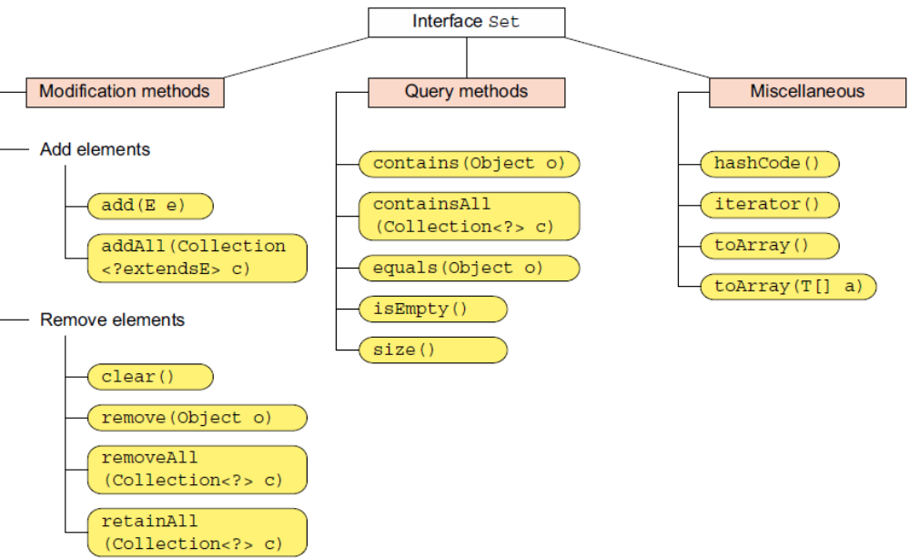

TreeSet

- Elements are order in natural order (archived by implementing Comparable interface)
Or by passing Comparator while instantiating a TreeSet.If you fail to specify either of these, TreeSet will throw a runtime exception when you try to add an object to it.
- Unlike the other Set implementations like HashSet and LinkedHashSet, which use
equals() to compare objects for equality, a TreeSet uses method compareTo() (forthe Comparable interface) or compare() (for the Comparator interface) to compare objects for equality and their order.
- If two object instances are equal according to theirmethod equals(), but not according to their methods compare() or compareTo(),the Setcan exhibit inconsistent behavior.
- String, enum, File implement comparable.
- StringBuffer and StringBuilder do not

Map

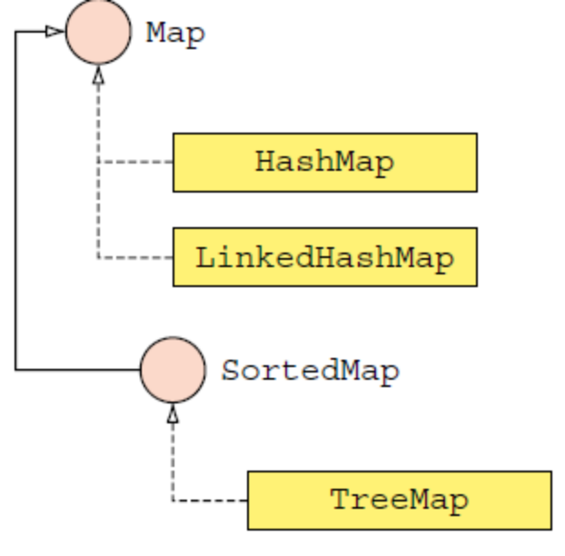

- No duplicates
- The addition of a null value as a key or value dependson a particular Map implementation. For example,HashMap and LinkedHashMap allow the insertion ofnull as a key, but TreeMap doesn’t—it throws an exception.
- Are not synchronized, not to be used in multithreaded environment
- If you delete a key-value pair it is not removed from its copy

HashMap

- hashMap value as ArrayList is common

Map<String, List<Double>> salaryMap = new HashMap<>();

- Method get(key) retrives values for a key.
- Method get(key) and containsKey() depend on overriding both hashCode and equals.
- Contains Value depends only on equals()

- if adding duplicate keys, values are overwtitten =>TestHashMap3
- You can add a value with null as the key in a HashMap.
- Methodremove() removes the mapping for the specified key from a Map if it ispresent. It returns the value associated with the key, or null if the key doesn’t exist inthe map.
- List can be used as key as well . Size and order of the elements must be same to be considered equal by their equals()
- Method remove() removes a maximum of one key-value pairfrom a HashMap. Method clear() clears all the entries of a HashMap.Method remove() accepts a method parameter but clear() doesn’t.
- You can copy entire map by using putAll(). If key in target exists, values are replaced

RETRIEVING KEYS, VALUES, AND KEY-VALUE PAIRS

Method values() returns a Collection object, method keySet() returns a Set object, and method entrySet() returns a Map.Entryobject.

LinkedHashMap

- ordered HashMap

TreeMap

- natural ordering of keys defined by Comparator passed to Constructor
- querying is fast
- uses compare() and compareTo methods to compare objects
- When you create a TreeMap object, you should specify how its keys should be ordered.
- If a Class is created without passing it Comparator object and the class does not implement comparable interface, it compiles ok, but any attempt to add key-pair value results in RuntimeException (ClassCastException)
- When you pass a Comparator object to a TreeMap constructor, the natural order of its keys is ignored.
- Unlike a HashMap, a TreeMap uses method compare() or compareTo() to determine the equality of its keys. In the following example, a TreeMap can access the valueassociated with a key, even though its key doesn’t override its method equals() orhashCode():

