Strings

- class StringBuilder doesn’t support search or replace methods based on regex.
- contains() accepts a method parameter of type CharSequence, you can pass to it both a String or a StringBuilder object
- Method subSequence() returns CharSequence, and method substring() returns String.
- Methods subSequence() and substring() don’t include the character at the end position in the result string. Unlike methods indexOf() and lastIndexOf(), they throw the runtime exception String-IndexOutOfBoundsException for invalid start and end positions.
- Tokenizing is the process of splitting a string, based on a separator, into tokens.

Replacing

- Unlike replace, replaceAll() doesn’t accept method parameters of type CharSequence. Watch out for passing of objects of class StringBuilder to replace.

Comparing

- Lexicographically, a lowercase letter is greater than its equivalent
uppercase letter. Method compareTo() returns a negative number
(not necessarily –1) if the String object on which it’s called is lexicographically
smaller than the one it’s compared to.

“S”.compareTo(“s”); // -32

Scanner

- If delimiter is not specified than space is the delimiter
- If scanner.nextInt is called and next token is not int than class throws InputMismatchException
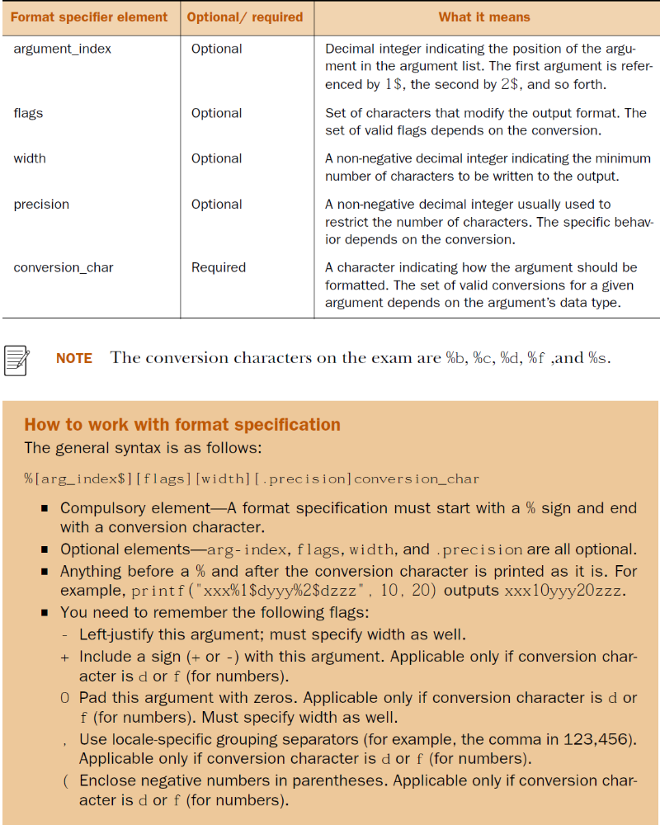

Formatting

- You can pass only literals and variables that can be converted
to a Unicode character (char, byte, short, int, Character, Byte, Short,
and Integer) to the %c specifier. Passing variables of type boolean, long,
float, Boolean, Long, Float, or any other class will throw Illegal-
FormatConversionException.

- Also, the flags +, 0, (, and ,(comma) can be specified only with the numeric specifiers
%d and %f. If you try to use them with any other format specifier (%b, %s, or %c), you’ll
get a runtime exception.

- You can pass any type of primitive variable or object reference
to the format specifier %s.

- You can specify that the argument_index change the arguments
used at a particular location:

age = 40;
System.out.format("Name is %2$s, age is %1$s", name, age);
The output of the code is as follows:
Name is 40, age is Harry

