Threads

- Multiple threads can be supported by an underlying system by:
  - using multiple hardware processors
  - by time-slicing a single processor
  - by time-slicing multiple processors

- A Thread instance is a Java object. The implementation of Java
threads is JVM-specific. A JVM implementation might even choose not to map Java
threads to native threads at all!
- A thread of execution has its own set of program counter (PC) registers to store the next set of instructions to execute. It also has its own stack that stores method frames to store the state of a method invocation.
  - The state of a method invocation includes the value of local variables, method parameters, method return values, exception handler parameters, and intermediate values.
- A process like JVM’s can create multiple threads of execution to execute multiple tasks simultaneously.

A JVM starts execution of a Java application using a thread of execution: main. This thread executes code defined in method main() and can create other threads of execution. The main thread is named ‘main’ by the JVM. Don’t confuse it with the method main().
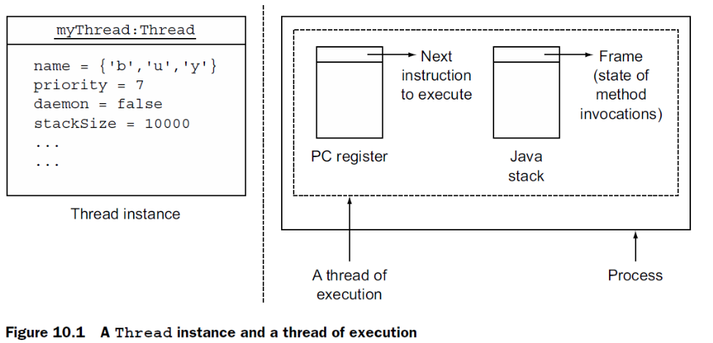

To create your own thread objects using class Thread, you must
- Extend class Thread
- Override its method run()

To create and start a new thread of execution, you must
- Call start() on your Thread instance

The exact time of thread execution is determined by how the underlying
thread scheduler schedules the execution of threads.
Watch out for code that overrides method start() in a class that extends Thread. If it doesn’t call method start() from its superclass Thread, it won’t start a new thread of execution.

Class Thread defines multiple overloaded constructors. The following constructors
allocate a new Thread object:

Thread()
Thread(String name)
Thread(Runnable target)
Thread(Runnable target, String name)
A Thread constructor that accepts a string value enables you to create a thread with a
name. But if you don’t assign an explicit name to a thread, Java automatically generates
and assigns a name to it.

Thread Priority
By default, a thread creates another thread with the same priority as its own. It can also be explicitly set for a Thread instance, using Thread’s method setPriority(int). A thread scheduler might choose to execute threads with higher priorities over threads with lower priorities, though you can’t guarantee it.

Thread States

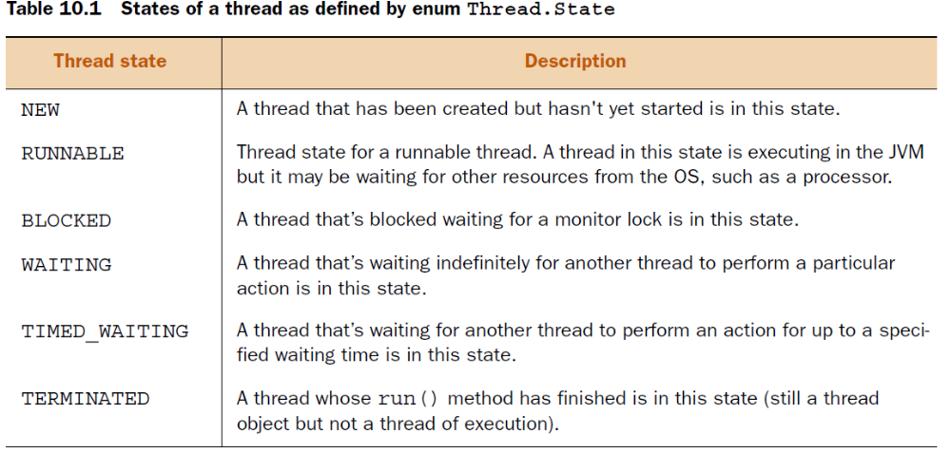

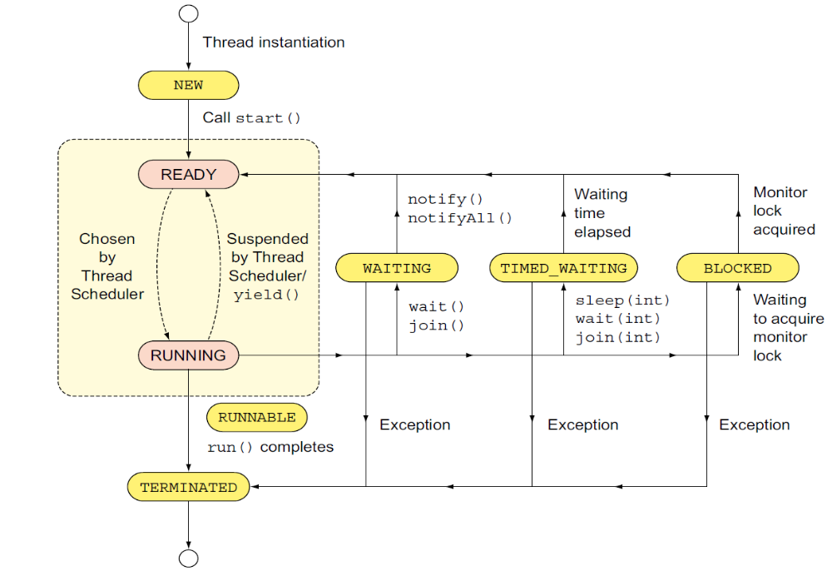

Thread Methods

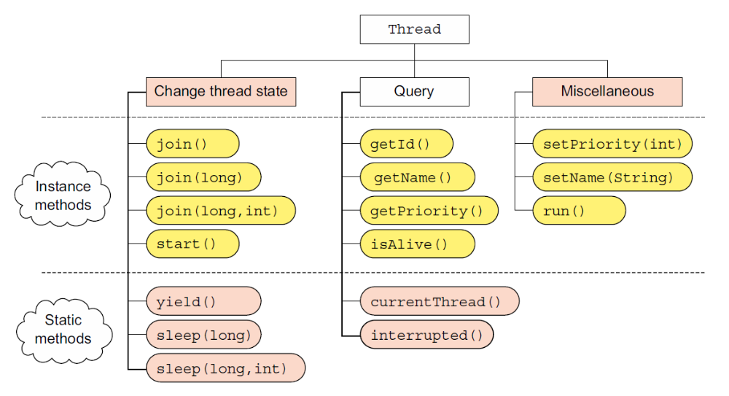

You can call start() only once on a Thread instance when it’s in the NEW state. Calling start() on a thread in any other state will throw an IllegalThreadStateException.

Calling run() on a Thread instance doesn’t start a new thread of execution. The run() continues to execute in the same thread. Watch out for trick questions on using start() versus run() in the exam.

The static method yield() makes the currently executing thread pause its execution and give up its current use of the processor. But it only acts as a hint to the scheduler. The scheduler might also ignore it. The static method yield() can be placed literally anywhere in your code—not only in method run().

So what’s guaranteed from this method call? To be precise, nothing. It might not make the currently executing thread give up its processor time. If it does, it doesn’t guarantee when it will happen and when the thread will resume its execution. Method yield() is static. It can be called from any method,
and it doesn’t throw any exceptions.

Thread.sleep() is guaranteed to cause the currently executing
thread to temporarily give up its execution for at least the specified number of milliseconds
(and nanoseconds) and move to the READY state.

Class Thread defines the overloaded versions of sleep() as follows:
public static native void sleep(long milli) throws InterruptedException;
public static void sleep(long milli, int nanos) throws InterruptedException

A thread that’s suspended due to a call to sleep doesn’t lose
ownership of any monitors.

Thread,join()

A thread might need to pause its own execution when it’s waiting for another thread
to complete its task. If thread A calls join() on a Thread instance B, A will wait for B
to complete its execution before A can proceed to its own completion.

Method join() guarantees that the calling thread won’t execute
its remaining code until the thread on which it calls join() completes.

Class Thread defines overloaded join() methods as follows:
public final synchronized void join(long milli) throws InterruptedException
public final synchronized void join(long millis, int nanos)
throws InterruptedException
public final void join() throws InterruptedException
The variations of join() that accept milliseconds and nanoseconds wait for at least
the specified duration (if they’re not interrupted!).

Shared data
You can protect your shared data by
making it accessible (for reading and writing) to only one thread at a point of time.

Other techniques include:
- defining immutable classes (the states of which can’t be modified)
- defining volatile variables.
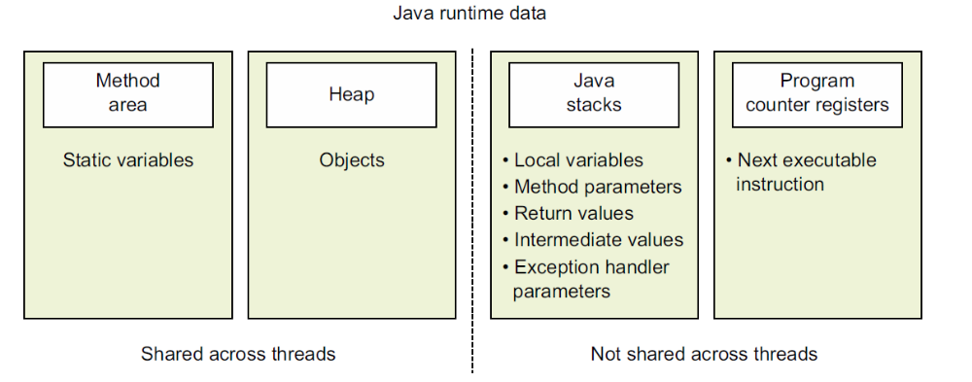

The method area includes class information
that includes a note on all its variables and methods. This data set includes the static
variables, which are accessible and shared by all the threads in a JVM. The static variables
are shared by one class loader—that is, each class loader has its own set of
static variables.

The heap includes objects that are created during the lifetime of an
application, again shared by multiple threads and processes.

On instantiation, each thread gets a PC register,
which defines the next set of instructions to execute.

Each thread is also assigned a Java stack. When a thread begins execution of a method, a method frame
is created and inserted into the java stack, which is used to store the local variables,
method parameters, return values, and intermediate values that might be used in a
method.

Of all this data, the method area and heap are shared across threads.

Operations that use arithmetic and assignment operators like ++,
--, +=, -=, *=, and /= aren’t atomic. Multiple threads that manipulate
variable values using these operators can interleave.

You can lock objects by defining synchronized methods and synchronized statements.
Java implements synchronization by using monitors
Every Java object is associated with a monitor, which can be locked or unlocked by a
thread. At a time, only one thread can hold lock on a monitor and is referred to as the
monitor owner. Owning the monitor is also referred to as acquiring the monitor. If another
thread wants to acquire the monitor of that object, it must wait for it to be released.

When the keyword synchronized is added to a method, only one thread can
execute it at a time. To execute a synchronized method, a thread must acquire the
monitor of the object on which the method is called.
When acquired, a thread can release the lock on the monitor if:
- It has completed its execution.
■ It needs to wait for another operation to complete.

A thread releases the lock on an object monitor after it exits a
synchronized method, whether due to successful completion or due to an
exception.

Synchronized methods
For nonstatic instance synchronized methods, a thread locks
the monitor of the object on which the synchronized method is called.
To execute static synchronized methods, a thread locks the monitor associated
with the Class object of its class.

Sunchronized Statements

Multiple threads can concurrently execute methods with synchronized
statements if they acquire locks on monitors of separate objects.

Immutable objects

Shared immutable objects can’t result in inconsistent object
data or an incorrect object state because, once initialized, they can’t be
modified.

Volatile (nestaly, tekavy, prchavy) keyword

The Java volatile keyword is used to mark a Java variable as "being stored in main memory". More precisely that means, that every read of a volatile variable will be read from the computer's main memory, and not from the CPU cache, and that every write to a volatile variable will be written to main memory, and not just to the CPU cache.
Declaring a variable volatile guarantees the visibility for other threads of writes to that variable.

A read or write operation on a volatile variable creates a happens-before relationship
with operations on the same object by other threads. As a result, the compiler can’t
include optimizations that might enable threads to read the values of volatile variables from their own local cache.

Multithreaded environment problems
Variables you should care about:
Threads can share the heap that includes class variables and instance variables.
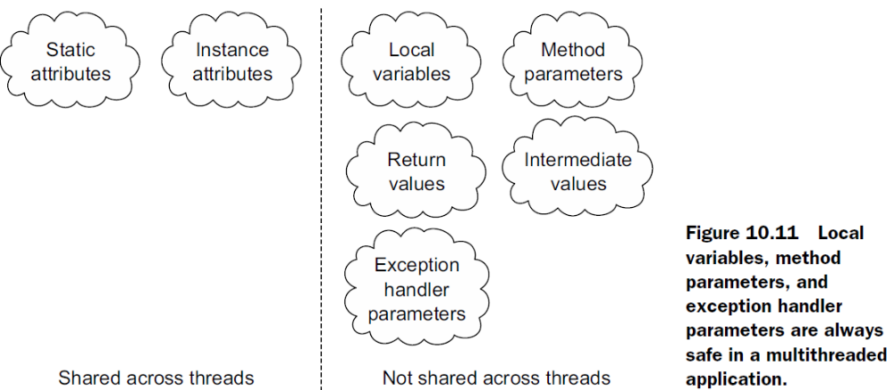

Notifications

Methods wait(), notify(), and notifyAll() are defined in
class Object and not in class Thread.
Because
these methods are defined in class Object, they can be called on any Java object.
To call wait() or notify() a thread must own the object’s monitor lock. So calls to
these methods should be placed within synchronized methods or blocks or else an IllegalMonitor-
StateException will be thrown by the JVM.
If multiple threads are waiting on an object’s monitor, notify() wakes up one of
these threads. Which thread will be chosen isn’t defined and is specific to the JVM
implementation. Method notifyAll() wakes up all the threads that are waiting on an
object’s monitor. These threads compete in the usual manner to acquire a lock on the
object’s monitor and resume their execution.

The overloaded wait() methods enable you to specify a wait timeout:

public final void wait(long timeout) throws InterruptedException
public final void wait(long timeout, int nanos) throws InterruptedException
All overloaded versions of wait() throw a checked
InterruptedException. Methods notify() and notifyAll() don’t throw
an InterruptedException.

Unlike the Thread’s method join(), which waits for another thread to complete its
execution, methods wait() and notify() don’t require a thread to complete their
execution. The thread that calls wait(), waits for another thread to notify it using
method notify() or notifyAll().

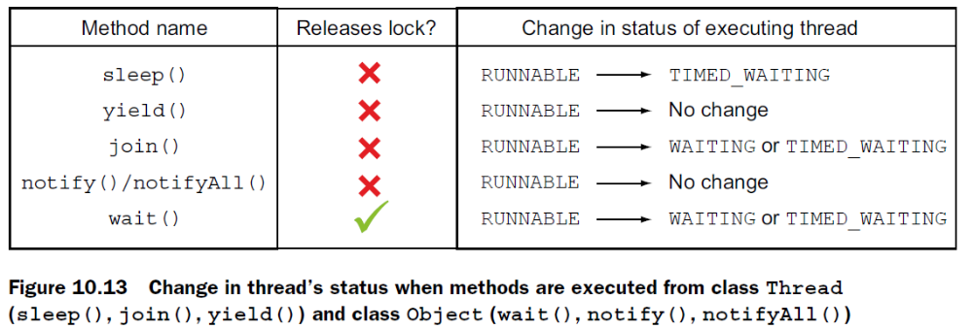

- Deadlock – resource struggle
- Starvation – high priority threads being executed and OS doesn’t get to low ones
- Livelock - threads aren’t blocked,but cannot complete execution

Happens before

The execution of start()happens-before any action in a thread is started.
■ When code is defined in a sequence, step 1 happens-before step 2.
■ Unlocking of an object monitor happens-before any other thread acquires a lock
on it.
■ A write to a volatile field happens-before every subsequent read of that field.
■ All actions in a thread happens-before any other thread returns from a join on
that thread.

