Concurency
Concurrent collection classes
Interface BlockingQueue
- BlockingQueue defines a first-in-first-out data structure that blocks or times out
when you attempt to add items to a full queue, or retrieve from an empty queue. Safe to use when shared between multiple threads.
- implementing classes like ArrayBlockingQueue include a constructor to define an initial capacity (which can’t be modified) from which items are added and removed.
- It blocks adding new elements if the queue has reached its capacity.
- It also blocks removing elements from an empty queue
Interface ConcurrentMap
The ConcurrentMap interface extends the java.util.Map interface. It defines methods to replace or remove a key-value pair if the key is present, or add a value if the key is absent.

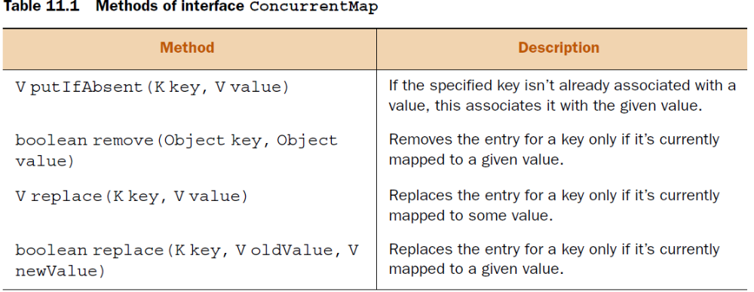
Implementation ConcurrentHashMap

A HashMap is an unsynchronized collection. If you’re manipulating a HashMap using multiple threads, you must synchronize its access. But locking the entire HashMap object can create serious performance issues when it’s being accessed by multiple threads. If multiple threads are retrieving values, it makes sense to allow concurrent read operations and monitor write operations.

The ConcurrentHashMap class is the answer to improving the responsiveness of HashMap when it needs to be accessed concurrently by multiple threads. Instead of exclusively locking itself to be accessed by one thread, ConcurrentHashMap allows access by multiple threads. It concurrently allows multiple threads to read its values and limited threads to modify its values.

Also, the iterators of ConcurrentHashMap don’t throw a ConcurrentModificationException, so you don’t need to lock the collection while iterating it.

With the added benefits of offering better performance when accessed by multiple threads concurrently, this collection also offers some drawbacks. Because it doesn’t lock the complete collections while modifying their elements, methods like size() might not return the exact accurate size of a ConcurrentHashMap when invoked by multiple threads.

class UseConcurrentMap {
static final ConcurrentMap<Integer, String> map =
new ConcurrentHashMap<>();
static {
//code to populate map
}
static void manipulateMap(Integer key, String value) {
// complex computations
if(!map.containsKey(key)) -- may become subject to race conditions
map.put(key, value);
}
}
So you use atomic oeration
static void manipulateMap(Integer key, String value) {
// complex computations
map.replace(key, value);
}

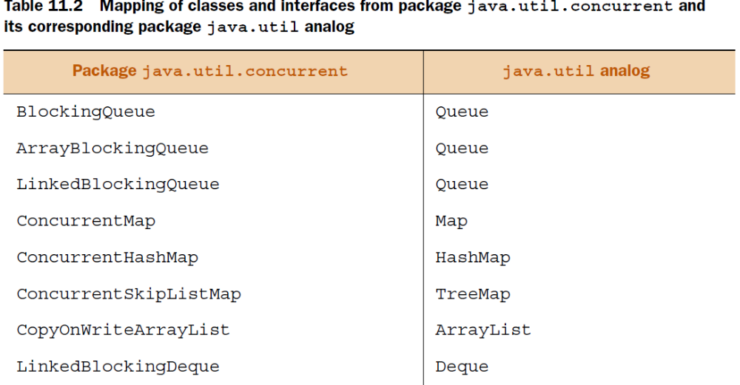
A concurrent collection helps avoid memory consistency errors by defining a happens-before relationship between an operation that adds an object to thecollection and subsequent operations that access or remove that object.

Locks
Lock objects offer multiple advantages over implicit locking of an object’s monitor.
Unlike an implicit lock, a thread can use explicit lock objects to wait to acquire a lock until a time duration elapses.

To execute synchronized code, a thread must acquire either an implicit or an explicit lock on an object’s monitor.

Lock objects also support interruptible lock waits, nonblock-structured locks, lock polling, and scalability benefits.
Lock and ReadWriteLock are interfaces. ReentrantLock and ReentrantReadWriteLock are concrete classes.

Methods

Method lock() is comparable to intrinsic locks because it waits until a lock can be acquired on a Lock object.

Call unlock() on a Lock object to release its lock when you no longer need it. If you don’t call unlock() on a Lock object after acquiring a lock on it, the code will still compile successfully.

Method tryLock() tries to acquire a lock on a Lock object, and returns immediately a boolean value specifying whether it could obtain the lock or not.

Methods lockInterruptibly() and tryLock(long time, TimeUnit unit) of the Lock interface enable you to specify a waiting timeout or to try and acquire a lock while being available for interruption.

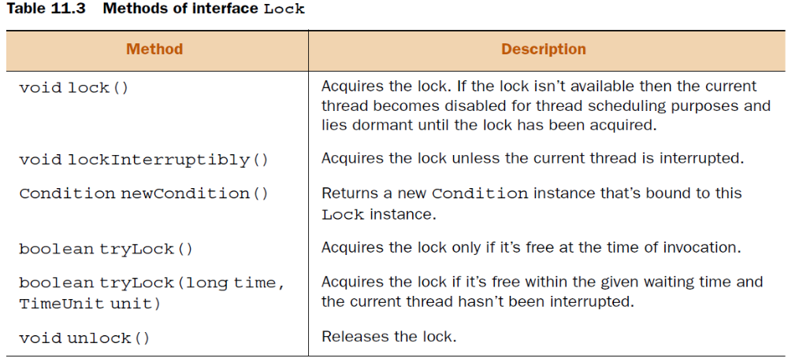
ReentrantLock
A reentrant mutual exclusion Lock with the same basic behavior and semantics as the implicit monitor lock accessed using synchronized methods and statements, but with extended capabilities.
A ReentrantLock is owned by the thread last successfully locking, but not yet unlocking it. A thread invoking lock will return, successfully acquiring the lock, when the lock is not owned by another thread. The method will return immediately if the current thread already owns the lock. This can be checked using methodsisHeldByCurrentThread(), and getHoldCount().
It allows the thread to immediately react to the interrupt signal sent to it from another thread. lockInterruptibly() may block if the the lock is already held by another thread and will wait until the lock is aquired. This is the same as with regular lock(). But if another thread interrupts the waiting thread lockInterruptibly() will throw InterruptedException.
Interface ReadWriteLock
Interface ReadWriteLock maintains a pair of associated locks, one for read-only operations and another for write-only operations. The read-only lock may be held simultaneously by multiple reader threads as long as there are no writing processes in progress. The write-only lock is an exclusive lock. It can be acquired by only one thread.

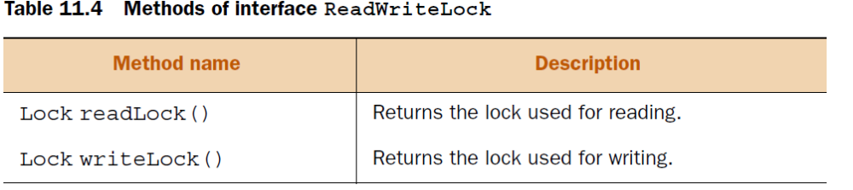
The ReadWriteLock interface doesn’t extend Lock or any other interface. It maintains a pair of associated Locks—one for only reading operations and one for writing.
Implemnatation of ReadWiritrLock is ReentrantReadWriteLock

You can acquire read locks until a write lock has been acquired on a ReadWriteLock object.
WriteLock is an exclusive lock; it can be acquired by only one thread when no read thread has been acquired.

Atomic variables
The java.util.concurrent.atomic package defines multiple classes that support atomic operations of read-compare/modify-write on single variables. At the surface, these operations might seem similar to the operations with volatile variables. Though modifications to a volatile variable are guaranteed to be visible to other threads, volatile variables can’t define a sequence of operations (like read-compare/modify-write) as an atomic operation.

Nonatomic statements include loading of variable values from memory to registers, manipulating values, and loading them back to memory
Java defines multiple convenient classes in the java.util.concurrent.atomic package that define frequently used operations like read-modify-write as atomic operations.

Watch out!
Method incrementAndGet() returns the updated value but method AtomicInteger’s getAndIncrement() returns the previous value.

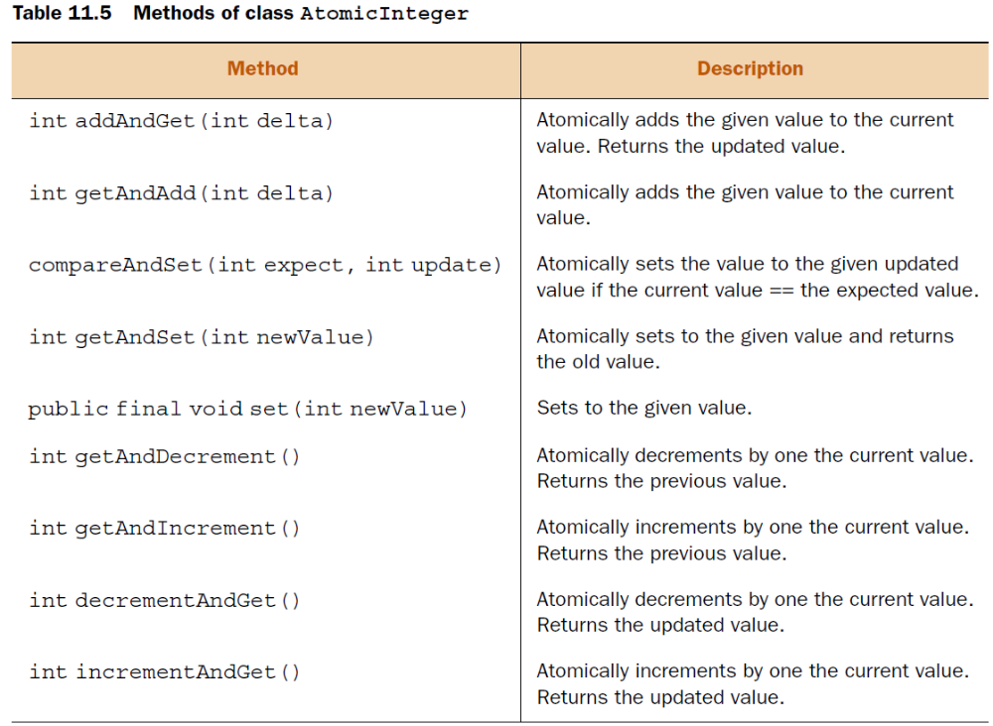
Other commonly used classes defined in the java.util.concurrent.atomic package are AtomicBoolean, AtomicLong, AtomicIntegerArray, AtomicLongArray, and AtomicReference<V>.

AtomicLong defines the same methods as class AtomicInteger.
The difference is the type of method parameters and their return types (long instead of int).

Executors
The Executor framework enables decoupling of task submission with task execution.
By using this framework, you can create tasks using interfaces Runnable and Callable.
The Runnable interface defines method run() and the Callable interface defines method call().
These tasks are submitted to Executor to launch new tasks
Executor-Service extends Executor and adds methods to manage the lifecycle of tasks and
executors.
ScheduledExecutorService extends ExecutorService and supports future or periodic execution of tasks.

Future represents the state of asynchronous tasks and can be used to query their status or cancel them

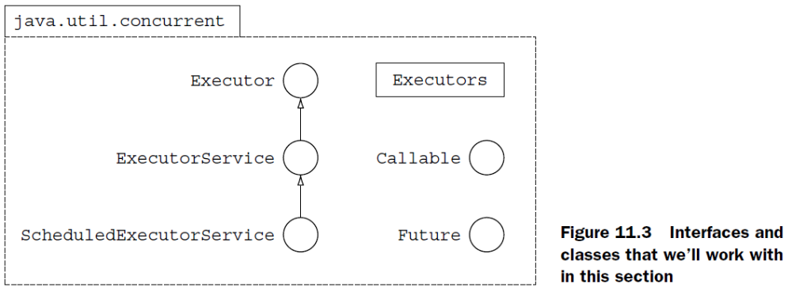
Interface Executor
With class Thread and the Runnable interface, the task executed by a thread and the thread itself are closely connected. The Executor interface allows you to define classes that know how to execute Runnable tasks. It allows you to decouple task submission and its execution. By implementing its sole method, void execute(Runnable), you can determine how you want to execute the tasks:

- The order of execution of tasks
- How many tasks can execute concurrently
- How many tasks can be queued
- Which task will execute first

You use class Executors to call utility and factory methods for interfaces Executor, ExecutorService, and ScheduledExecutorService.

The executor interface defines only one method void execute(Runnable)

Interface Callable
Comparing interfaces Runnable and Callable, method run() of the Runnable interface
doesn’t return a value and can’t throw a checked exception. Executed by ExecutorService.
If you don’t want Callable to return a value, you can create it using Callable<Void>, defining the return type of call() as Void and returning null from it.

Interface ExecutorService
The ExecutorService interface extends the Executor interface and defines methods
to manage progress and termination of tasks that are submitted to it. It defines methods
to:

- Submit single Runnable and Callable objects for execution, returning Future objects
- Submit multiple Runnable objects for execution, returning Future objects
- Shut down the ExecutorService, allowing or disallowing submitted tasks to be Completed

Thread pools
By limiting the number of concurrent tasks, an application ensures that it doesn’t fail or have resource exhaustion or suffer performance issues. The solution is to use pools of threads, which create a predefined number of threads and reuse them to execute tasks. You must optimize the size of the thread pool. The threads shouldn’t overwhelm the scheduler and introduce unnecessary thread contention and performance degradation. There should be enough to only keep the processor busy.
A thread pool includes a homogeneous pool of worker threads. These are usually bound to a work queue, holding references to tasks that are waiting to be executed. A worker thread would typically request the next task for execution, execute it, and go back to waiting to execute the next task.

Class Executors defines utility and factory methods for interfaces Executor, ExecutorService, and ScheduledExecutorService.

Method shutdown() doesn’t accept submission of new tasks and waits for the existing tasks to complete to execution.

Method shutdownNow() cancels currently executing tasks, apart from refusing to accept new tasks.
Method awaitTermination() blocks until all tasks have completed execution after a shutdown request, the timeout occurs, or the current thread is interrupted—whichever happens first.

Interface ScheduledExecutorService
The ScheduledExecutorService interface supports future or periodic execution of tasks.

Future represents the state of asynchronous tasks and can be used to query their status or cancel them.

ScheduledExecutorService can schedule Callable or Runnable tasks that execute just once, after a given delay.

ScheduledExecutorService can schedule only Runnable tasks (not Callable tasks) that can execute multiple times, starting its first execution after an initial delay and subsequent execution after the specified period.

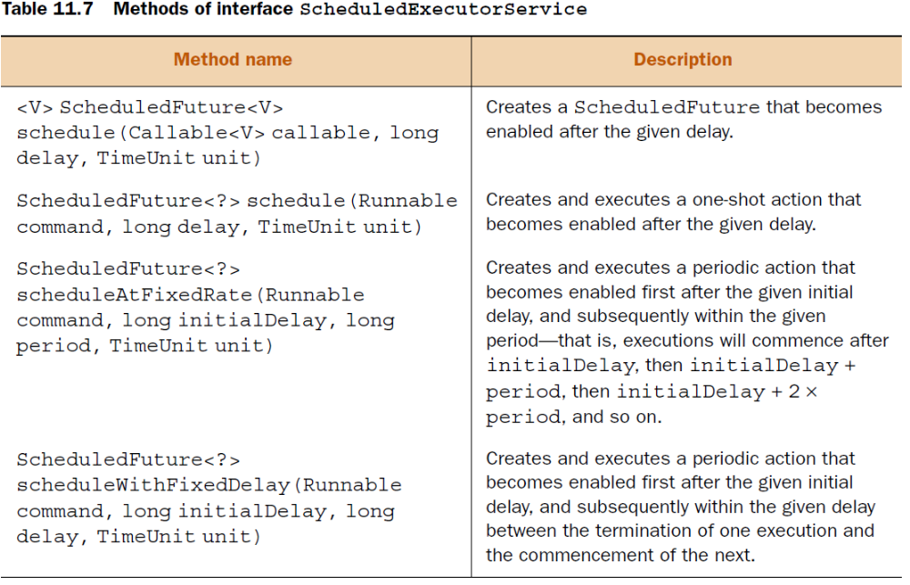

Parallel fork/join framework
the fork/join framework extends the existing Java concurrency package, supporting hardware parallelism, a key feature of multicore systems. The fork/join framework isn’t intended to replace
or compete with the existing concurrency classes from the java.util.concurrent package.
It works by breaking down larger, processing-intensive tasks into smaller, independent tasks recursively, processing each unit of a task and then merging back the results.

The fork/join framework is best suited for tasks that are processor intensive and that can be divided into smaller tasks that can execute independently, in parallel. Tasks that block, work with I/O, or need synchronization aren’t good candidates to use with the fork/join framework.

As you can see in figure 11.4, the size of a problem is evaluated before it’s further divided. If the problem is small enough (smaller than or equal to a threshold limit), it isn’t subdivided and is executed sequentially. The bigger problems are subdivided into two or more subproblems, and the fork/join framework recursively invokes itself on the subproblems in parallel, waits for their results, and then combines them. You should select the threshold limit carefully.

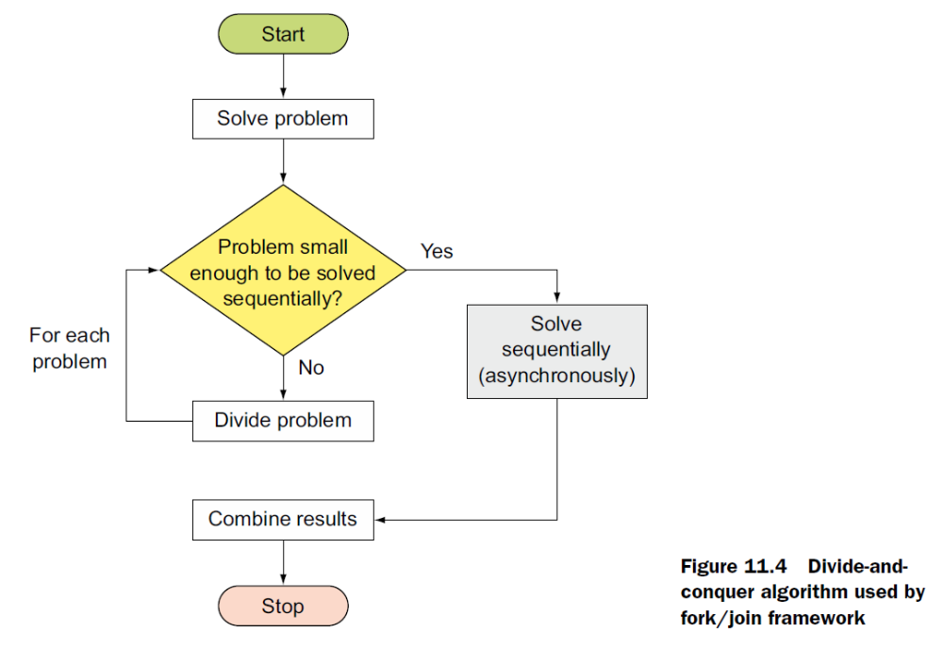
Class ForkJoinPool is a concrete implementation of the fork/join framework. It implements the ExecutorService interface. Like ExecutorService, a fork/join framework maintains a queue of tasks that are used to assigns tasks to its multiple worker threads.
But it’s different from an ExecutorService because a fork/join framework implements a work-stealing algorithm. In this algorithm, when worker threads run out of tasks, they steal tasks from other worker threads to avoid blocking waiting threads.

A large number of ForkJoinTasks can be executed by a smaller number of actual threads in a ForkJoinPool. Figure 11.6 shows class ForkJoinPool and class ForkJoinTask and its two subclasses, RecursiveTask and RecursiveAction.
RecursiveAction is used for computations that don’t return a result, and RecursiveTask is used for computations that return a result.
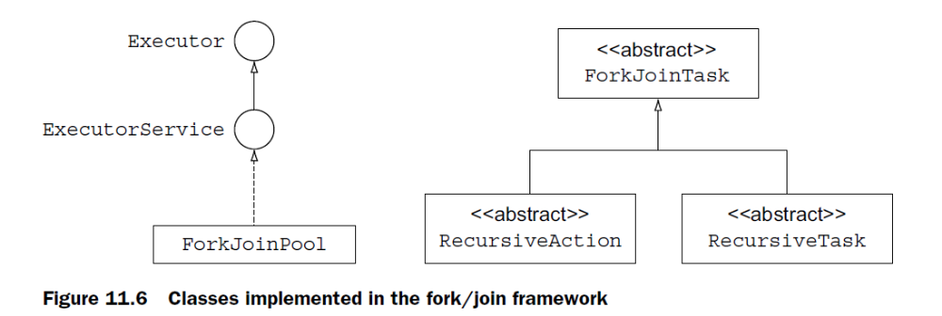

The fork/join framework recommends 100–10,000 computational steps in the compute method so that its work-stealing algorithm and join() can work effectively.

