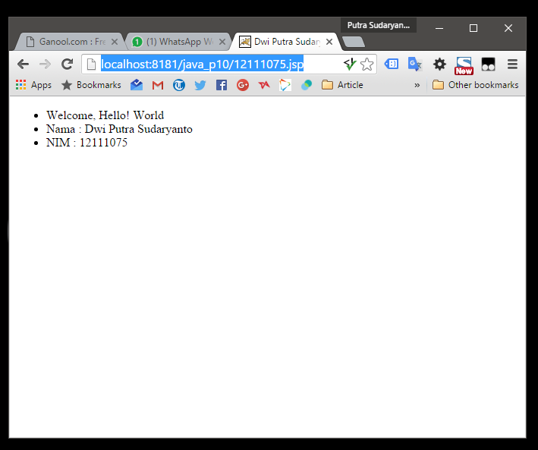

<!DOCTYPE html>

<html>

<head>

<meta charset="UTF-8" />

<title><% out.println("Dwi Putra Sudaryanto | 12111075");%></title>

<meta name="viewport" content="width=device-width, initial-scale=1, maximum-scale=1">

<meta name="author" content="Ommu Platform (support@ommu.co)" />

<link rel="shortcut icon" href="/favicon.ico" />

<style type="text/css"></style>

</head>

<body>

<ul>

<li><% out.println("Welcome, Hello! World");%></li>

<li><span><% out.println("Nama");%></span>: <% out.println("Dwi Putra Sudaryanto");%></li>

<li><span><% out.println("NIM");%></span>: <% out.println("12111075");%></li>

</ul>

</body>

</html>