**LAPORAN TUGAS**

**Pemrograman Berbasis Java**

**Database Wilayah Indonesia Berdasarkan Master File Desa Badan Pusat Statistik (MFD BPS) Indonesia**



**Disusun oleh:**

Dwi Putra Sudaryanto

12111075

**PROGRAM STUDI TEKNIK INFORMATIKA**

**FAKULTAS TEKNOLOGI INFORMASI**

**UNIVERSITAS MERCUBUANA YOGYAKARTA**

# **DAFTAR ISI**

**DAFTAR ISI** 2

**BAB I PENDAHULUAN** 4

**1.1.** **Latar Belakang** 4

**1.2.** **Alasan Pemilihan Masalah** 4

**BAB II DATABASE** 5

**2.1.** **Rancangan Tabel** 5

2.1.1. Tabel 5

2.1.2. Trigger 5

2.1.3. Store Prosedure 7

2.1.4. View 8

**2.2.** **Relasi Database** 9

**BAB III USER INTERFACE** 10

**3.1.** **Welcome** 10

**3.2.** **Provinsi** 10

3.1.1. Insert 10

3.1.2. Update 10

3.1.3. View 10

**3.3.** **Kabupaten / Kota** 11

3.2.1. Insert 11

3.2.2. Update 11

3.2.3. View 12

**3.4.** **Kecamatan** 12

3.3.1. Insert 12

3.3.2. Update 13

3.3.3. View 13

**3.5.** **Desa / Kelurahan** 14

3.4.1. Insert 14

3.4.2. Update 14

3.4.3. View 15

**BAB IV MENU, STRUCTURE DAN TESTING** 16

**4.1.** **Menu** 16

**4.2.** **Structure** 17

**4.3.** **Testing Aplikasi** 18

**BAB V PENUTUP** 19

**5.1.** **Kesimpulan** 19

**5.2.** **Kesulitan** 19

# **BAB I PENDAHULUAN**

* 1. **Latar Belakang**

Dokumen ini merupakan diskripsi dari aplikasi Database Wilayah Indonesia Berdasarkan Master File Desa Badan Pusat Statistik (MFD BPS) Indonesia yang dikembangkan menggunakan bahasa pemograman berbasis java. Dokumen ini dibuat untuk memenuhi tugas mata kuliah Pemograman Berbasis Java.

* 1. **Alasan Pemilihan Masalah**

Master File Desa Badan Pusat Statistik (MFD BPS) Indonesia merupakan acuan dasar yang digunakan oleh pengembang aplikasi baik website, mobile maupun desktop jika ingin mengembangkan sebuah aplikasi yang memiliki basis data daerah Indonesia.

Aplikasi ini dikembangkan untuk mempermudah siapapun baik personal maupun organisasi untuk mengelola database wilayah Indonesia menggunakan konsep MFD online untuk selanjutnya dapat dikembangkan kembali.

# **BAB II DATABASE**

1. **Rancangan Tabel**
2. Tabel

|  |  |
| --- | --- |
| **Tebel** | **Colom** |
| ommu_core_zone_province | `province_id` smallint(5), `publish` tinyint(1), `province` varchar(64), `mfdonline` char(2), `creation_date`, `modified_date` |
| ommu_core_zone_city | `city_id` int(11), `publish` tinyint(1), `province_id` smallint(5), `city` varchar(64) , `mfdonline` char(4), `creation_date`, `modified_date` |
| ommu_core_zone_districts | `district_id` int(11), `publish` tinyint(1), `city_id` int(11), `district_name` varchar(64), `mfdonline` char(7), `creation_date`, `modified_date` |
| ommu_core_zone_village | `village_id`, `publish`, `district_id`, `village_name`, `zipcode`, `mfdonline`, `creation_date`, `modified_date` |

1. Trigger

|  |  |
| --- | --- |
| **Name** | **Deskripsi** |
| coreBeforeInsertCity | DECLARE province_id_tr SMALLINT;    /*CALL getOmmuZoneProvinceIdWithCityMfdonline(NEW.mfdonline, province_id_tr);*/  SELECT `province_id` INTO province_id_tr FROM `ommu_core_zone_province` WHERE `mfdonline`=LEFT(NEW.mfdonline,2);  IF (province_id_tr IS NOT NULL) THEN  SET NEW.province_id = province_id_tr;  END IF;    SET NEW.city = TRIM(NEW.city); |
| coreBeforeUpdateCity | DECLARE province_id_tr SMALLINT;    IF (NEW.mfdonline <> OLD.mfdonline) THEN  /*CALL getOmmuZoneProvinceIdWithCityMfdonline(NEW.mfdonline, province_id_tr);*/  SELECT `province_id` INTO province_id_tr FROM `ommu_core_zone_province` WHERE `mfdonline`=LEFT(NEW.mfdonline,2);  IF (province_id_tr IS NOT NULL) THEN  SET NEW.province_id = province_id_tr;  END IF;  END IF;  SET NEW.city = TRIM(NEW.city);  SET NEW.modified_date = NOW(); |
| coreBeforeInsertDistricts | DECLARE `city_id_tr` INT;    /*CALL getOmmuZoneCityIdWithDistrictMfdonline(NEW.mfdonline, city_id_tr);*/  SELECT `city_id` INTO city_id_tr FROM `ommu_core_zone_city` WHERE `mfdonline`=LEFT(NEW.mfdonline,4);  IF (city_id_tr IS NOT NULL) THEN  SET NEW.city_id = city_id_tr;  END IF;    SET NEW.district_name = TRIM(NEW.district_name); |
| coreBeforeUpdateDistricts | DECLARE `city_id_tr` INT;    IF (NEW.mfdonline <> OLD.mfdonline) THEN  /*CALL getOmmuZoneCityIdWithDistrictMfdonline(NEW.mfdonline, city_id_tr);*/  SELECT `city_id` INTO city_id_tr FROM `ommu_core_zone_city` WHERE `mfdonline`=LEFT(NEW.mfdonline,4);  IF (city_id_tr IS NOT NULL) THEN  SET NEW.city_id = city_id_tr;  END IF;  END IF;  SET NEW.district_name = TRIM(NEW.district_name);  SET NEW.modified_date = NOW(); |
| coreBeforeInsertProvince | SET NEW.province = TRIM(NEW.province); |
| coreBeforeUpdateProvince | SET NEW.province = TRIM(NEW.province);  SET NEW.modified_date = NOW(); |
| coreBeforeInsertVillage | DECLARE `district_id_tr` INT;    /*CALL getOmmuZoneCityIdWithDistrictMfdonline(NEW.mfdonline, city_id_tr);*/  SELECT `district_id` INTO district_id_tr FROM `ommu_core_zone_districts` WHERE `mfdonline`=LEFT(NEW.mfdonline,7);  IF (district_id_tr IS NOT NULL) THEN  SET NEW.district_id = district_id_tr;  END IF;    SET NEW.village_name = TRIM(NEW.village_name);  SET NEW.zipcode = TRIM(NEW.zipcode); |
| coreBeforeUpdateVillage | DECLARE `district_id_tr` INT;    IF (NEW.mfdonline <> OLD.mfdonline) THEN  /*CALL getOmmuZoneCityIdWithDistrictMfdonline(NEW.mfdonline, city_id_tr);*/  SELECT `district_id` INTO district_id_tr FROM `ommu_core_zone_districts` WHERE `mfdonline`=LEFT(NEW.mfdonline,7);  IF (district_id_tr IS NOT NULL) THEN  SET NEW.district_id = district_id_tr;  END IF;  END IF;  SET NEW.village_name = TRIM(NEW.village_name);  SET NEW.zipcode = TRIM(NEW.zipcode);  SET NEW.modified_date = NOW(); |

1. Store Prosedure

|  |
| --- |
| **Prosedure** |
| /*!50003 CREATE DEFINER=`root`@`localhost` PROCEDURE `getOmmuZoneCityIdWithDistrictMfdonline`(IN `mfdonline_sp` CHAR, OUT `city_id_sp` INT)  BEGIN  SELECT `city_id` INTO city_id_sp FROM `ommu_core_zone_city` WHERE `mfdonline`=LEFT(mfdonline_sp,4);  END */$$  DELIMITER ; |
| /*!50003 CREATE DEFINER=`root`@`localhost` PROCEDURE `getOmmuZoneCountryId`(IN `province_id_sp` SMALLINT, OUT `country_id_sp` SMALLINT)  BEGIN  SELECT `country_id` INTO country_id_sp FROM `ommu_core_zone_province` WHERE `province_id`=province_id_sp;  END */$$  DELIMITER ; |
| /*!50003 CREATE DEFINER=`root`@`localhost` PROCEDURE `getOmmuZoneProvinceId`(in `city_id_sp` INT, OUT `province_id_sp` SMALLINT)  BEGIN  SELECT `province_id` INTO province_id_sp FROM `ommu_core_zone_city` WHERE `city_id`=city_id_sp;  END */$$  DELIMITER ; |
| /*!50003 CREATE DEFINER=`root`@`localhost` PROCEDURE `getOmmuZoneProvinceIdWithCityMfdonline`(IN `mfdonline_sp` CHAR, OUT `province_id_sp` SMALLINT)  BEGIN  SELECT `province_id` INTO province_id_sp FROM `ommu_core_zone_province` WHERE `mfdonline`=LEFT(mfdonline_sp,2);  /*  CALL getOmmuZoneProvinceIdWithCityMfdonline(NEW.mfdonline, province_id_tr);  SELECT `province_id` INTO province_id_tr FROM `ommu_core_zone_province` WHERE `mfdonline`=LEFT(NEW.mfdonline,2);*/  END */$$  DELIMITER ; |

1. View

|  |  |
| --- | --- |
| **Name and View** | **Deskripsi** |
| `_view_core_zone_city`(  `city_id` int(11) unsigned ,  `city` varchar(64) ,  `province` varchar(64)  ) | select `a`.`city_id` AS `city_id`, `a`.`city` AS `city`, `b`.`province` AS `province` from (`ommu_core_zone_city` `a` left join `ommu_core_zone_province` `b` on((`a`.`province_id` = `b`.`province_id`))) |
| `_view_core_zone_districts`(  `district_id` int(11) unsigned ,  `district_name` varchar(64) ,  `city` varchar(64) ,  `province` varchar(64)  ) | select `a`.`district_id` AS `district_id`, `a`.`district_name` AS `district_name`, `b`.`city` AS `city`, `b`.`province` AS `province` from (`ommu_core_zone_districts` `a` left join `_view_core_zone_city` `b` on((`a`.`city_id` = `b`.`city_id`))) |
| `_view_core_zone_village`(  `village_id` int(11) unsigned ,  `village_name` varchar(64) ,  `district_name` varchar(64) ,  `city` varchar(64) ,  `province` varchar(64)  ) | select `a`.`village_id` AS `village_id`, `a`.`village_name` AS `village_name`, `b`.`district_name` AS `district_name`, `b`.`city` AS `city`, `b`.`province` AS `province` from (`ommu_core_zone_village` `a` left join `_view_core_zone_districts` `b` on((`a`.`district_id` = `b`.`district_id`))) |

1. **Relasi Database**

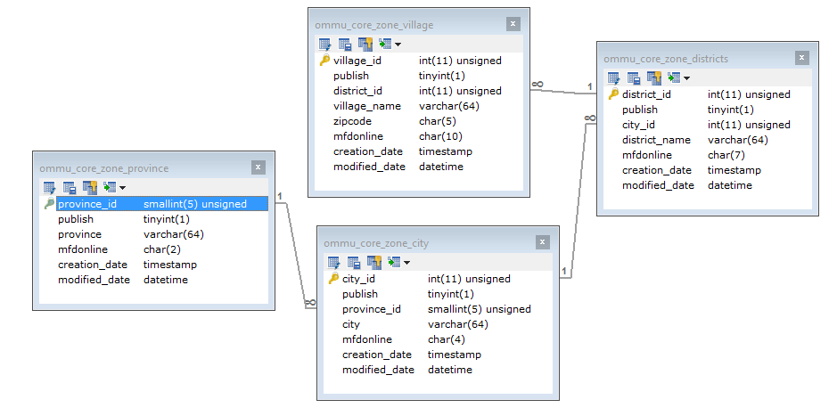

# **BAB III USER INTERFACE**

1. **Welcome**
2. **Provinsi**
3. Insert

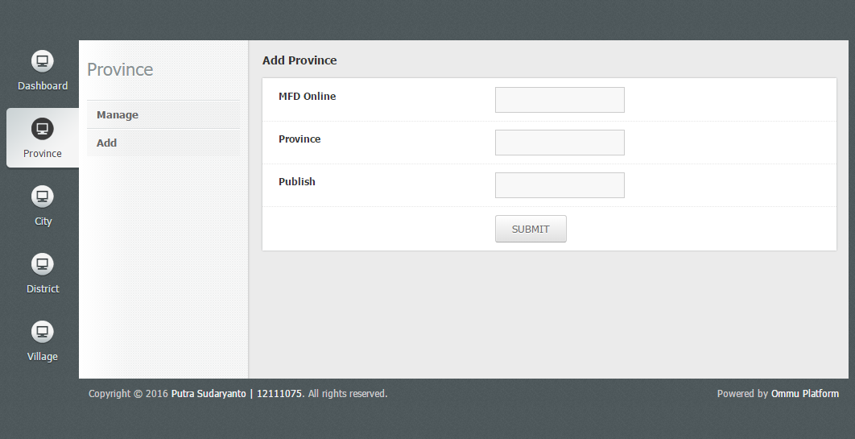

1. Update

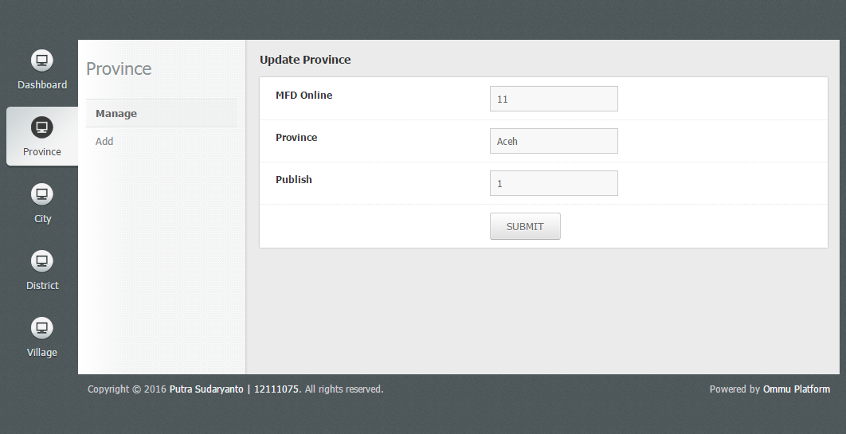

1. View

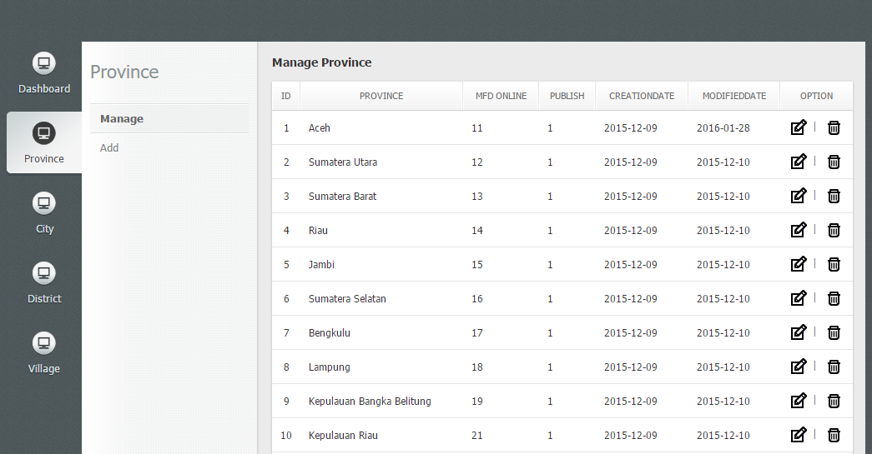

1. **Kabupaten / Kota**
2. Insert

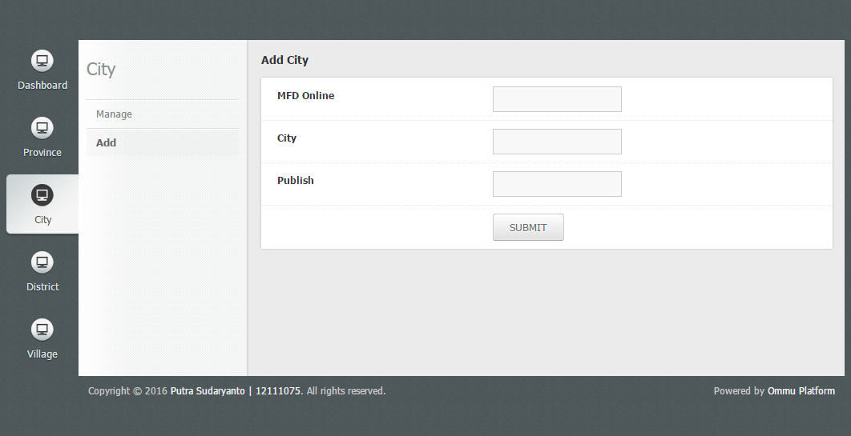

1. Update

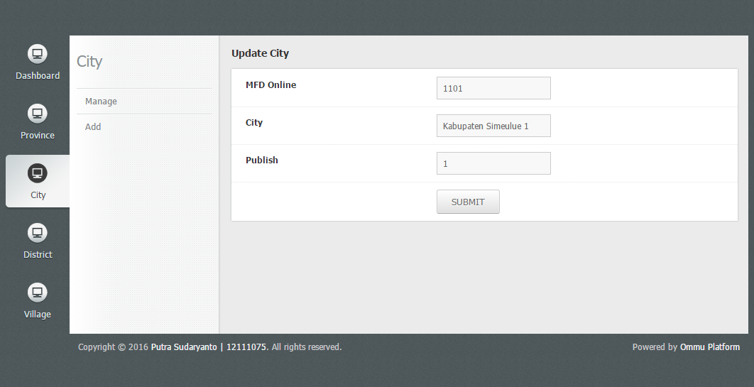

1. View

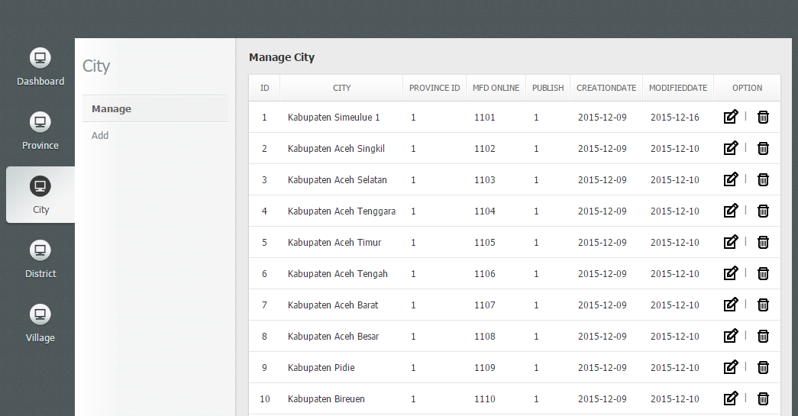

1. **Kecamatan**
2. Insert

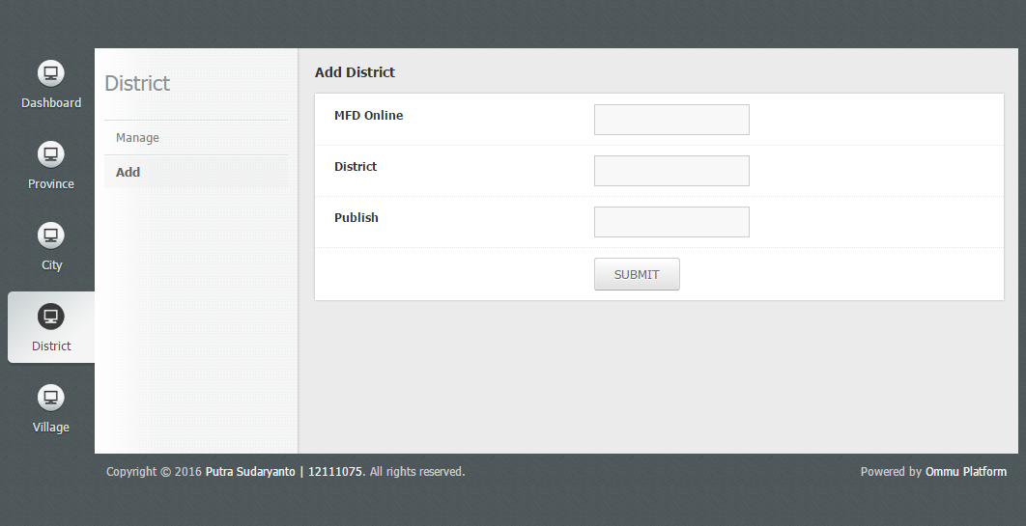

1. Update

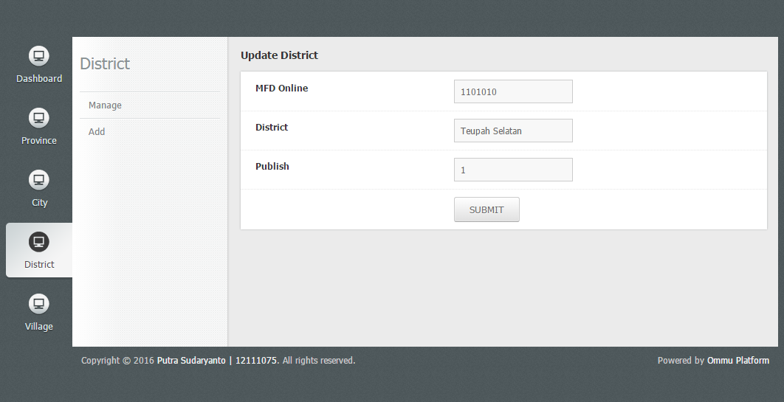

1. View

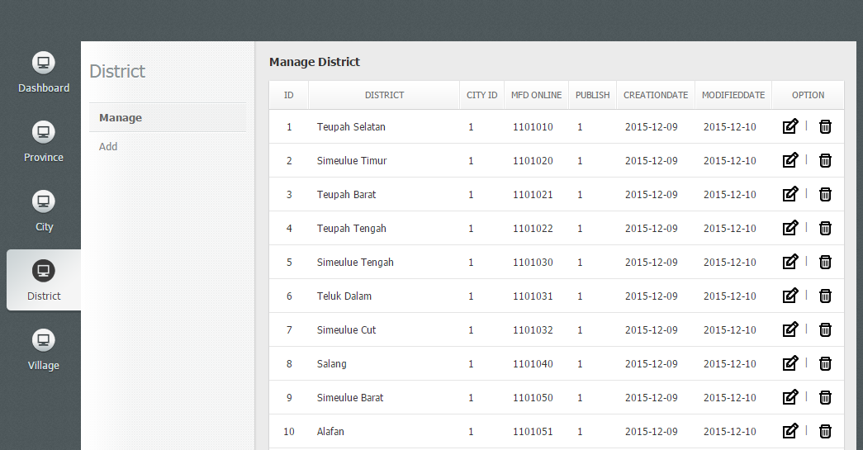

1. **Desa / Kelurahan**
2. Insert

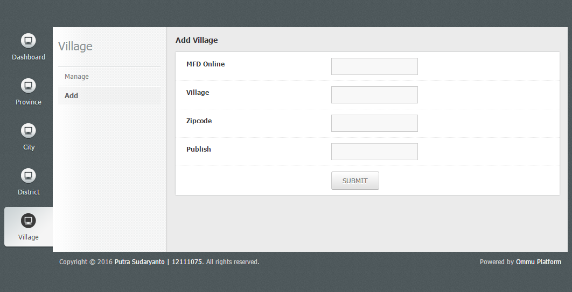

1. Update

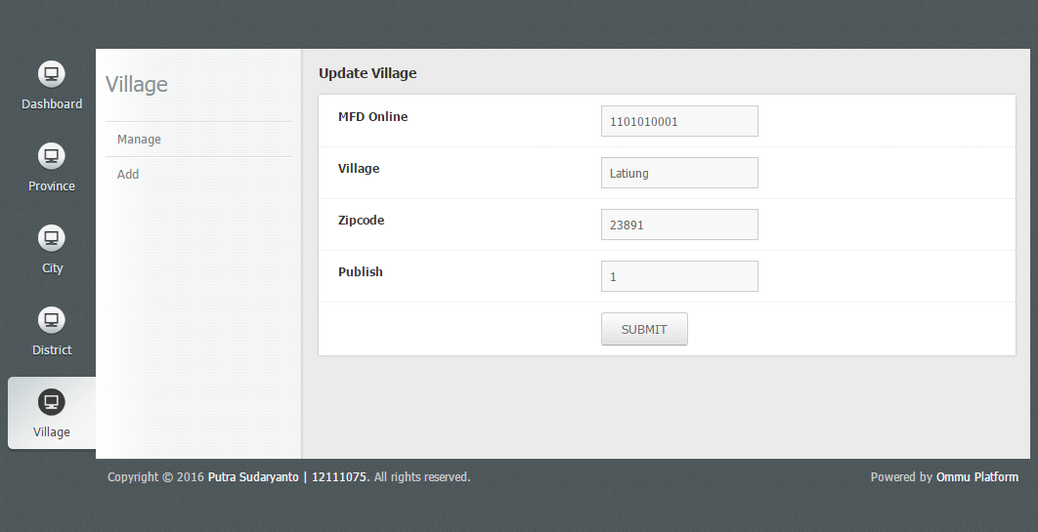

1. View

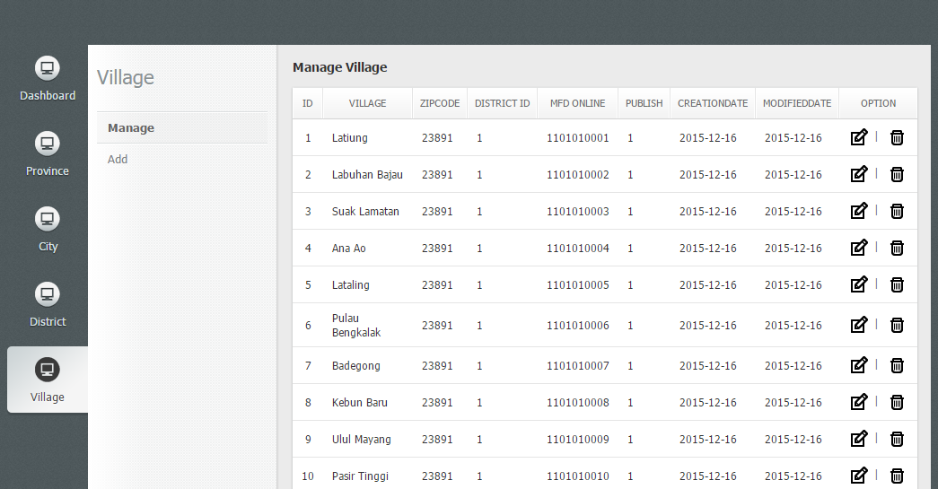

# **BAB IV MENU, STRUCTURE DAN TESTING**

1. **Menu**

|  |  |  |
| --- | --- | --- |
| **Mainmenu** | **Submenu** | **Content Menu** |
| Dashboard | Manage | Update |
| Delete |
| Add | - |
| Province | Manage | Update |
| Delete |
| Add | - |
| City | Manage | Update |
| Delete |
| Add | - |
| District | Manage | Update |
| Delete |
| Add | - |
| Village | Manage | Update |
| Delete |
| Add | - |

1. **Structure**

* Controller
* City.java
* District.java
* Province.java
* Village.java
* Site.java
* Database
* Database.java
* Model
* CityModel.java
* DistrictModel.java
* ProvinceModel.java
* VillageModel.java
* Page
* CityPage.java
* DistrictPage.java
* ProvincePage.java
* VillagePage.java
* View
* City
* admin_delete.jsp
* admin_form.jsp
* admin_manage.jsp
* District
* admin_delete.jsp
* admin_form.jsp
* admin_manage.jsp
* Province
* admin_delete.jsp
* admin_form.jsp
* admin_manage.jsp
* Site
* admin_delete.jsp
* admin_form.jsp
* admin_manage.jsp
* Village
* admin_delete.jsp
* admin_form.jsp
* admin_manage.jsp
* web.xml

1. **Testing Aplikasi**

|  |  |  |  |
| --- | --- | --- | --- |
| **Mainmenu** | **Function Menu** | **Result** | |
| **Yes** | **No** |
| Dashboard | Manage | √ |  |
| Add | √ |  |
| Update | √ |  |
| Delete | √ |  |
| Province | Manage | √ |  |
| Add | √ |  |
| Update | √ |  |
| Delete | √ |  |
| City | Manage | √ |  |
| Add | √ |  |
| Update | √ |  |
| Delete | √ |  |
| District | Manage | √ |  |
| Add | √ |  |
| Update | √ |  |
| Delete | √ |  |
| Village | Manage | √ |  |
| Add | √ |  |
| Update | √ |  |
| Delete | √ |  |

# **BAB V PENUTUP**

1. **Kesimpulan**

Aplikasi yang dikembangkan dengan bahasa pemrograman Java tidah hanya selalu berupa aplikasi desktop tapi juga bisa berupa aplikasi berbasis website. Dengan bantuan JDBC kita bisa mengembangkan sebuah aplikasi berbasis website dengan bahasa pemrograman java yang bersifat dinamis dan terhubung dengan dengan basis data.

1. **Kesulitan**

Kesulitan yang saya alami dalam mengembangkan aplikasi berbasis website dengan Bahasa pemrograman java dan fitur JDBC, diantaranya:

1. Model, untuk memasukkan sebuah value hasil dari relation database harus mendefiniskan variable yang akan dimasukkan. Sering terjadi kesalahan dan keluapaan nama variable karena netbean tidak ada suggestion nama variable.
2. Berbeda dengan nama variable yang dapat digunakan, untuk java _ (underscore) tidak bisa digunakan dengan error *properly,* ini yang menjadikan java tidak terlalu familiar dibandingkan bahasa pemrograman yang lain.
3. Dropdown, Autosuggest, Checkbox and Radio Condition (Validation), terlalu manual
4. Dalan kesulitan-kesulitan lainnya.. ☺ ☺