**JENKINS SETUP FOR CALIPER:**

**1. Install jenkins on you pc and change the home director of jenking for “/var/lib/jenkins” to “/home/jenkins”**

NOTE: 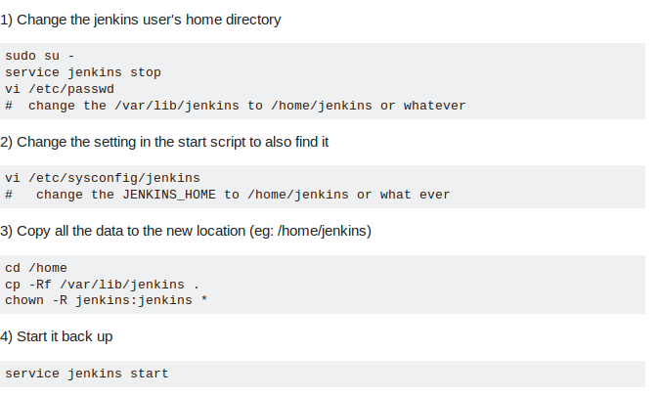

If “/etc/sysconfig/jenkins” file is not present in your PC then please ignore step-2.

**2. Setting up for triggering a single target.**

Initial Setup for cofiguring the inputs required to execute caliper.

* Download caliper in “/home/jenkins/workspace” folder as shown below

**cd /home/jenkins/workspace**

`**git clone** [**https://github.com/open-estuary/caliper.git**](https://github.com/open-estuary/caliper.git)`

* Install caliper with the command **sudo python setup.py install**.
* **cd /home/jenkins/workspace/caliper/utils/automation_scripts/.automationconfig**
* `**cp automation_X.cfg automation_1.cfg**` and update automation_1.cfg with the relevent details as discribed in Automation_UserDoc.docx
* `**cd /home/jenkins/workspace/caliper/utils/automation_scripts/testlist** `
* `**cp testList_template testlist_1**` and modify testlist_1 as per Automation_UserDoc.docx

Configuring Jenkins

* Create a new project of type “PIPELINE”

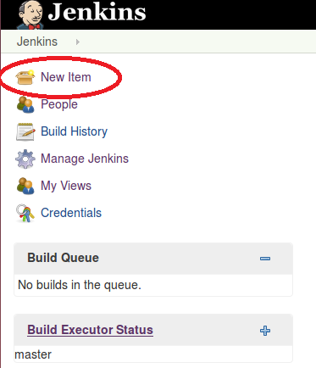

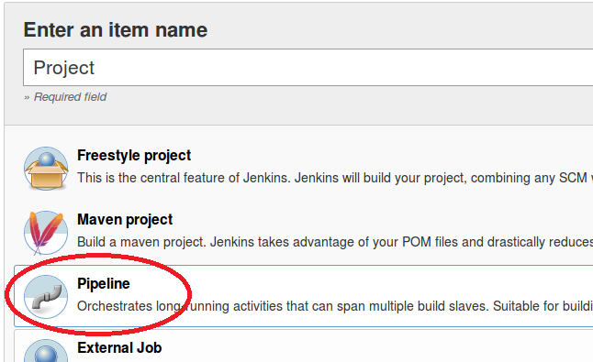

* In the configuration , under Pipeline write the following script. Here –caliper_option='-xxxx testing_R7' is just as example, you can use what ever operation suitable accordingly. And then press save button.

NOTE:

./automation **1 ***** -> “1” represents to run with the configuration provided with automation_”1”.cfg and testlist_”1”**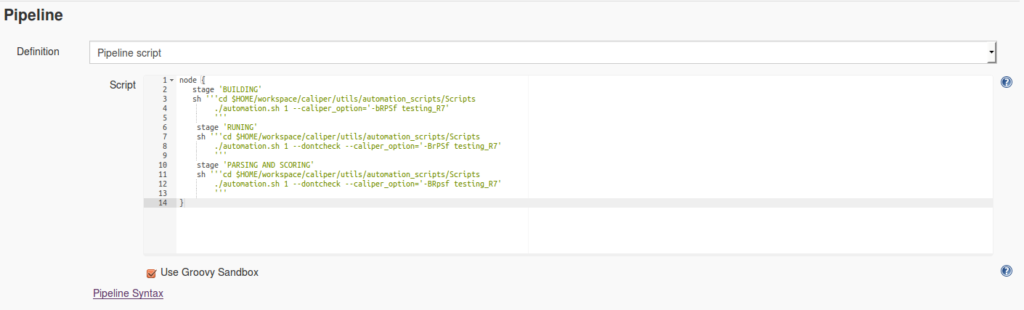

* Run the project by pressing the build button

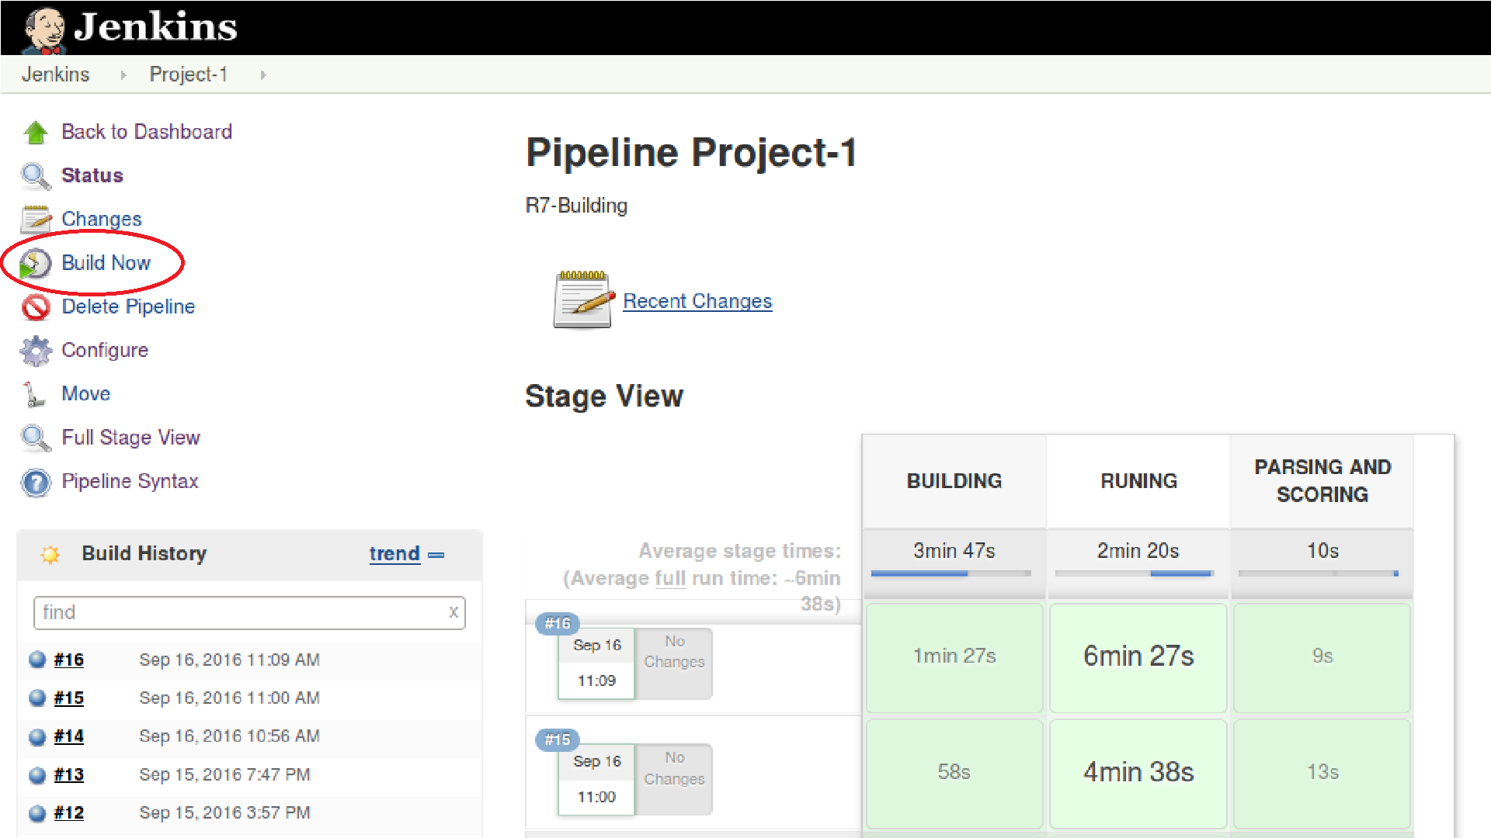

**3. Configure Jenkins to Run multiple targets.**

* Repeat step 2 for each new target
  + Create automation_2.cfg and testlist_2 for second target and run it as ./automation.sh **2**
  + Create automation_3.cfg and testlist_3 for second target and run it as ./automation.sh **3**

so on . . .

* Create a new project for type FREESTYLE and configure it as shown in the figure, this project will be used to trigger all the other project

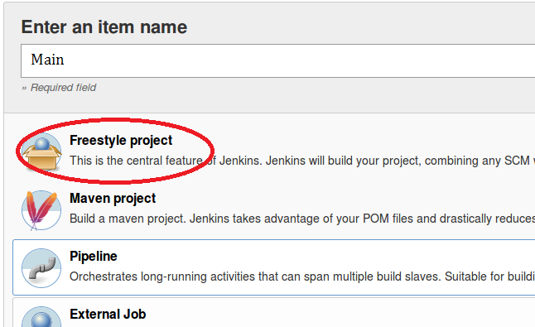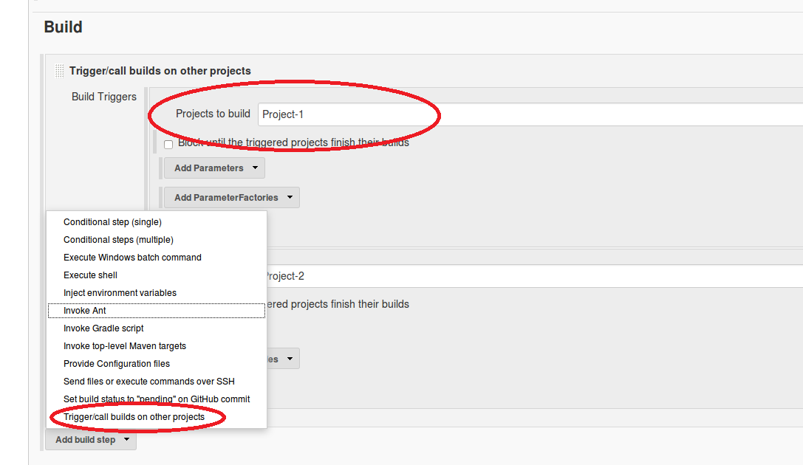

* Finally we have 3 projects , Main ,Project-1, Project-2 .
  + Project-1 – represents target 1
  + Project-2 – represents target 2
  + Main – Used to trigger Project 1 and Project 2

**4. Copying to Database:**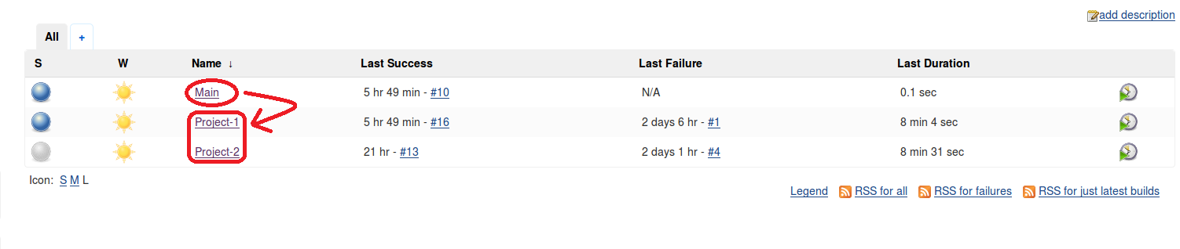

If you want to copy your caliper output logs to a destination then for each target create a Database_X file as mention in the Automation_UserDoc.docx and re-configure the all Project as below. **Notice –copy option used**

