2)
Sol)
Source Code: 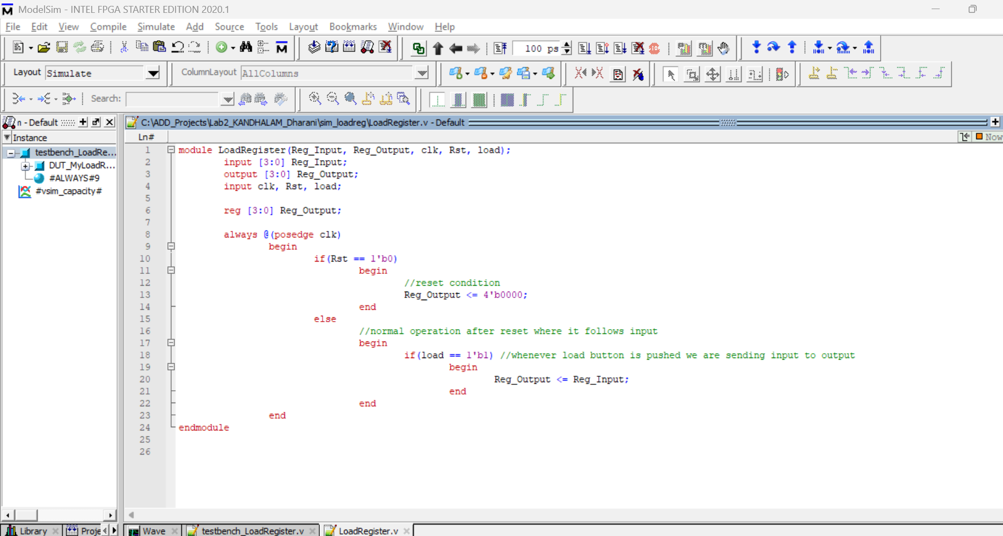
TestBench code:
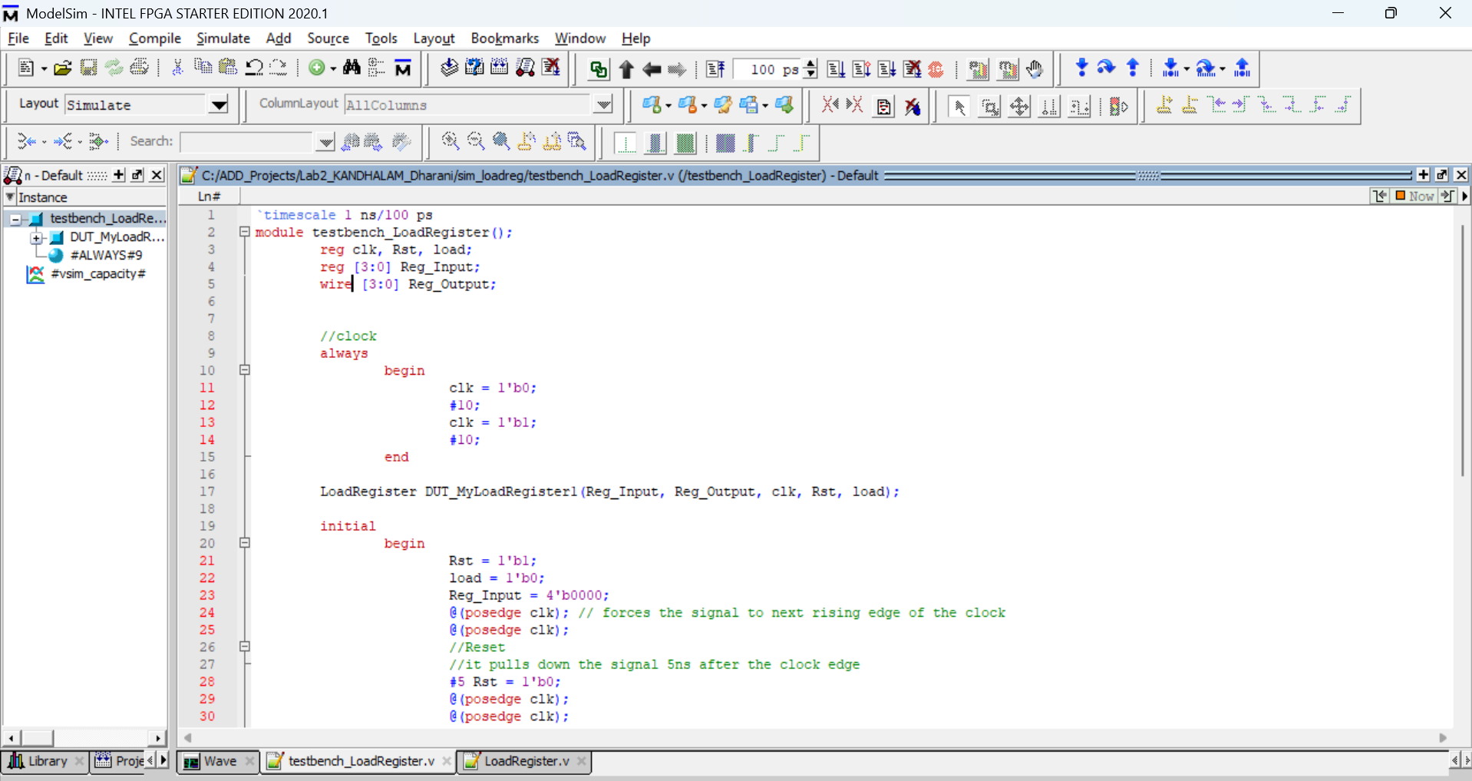
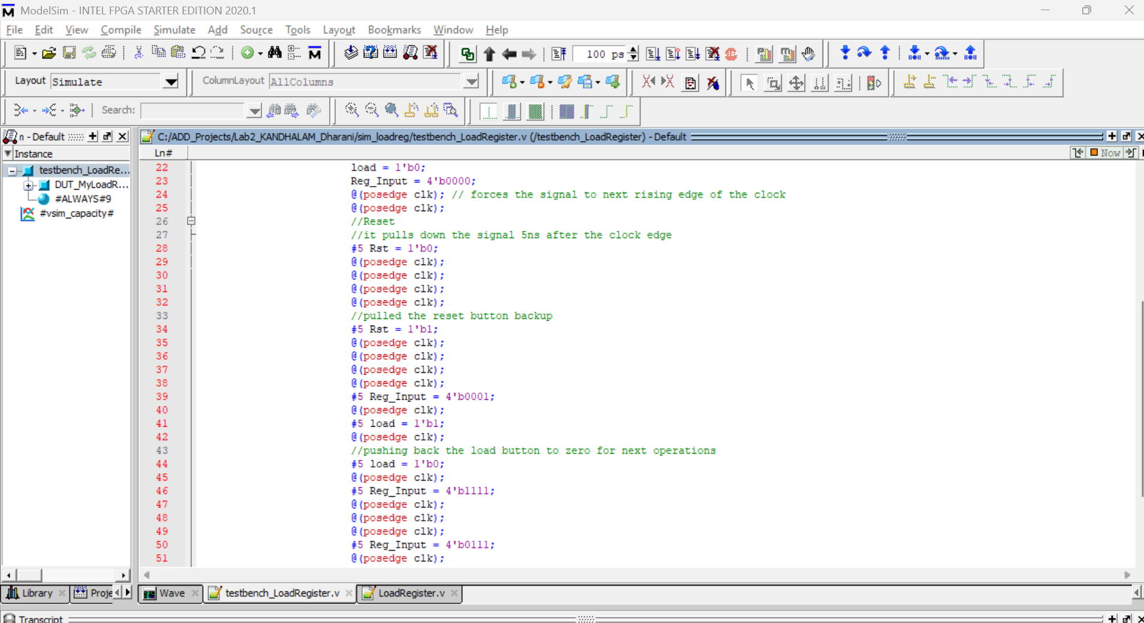
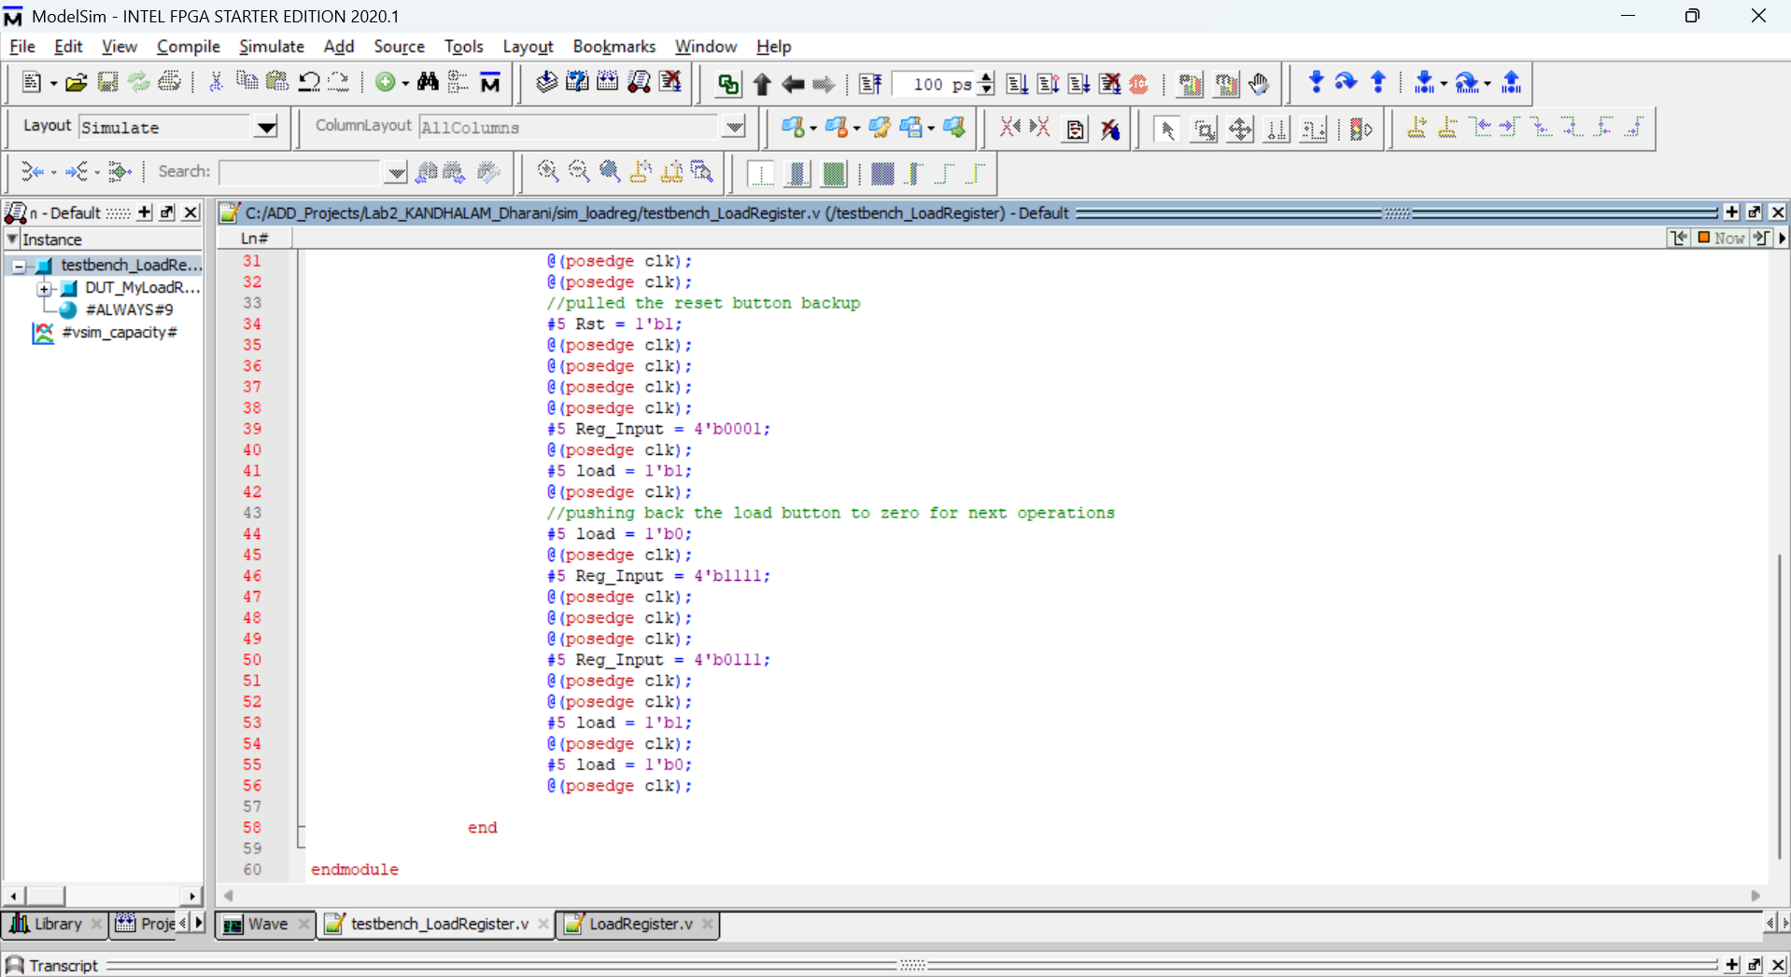
Simulation:
Clk – as always block doesn’t contain any sensitivity list, it’s just keep on going 10ns high and 10ns low.
Rst – as we set reset high at beginning in initial block it is high for some time in starting of the simulation and went low.
Output – as we didn’t define any out for starting simulation it is red(undefined) once reset line goes high the output went to 0000 as defined.
In this case, like reset goes to low in middle of clk transition, then the immediate next rising edge of the clk the output follows to 0000 for reset.
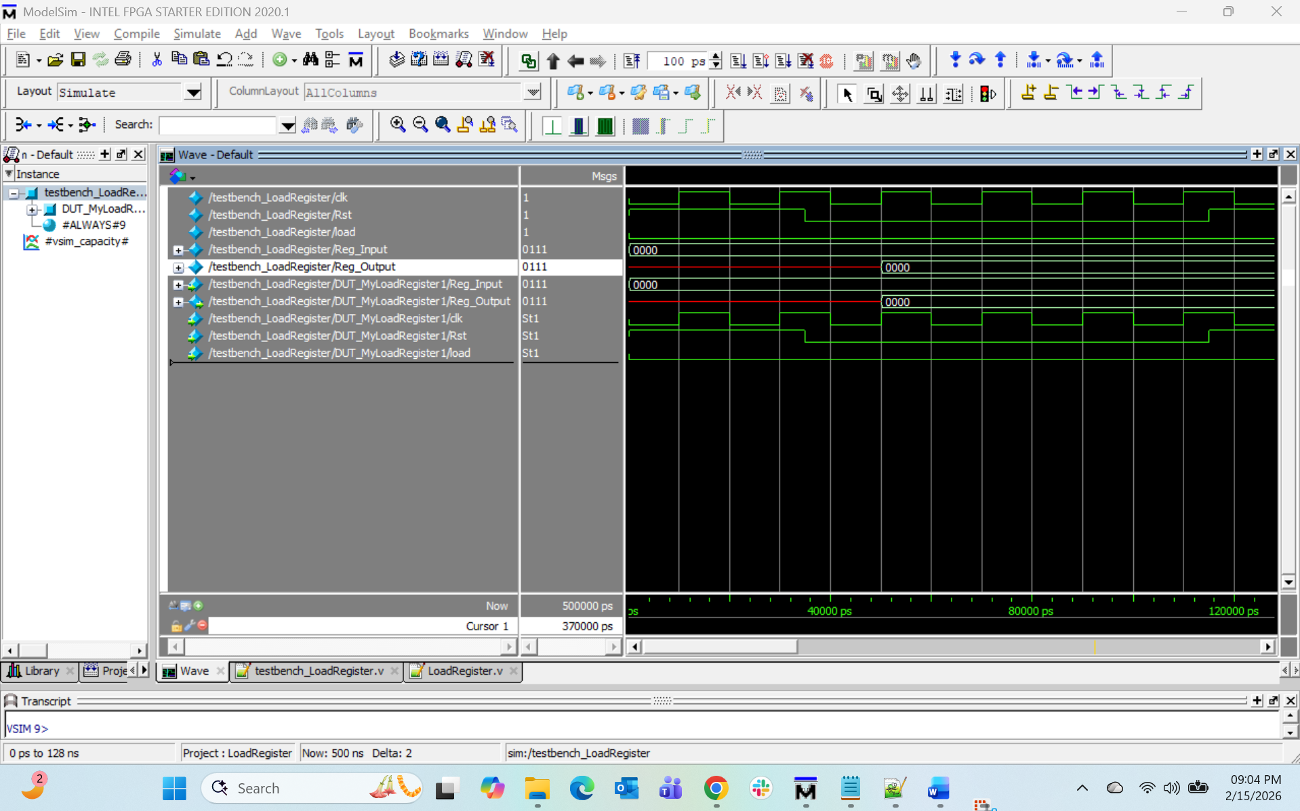
As per our register design the output follows input only when load button is pressed, that explains in below case.
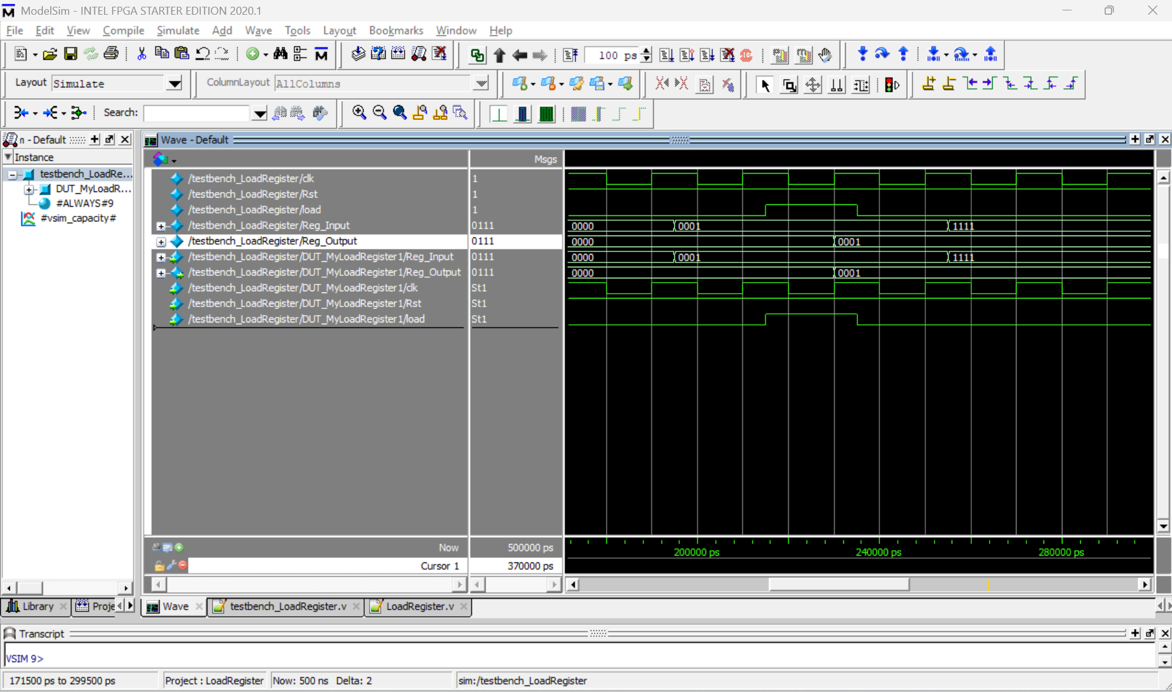
As there is no load button high the output doesn’t changed even though the input changed to 1111.
