**I Putu Sugosa Anggaramukti**

**72180268**

**White Box Testing**

**Skenario**

* 1-2-3
* 1-4-5
* 1-6-7
* 1-8-9
* 1-10-11
* 1-12-13

**Testing**

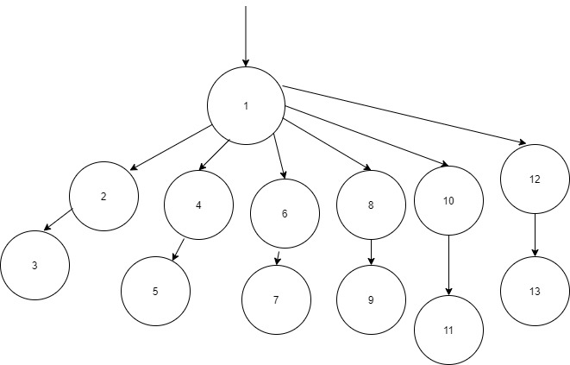

**Test Case**

|  |  |  |  |  |  |
| --- | --- | --- | --- | --- | --- |
| **ID** | **Test Case** | **Value** | **Expected** | **Pass/Fail** | **Desc** |
| a | Input Cek Hadiah | Harga >300000 dan harga <499999 | Pass | Pass |  |
| b | Input Cek Hadiah | Harga >=500000 dan harga <699999 | Pass | Pass |  |
| c | Input Cek Hadiah | Harga >=700000 dan harga <899999 | Pass | Pass |  |
| d | Input Cek Hadiah | Harga >=900000 dan harga <999999 | Pass | Pass |  |
| e | Input Cek Hadiah | Harga >=1000000 | Pass | Pass |  |
| f | Input Cek Hadiah | Harga <299999 | Pass | Pass |  |