Courtney Kirkham, Mark Lero, Dean Dixon, Jonathan Bowie, Nicholas Kinderman

CSC 424 – Software Engineering II

Spring 2017

Prof. Lindy Nelson

Project Plan

Table of Contents

I. Project Name

II. Vision Statement

III. Product Roadmap

IV. Definition of Done

V. Release Schedule

VI. Issues and Concerns

VII. Team Roles

VIII. Team Commitment

IX. Collaboration Tools

X. Meeting Schedule

XI. Communication and Logistics Plan

**I. Project Name**

The project name has not yet been decided, but is currently being referred to as "Paddle Racers".

Return to Table of Contents

**II. Vision Statement**

For paddle race directors and racers who want an online resource for creating and managing races, as well as viewing race results, [Paddle Racers] is a web application that is free and easy to use. Unlike paid, generalized tools, our product provides specialized registration and time management tools for paddle races, which supports our strategy to promote paddling and make it more accessible.

Return to Table of Contents

**III. Product Roadmap**

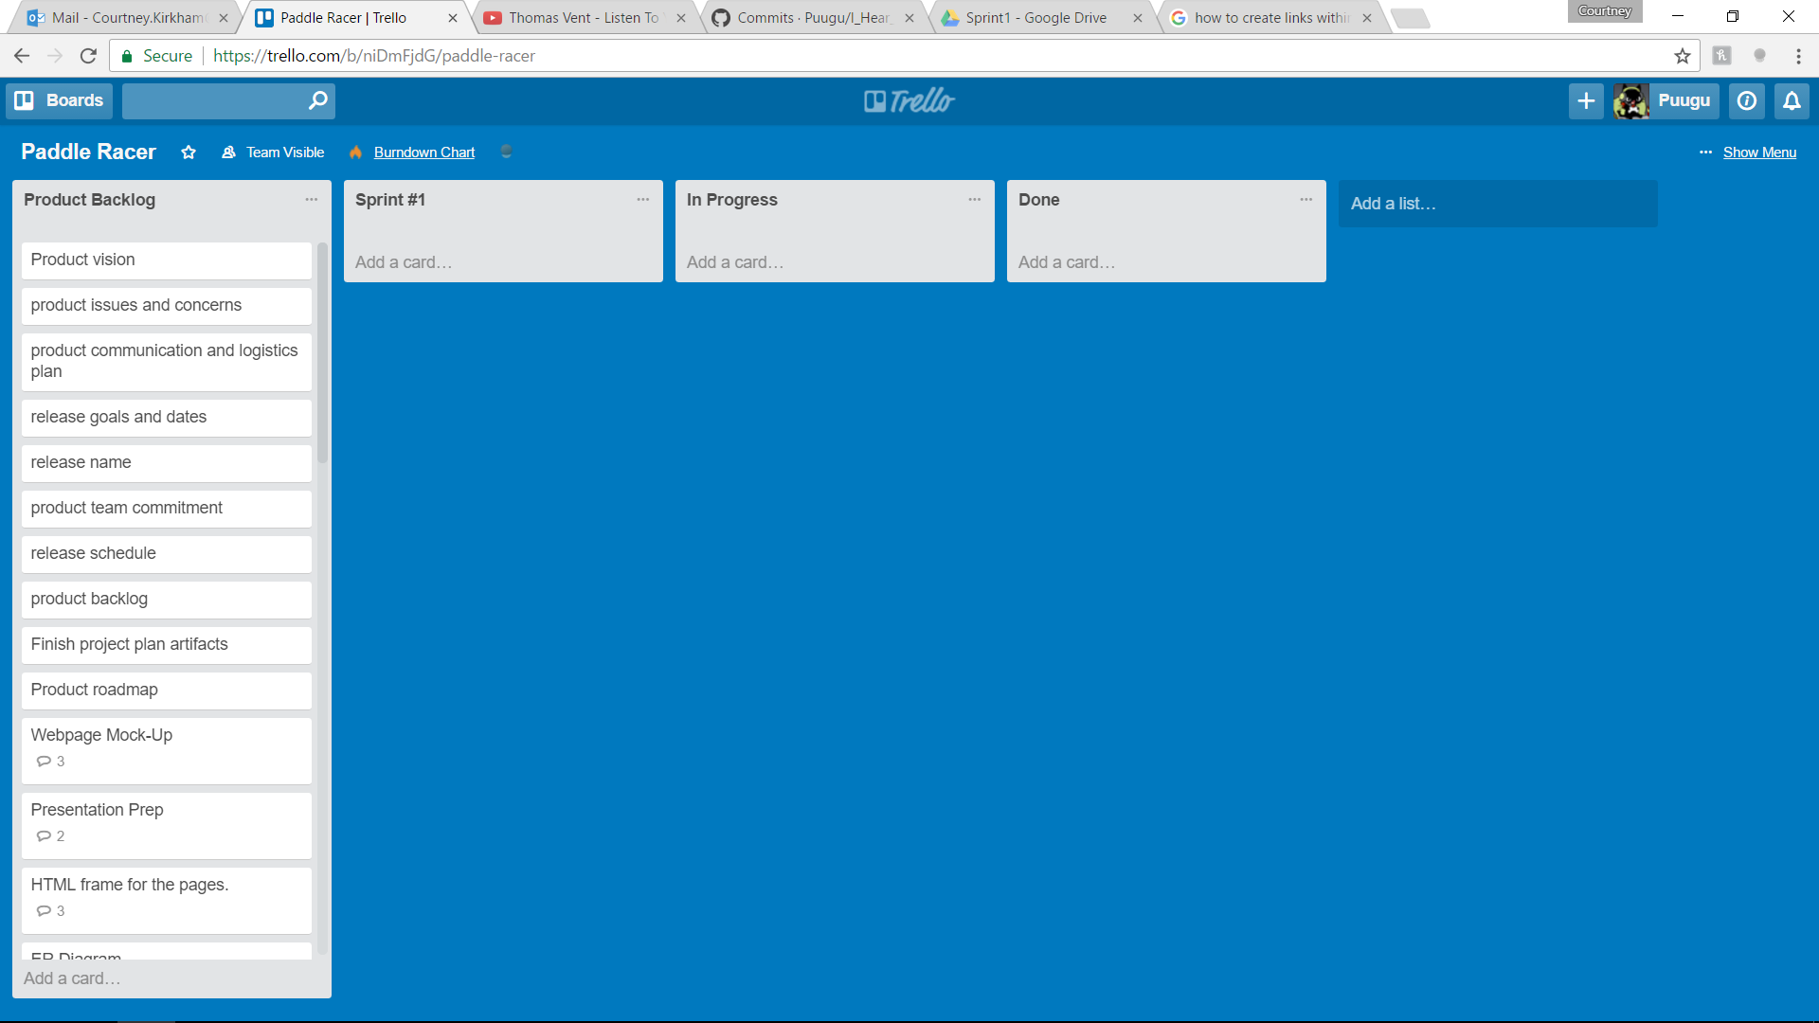

Return to Table of Contents

**IV. Definition of Done**

[Paddle Racers] functionality is divided into two main focuses – those for the race directors and those for race participants. The race directors will be able to create and edit races, manage timekeeping, and view race results. Race participants will be able to register for races and view their results.

Return to Table of Contents

**V. Release Schedule**

The first release will provide the core race director functionality for the [Paddle Racers] web application. The second release will allow racers to register for races. The third release will allow for timekeeping. The fourth, and, at present, final release will allow the posting and viewing of race results.

Return to Table of Contents

**VI. Issues and Concerns**

Our team is concerned about the proficiency of the team regarding html, javascript, css, and bootstrap. Another concern is the need to build the database and figure out the logic for creating the races and editing the results. Coordinating the time keeping is another concern, as is making a secure database for user accounts. The team still needs to figure out what language to use for the backend of our project. We are optimistic about being able to learn these skills throughout the lifetime of the project, but recognize they represent a wide variety of skills we need to develop.

Return to Table of Contents

**VII. Team Roles**

Our first release is divided into five sprints. For each of those five sprints, we rotate who will represent the product owner and who will represent the product owner. For all five sprints, all of the group members, including those fulfilling the roles of scrum master and product owner, make up the development team. For the first sprint, Nicholas Kinderman will be the product owner and Courtney Kirkham will be the scrum master. During the second sprint, the product owner will be Mark Lero and the scrum master will be Nicholas Kinderman. The product owner for the third sprint will be Jonathan Bowie, and the scrum master will be Mark Lero. The fourth sprint will see Dean Dixon as the product owner and Jonathan Bowie as the scrum master. The fifth and final sprint will have Courtney Kirkham as the product owner and Dean Dixon as the scrum master.

Return to Table of Contents

**VIII. Team Commitment**

The team commits to showing up for every meeting and class. If a team member cannot show up for some reason, they will let the team know as soon as possible. They will also get in touch with a team member to find out what they missed before the next meeting commences. The team commits to commenting code, and will sign code they contribute so code reviewers know who is responsible for what portion of the final code. Finally, the team commits to naming variables using camel case and prioritizing descriptive variable names over brief ones.

Return to Table of Contents

**IX. Collaboration Tools**

The team will use Trello for keeping track of the product and sprint backlogs. GitHub is used for version control. Discord, text messages, and e-mail will be used for communication between in – person meetings. Google Drive will be used for keeping track of project files in addition to GitHub.

Return to Table of Contents

**X. Meeting Schedule**

The team will meet Monday nights after class, on Wednesday evenings at 10:30 PM via Discord, and on Sunday afternoons at 1:00 PM at Quickly Asian Fusion Café in D'Iberville.

Return to Table of Contents

**XI. Communication and Logistics Plan**

The Monday night meetings are for sprint reviews and sprint planning. The Wednesday evening meetings are to check on the team's progress and address any roadblocks in the midst of the week, as well as serving as a hand-off timeline if any of the tasks for the sprint are scheduled to change hands in the midst of the sprint. The Sunday afternoon meetings are for the team to go over what they have completed and provide an overview for what will be presented in class on Mondays. Throughout the week, the team members will communicate via text messages and e-mails if they need to ask the team for feedback or assistance. All team members are to check e-mail daily. Text messages and e-mails will be responded to within a twenty-four hour time period to at least let the other team members know that their message has been received and is being considered.

Return to Table of Contents