Courtney Kirkham, Mark Lero, Dean Dixon, Jonathan Bowie, Nicholas Kinderman

CSC 424 – Software Engineering II

Spring 2017

Prof. Lindy Nelson

Sprint Plan – Sprint Number

Table of Contents

I. Sprint Name

II. Sprint Goals and Dates

III. Sprint Backlog

IV. Definition of Done

V. Sprint Burndown Chart

VI. Team Velocity

VII. Team Roles

VIII. Team Commitment

IX. Issues and Concerns

X. Meeting Schedule

XI. Communication and Logistics Plan

XII. Collaboration Tools

**I.** **Sprint Name**

The project name has not yet been decided, but is currently being referred to as "Paddle Racers". The name of the first sprint is Sprint 1.

Return to Table of Contents

**II. Sprint Goals and Dates**

Sprint 1 will begin on Monday, 20 March 2017 and end on Monday, 27 March 2017. In Sprint 1, our team will create a mock-up of what the [Paddle Racers] web page will look like, create the basic framework for the webpages, generate an ER diagram for the database, create content for the "About" and "FAQ" webpages, prepare a presentation for the CSC 424 Software Engineering II course on our progress after Sprint 1, and revise the project and release planning documents, as per Prof. Nelson's specifications.

Return to Table of Contents

**III.** **Sprint Backlog**

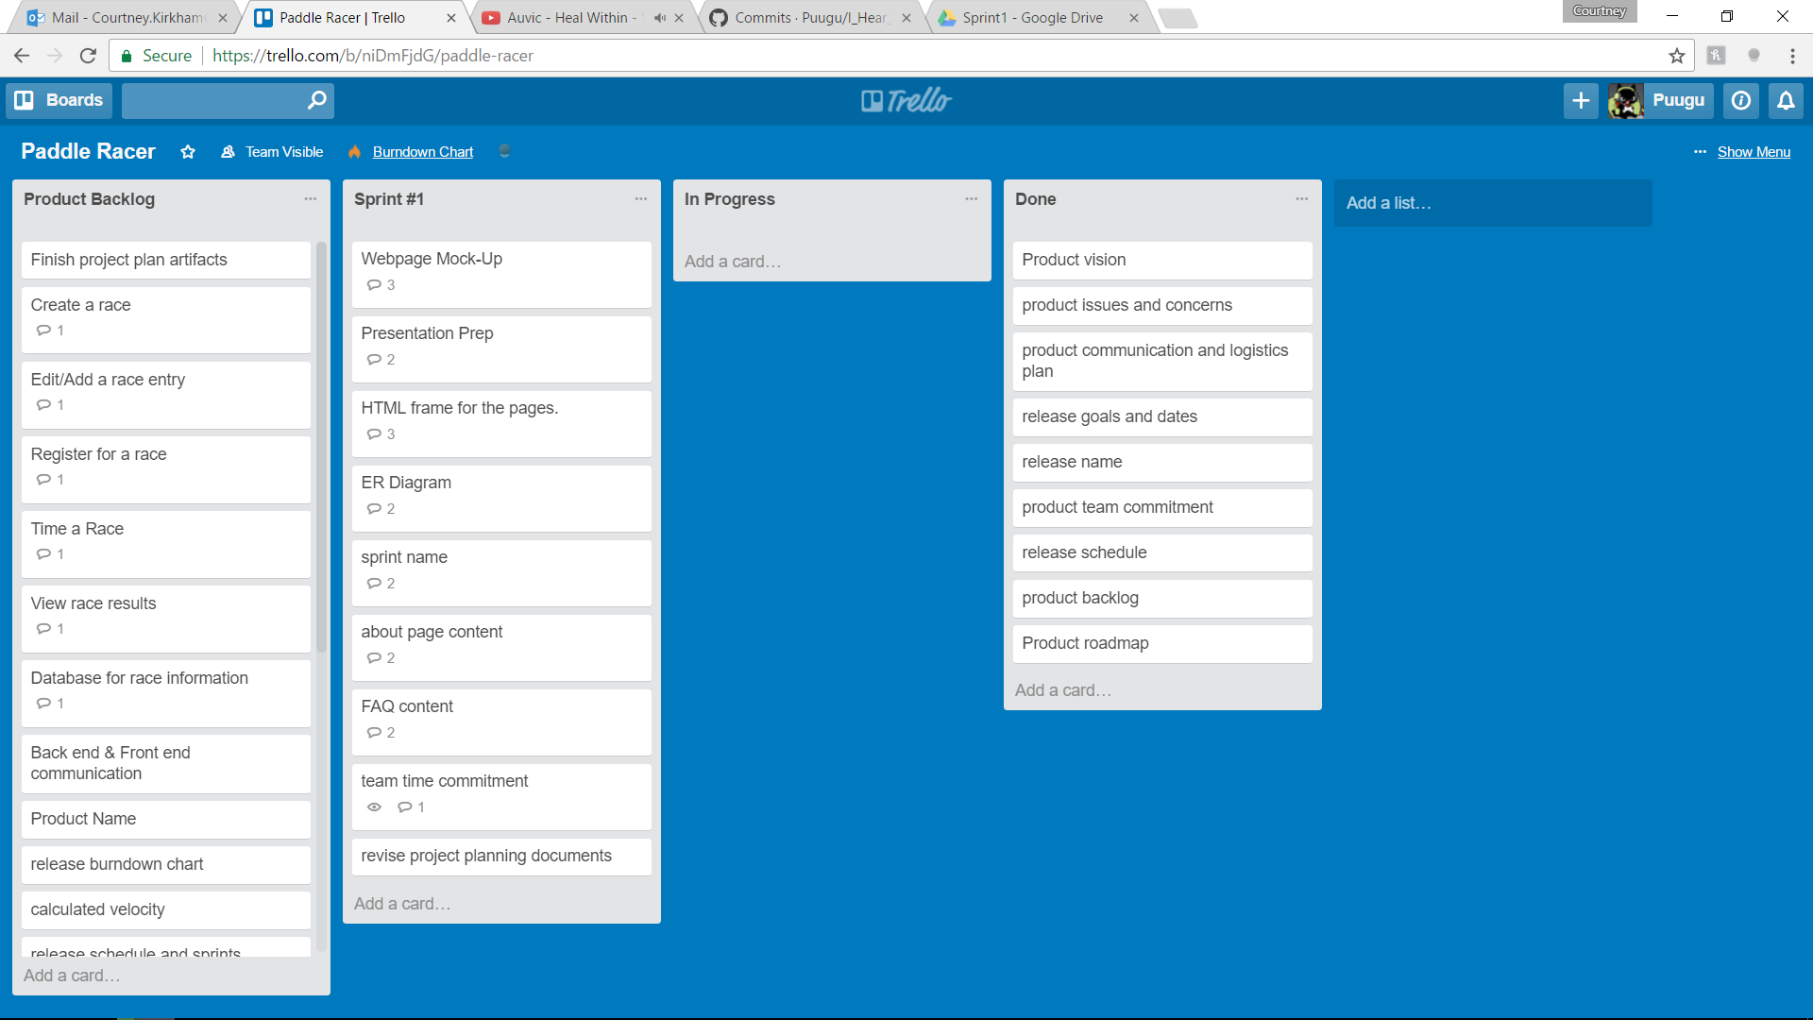

Return to Table of Contents

**IV.** **Definition of Done**

The ER diagram will cover the entities relevant to race directors and racers. The webpage mock – up will be a set of rudimentary images that will show the basic layout for the webpage. The framework for the webpages will be a rudimentary website following the layout of the mock-up. There should be basic navigation between the webpages. The "About" content will go over what the [Paddle Racers] site offers users and provide a bit of information regarding the team that will create [Paddle Racers]. The "FAQ" content will provide some basic questions our team expects users will have and the correct answers to those questions. All of the previously mentioned tasks will be provided to the Product Owner for review before being marked as complete. The project and release documents, as well as the presentation will be presented to the team for review and approval before being submitted to Prof. Nelson.

Return to Table of Contents

**V.** **Sprint Burndown Chart**

|  |  |  |  |  |  |
| --- | --- | --- | --- | --- | --- |
|  |  | Paddle Racers Burndown Chart | | | |
| 100 |  |  |  |  |  |
| 90 |  |  |  |  |  |
| 80 |  |  |  |  |  |
| 70 |  |  |  |  |  |
| 60 |  |  |  |  |  |
| 50 |  |  |  |  |  |
| 40 |  |  |  |  |  |
| 30 |  |  |  |  |  |
| 20 |  |  |  |  |  |
| 10 |  |  |  |  |  |
|  | Sprint 1 | Sprint 2 | Sprint 3 | Sprint 4 | Sprint 5 |

Return to Table of Contents

**VI.** **Team Velocity**

In the team's first sprint, 20 story points were completed. The team has completed 1 sprint. This results in a calculated velocity of 20.

Return to Table of Contents

**VII.** **Team Roles**

Our first release is divided into five sprints. For each of those five sprints, we rotate who will represent the product owner and who will represent the product owner. For all five sprints, all of the group members, including those fulfilling the roles of scrum master and product owner, make up the development team. For the first sprint, Nicholas Kinderman will be the product owner and Courtney Kirkham will be the scrum master.

Return to Table of Contents

**VIII.** **Team Commitment**

The team commits to showing up for every meeting and class. If a team member cannot show up for some reason, they will let the team know as soon as possible. They will also get in touch with a team member to find out what they missed before the next meeting commences. The team commits to commenting code, and will sign code they contribute so code reviewers know who is responsible for what portion of the final code. Finally, the team commits to naming variables using camel case and prioritizing descriptive variable names over brief ones.

Return to Table of Contents

**IX.** **Issues and Concerns**

Our team is concerned about the proficiency of the team regarding html, javascript, css, and bootstrap. Another concern is the need to build the database and figure out the logic for creating the races and editing the results. Coordinating the time keeping is another concern, as is making a secure database for user accounts. The team still needs to figure out what language to use for the backend of our project. We are optimistic about being able to learn these skills throughout the lifetime of the project, but recognize they represent a wide variety of skills we need to develop.

Return to Table of Contents

**X.** **Meeting Schedule**

The team will meet Monday nights after class, on Wednesday evenings at 10:30 PM via Discord, and on Sunday afternoons at 1:00 PM at Quickly Asian Fusion Café in D'Iberville.

Return to Table of Contents

**XI.** **Communication and Logistics Plan**

The Monday night meetings are for sprint reviews and sprint planning. The Wednesday evening meetings are to check on the team's progress and address any roadblocks in the midst of the week, as well as serving as a hand-off timeline if any of the tasks for the sprint are scheduled to change hands in the midst of the sprint. The Sunday afternoon meetings are for the team to go over what they have completed and provide an overview for what will be presented in class on Mondays. Throughout the week, the team members will communicate via text messages and e-mails if they need to ask the team for feedback or assistance. All team members are to check e-mail daily. Text messages and e-mails will be responded to within a twenty-four hour time period to at least let the other team members know that their message has been received and is being considered.

Return to Table of Contents

**XII. Collaboration Tools**

The team will use Trello for keeping track of the product and sprint backlogs. GitHub is used for version control. Discord, text messages, and e-mail will be used for communication between in – person meetings. Google Drive will be used for keeping track of project files in addition to GitHub.

Return to Table of Contents