Courtney Kirkham, Mark Lero, Dean Dixon, Jonathan Bowie, Nicholas Kinderman

CSC 424 – Software Engineering II

Spring 2017

Prof. Lindy Nelson

Sprint Plan – Sprint 2

Table of Contents

I. Sprint Name

II. Sprint Goals and Dates

III. Sprint Backlog

IV. Definition of Done

V. Sprint Burndown Chart

VI. Team Velocity

VII. Team Capacity Calculation

VIII. Team Roles

IX. Team Commitment

X. Issues and Concerns

XI. Meeting Schedule

XII. Communication and Logistics Plan

XIII. Collaboration Tools

**I.** **Sprint Name**

The project name has not yet been decided, but is currently being referred to as "Paddle Racers". The name of the second sprint is Sprint 2.

Return to Table of Contents

**II. Sprint Goals and Dates**

All of the goals for Sprint 2 are expected to be completed by 3 April 2017. The first goal for the sprint is to determine the input fields required for creating a race. During this sprint, these input fields will be used to create a visual mock – up for creating a race. The website will have the input fields added during this sprint. The create statements will be written for the tables for the database. Additionally, a team member will work on completing the php and mySQL sections of Code Academy during this sprint. This sprint will also see the completion of the planning document for sprint 2 and the acquisition of publicly available images for the website.

Return to Table of Contents

**III.** **Sprint Backlog**

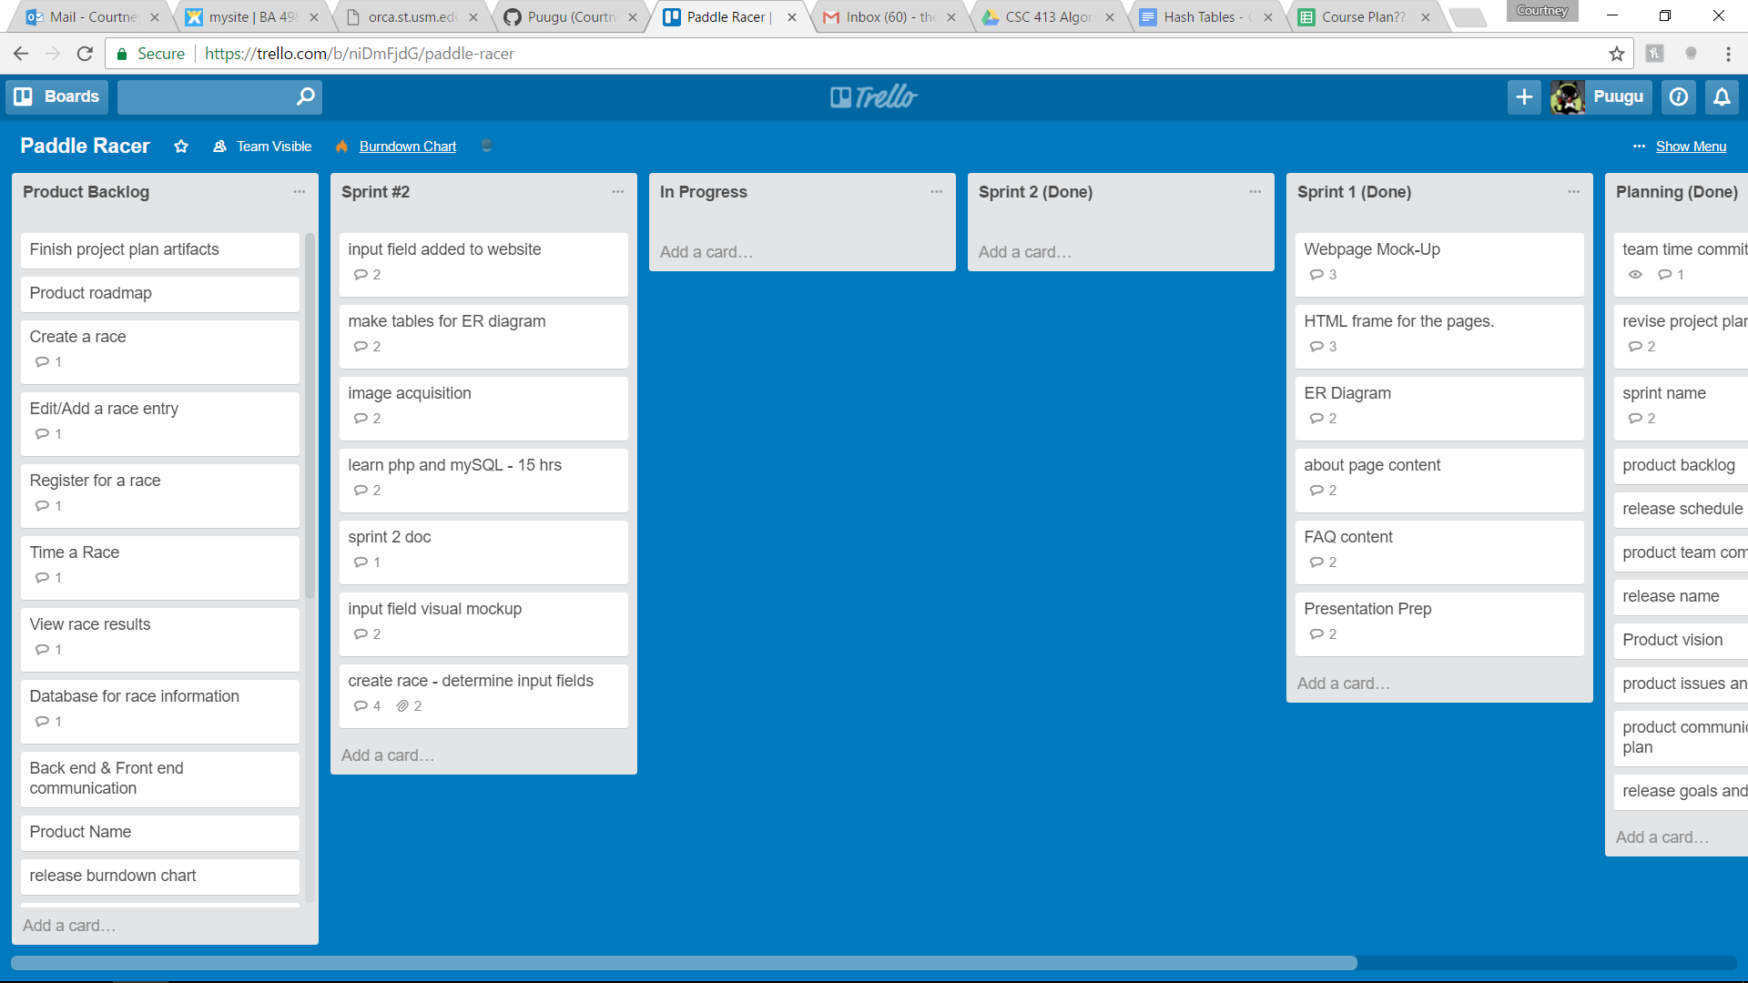

Return to Table of Contents

**IV.** **Definition of Done**

The list of input fields needed for a race director to create a race will be complete when the Product Owner approves the list as comprehensive without being excessive. The visual mock-up for the input fields will be complete when an image is created that displays all of the elements from the list of input fields; this will also be submitted to the Product Owner for approval. The addition of the input fields for the create race functionality will be considered complete when the webpage for creating races displays all of the input fields from the list, as per the layout provided in the visual mock – up. This will require approval by the Product Owner. The Sprint 2 Planning Document will be considered complete when it covers all of the requirements issued by Professor Nelson and the Development Team, Product Owner, and Scrum Master agree with it. The create statements for the database will be complete with they successfully create all the tables for the entries provided on the ER diagram from Sprint 1. Learning PHP and mySQL will be done when the courses are completed on Code Academy. The acquisition of images for the website will be complete when a collection of at least 15 publicly useable images related to paddle racing and its environment is compiled.

Return to Table of Contents

**V.** **Sprint Burndown Chart**

|  |  |  |  |  |  |
| --- | --- | --- | --- | --- | --- |
|  |  | Paddle Racers Burndown Chart | | | |
| 100 |  |  |  |  |  |
| 90 |  |  |  |  |  |
| 80 |  |  |  |  |  |
| 70 |  |  |  |  |  |
| 60 |  |  |  |  |  |
| 50 |  |  |  |  |  |
| 40 |  |  |  |  |  |
| 30 |  |  |  |  |  |
| 20 |  |  |  |  |  |
| 10 | 20 | 36 |  |  |  |
|  | Sprint 1 | Sprint 2 | Sprint 3 | Sprint 4 | Sprint 5 |

Return to Table of Contents

**VI.** **Team Velocity**

In the team's first sprint, 20 story points were completed. The team has completed 1 sprint. This results in a calculated velocity of 20.

The team expects to be able to complete 16 story points this sprint for an expected velocity of 18.

Return to Table of Contents

**VII.** **Team Capacity Calculation**

The team expects to be able to complete an average of 16 story points in each sprint for an expected completion of 80 story points by the first release. In a best – case scenario, the team expects to be able to complete 20 story points in each sprint, for a maximum team capacity of 100 story points by the first release.

Return to Table of Contents

**VIII.** **Team Roles**

Our first release is divided into five sprints. For each of those five sprints, we rotate who will represent the product owner and who will represent the product owner. For Sprint 2, Nicholas Kinderman will be the Scrum Master, Mark Lero will be the Product Owner, and the development team will be comprised of Nicholas Kinderman, Mark Lero, Courtney Kirkham, Dean Dixon, and Jonathan Bowie. The team realizes that the Scrum Master and Product Owner are not supposed to be part of the Development Team in our project, but the plan had already been completed and work had begun by the time we received notification of this clarification. The team agreed to implement this practice beginning Sprint 3 (should it be named such).

Return to Table of Contents

**IX.** **Team Commitment**

The team commits to showing up for every meeting and class. If a team member cannot show up for some reason, they will let the team know as soon as possible. They will also get in touch with a team member to find out what they missed before the next meeting commences. When contacted by another member of the team for feedback or questions, the team commits to offering some notification acknowledging the message and either responding to the question/offering feedback or providing a timeframe in which a response can be expected; they will offer this notification within twenty-four hours of receiving the request. The team commits to moving their tasks on Trello, and the Product Owner commits to checking regularly to see which stories have been submitted for approval. The team commits to commenting code, and will sign code they contribute so code reviewers know who is responsible for what portion of the final code. Finally, the team commits to naming variables using camel case and prioritizing descriptive variable names over brief ones.

Return to Table of Contents

**X.** **Issues and Concerns**

Our team is concerned about the proficiency of the team regarding communication between the database and the website. Another concern is the need to build the database and figure out the logic for creating the races and editing the results. Coordinating the time keeping is another concern, as is making a secure database for user accounts. The team still needs to figure out what language to use for the backend of our project. The team has also recognized that we could stand to improve our communication and better commit to using our collaborative tools. We are optimistic about being able to learn these skills throughout the lifetime of the project, but recognize they represent a wide variety of skills we need to develop.

Return to Table of Contents

**XI.** **Meeting Schedule**

The team will meet Monday nights after class, on Wednesday evenings at 10:30 PM via Discord, and on Sunday afternoons at 1:00 PM at Quickly Asian Fusion Café in D'Iberville.

Return to Table of Contents

**XII.** **Communication and Logistics Plan**

The Monday night meetings are for sprint reviews and sprint planning. The Wednesday evening meetings are to check on the team's progress and address any roadblocks in the midst of the week, as well as serving as a hand-off timeline if any of the tasks for the sprint are scheduled to change hands in the midst of the sprint. The Sunday afternoon meetings are for the team to go over what they have completed and provide an overview for what will be presented in class on Mondays. Throughout the week, the team members will communicate via text messages and e-mails if they need to ask the team for feedback or assistance. All team members are to check e-mail daily. Text messages and e-mails will be responded to within a twenty-four hour time period to at least let the other team members know that their message has been received and is being considered.

Return to Table of Contents

**XIII. Collaboration Tools**

The team will use Trello for keeping track of the product and sprint backlogs. GitHub is used for version control. Discord, text messages, and e-mail will be used for communication between in – person meetings. Google Drive will be used for keeping track of project files in addition to GitHub.

Return to Table of Contents