Courtney Kirkham, Mark Lero, Dean Dixon, Jonathan Bowie, Nicholas Kinderman

CSC 424 – Software Engineering II

Spring 2017

Prof. Lindy Nelson

Sprint Plan – Sprint Three

Table of Contents

I. Sprint Name

II. Sprint Goals and Dates

III. Sprint Backlog

IV. Definition of Done

V. Sprint Burndown Chart

VI. Team Velocity

VII. Team Capacity Calculation

VIII. Team Roles

IX. Team Commitment

X. Issues and Concerns

XI. Meeting Schedule

XII. Communication and Logistics Plan

XIII. Collaboration Tools

**I.** **Sprint Name**

The project name has not yet been decided, but is currently being referred to as "Paddle Racers". The name of the third sprint is Sprint 3.

Return to Table of Contents

**II. Sprint Goals and Dates**

Courtney will finish the sprint 2 retrospective document and type the sprint 3 planning document by Saturday, 8 April 2017. She will also create a mock-up for every webpage currently on the site by Sunday, 9 April 2017. Mark is the Scrum Master for sprint 3. He will create the queries to add and get information from the database, based on the designs from the ER diagram and the current web page mockups by Sunday, 9 April 2017. Jonathan is the Product Owner for Sprint 3. He will finish the php Code Academy course from last sprint and help Dean finish the adding the functionality for creating and editing races to the website by Sunday, 9 April 2017. Nick will be get at least one textbox communicating with the database by Sunday, 9 April 2017.

Return to Table of Contents

**III.** **Sprint Backlog**

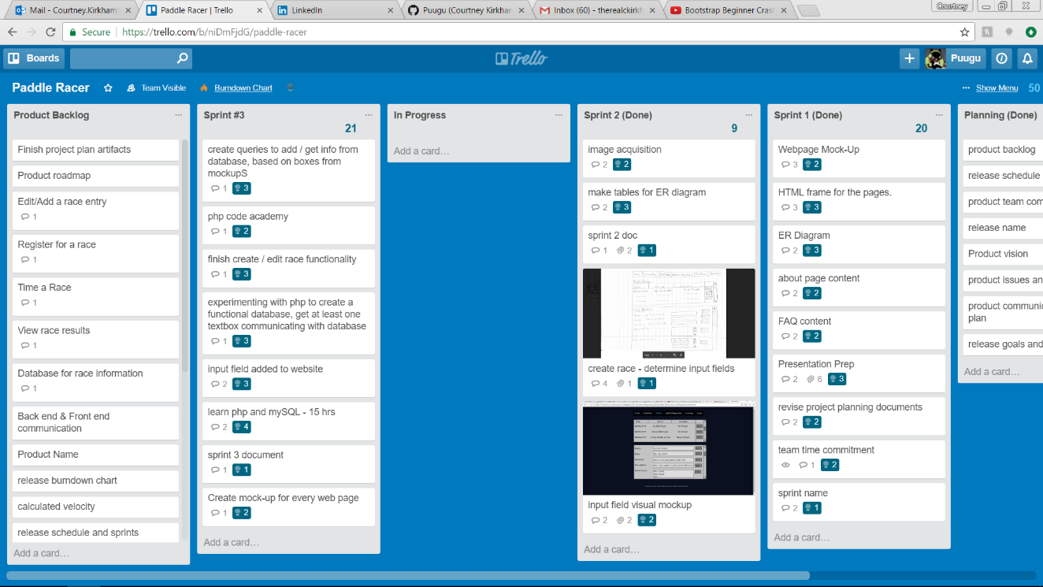

Return to Table of Contents

**IV.** **Definition of Done**

The Sprint 2 Retrospective and Sprint 3 Planning Documents will be considered complete when they cover all of the requirements issued by Professor Nelson and the Development Team, Product Owner, and Scrum Master agree with it. The web page mock ups will be complete when there is a Product Owner approved mock up for each webpage currently on the site. The database queries will be complete when there is a query for each relationship represented on the ER diagram that functions properly. The PHP Code Academy course will be considered done when the course is completed as to Code Academy's course requirements. The functionality for creating and editing races will be complete when the entry forms and navigation buttons necessary for a user to be able to create and edit a race (as laid out by the mock ups) are all present. The communication between a textbox and the database will be done when a test user can enter information into one text box (of Nick's choosing) and have that information be reflected in the database.

Return to Table of Contents

**V.** **Sprint Burndown Chart**

|  |  |  |  |  |  |
| --- | --- | --- | --- | --- | --- |
|  |  | Paddle Racers Burndown Chart | | |  |
| 55 |  |  |  |  |  |
| 50 |  |  |  |  |  |
| 45 |  |  |  |  |  |
| 40 |  |  |  |  |  |
| 35 |  |  |  |  |  |
| 30 |  |  |  |  |  |
| 25 |  |  |  |  |  |
| 20 |  |  |  |  |  |
| 15 |  |  |  |  |  |
| 10 |  |  |  |  |  |
| 5 |  |  |  |  |  |
| 0 | 20 | 29 | 50 |  |  |
|  | Sprint 1 | Sprint 2 | Sprint 3 | Sprint 4 | Sprint 5 |

Return to Table of Contents

**VI.** **Team Velocity**

In the team's first sprint, 20 story points were completed. In the team's second sprint, 9 story points were completed. The team has completed 2 sprints. This results in a calculated velocity of 14.5.

The team expects to be able to complete 21 story points this sprint for an expected velocity of 16.67.

Return to Table of Contents

**VII.** **Team Capacity Calculation**

The team expects to be able to complete an average of 16 story points in each sprint for an expected completion of 80 story points by the first release. In a best – case scenario, the team expects to be able to complete 20 story points in each sprint, for a maximum team capacity of 100 story points by the first release.

Return to Table of Contents

**VIII.** **Team Roles**

Our first release is divided into five sprints. For each of those five sprints, we rotate who will represent the product owner and who will represent the product owner. For Sprint 3, Mark Lero will be the Scrum Master, Jonathan Bowie will be the Product Owner, and the development team will be comprised of Nicholas Kinderman, Mark Lero, Courtney Kirkham, Dean Dixon, and Jonathan Bowie.

Return to Table of Contents

**IX.** **Team Commitment**

The team commits to showing up for every meeting and class. If a team member cannot show up for some reason, they will let the team know as soon as possible. They will also get in touch with a team member to find out what they missed before the next meeting commences. When contacted by another member of the team for feedback or questions, the team commits to offering some notification acknowledging the message and either responding to the question/offering feedback or providing a timeframe in which a response can be expected; they will offer this notification within twenty-four hours of receiving the request. The team commits to communicating primarily through text messages throughout the week, following up with e-mail or voice communication as needed. The team also commits to daily check-ins with the scrum master via e-mail.

While roadblocks are an unavoidable part of life, when once comes up, the affected team member(s) will notify the team as soon as they know so the team can best figure out how to adapt. The team commits to moving their tasks on Trello, and the Product Owner commits to checking regularly to see which stories have been submitted for approval. The team commits to commenting code, and will sign code they contribute so code reviewers know who is responsible for what portion of the final code. Finally, the team commits to naming variables using camel case and prioritizing descriptive variable names over brief ones.

Return to Table of Contents

**X.** **Issues and Concerns**

Our team is concerned about the proficiency of the team regarding communication between the database and the website. Another concern is the need to build the database and figure out the logic for creating the races and editing the results. Coordinating the time keeping is another concern, as is making a secure database for user accounts. The team still needs to figure out what language to use for the backend of our project. The team has also recognized that we could stand to improve our communication and better commit to using our collaborative tools. We are optimistic about being able to learn these skills throughout the lifetime of the project, but recognize they represent a wide variety of skills we need to develop.

Return to Table of Contents

**XI.** **Meeting Schedule**

The team will meet Monday nights after class, on Wednesday evenings at 10:30 PM via Discord, and on Sunday afternoons at 1:30 PM at Quickly Asian Fusion Café in D'Iberville.

Return to Table of Contents

**XII.** **Communication and Logistics Plan**

The Monday night meetings are for sprint reviews and sprint planning. The Wednesday evening meetings are to check on the team's progress and address any roadblocks in the midst of the week, as well as serving as a hand-off timeline if any of the tasks for the sprint are scheduled to change hands in the midst of the sprint. The Sunday afternoon meetings are for the team to go over what they have completed and provide an overview for what will be presented in class on Mondays. Throughout the week, the team members will communicate via text messages and e-mails if they need to ask the team for feedback or assistance. All team members are to check e-mail daily. Text messages and e-mails will be responded to within a twenty-four hour time period to at least let the other team members know that their message has been received and is being considered. Text messages will be the primary method of event-driven communication throughout the week, with follow-up in e-mail or voice clients as necessary. Additionally, if one (or more) of the team members encounters a road block, whether project related or not, that will cause a delay or inability to complete their allotted work for the sprint, they are to notify the team as soon as possible, so that the team may best figure out how to accommodate the change in situation.

Return to Table of Contents

**XIII. Collaboration Tools**

The team will use Trello for keeping track of the product and sprint backlogs. GitHub is used for version control. Discord, text messages, and e-mail will be used for communication between in – person meetings. Google Drive will be used for keeping track of project files in addition to GitHub.

Return to Table of Contents