Courtney Kirkham, Mark Lero, Dean Dixon, Jonathan Bowie, Nicholas Kinderman

CSC 424 – Software Engineering II

Spring 2017

Prof. Lindy Nelson

Sprint Plan – Sprint 4

Table of Contents

I. Sprint Name

II. Sprint Goals and Dates

III. Sprint Backlog

IV. Definition of Done

V. Sprint Burndown Chart

VI. Team Velocity

VII. Team Capacity Calculation

VIII. Team Roles

IX. Team Commitment

X. Issues and Concerns

XI. Meeting Schedule

XII. Communication and Logistics Plan

XIII. Collaboration Tools

**I.** **Sprint Name**

The project name has not yet been decided, but is currently being referred to as "Paddle Racers". The name of the forth sprint is Sprint 4.

Return to Table of Contents

**II. Sprint Goals and Dates**

All tasks for Sprint 4 will be completed by Sunday 16 April 2016 at 13:30 CST. Mark will import the sql tables into xamp and get the queries working. Courtney will type the Sprint 3 retrospective, type the Sprint 4 plan, and create a design for a creative overhaul of the Paddle Racers website. Nick will get the database table communicating with the website php for all of the currently live input and output fields. Jonathan will implement the remaining race director web pages, following the layouts from Sprint 3, and will clean up the html and css files. Dean will finish documenting his code from previous sprints and write a user documentation guide for the entire website. Courtney will also research various web hosting services. After getting the team's approval, she will set one up so that the team can use it.

Return to Table of Contents

**III.** **Sprint Backlog**

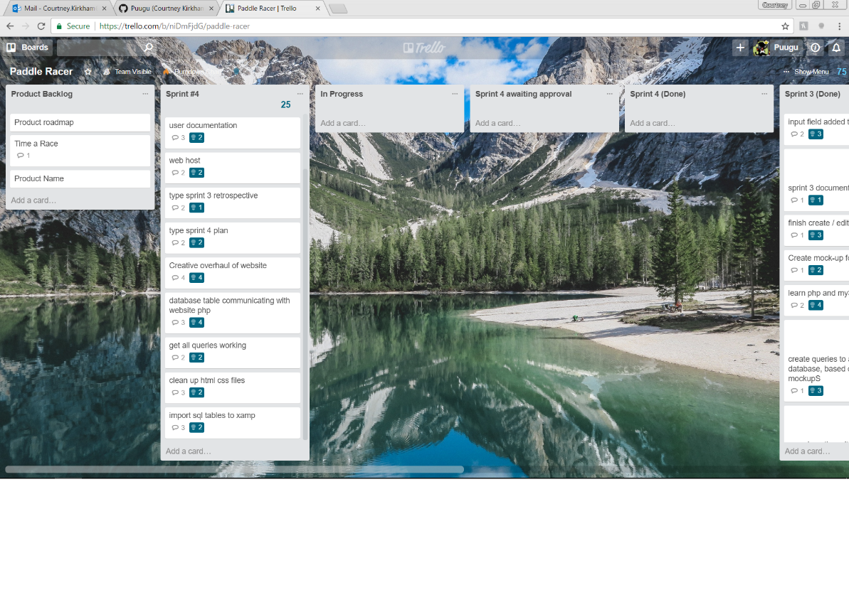

Return to Table of Contents

**IV.** **Definition of Done**

The process of importing the sql tables into xamp will be considered complete when all the tables for the database have been recreated in xamp. They will be considered working when all the queries correctly function with test data. The Sprint 3 retrospective and Sprint 4 planning documents will be considered complete when they are typed to Professor Nelson's specifications. The design for the creative overhaul will be complete when a colour scheme has been established, a more coherent plan for the navigation bars has been established, and images have been incorporated into the website. The communication between the database and website with php will be complete when all the input and output fields correctly communicate between the database and the website for the create race and edit race webpages for the race directors. The remaining web pages for the directors will be considered implemented when they are all live and ready to connect with the backend in the next sprint. The html and css files will be considered done when there is only one css file and when the html files are organized into coherent folders. Dean's code documentation will be done when the files that he has wrote (or, if Jonathan merges some of those files with others during his reorganizing of the html and css files, the code snippets Dean wrote) have been properly documented according to the standards agreed upon by the development team and allow his code to be understood by a programmer unfamiliar with the project. Dean's user documentation will be considered complete when he has created a "Help" page on the website with sections explaining how each part of the Paddle Racers website works.

Return to Table of Contents

**V.** **Sprint Burndown Chart**

|  |  |  |  |  |  |
| --- | --- | --- | --- | --- | --- |
|  |  | Paddle Racers Burndown Chart | | |  |
| 100 |  |  |  |  |  |
| 95 |  |  |  |  |  |
| 90 |  |  |  |  |  |
| 85 |  |  |  |  |  |
| 80 |  |  |  |  |  |
| 75 |  |  |  |  |  |
| 70 |  |  |  |  |  |
| 65 |  |  |  |  |  |
| 60 |  |  |  |  |  |
| 55 |  |  |  |  |  |
| 50 |  |  |  |  |  |
| 45 |  |  |  |  |  |
| 40 |  |  |  |  |  |
| 35 |  |  |  |  |  |
| 30 |  |  |  |  |  |
| 25 |  |  |  |  |  |
| 20 |  |  |  |  |  |
| 15 |  |  |  |  |  |
| 10 |  |  |  |  |  |
| 5 |  |  |  |  |  |
| 0 | 20 | 29 | 50 | 75 |  |
|  | Sprint 1 | Sprint 2 | Sprint 3 | Sprint 4 | Sprint 5 |

Return to Table of Contents

**VI.** **Team Velocity**

In the team's first sprint, 20 story points were completed. In the team's second sprint, 9 story points were completed. 21 story points were completed during the team's third sprint. The team has completed 3 sprints. This results in a calculated velocity of 16.67.

The team estimates completing 25 story points during Sprint 4 for an expected velocity of 18.75.

Return to Table of Contents

**VII.** **Team Capacity Calculation**

The team expects to be able to complete an average of 16 story points in each sprint for an expected completion of 80 story points by the first release. In a best – case scenario, the team expects to be able to complete 20 story points in each sprint, for a maximum team capacity of 100 story points by the first release.

Return to Table of Contents

**VIII.** **Team Roles**

Our first release is divided into five sprints. For each of those five sprints, we rotate who will represent the product owner and who will represent the product owner. For Sprint 4, Jonathan Bowie will be the Scrum Master, Dean Dixon will be the Product Owner, and the development team will be comprised of Nicholas Kinderman, Mark Lero, Courtney Kirkham, Dean Dixon, and Jonathan Bowie.

Return to Table of Contents

**IX.** **Team Commitment**

The team commits to showing up for every meeting and class. If a team member cannot show up for some reason, they will let the team know as soon as possible. They will also get in touch with a team member to find out what they missed before the next meeting commences. When contacted by another member of the team for feedback or questions, the team commits to offering some notification acknowledging the message and either responding to the question/offering feedback or providing a timeframe in which a response can be expected; they will offer this notification within twenty-four hours of receiving the request. The team commits to communicating primarily through text messages throughout the week, following up with e-mail or voice communication as needed. The team also commits to daily check-ins with the scrum master via e-mail.

While roadblocks are an unavoidable part of life, when once comes up, the affected team member(s) will notify the team as soon as they know so the team can best figure out how to adapt. The team commits to moving their tasks on Trello, and the Product Owner commits to checking regularly to see which stories have been submitted for approval. The team commits to commenting code, and will sign code they contribute so code reviewers know who is responsible for what portion of the final code. Finally, the team commits to naming variables using camel case and prioritizing descriptive variable names over brief ones.

Return to Table of Contents

**X.** **Issues and Concerns**

The team is concerned about coordinating the time keeping of the racers, as well as making a secure database for user accounts. The team has also recognized that we could stand to improve our communication and better commit to using our collaborative tools. We are optimistic about being able to learn these skills throughout the lifetime of the project, but recognize they represent a wide variety of skills we need to develop. One of our biggest issues thus far in this release is difficulty with team members fulfilling their roles as Product Owner or Scrum Master.

Return to Table of Contents

**XI.** **Meeting Schedule**

The team will meet Monday nights after class, on Wednesday evenings at 10:30 PM via Discord, and on Sunday afternoons at 1:30 PM at Quickly Asian Fusion Café in D'Iberville.

Return to Table of Contents

**XII.** **Communication and Logistics Plan**

The Monday night meetings are for sprint reviews and sprint planning. The Wednesday evening meetings are to check on the team's progress and address any roadblocks in the midst of the week, as well as serving as a hand-off timeline if any of the tasks for the sprint are scheduled to change hands in the midst of the sprint. The Sunday afternoon meetings are for the team to go over what they have completed and provide an overview for what will be presented in class on Mondays. Throughout the week, the team members will communicate via text messages and e-mails if they need to ask the team for feedback or assistance. All team members are to check e-mail daily. Text messages and e-mails will be responded to within a twenty-four hour time period to at least let the other team members know that their message has been received and is being considered. E-mail will be the primary method of event-driven communication throughout the week, with follow-up in voice clients as necessary. Additionally, if one (or more) of the team members encounters a road block, whether project related or not, that will cause a delay or inability to complete their allotted work for the sprint, they are to notify the team as soon as possible, so that the team may best figure out how to accommodate the change in situation.

The Scrum Master will e-mail the team daily to check on their progress. Each member of the team is expected to reply to this e-mail every day.

Return to Table of Contents

**XIII. Collaboration Tools**

The team will use Trello for keeping track of the product and sprint backlogs. GitHub is used for version control. Discord, text messages, and e-mail will be used for communication between in – person meetings. Google Drive will be used for keeping track of project files in addition to GitHub.

Xamp will be the local server.

Return to Table of Contents