Courtney Kirkham, Mark Lero, Dean Dixon, Jonathan Bowie, Nicholas Kinderman

CSC 424 – Software Engineering II

Spring 2017

Prof. Lindy Nelson

Sprint Plan – Sprint 5

Table of Contents

I. Sprint Name

II. Sprint Goals and Dates

III. Sprint Backlog

IV. Definition of Done

V. Sprint Burndown Chart

VI. Team Velocity

VII. Team Capacity Calculation

VIII. Team Roles

IX. Team Commitment

X. Issues and Concerns

XI. Meeting Schedule

XII. Communication and Logistics Plan

XIII. Collaboration Tools

**I.** **Sprint Name**

The project name has been named "Paddle Racers". The name of the fifth sprint is Sprint 5.

Return to Table of Contents

**II. Sprint Goals and Dates**

All stories for Sprint 5 will be completed by Monday, 24 April 2017. Courtney will type the Sprint 4 retrospective and the Sprint 5 plan as well as creating a logo for Paddle Racers. Nick will get the php functionality working for the create race, edit race, add participants, and edit participants. If he has time, he will also get the functionality working for entering race times. Mark will update the sql for the project. Jonathan will implement the user login page and the creative overhaul. Dean will revise the user documentation to reflect any changes from the creative overhaul.

Return to Table of Contents

**III.** **Sprint Backlog**

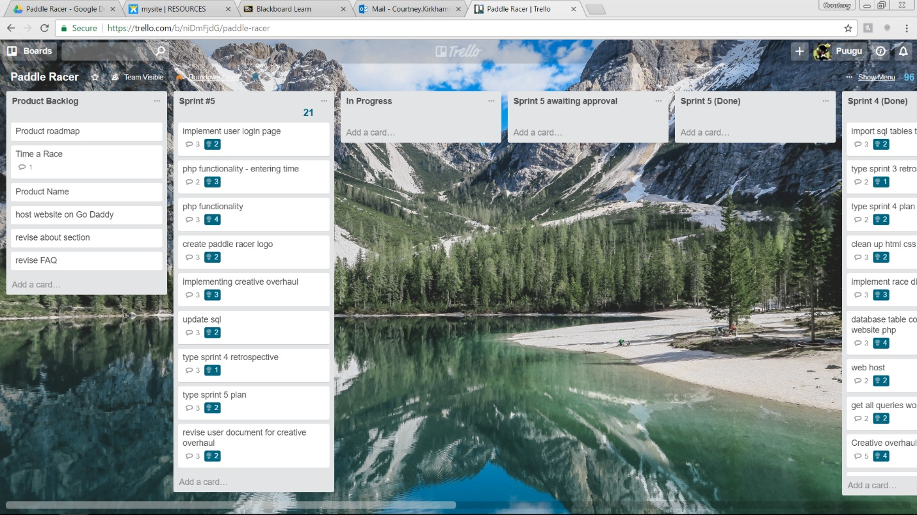

Return to Table of Contents

**IV.** **Definition of Done**

The Sprint 4 retrospective and the Sprint 5 plan will be considered done when they have been typed to Prof. Nelson's specifications and submitted to the group for approval. The Paddle Racers logo will be done when a rectangular image with the text "Paddle Racers" on the left and an image of a person kayaking on the right has been created. The php functionality working for the create race, edit race, add participants, and edit participants requires the full functionality of each database interaction for these pages to be implemented. The php functionality for entering time will be done when users are able to enter race times and those times are accurately stored in the database. The SQL update requires updating the current queries to reflect the front end for the first release. Some of the relationships for BIB Number, participants, teams, and races will be adjusted so that participants may be part of a team, a race may have teams, and that either a participant or a team will have a BIB Number. The creative overhaul will be complete when the web pages reflect the design changes described in the creative overhaul document. The user login page will be done when a race director is able to create, log in, and log out of an account. The user guide will be done when a web page exists that explains to a user how to navigate the website in order to perform various functions.

Return to Table of Contents

**V.** **Sprint Burndown Chart**

|  |  |  |  |  |  |
| --- | --- | --- | --- | --- | --- |
|  |  | Paddle Racers Burndown Chart | | |  |
| 100 |  |  |  |  |  |
| 95 |  |  |  |  |  |
| 90 |  |  |  |  |  |
| 85 |  |  |  |  |  |
| 80 |  |  |  |  |  |
| 75 |  |  |  |  |  |
| 70 |  |  |  |  |  |
| 65 |  |  |  |  |  |
| 60 |  |  |  |  |  |
| 55 |  |  |  |  |  |
| 50 |  |  |  |  |  |
| 45 |  |  |  |  |  |
| 40 |  |  |  |  |  |
| 35 |  |  |  |  |  |
| 30 |  |  |  |  |  |
| 25 |  |  |  |  |  |
| 20 |  |  |  |  |  |
| 15 |  |  |  |  |  |
| 10 |  |  |  |  |  |
| 5 |  |  |  |  |  |
| 0 | 20 | 29 | 50 | 75 | 96 |
|  | Sprint 1 | Sprint 2 | Sprint 3 | Sprint 4 | Sprint 5 |

Return to Table of Contents

**VI.** **Team Velocity**

In the team's first sprint, 20 story points were completed. In the team's second sprint, 9 story points were completed. 21 story points were completed during the team's third sprint. The team completed 25 story points during our fourth sprint. The team has completed 4 sprints. This results in a calculated velocity of 18.75.

The team estimates completing 21 story points during Sprint 4 for an expected velocity of 19.2.

Return to Table of Contents

**VII.** **Team Capacity Calculation**

The team expects to be able to complete an average of 16 story points in each sprint for an expected completion of 80 story points by the first release. In a best – case scenario, the team expects to be able to complete 20 story points in each sprint, for a maximum team capacity of 100 story points by the first release.

Return to Table of Contents

**VIII.** **Team Roles**

Our first release is divided into five sprints. For each of those five sprints, we rotate who will represent the product owner and who will represent the product owner. For Sprint 5, Dean Dixon will be the Scrum Master, Courtney Kirkham will be the Product Owner, and the development team will be comprised of Nicholas Kinderman, Mark Lero, Courtney Kirkham, Dean Dixon, and Jonathan Bowie.

Return to Table of Contents

**IX.** **Team Commitment**

The team commits to showing up for every meeting and class. If a team member cannot show up for some reason, they will let the team know as soon as possible. They will also get in touch with a team member to find out what they missed before the next meeting commences. When contacted by another member of the team for feedback or questions, the team commits to offering some notification acknowledging the message and either responding to the question/offering feedback or providing a timeframe in which a response can be expected; they will offer this notification within twenty-four hours of receiving the request. The team commits to communicating primarily through text messages throughout the week, following up with e-mail or voice communication as needed. The team also commits to daily check-ins with the scrum master via e-mail.

While roadblocks are an unavoidable part of life, when once comes up, the affected team member(s) will notify the team as soon as they know so the team can best figure out how to adapt. The team commits to moving their tasks on Trello, and the Product Owner commits to checking regularly to see which stories have been submitted for approval. The team commits to commenting code, and will sign code they contribute so code reviewers know who is responsible for what portion of the final code. Finally, the team commits to naming variables using camel case and prioritizing descriptive variable names over brief ones.

Return to Table of Contents

**X.** **Issues and Concerns**

The team is concerned about coordinating the time keeping of the racers, as well as making a secure database for user accounts. This is especially a high concern regarding implementing user accounts and security. The team has also recognized that we could stand to improve our communication and better commit to using our collaborative tools. We are optimistic about being able to learn these skills throughout the lifetime of the project, but recognize they represent a wide variety of skills we need to develop. One of our biggest issues thus far in this release is difficulty with team members fulfilling their roles as Product Owner or Scrum Master.

Return to Table of Contents

**XI.** **Meeting Schedule**

The team will meet Monday nights after class, on Wednesday evenings at 10:30 PM via Discord, and on Sunday afternoons at 1:30 PM at Quickly Asian Fusion Café in D'Iberville.

Return to Table of Contents

**XII.** **Communication and Logistics Plan**

The Monday night meetings are for sprint reviews and sprint planning. The Wednesday evening meetings are to check on the team's progress and address any roadblocks in the midst of the week, as well as serving as a hand-off timeline if any of the tasks for the sprint are scheduled to change hands in the midst of the sprint. The Sunday afternoon meetings are for the team to go over what they have completed and provide an overview for what will be presented in class on Mondays. Throughout the week, the team members will communicate via text messages and e-mails if they need to ask the team for feedback or assistance. All team members are to check e-mail daily. Text messages and e-mails will be responded to within a twenty-four hour time period to at least let the other team members know that their message has been received and is being considered. E-mail will be the primary method of event-driven communication throughout the week, with follow-up in voice clients as necessary. Additionally, if one (or more) of the team members encounters a road block, whether project related or not, that will cause a delay or inability to complete their allotted work for the sprint, they are to notify the team as soon as possible, so that the team may best figure out how to accommodate the change in situation.

The Scrum Master will e-mail the team daily to check on their progress. Each member of the team is expected to reply to this e-mail every day.

Return to Table of Contents

**XIII. Collaboration Tools**

The team will use Trello for keeping track of the product and sprint backlogs. GitHub is used for version control. Discord, text messages, and e-mail will be used for communication between in – person meetings. Google Drive will be used for keeping track of project files in addition to GitHub.

Xamp will be the local server.

Return to Table of Contents