insert into Projects

values (newid(), 'Wood', 'india', 'Alpha', 100000),

(newid(), 'Wood and medal', 'germany', 'Bravo', 100000),

(newid(), 'rocks', 'Latvia', 'Delta', 10),

(newid(), 'stick and stones', 'Mongolia', 'War Base', 1000),

(newid(), 'Coal', 'Cameroon', 'BlackHouse', 1000000),

(newid(), 'Wood', 'Libya', 'Iota', 100000),

(newid(), 'birch Wood', 'Russia', 'Zeta', 100000),

(newid(), 'colored Wood', 'UAE', 'Epsilon', 100000),

(newid(), 'Wood, Sand and Copper', 'Kiuri kodu', 'Gamma', 1),

(newid(), 'Wood, rocks, metal and Karhu', 'Finland', 'Sauna', 10000)  
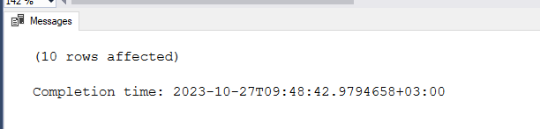

insert into Specialists

values ('BBQ', '1EA39C9B-D564-4D38-B553-A326AAF5B292'),

('Plumbing', '1EA39C9B-D564-4D38-B553-A326AAF5B292'),

('Electrician', '1EA39C9B-D564-4D38-B553-A326AAF5B292'),

('HVAC contractors', '1EA39C9B-D564-4D38-B553-A326AAF5B292'),

('Drywalling', '1EA39C9B-D564-4D38-B553-A326AAF5B292'),

('flooring', '1EA39C9B-D564-4D38-B553-A326AAF5B292'),

('Restoration contractor', '1EA39C9B-D564-4D38-B553-A326AAF5B292'),

('Demolition contractor', '1EA39C9B-D564-4D38-B553-A326AAF5B292'),

('Paving', '1EA39C9B-D564-4D38-B553-A326AAF5B292'),

('Roofer', '1EA39C9B-D564-4D38-B553-A326AAF5B292')

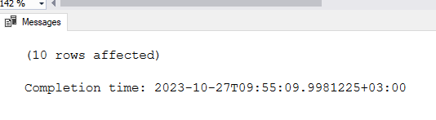

insert into Employees

values (newid(), 'Marken', 'Lemming', '2001-01-01 12:12:12', 'Minu.email@hotmail.com', 'Male', '2002-01-01 12:12:12', 27, 2567890, 500, 'Roofing'),

(newid(), 'Kiur', 'Arbeiter', '1998-01-01 12:12:12', 'Minu.email@hotmail.com', 'Male', '2002-01-01 12:12:12', 43, 2567891, 5000, 'Roofing'),

(newid(), 'Henri', 'Evert', '1892-01-01 12:12:12', 'Minu.email@hotmail.com', 'Male', '2002-01-01 12:12:12', 22, 2567892, 5000, 'Roofing'),

(newid(), 'Kristo', 'Kuurits', '1979-01-01 12:12:12', 'Minu.email@hotmail.com', 'Male', '2002-01-01 12:12:12', 63, 2567893, 5000, 'Roofing'),

(newid(), 'Meelis', 'Mets', '1999-01-01 12:12:12', 'Minu.email@hotmail.com', 'Male', '2002-01-01 12:12:12', 007, 2567894, 5000, 'Roofing'),

(newid(), 'Igor', 'Ivan', '1998-01-01 12:12:12', 'Minu.email@hotmail.com', 'Male', '2002-01-01 12:12:12', 94, 2567895, 5000, 'Roofing'),

(newid(), 'Dima', 'Jafanki', '1989-01-01 12:12:12', 'Minu.email@hotmail.com', 'Male', '2002-01-01 12:12:12', 01, 2567896, 5000, 'Roofing'),

(newid(), 'Timo', 'Krakausgi', '2002-01-01 12:12:12', 'Minu.email@hotmail.com', 'Male', '2002-01-01 12:12:12', 91, 2567897, 5000, 'Roofing'),

(newid(), 'Artur', 'Erissaar', '1922-01-01 12:12:12', 'Minu.email@hotmail.com', 'Male', '2002-01-01 12:12:12', 73, 2567898, 5000, 'Roofing'),

(newid(), 'Madis', 'Uleksin', '1989-01-01 12:12:12', 'Minu.email@hotmail.com', 'Male', '2002-01-01 12:12:12', 29, 2567899, 5000, 'Roofing')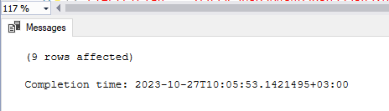  
create procedure spGetEmployees

as begin

select FirstName, Gender from Employees

end

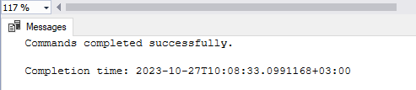

create procedure spGetEmployees

@Gender nvarchar(20),

@Name nvarchar(20)

as begin

select FirstName, Gender from Employees

where Gender = @Gender

and FirstName = @Name

end

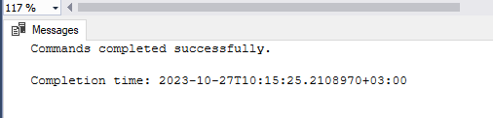

spGetEmployees 'Male', 'Marken'

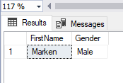

select FirstName, Gender, Salary, Name

from Employees

left join Projects

on Employees.Id = Projects.Id  
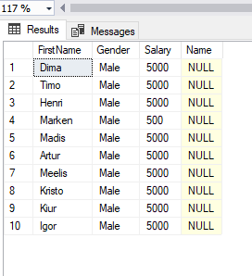

select FirstName, Gender, Salary, Name

from Employees

right join Projects

on Employees.Id = Projects.Id

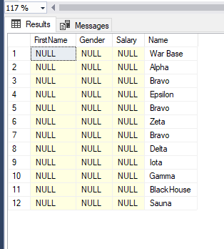

select FirstName, Gender, Salary, Name

from Employees

cross join Projects

